Assignment1

Leiwen Lin**,** [leven@gwu.edu](mailto:leven@gwu.edu)

Programming for Analytics (DNSC 6211)

**Instructor:** Shivraj Kanungo

* Part A

As .R file suggested

Result:

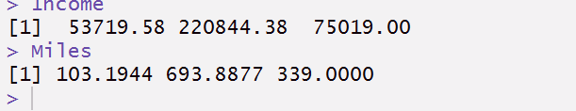

* Part B

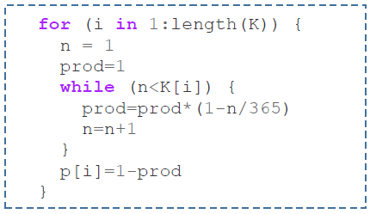

Vector K[i]: present number of people in a class

Vector P[i]: present probablity of at least two people have the same birthday date under a certain number of people

Prod: after 'while' iteration, prod is the probability of no other people have the same birthday date.

First loop(for loop):In order to let each slot of vector P contain its attributed probability

Second loop(while loop):In order to compute Permutation(365,K[i])/365^K[i]（365*364*363....../365^n）

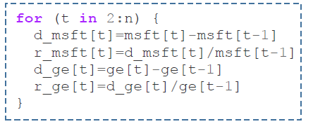

d_msft[t]=msft[t]-msft[t-1]: the change of day price: how much is the price of microsoft going up?

r_msft[t]=d_msft[t]/msft[t-1] : the change rate of day price: microsoft daily return

d_ge[t]=ge[t]-ge[t-1]: the change of day price: how much is the price of GE going up?

r_ge[t]=d_ge[t]/ge[t-1]: the change rate of day price: GE stock daily return

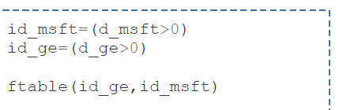

id_msft=(d_msft>0) :create a vector 'id_msft' which indicates today Microsoft price whether goes up（the slot containing TRUE means price goes up the following day, vice versa）

id_ge=(d_ge>0):create a vector'id_ge' which indicates today GE price whether goes up（the slot containing TRUE means price goes up the following day, vice versa）

ftable(id_ge,id_msft):create a matrix shows that the numbers days of two stock price going down together, Microsoft going down while GE going up, Microsoft going up while GE going down and two stock price both going up.

* Part C

As .R file suggested

Result: e.g:n = 10

