**Network Programming for Engineers (ECE 5650)**

**Lab 3**

**Team Members Names: Anika Tasnim & Li Lin**

1. Start my web browser



1. Start up the Wireshark software.

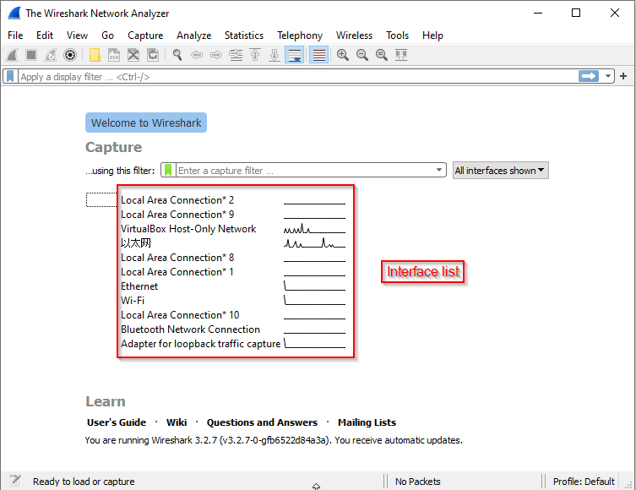

1. Double click or right click on Ethernet to start capturing for Ethernet

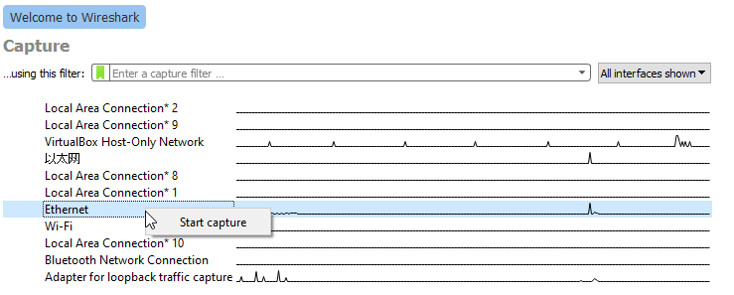

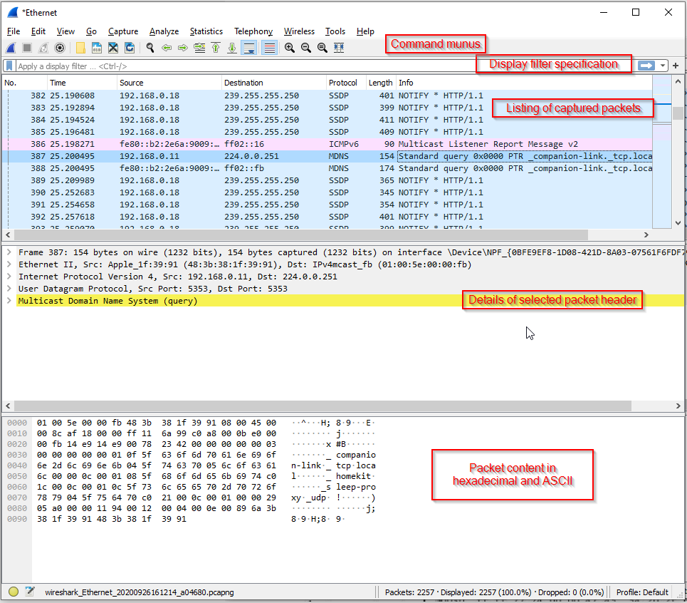

1. Keep capturing running and type below link in web browser and wait for homepage displayed

<http://nabil.eng.wayne.edu/news/index.html>



1. Stop capturing

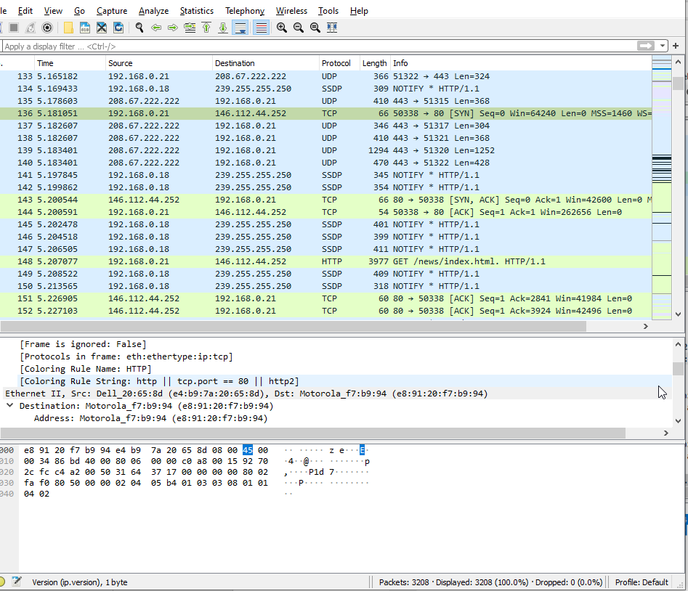

**Q1)** List 3 different protocols that appear in the protocol column in the unfiltered packet-listing window.

**Answer: From above picture, there are UDP,TCP，SSDP, HTTP**

1. Type in “http” into the display filter specification window, then select “*Apply*”

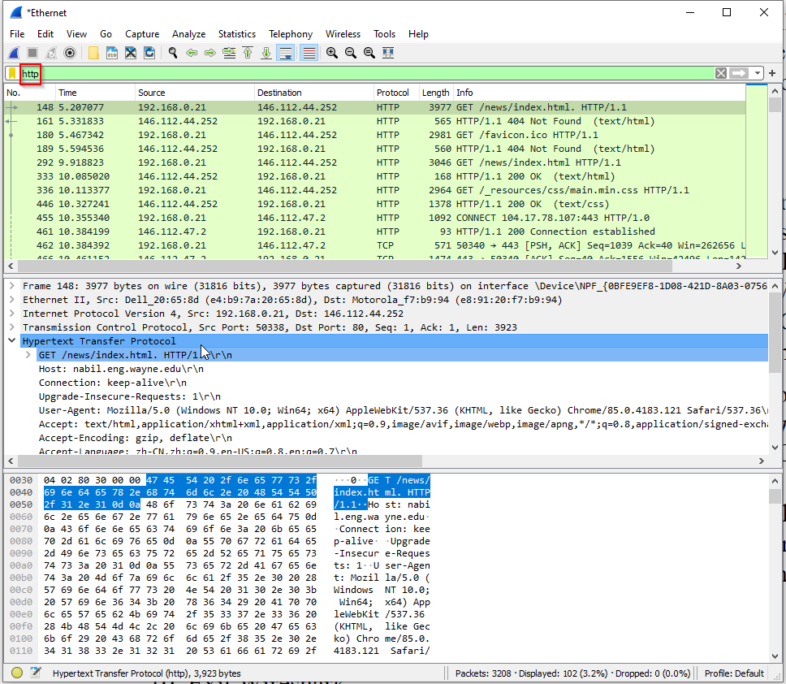

1. Find the HTTP GET message that was sent from my computer to the nabil.eng.wayne.edu HTTP server.

**Q2)** How long did it take from when the HTTP GET message was sent until the 200 OK reply was received?

Answer: Time = 18.023118 – 17.856921 = 0.166197(s) = 166.197ms

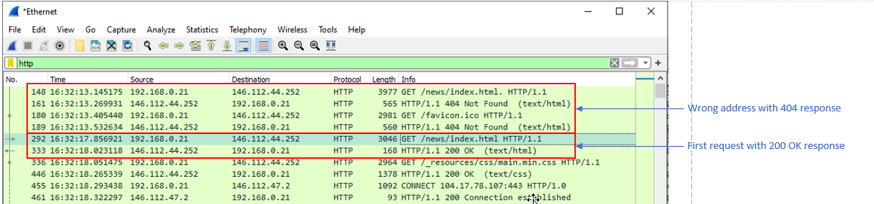

**Hypertext Transfer Protocol**

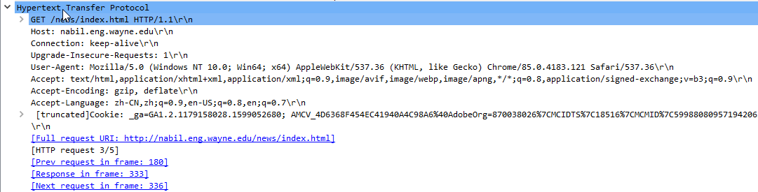

**Transmission Control Protocol**

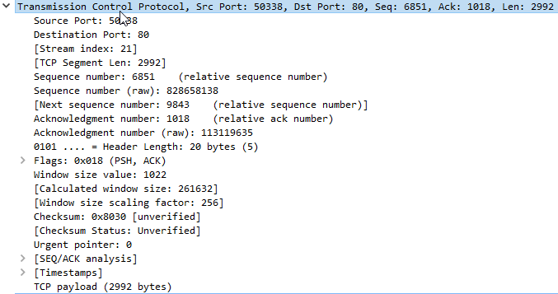

Server port

My computer port

**Internet Protocol Version 4**:

My computer address

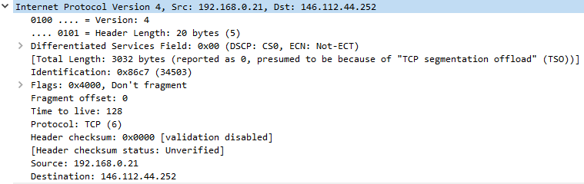

Server address

**Q3)** What is the Internet address of the webserver?

Answer: From the IPv4 protocol, the webserver address is 146.112.44.252

**Q4) What is the Internet address of your computer?**

Answer: From the IPv4 protocol , my computer IPv4 address is 192.168.0.21 which is also same as ipconfig result shown as below.

**Ethernet II**:

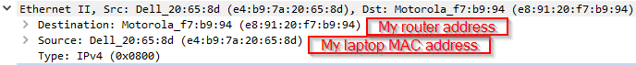

**Frame:**

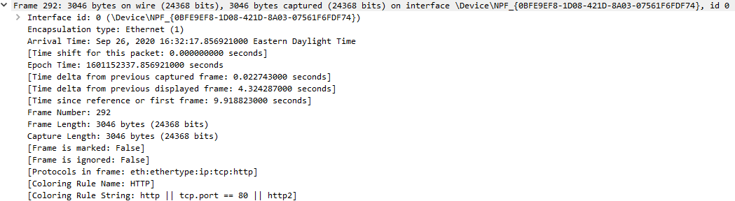

1. My laptop address:

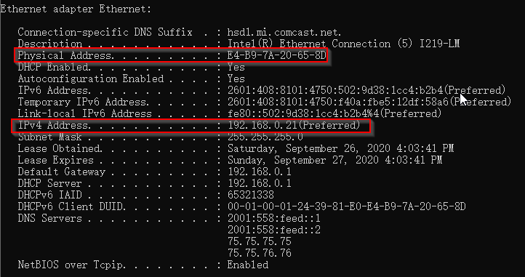

1. **Q5)** Print and include snapshots of the two HTTP messages (GET and OK) referred to in Q2).
   1. GET message

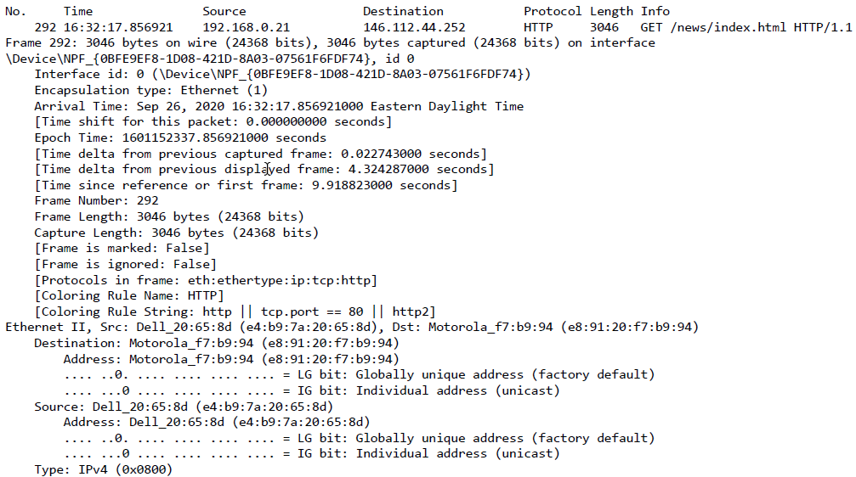

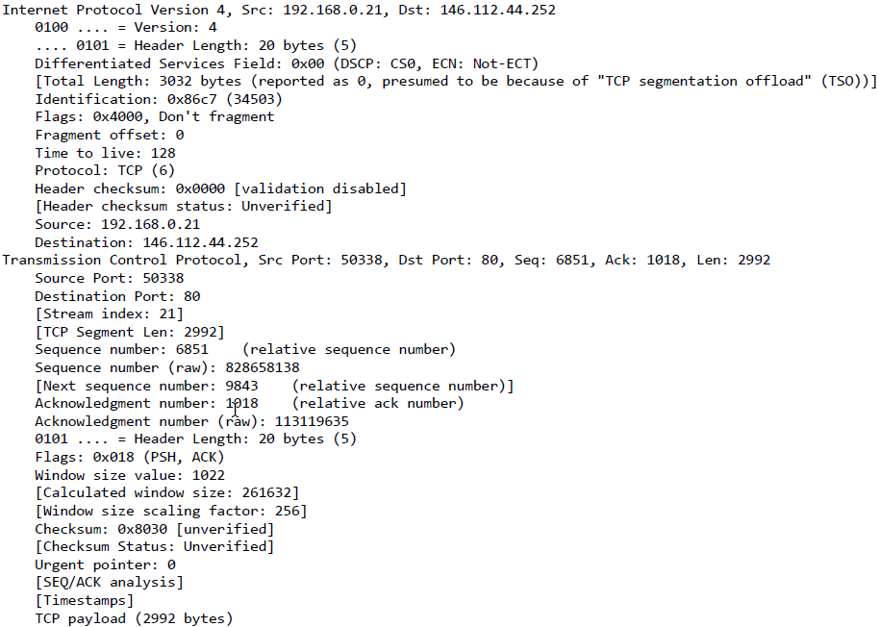

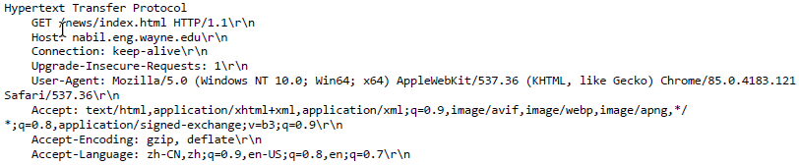

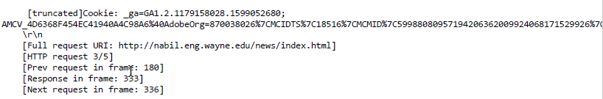

* 1. GET OK response message

