PEAP-AI Technical Summary
This document summarizes the workflow, architecture, programming stack, and LLM usage of PEAP-AI as implemented in the LLED_bot_MVP repository (LLED 200 Essay Feedback MVP) for formative AI feedback on Descriptive Report drafts.

1. Workflow and Architecture

1.1 System Overview
PEAP-AI is a locally hosted web application MVP. A student submits an essay draft; the backend orchestrates multiple LLM calls through a LangGraph StateGraph; the system returns strictly schema-validated JSON feedback; the browser renders a two-column view with paragraph-level annotations, sidebar cards, and an overall summary.
Current scope excludes user authentication, persistence, and RAG vector retrieval. Course material references are attached via deterministic mapping, not retrieval.

1.2 End-to-End Workflow
Stage | Behavior
Input | Paste plain text or upload .txt, .md, .doc, .docx, or .pdf; fileExtractor extracts essay_text.
Submit | POST /api/essay-feedback with body { essay_text }.
Orchestration | runFeedbackGraph: parse paragraphs, load prompt.md, run three parallel dimension branches, merge (up to 12 annotations), validate with Zod, optionally repair JSON once, attach course material labels.
Output | FeedbackResponse with paragraphs, annotations (offsets, function, level, evidence, revision guidance), and overall_feedback.
UI | Highlights linked to sidebar cards, dimension/level filters, Summary tab, sessionStorage cache for the latest result.

1.3 LangGraph Feedback Workflow (Implemented)
The diagram below reflects the StateGraph compiled in src/backend/lib/feedbackGraph.ts (@langchain/langgraph).
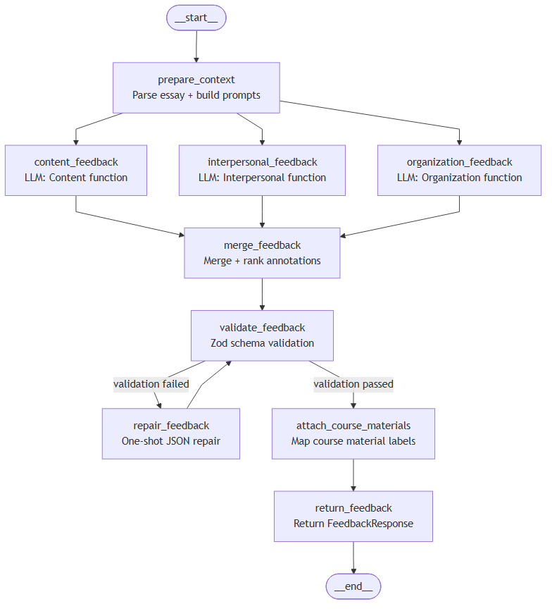
Graph nodes (in execution order):
- prepare_context — parseEssay + buildPromptMessages from prompt.md
- content_feedback — parallel LLM branch (Content function, max 4 annotations)
- interpersonal_feedback — parallel LLM branch (Interpersonal function)
- organization_feedback — parallel LLM branch (Organization function)
- merge_feedback — merge branches, sort by severity, cap at 12 annotations
- validate_feedback — Zod validation of offsets, paragraph IDs, and schema
- repair_feedback (conditional) — one repair attempt if validation fails
- attach_course_materials — map function + level to course material labels
- return_feedback — return FeedbackResponse to the API layer
Typical LLM calls per submission: about 3 (parallel dimension nodes). If repair runs, add 1 additional call.

1.4 Layered Architecture
Layer | Location / role
Presentation | src/frontend/ — HTML, CSS, TypeScript
API | src/backend/server.ts — Express 5
Orchestration | src/backend/lib/feedbackGraph.ts — LangGraph StateGraph
LLM + Prompt | openaiClient.ts, promptBuilder.ts, prompts/prompt.md
Validation + Shared | schemaValidator.ts (Zod), src/shared/schema.ts
Course mapping | src/shared/courseMaterials.ts

1.5 Evaluation Framework
Feedback aligns with the Academic Writing Matrix: three functional dimensions (Content, Interpersonal, Organization) crossed with three levels (text, section, clause_word). The prompt forbids scoring and sentence rewriting; it provides diagnostic feedback and revision guidance only.

2. Programming Languages and Stack
Category | Choice
Primary language | TypeScript (strict: true) across backend, frontend, shared
Markup & styling | HTML5 and CSS (no React/Vue SPA framework)
Runtime | Node.js 20 or newer
Backend | Express 5
Workflow engine | LangGraph (@langchain/langgraph)
Validation | Zod 4
Document parsing | mammoth, pdf-parse, word-extractor
Uploads | multer (in-memory, max 10 MB per file)
Build | tsc for frontend bundle; tsx watch + concurrently in dev

3. LLM Models
PEAP-AI currently uses OpenAI models as the primary integration path. The backend adapter (openaiClient.ts) calls the OpenAI Chat Completions API with structured JSON schema output (response_format: json_schema, strict: true).
The architecture is adapter-based: additional large language models (e.g., Anthropic, Google, Azure OpenAI, or other OpenAI-compatible endpoints) can be wired in by implementing the same structured-feedback contract behind the LangGraph nodes, without changing the frontend schema.
Item | Details
Primary provider | OpenAI (current production path)
Default model | gpt-5.4-mini (overridable via OPENAI_MODEL; see .env.example)
Configuration | OPENAI_API_KEY (required), OPENAI_MODEL (optional), PORT
Invocation pattern | Parallel dimension nodes + optional single repair pass
Extensibility | Other LLMs supported in principle via adapter swap or multi-provider routing

4. Document Metadata
Field | Value
Title | PEAP-AI Technical Summary
Version | MVP (essay-feedback-mvp v0.1.0)
Date | 2026-06-03

Prepared by: Lin Manshan (林满山)
Email: lin.manshan050813@gmail.com
Source: LLED_bot_MVP repository — for course documentation and future HelpMe migration.

