**COMP 3074 Lab Exercise 3**

Tasks:

1. Build a shopping list application
2. Show the list of items to buy
3. Add element to the list
4. Remove element from the list

**1&2. Build a shopping list application, show the list of items to buy**

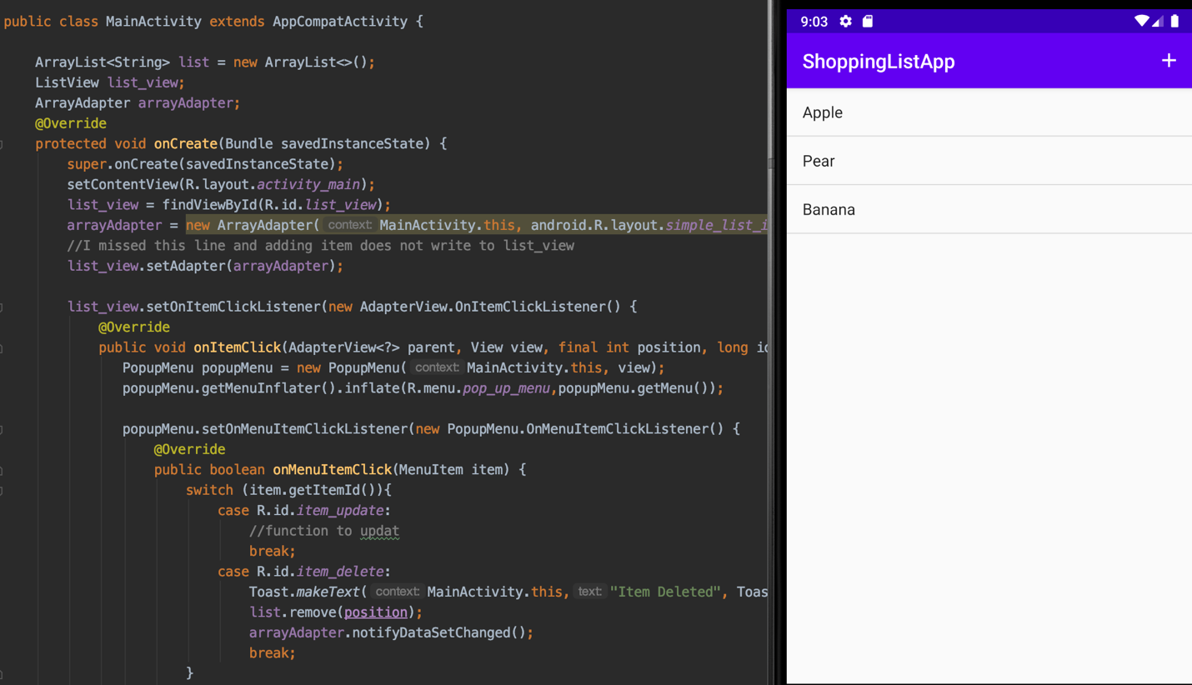

**3. Add element to the list**

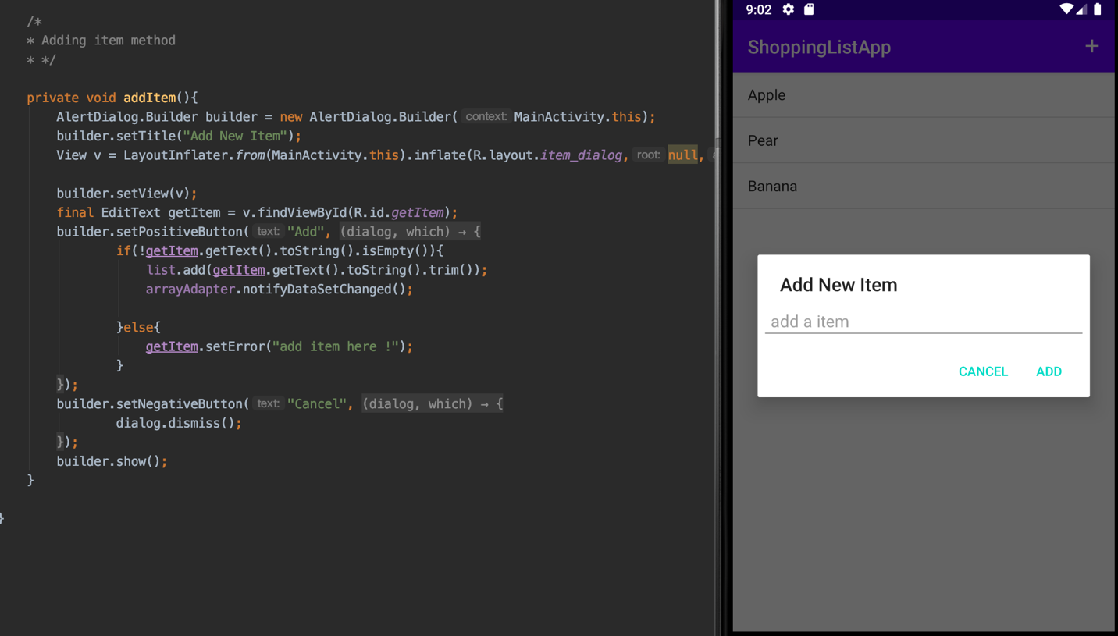

**4. Remove element from the list**

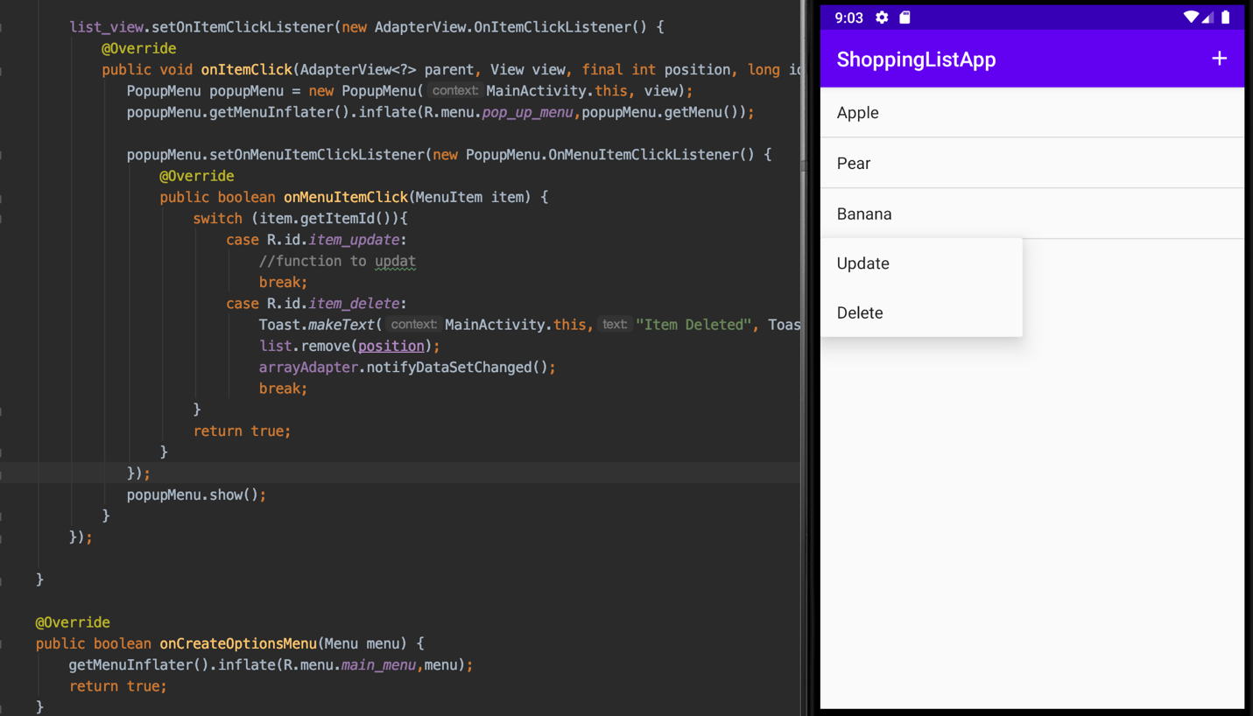

**GitHub Project Source Code Link:** [**https://github.com/linminca/comp3074_lab_project/tree/master/wk4/ShoppingListApp**](https://github.com/linminca/comp3074_lab_project/tree/master/wk4/ShoppingListApp)

**Reference:**

[**https://www.youtube.com/watch?v=IxNC-mhswww&ab_channel=RajJani**](https://www.youtube.com/watch?v=IxNC-mhswww&ab_channel=RajJani)