AMS 582: Design of Experiment

**Fractional Factorial Design**

Group 10:

Linna Hu

111783771

Professor: Stephen Finch

December 6, 2018

# Introduction

Ten independent variables are in my model (called A through J). The value of each variable, $x_{i}$, satisfies $-1≤x_{i}≤1$, for $i=1, 2, …10$. The dependent variable Y is given by $Y=f\left(a, b, …, n\right)+ε$. Our goal is to determine $f\left(a, b, …, j\right)$ by designing an experiment, requesting the values of the dependent variable generated by the model for a specified set of runs and analyzing the features of data.

1024 factorial design has all settings of 10 variables. Although it provides detailed information under each setting, it’s very difficult to afford this number of runs. Hence, a less run times experience-Fractional Factorial Design is considered. That is, I selected $2^{10-3}=128$ fractional factorial design as a more economical way to build my model.

The design of experiment and data analysis are mainly completed in R and with the help of {FrF2} package.

# Methodology

## Design of Experiment

First, I decided to consider 128 fractional factorial design because it has 128 runs. That is a suitable number of runs because less runs are not enough to get the significant factors and more runs will waste more time and cost more points (data is very valuable resources) So I {FrF2}, a R package, to generate fraction factorial 2-level factors design.

Second, I used some R code to find the significant factors and select generators. The code is in the Appendix.

Then, I found one-way significant factors that exist in the alias structure, so I request data second time to detach the confounding one-way factors by fold-over method. All alias structures is in the Appendix.

1. **Validation**

I used Residual analysis and cross validation to implement my model, as well as to check the R-square value and validate my model. In the residual graph, I plotted the residuals versus fitted value and normal Q-Q plot to see whether the residuals randomly followed normal distribution over the whole range. In the 5-fold cross validation, 5 different model estimation error values were summed up and compared with 0.

1. **Result**
2. **Model**

I used main effort plot (MEPlot) and interaction plot (IAPlot) to find the potential significant main efforts and potential significant two-way interactions. The Figure 1 and 2 are showed below.

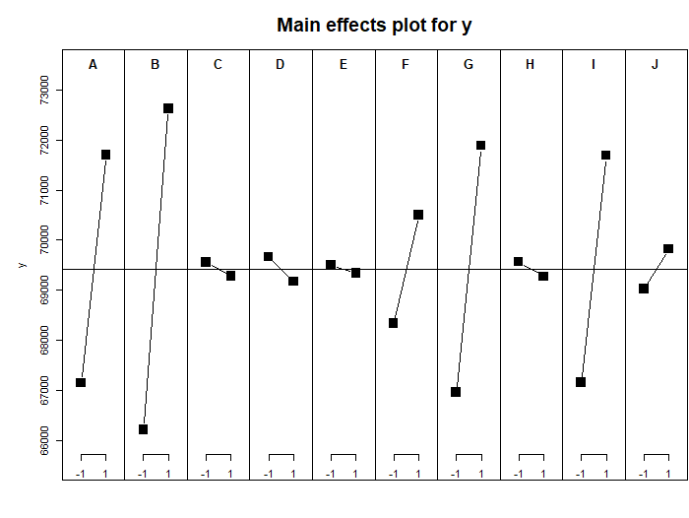

Figure 1

The Figure 1 indicates that the significant one-way factors are A. B. G. I.

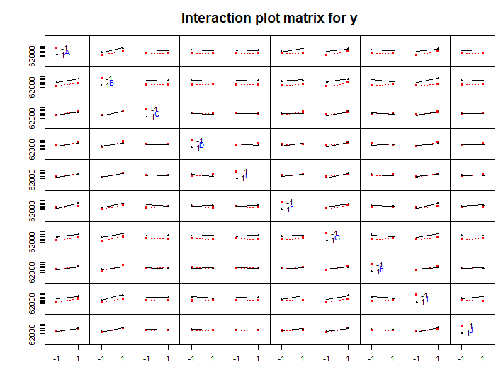

Figure 2

The figure 2 shows that there is no two-way interaction factors significant.

As we can see, non-significant effects should effectively follow an approximately normal distribution with the same location and scale. Significant effects will vary from this normal distribution. Therefore, another method of determining significant effects is to generate a normal probability plot of all effects. The effects that deviate substantially from the straight line fit to the data are considered significant. It is helpful to use both the numerical output from the fit and graphical techniques such as the normal probability plot in deciding which terms to keep in the model. So the normal plot , figure 3, is showed below.

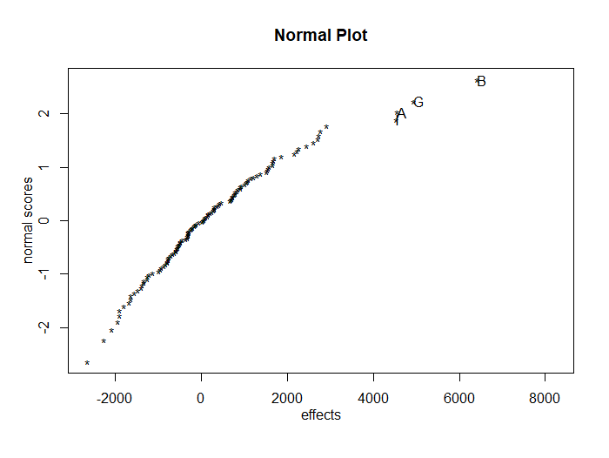

Figure 3

The figure 3 illustrates that the significant factors are I. A. G. B, this conclusion is same as the conclusion I got from figure 1 and figure 2.

1. **Variable Selection**

The second step is to check the alias structure, so I requested the 2nd data (Figure 4) and found out the alias combination of five-way. The alias combinations are showed below:

A = B:D:F:J = B:C:D:E:H = B:C:F:G:I

B = A:C:D:E:H = A:C:F:G:I = A:D:F:J

G = C:D:I:J = A:B:C:F:I = D:E:F:H:I

I = C:D:G:J = A:B:C:F:G = D:E:F:G:H

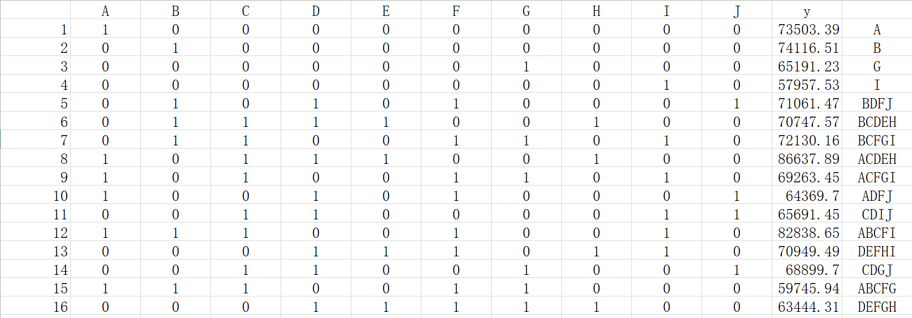

Figure 4

As we can see in the figure 4, BDFJ, BCDEH and BCFGI are the alias structure of A, and the Y value of A is clearly larger than these three alias structure. ACDEH, ACFGI and ADFJ are the alias structure of B, and the Y value of ACDEH is clearly larger than B. So the real significant factor is ACDEH. CDIJ, ABCFI and DEFHI are the alias structure of G, and the Y value of ABCFI is clearly larger than G. So the real significant factor is ABCFI. CDGJ, ABCFG and DEFGH are the alias structure of I, and the Y value of CDGJ is clearly larger than I. So the real significant factor is CDGJ. So the real significant factor is A, ACDEH, ABCFI and CDGJ.

In order to check whether those factors are include in the final model or not, I generate linear models. The figure of the linear model as below:

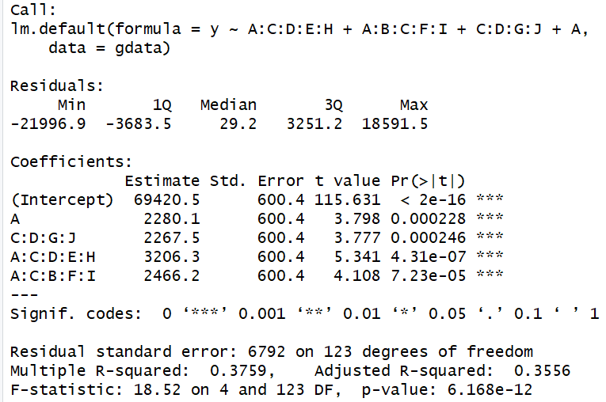

Figure 5

The figure of linear model before checking as below:

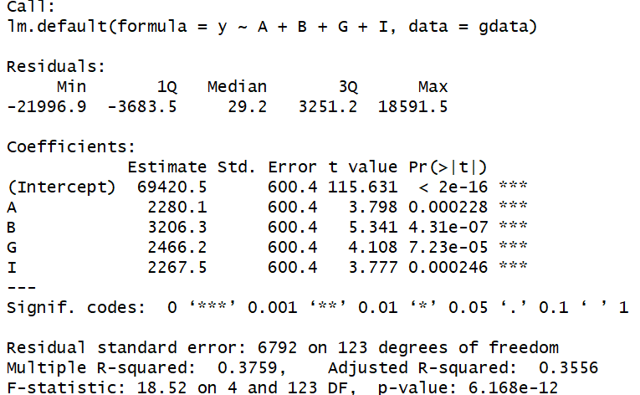

Figure 6

As we can see in the two figure, the R-squared is the same. So I’d like to choose the one with less complex.

Then we can get the variables choosing table as below:

|  |  |
| --- | --- |
| Variables | Choice |
| A | In |
| B | In |
| C | Out |
| D | Out |
| E | Out |
| F | Out |
| G | In |
| H | Out |
| I | In |
| J | Out |

$$Y=69420.5+2280.1×A+3206.3×B+2466.2×G+2267.5×I+ε$$

To further explore the performance of my model, I implemented residual analysis and cross validation.

1. **Model Validation**
   1. **Residual Analysis**

The Figure 7 shows the residuals are roughly randomly scattered without any apparent pattern. The Figure 8, normal Q-Q plot, indicates the residuals almost follow normal distribution, from which we can say that the model fitted the data well.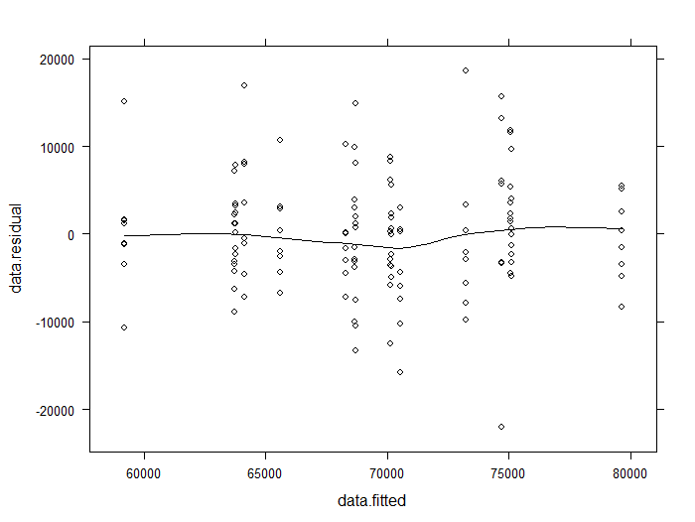

**Figure 7**

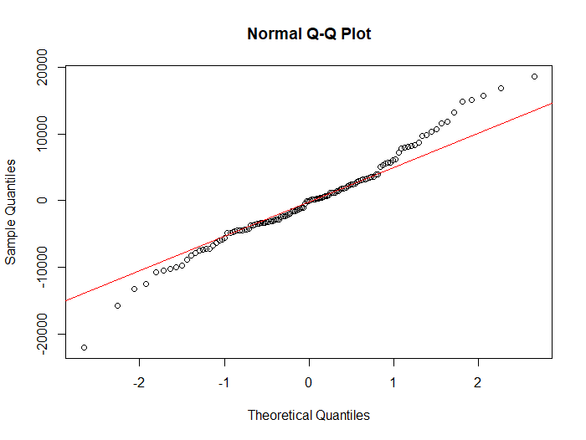

**Figure 8**

* 1. **Cross Validation**

The 5-fold cross validation told that the residual mean squared error is 6866.403, close to 6792 given by linear regression, which means my model describes the data appropriately.

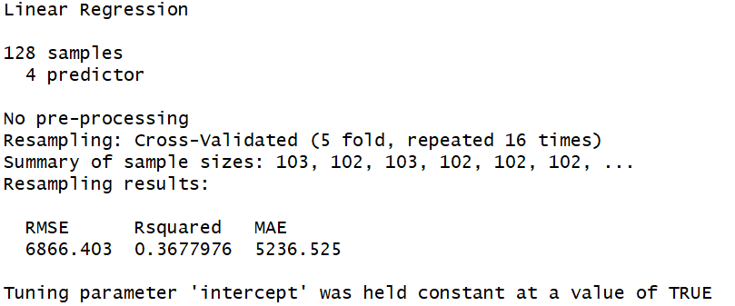

**Figure 9**

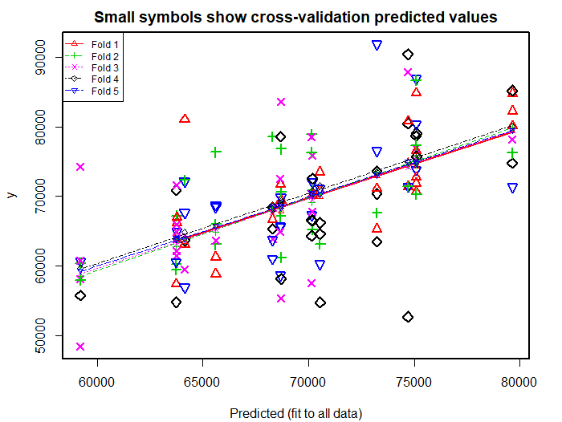

**Figure 10**

1. **Conclusion**

I utilized $2^{10-3}$ fractional factorial design to explore significant main effects and interactions from 10 variables and 1 response in R.

Through observing main effect plot, interaction plot and normal plot, I selected the most significant factors. After ensuring neither 2-way confounding factors nor other significant 3-way interaction, I built my final model:

$$Y=69420.5+2280.1×A+3206.3×B+2466.2×G+2267.5×I+ε$$

Then I found R-squared value, residual analysis and cross validation showed that the model fitted my data properly.

**Appendix 1**

Alias Structure for $2^{10-3}$ Fractional Factorial Design

A = B:D:F:J = B:C:D:E:H = B:C:F:G:I

B = A:C:D:E:H = A:C:F:G:I = A:D:F:J

C = D:G:I:J = E:F:H:J = A:B:D:E:H = A:B:F:G:I

D = C:G:I:J = A:B:C:E:H = E:F:G:H:I = A:B:F:J

E = C:F:H:J = A:B:C:D:H = D:F:G:H:I

F = C:E:H:J = A:B:C:G:I = D:E:G:H:I = A:B:D:J

G = C:D:I:J = A:B:C:F:I = D:E:F:H:I

H = C:E:F:J = A:B:C:D:E = D:E:F:G:I

I = C:D:G:J = A:B:C:F:G = D:E:F:G:H

J = C:D:G:I = C:E:F:H = A:B:D:F

A:B = C:D:E:H = C:F:G:I = E:G:H:I:J = D:F:J

A:C = B:D:E:H = B:F:G:I = A:D:G:I:J = A:E:F:H:J = B:C:D:F:J

A:D = B:C:E:H = A:C:G:I:J = B:F:J

A:E = B:C:D:H = A:C:F:H:J = B:D:E:F:J = B:G:H:I:J

A:F = B:C:G:I = A:C:E:H:J = B:D:J

A:G = B:C:F:I = A:C:D:I:J = B:D:F:G:J = B:E:H:I:J

A:H = B:C:D:E = A:C:E:F:J = B:D:F:H:J = B:E:G:I:J

A:I = B:C:F:G = A:C:D:G:J = B:D:F:I:J = B:E:G:H:J

A:J = A:C:D:G:I = A:C:E:F:H = B:E:G:H:I = B:D:F

B:C = A:F:G:I = A:C:D:F:J = B:D:G:I:J = B:E:F:H:J = A:D:E:H

B:D = B:C:G:I:J = A:F:J = A:C:E:H

B:E = A:D:E:F:J = A:G:H:I:J = B:C:F:H:J = A:C:D:H

B:F = B:C:E:H:J = A:D:J = A:C:G:I

B:G = A:D:F:G:J = A:E:H:I:J = B:C:D:I:J = A:C:F:I

B:H = A:D:F:H:J = A:E:G:I:J = B:C:E:F:J = A:C:D:E

B:I = A:D:F:I:J = A:E:G:H:J = B:C:D:G:J = A:C:F:G

B:J = A:E:G:H:I = B:C:D:G:I = B:C:E:F:H = A:D:F

C:D = A:B:C:F:J = D:E:F:H:J = G:I:J = A:B:E:H

C:E = D:E:G:I:J = F:H:J = A:B:D:H

C:F = A:B:C:D:J = D:F:G:I:J = E:H:J = A:B:G:I

C:G = E:F:G:H:J = D:I:J = A:B:F:I

C:H = D:G:H:I:J = E:F:J = A:B:D:E

C:I = E:F:H:I:J = D:G:J = A:B:F:G

C:J = A:B:C:D:F = D:G:I = E:F:H

D:E = F:G:H:I = A:B:E:F:J = C:D:F:H:J = C:E:G:I:J = A:B:C:H

D:F = E:G:H:I = C:D:E:H:J = C:F:G:I:J = A:B:J

D:G = E:F:H:I = A:B:F:G:J = C:I:J

D:H = E:F:G:I = A:B:F:H:J = C:D:E:F:J = C:G:H:I:J = A:B:C:E

D:I = E:F:G:H = A:B:F:I:J = C:G:J

D:J = C:D:E:F:H = A:B:F = C:G:I

E:F = D:G:H:I = A:B:D:E:J = C:H:J

E:G = D:F:H:I = A:B:H:I:J = C:D:E:I:J = C:F:G:H:J

E:H = D:F:G:I = A:B:G:I:J = C:F:J = A:B:C:D

E:I = D:F:G:H = A:B:G:H:J = C:D:E:G:J = C:F:H:I:J

E:J = A:B:D:E:F = A:B:G:H:I = C:D:E:G:I = C:F:H

F:G = D:E:H:I = A:B:D:G:J = C:D:F:I:J = C:E:G:H:J = A:B:C:I

F:H = D:E:G:I = A:B:D:H:J = C:E:J

F:I = D:E:G:H = A:B:D:I:J = C:D:F:G:J = C:E:H:I:J = A:B:C:G

F:J = C:D:F:G:I = A:B:D = C:E:H

G:H = D:E:F:I = A:B:E:I:J = C:D:H:I:J = C:E:F:G:J

G:I = D:E:F:H = A:B:E:H:J = C:D:J = A:B:C:F

G:J = A:B:D:F:G = A:B:E:H:I = C:E:F:G:H = C:D:I

H:I = D:E:F:G = A:B:E:G:J = C:D:G:H:J = C:E:F:I:J

H:J = A:B:D:F:H = A:B:E:G:I = C:D:G:H:I = C:E:F

I:J = A:B:D:F:I = A:B:E:G:H = C:E:F:H:I = C:D:G

A:B:C = C:D:F:J = D:E:H = F:G:I

A:B:E = D:E:F:J = G:H:I:J = C:E:F:G:I = C:D:H

A:B:G = D:F:G:J = E:H:I:J = C:D:E:G:H = C:F:I

A:B:H = D:F:H:J = E:G:I:J = C:F:G:H:I = C:D:E

A:B:I = D:F:I:J = E:G:H:J = C:D:E:H:I = C:F:G

A:C:D = A:G:I:J = B:C:F:J = B:D:F:G:I = B:E:H

A:C:E = A:F:H:J = B:E:F:G:I = B:D:H

A:C:F = A:E:H:J = B:C:D:J = B:D:E:F:H = B:G:I

A:C:G = A:D:I:J = B:D:E:G:H = B:F:I

A:C:H = A:E:F:J = B:F:G:H:I = B:D:E

A:C:I = B:D:E:H:I = B:F:G = A:D:G:J

A:C:J = A:E:F:H = B:C:D:F = B:D:E:H:J = B:F:G:I:J = A:D:G:I

A:D:E = B:E:F:J = A:F:G:H:I = B:C:H

A:D:G = B:F:G:J = A:E:F:H:I = B:C:D:F:I = B:C:E:G:H = A:C:I:J

A:D:H = B:F:H:J = A:E:F:G:I = B:C:E

A:D:I = B:F:I:J = A:E:F:G:H = B:C:D:F:G = B:C:E:H:I = A:C:G:J

A:E:F = B:D:E:J = A:D:G:H:I = B:C:D:F:H = B:C:E:G:I = A:C:H:J

A:E:G = B:H:I:J = A:D:F:H:I = B:C:D:G:H = B:C:E:F:I

A:E:H = B:G:I:J = A:D:F:G:I = B:C:D = A:C:F:J

A:E:I = B:G:H:J = A:D:F:G:H = B:C:D:H:I = B:C:E:F:G

A:E:J = B:D:E:F = B:G:H:I = B:C:D:H:J = A:C:F:H

A:F:G = B:D:G:J = A:D:E:H:I = B:C:I

A:F:H = B:D:H:J = A:D:E:G:I = B:C:D:E:F = B:C:G:H:I = A:C:E:J

A:F:I = B:D:I:J = A:D:E:G:H = B:C:G

A:G:H = B:E:I:J = A:D:E:F:I = B:C:D:E:G = B:C:F:H:I

A:G:I = B:E:H:J = A:D:E:F:H = B:C:F = A:C:D:J

A:G:J = B:D:F:G = B:E:H:I = B:C:F:I:J = A:C:D:I

A:H:I = B:E:G:J = A:D:E:F:G = B:C:D:E:I = B:C:F:G:H

A:H:J = B:D:F:H = B:E:G:I = B:C:D:E:J = A:C:E:F

A:I:J = B:D:F:I = B:E:G:H = B:C:F:G:J = A:C:D:G

B:C:J = B:D:G:I = B:E:F:H = A:D:E:H:J = A:F:G:I:J = A:C:D:F

B:D:G = A:F:G:J = B:C:I:J = A:C:D:F:I = A:C:E:G:H = B:E:F:H:I

B:D:I = A:F:I:J = B:C:G:J = A:C:D:F:G = A:C:E:H:I = B:E:F:G:H

B:E:F = B:C:H:J = A:C:D:F:H = A:C:E:G:I = B:D:G:H:I = A:D:E:J

B:E:G = A:H:I:J = A:C:D:G:H = A:C:E:F:I = B:D:F:H:I

B:E:I = A:G:H:J = A:C:D:H:I = A:C:E:F:G = B:D:F:G:H

B:E:J = A:G:H:I = B:C:F:H = A:C:D:H:J = A:D:E:F

B:F:H = A:D:H:J = B:C:E:J = A:C:D:E:F = A:C:G:H:I = B:D:E:G:I

B:G:H = A:E:I:J = A:C:D:E:G = A:C:F:H:I = B:D:E:F:I

B:G:J = A:E:H:I = B:C:D:I = A:C:F:I:J = A:D:F:G

B:H:I = A:E:G:J = A:C:D:E:I = A:C:F:G:H = B:D:E:F:G

B:H:J = A:E:G:I = B:C:E:F = A:C:D:E:J = A:D:F:H

B:I:J = A:E:G:H = B:C:D:G = A:C:F:G:J = A:D:F:I

C:D:F = D:E:H:J = F:G:I:J = A:B:D:G:I = A:B:E:F:H = C:E:G:H:I = A:B:C:J

C:E:G = D:E:I:J = F:G:H:J = A:B:D:G:H = A:B:E:F:I = C:D:F:H:I

C:E:I = D:E:G:J = F:H:I:J = A:B:D:H:I = A:B:E:F:G = C:D:F:G:H

C:G:H = D:H:I:J = E:F:G:J = A:B:D:E:G = A:B:F:H:I = C:D:E:F:I

C:H:I = D:G:H:J = E:F:I:J = A:B:D:E:I = A:B:F:G:H = C:D:E:F:G

D:E:F = C:D:H:J = A:B:C:F:H = G:H:I = A:B:E:J

D:E:G = C:E:I:J = A:B:C:G:H = F:H:I

D:E:I = C:E:G:J = A:B:C:H:I = F:G:H

D:E:J = C:D:F:H = C:E:G:I = A:B:C:H:J = F:G:H:I:J = A:B:E:F

D:F:G = C:F:I:J = A:B:C:D:I = E:H:I = A:B:G:J

D:F:H = C:D:E:J = A:B:C:E:F = E:G:I = A:B:H:J

D:F:I = C:F:G:J = A:B:C:D:G = E:G:H = A:B:I:J

D:G:H = C:H:I:J = A:B:C:E:G = E:F:I

D:H:I = C:G:H:J = A:B:C:E:I = E:F:G

D:H:J = C:D:E:F = C:G:H:I = A:B:C:E:J = E:F:G:I:J = A:B:F:H

E:G:J = C:D:E:I = C:F:G:H = D:F:H:I:J = A:B:H:I

E:I:J = C:D:E:G = C:F:H:I = D:F:G:H:J = A:B:G:H

F:G:J = C:D:F:I = C:E:G:H = A:B:C:I:J = D:E:H:I:J = A:B:D:G

F:I:J = C:D:F:G = C:E:H:I = A:B:C:G:J = D:E:G:H:J = A:B:D:I

G:H:J = C:D:H:I = C:E:F:G = D:E:F:I:J = A:B:E:I

H:I:J = C:D:G:H = C:E:F:I = D:E:F:G:J = A:B:E:G

A:C:E:G = B:D:G:H = B:E:F:I = A:D:E:I:J = A:F:G:H:J = B:C:H:I:J

A:C:E:I = B:D:H:I = B:E:F:G = A:D:E:G:J = A:F:H:I:J = B:C:G:H:J

A:C:G:H = B:D:E:G = B:F:H:I = A:D:H:I:J = A:E:F:G:J = B:C:E:I:J

A:C:H:I = B:D:E:I = B:F:G:H = A:D:G:H:J = A:E:F:I:J = B:C:E:G:J

A:D:E:G = A:F:H:I = B:C:G:H = A:C:E:I:J = B:D:H:I:J = B:E:F:G:J

A:D:E:I = A:F:G:H = B:C:H:I = A:C:E:G:J = B:D:G:H:J = B:E:F:I:J

A:D:G:H = A:E:F:I = B:C:E:G = A:C:H:I:J = B:D:E:I:J = B:F:G:H:J

A:D:H:I = A:E:F:G = B:C:E:I = A:C:G:H:J = B:D:E:G:J = B:F:H:I:J

**Appendix 2**

Design Table for $2^{10-3}$ Fractional Factorial Design

A B C D E F G H J K

1 1 1 -1 -1 -1 1 -1 -1 1 -1

2 -1 1 -1 -1 1 1 -1 -1 -1 1

3 -1 1 1 1 -1 1 -1 1 1 -1

4 -1 1 -1 1 -1 1 -1 -1 -1 -1

5 1 1 1 1 -1 1 -1 -1 -1 1

6 -1 1 -1 1 1 1 1 1 1 -1

7 -1 -1 -1 1 1 -1 -1 -1 -1 -1

8 -1 1 -1 -1 -1 1 1 1 1 1

9 1 -1 -1 -1 -1 -1 -1 1 1 -1

10 1 1 -1 -1 1 -1 1 1 1 1

11 1 -1 1 -1 1 1 -1 1 1 1

12 -1 1 1 -1 1 -1 -1 1 -1 -1

13 1 -1 -1 -1 1 -1 1 -1 -1 -1

14 1 -1 -1 1 1 -1 1 1 -1 1

15 -1 1 1 -1 1 1 -1 1 1 1

16 -1 1 1 -1 -1 -1 1 -1 1 -1

17 1 -1 -1 1 -1 1 -1 -1 -1 -1

18 1 1 1 -1 -1 1 1 1 1 -1

19 1 1 -1 1 1 -1 -1 -1 -1 -1

20 -1 -1 -1 1 -1 1 1 1 -1 1

21 1 -1 1 -1 -1 1 -1 -1 1 1

22 -1 -1 1 1 -1 -1 1 -1 -1 -1

23 1 1 -1 -1 -1 -1 -1 -1 -1 1

24 1 -1 -1 -1 -1 -1 1 1 -1 -1

25 -1 -1 -1 1 1 1 -1 -1 1 1

26 -1 -1 1 1 -1 1 -1 -1 -1 1

27 1 1 1 -1 -1 -1 -1 1 1 1

28 1 1 1 -1 -1 1 -1 1 -1 -1

29 -1 -1 -1 1 1 1 1 -1 -1 1

30 1 -1 1 1 1 1 1 -1 -1 -1

31 -1 -1 1 1 1 -1 -1 1 1 -1

32 -1 1 -1 1 1 -1 1 1 -1 1

33 1 1 1 1 1 -1 -1 1 1 -1

34 -1 1 -1 -1 1 -1 1 -1 -1 -1

35 1 1 1 1 1 1 -1 1 -1 1

36 -1 1 -1 1 1 1 -1 1 -1 -1

37 1 1 1 1 -1 1 1 -1 1 1

38 -1 -1 -1 1 1 -1 1 -1 1 -1

39 -1 -1 1 1 1 -1 1 1 -1 -1

40 -1 -1 1 -1 1 -1 -1 -1 1 1

41 1 1 -1 -1 1 1 1 1 -1 -1

42 1 1 1 -1 -1 -1 1 1 -1 1

43 -1 -1 -1 1 -1 -1 -1 1 -1 -1

44 -1 -1 1 -1 1 -1 1 -1 -1 1

45 -1 1 -1 1 1 -1 -1 1 1 1

46 1 1 -1 1 1 1 1 -1 -1 1

47 -1 -1 -1 -1 1 -1 -1 1 -1 1

48 1 1 1 1 1 -1 1 1 -1 -1

49 1 -1 -1 -1 1 -1 -1 -1 1 -1

50 -1 1 1 -1 -1 1 -1 -1 1 1

51 -1 1 -1 -1 -1 -1 -1 1 1 -1

52 1 -1 -1 1 -1 1 1 -1 1 -1

53 -1 1 1 1 -1 -1 -1 1 -1 1

54 -1 1 1 -1 1 -1 1 1 1 -1

55 -1 -1 -1 1 -1 1 -1 1 1 1

56 -1 -1 -1 -1 -1 1 -1 -1 1 -1

57 -1 -1 -1 -1 1 -1 1 1 1 1

58 -1 1 -1 -1 1 1 1 -1 1 1

59 -1 -1 1 -1 -1 1 1 1 1 -1

60 1 1 -1 1 -1 -1 1 1 1 -1

61 -1 -1 1 1 1 1 -1 1 -1 1

62 -1 1 1 1 1 -1 -1 -1 -1 1

63 -1 -1 1 -1 1 1 -1 -1 -1 -1

64 1 -1 1 1 1 -1 -1 -1 -1 1

65 1 1 1 1 -1 -1 1 -1 -1 -1

66 -1 1 -1 -1 -1 1 -1 1 -1 1

67 1 -1 -1 1 1 -1 -1 1 1 1

68 -1 1 -1 1 -1 -1 1 -1 -1 1

69 1 -1 1 1 1 -1 1 -1 1 1

70 1 -1 1 1 -1 1 -1 1 1 -1

71 1 1 1 1 -1 -1 -1 -1 1 -1

72 1 -1 1 -1 -1 1 1 -1 -1 1

73 -1 -1 -1 -1 -1 -1 -1 -1 -1 1

74 -1 -1 -1 1 -1 -1 1 1 1 -1

75 -1 -1 1 -1 -1 -1 -1 1 1 1

76 -1 1 1 -1 -1 1 1 -1 -1 1

77 -1 -1 -1 -1 1 1 -1 1 1 -1

78 -1 -1 -1 -1 -1 1 1 -1 -1 -1

79 -1 -1 -1 -1 -1 -1 1 -1 1 1

80 1 -1 1 -1 1 -1 -1 1 -1 -1

81 1 1 -1 1 1 -1 1 -1 1 -1

82 -1 -1 1 1 1 1 1 1 1 1

83 -1 1 1 -1 1 1 1 1 -1 1

84 -1 -1 1 -1 -1 1 -1 1 -1 -1

85 1 1 -1 1 -1 1 1 1 -1 1

86 1 1 -1 -1 -1 -1 1 -1 1 1

87 1 -1 1 -1 -1 -1 -1 -1 -1 -1

88 1 1 -1 -1 -1 1 1 -1 -1 -1

89 1 -1 -1 -1 1 1 -1 -1 -1 1

90 -1 1 -1 1 -1 1 1 -1 1 -1

91 1 1 -1 1 -1 1 -1 1 1 1

92 1 1 1 -1 1 -1 -1 -1 1 1

93 1 1 1 1 1 1 1 1 1 1

94 1 -1 1 1 1 1 -1 -1 1 -1

95 1 -1 -1 -1 1 1 1 -1 1 1

96 -1 1 1 1 1 1 1 -1 -1 -1

97 1 1 -1 -1 1 1 -1 1 1 -1

98 1 1 1 -1 1 1 1 -1 1 -1

99 1 1 1 -1 1 1 -1 -1 -1 -1

100 1 1 1 -1 1 -1 1 -1 -1 1

101 1 1 -1 -1 1 -1 -1 1 -1 1

102 1 -1 -1 -1 -1 1 1 1 1 1

103 -1 1 1 1 1 -1 1 -1 1 1

104 -1 -1 1 -1 1 1 1 -1 1 -1

105 1 -1 1 1 -1 1 1 1 -1 -1

106 -1 1 1 1 -1 -1 1 1 1 1

107 1 -1 -1 1 -1 -1 -1 -1 1 1

108 1 -1 -1 -1 -1 1 -1 1 -1 1

109 -1 -1 1 1 -1 1 1 -1 1 1

110 -1 1 -1 -1 -1 -1 1 1 -1 -1

111 1 -1 -1 1 1 1 1 1 1 -1

112 1 -1 1 -1 1 1 1 1 -1 1

113 -1 1 -1 -1 1 -1 -1 -1 1 -1

114 -1 1 1 1 -1 1 1 1 -1 -1

115 1 -1 1 -1 1 -1 1 1 1 -1

116 1 1 -1 1 1 1 -1 -1 1 1

117 1 1 -1 1 -1 -1 -1 1 -1 -1

118 -1 -1 -1 -1 1 1 1 1 -1 -1

119 1 -1 1 1 -1 -1 -1 1 -1 1

120 1 -1 -1 1 1 1 -1 1 -1 -1

121 1 -1 -1 1 -1 -1 1 -1 -1 1

122 -1 1 1 1 1 1 -1 -1 1 -1

123 1 -1 1 -1 -1 -1 1 -1 1 -1

124 -1 -1 1 1 -1 -1 -1 -1 1 -1

125 -1 1 -1 1 -1 -1 -1 -1 1 1

126 1 -1 1 1 -1 -1 1 1 1 1

127 -1 -1 1 -1 -1 -1 1 1 -1 1

128 -1 1 1 -1 -1 -1 -1 -1 -1 -1

**Appendix 3**

R code for $2^{10-3}$ Fractional Factorial Design

####### 582 project

#####fraction factorial 2-level factors design

library(FrF2)

x <- FrF2(128,10)

View(x)

write.csv(x, file= "C:/Users/Linna_hu/Desktop/582/design582_group10.csv")

####read data

mydata <-read.csv("C:/Users/Linna_hu/Desktop/Project_StonyBrook/Fall 2018/582/project/total10.csv", header = T)

y <- mydata[ ,11]

qqnorm(y) #### y follows normal

gdata<-mydata[ ,-c(1,2)]

##find potential significant main effect

MEPlot(lm(y~. , data=gdata)) ## A.B.F.G.I

#find potential significant 2-way interaction

IAPlot(lm(y~.^2,data=gdata)) ## no 2-way significant

#normal plot

DanielPlot(lm(y~.^3,data=gdata),alpha=0.01,main="Normal Plot") ##I.A.G.B

######## A.G.B.I is significant from three plot

###model

fit<-lm(y~.^3,data=gdata)

summary(step(fit)) ##A.B.F.G.I. BH.BI.FI.IJ.ACG.AEH.AEJ.AHJ.BHJ.CEG

fit2<-lm(y ~ A + B + F + G + I + B:H + B:I + F:I + I:J + A:C:G + A:E:H + A:E:J + A:H:J + B:H:J + C:E:G, data=gdata)

summary(fit2) ###A.B.G.I.AEJ.AHJ. BHJ.FI

fit3 <- lm(y~ A+B+G+I +A:E:J + A:H:J + B:H:J+F:I, data = gdata)

summary(fit3) ##A.B.G.I.I:F

fit4 <- lm(y~A+B+G+I+F:I, data=gdata)

summary(fit4) ###A.B.G.I

fit5 <- lm(y~ A+B+G+I, data=gdata)

summary(fit5)

anova(fit5)

#model: y=A+B+G+I

##########find out the alias combination

aliases(lm(y~.^5, data=gdata))

#A = B:D:F:J = B:C:D:E:H = B:C:F:G:I

#B = A:C:D:E:H = A:C:F:G:I = A:D:F:J

#G = C:D:I:J = A:B:C:F:I = D:E:F:H:I

#I = C:D:G:J = A:B:C:F:G = D:E:F:G:H

#######residual plot

library(lattice)

data.residual=resid(fit5)

data.fitted=fitted(fit5)

plot(data.fitted,data.residual)

xyplot(data.residual~data.fitted,type=c("smooth","p"),col="black")

qqnorm(data.residual)

qqline(data.residual,col="red")

##############Cross validation

library(caret)

train_control_cv=trainControl(method= "repeatedcv", number= 5, repeats=16)

lmfit= train(y~ A+B+G+I, data=gdata, trControl= train_control_cv, method= "lm")

lmfit

library(DAAG)

cv1= CVlm(data=gdata, m=5, form.lm= formula(y~A+B+G+I))

fit6<- lm(y~ A:C:D:E:H, data=gdata)

summary(fit6)

fit7<- lm(y~ A:C:D:E:H + A:B:C:F:I , data=gdata)

summary(fit7)

fit8<- lm(y~ A:C:D:E:H + A:B:C:F:I + C:D:G:J, data=gdata)

summary(fit8)

fit9<- lm(y~ A:C:D:E:H + A:B:C:F:I + C:D:G:J +A, data=gdata)

summary(fit9)