Requirements and Analysis Document for LEEP-Project

Version: 1

Date: 22/03-17

Author: Eli Knoph

This version overrides all previous versions.

**1 Introduction**

The LEEP app is an app for those who feel the need to ”log” the time they are spending on various activities. People who are curious what they actually are spending time on or people who need to increase the efficiency of their work are our domain people.

1.2 Definitions, acronyms, abbreviations

Log - To “log” is to determine a start and end time for an activity and to categorize the activity.

**2 Requirements**

**2.1 User interface**

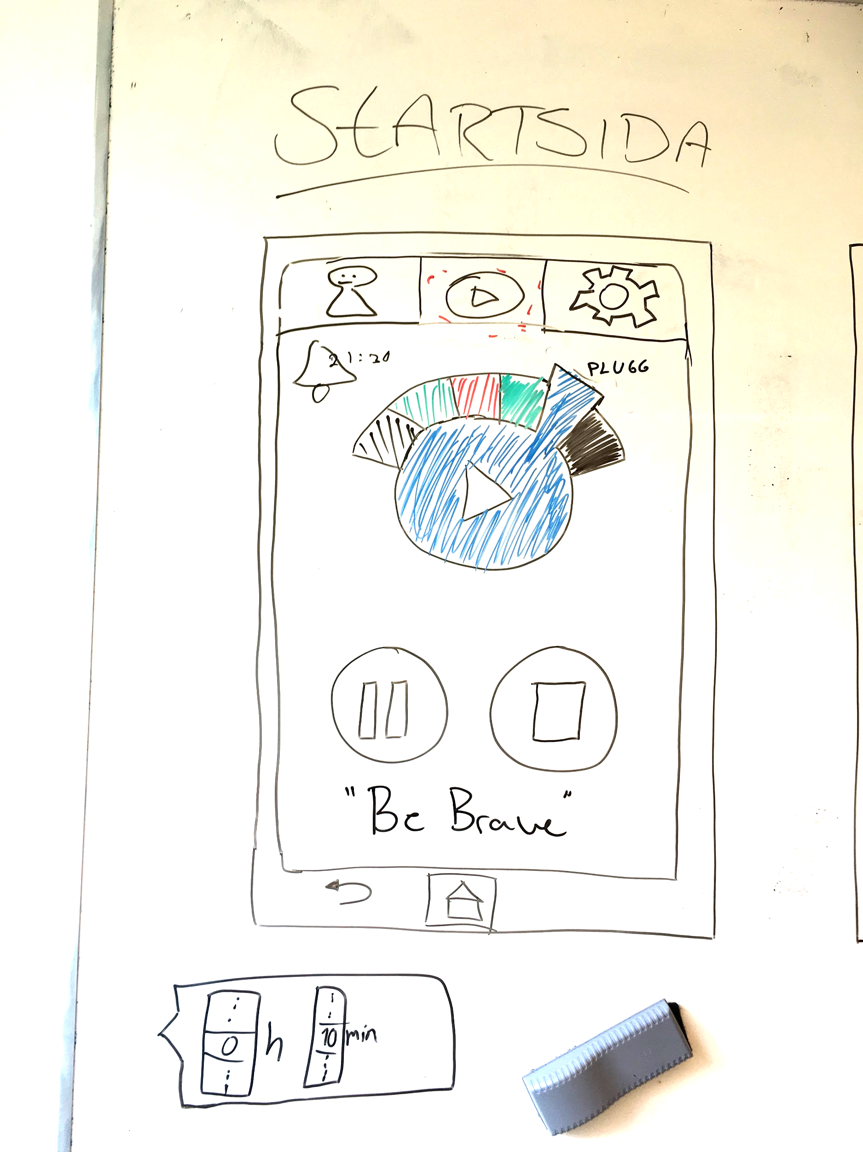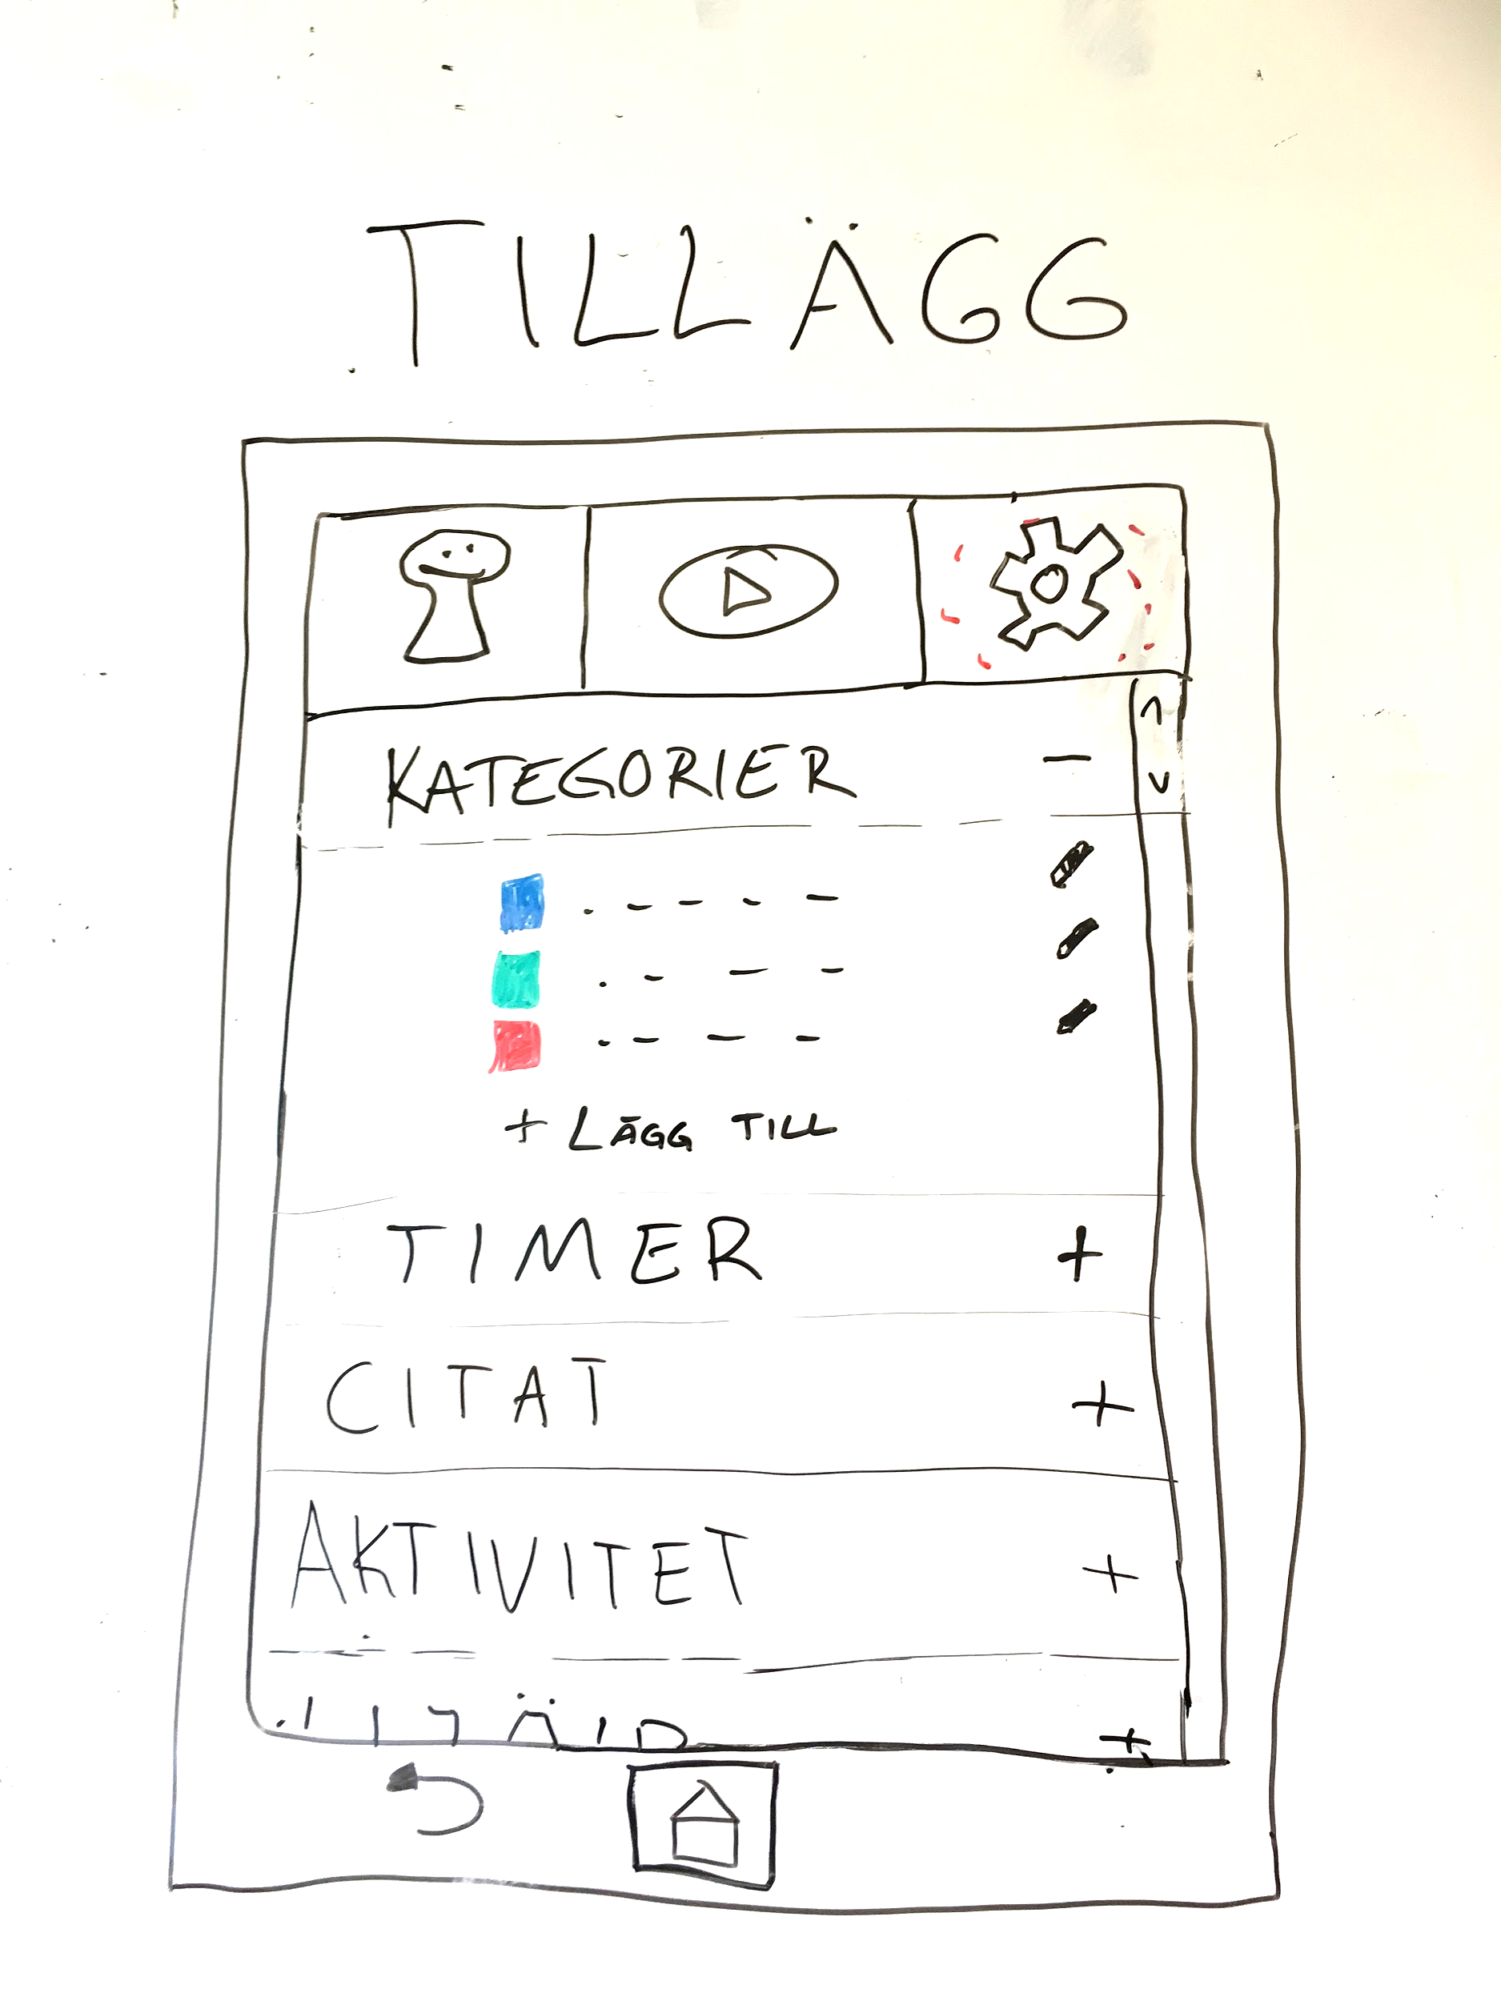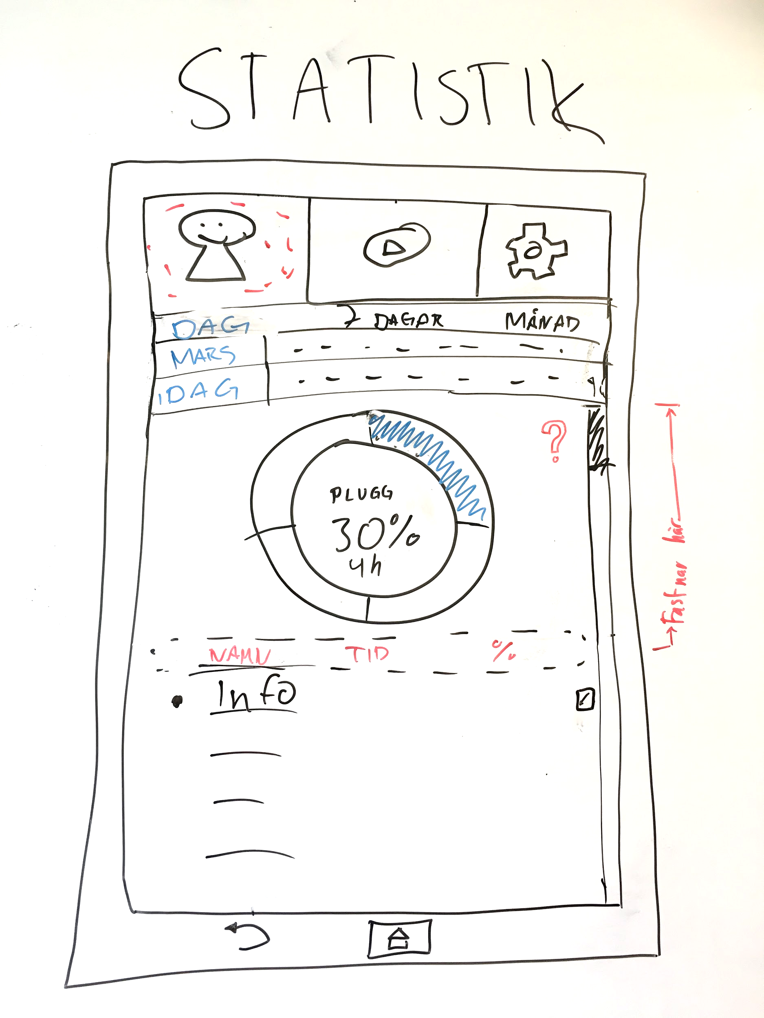

Easy to start to log time

**2.2 Functional requirements**

* Start activity - Pause - Stop
* Valuate today’s activities - Category, time and percentage spent on this activity
* Valuate statistics over a timelapse of - 7 days or a month.
* Start timer
* Add or edit categories
* Add or edit motivational quotes
* Add activity - In the past (if you missed to log it when it occured)
* A limited number of colours

**2.3 Non-functional requirements**

* Cannot add activities in the future - app is not a planning tool!
* There is a maximum of x categories you can choose between. (5,6,7?)
* You can only log one activity at a time.
* You cannot see statistics over all of your logs, only one month at a time.

**3 Use cases**

UC: for Additions/settings-view

(This should be max 4 pages. If longer use include (or extend) other use case, i.e. re-factor)

Summary: The user presses the additions/settings-view.

**Normal flow of events**

The user have pressed the settings icon/button.

|  |  |  |
| --- | --- | --- |
|  | Actor | System |
| 1 | The user presses the additions/settings icon/button |  |
| 2 |  | A list of possible additions is shown. Edit categories,add activity (that you missed to log), add quotes, start timer. |

**Alternate flow**

The user presses the “edit categories”

|  |  |  |
| --- | --- | --- |
|  | Actor | System |
| 1 | The user presses the “edit categories” item in the list. |  |
| 2 |  | A list inlay appears and shows the color (in form of a square) and name of (x maximum) categories. In the very far right of every category exists a pen symbol to edit that specific category. |
| 3 | The user presses the pen symbol. |  |
| 4 |  | The name of the category becomes editable (a textfield) and the color is clickable. |
| 5 | The user writes a new name for the category and presses enter. |  |
| 6 |  | The name of the category changes immediately as the user presses the enter button. |
| 7 | The user presses the color. |  |
| 8 |  | A module (nåt) appears and you can choose from x-antal colors. |

The user presses the “Timer” button.

|  |  |  |
| --- | --- | --- |
|  | Actor | System |
| 1 | The user presses the “Timer” button. |  |
| 2 |  | A list inlay appears and holds the information of two(three?) editable textfield (00)h : (00)min and a “start timer”-button. |
| 3 | The user enters values to the fields by clicking and presses the done-button. |  |
| 4 |  | The two fields starts counting down. (This is also shown at the “main page” of the program. As it approaches the end an alarm goes off. (Sound or vibrations) |

The user presses “add activity” in the list

|  |  |  |
| --- | --- | --- |
|  | Actor | System |
| 1 | The user presses “add activity” in the list. |  |
| 2 |  | A list inlay appears which holds the information of when the activity took place, which category and time. |
| 3 | The user enters the data and presses the “add acitivity”-button. |  |
| 4 |  | The activity is being added to the statistics and all the previous data in the fields is being removed and a small square tells the user that it has been added. |

UC: for Statistic-view

(This should be max 4 pages. If longer use include (or extend) other use case, i.e. re-factor)

Summary: If the user presses the statitic icon/button in the

**Normal flow of events**

The user have pressed the statitic icon/button.

|  |  |  |
| --- | --- | --- |
|  | Actor | System |
| 1 | The user presses the statitic icon/button |  |
| 2 |  | A view that shows the statitic over the logged activities. |
| 3 |  | At the start the statitic over the day is represented in the progress indicator. |
| 4 |  | The logged activities will be shown beneath the progress indicator where the category will be shown and the time that category was logged. |

**Alternate flow**

The user presses the “7 DAGAR” button (in the module tab)

|  |  |  |
| --- | --- | --- |
|  | Actor | System |
| 1 | The user presses the “7 DAGAR” button. |  |
| 2 |  | The statitic over the 7 following choosed days is represented in the progress indicator. |
| 3 |  | The logged activities will be shown beneath the progress indicator where the category will be shown and the amount of time every category was logged will be shown next to it. And the % - amount of time the category was logged. |

The user presses the “MÅNAD” button.

|  |  |  |
| --- | --- | --- |
|  | Actor | System |
| 1 | The user presses the “MÅNAD” button. |  |
| 2 |  | The statitic over the month is represented in the progress indicator. |
| 3 |  | The logged activities in the choosed month will be shown beneath the progress indicator where the category will be shown and the amount of time every category was logged will be shown next to it. And the % - amount of time the category was logged. |

The user chooses an other day than the default

|  |  |  |
| --- | --- | --- |
|  | Actor | System |
| 1 | The user chooses an other day then the default. |  |
| 2 |  | The statistics over the choosed day is represented in the progress indicator. |
| 3 |  | The logged activities will be shown beneath the progress indicator where the category will be shown and the time that category was logged. |

The user chooses an other month than the default

|  |  |  |
| --- | --- | --- |
|  | Actor | System |
| 1 | The user chooses an other month that the default |  |
| 2 |  | The statistics over the choosed month is represented in the progress indicator. |
| 3 |  | The logged activities will be shown beneath the progress indicator where the category will be shown and the time that category was logged. |

The user presses the question mark

|  |  |  |
| --- | --- | --- |
|  | Actor | System |
| 1 | The user presses the question mark |  |
| 2 |  | A view that will show the information about the function of the view and how the progress indicator works and the logged activities. |

The user presses the penn-icon next to the activities in the “list” that shows the logged activities.

|  |  |  |
| --- | --- | --- |
|  | Actor | System |
| 1 | The user presses the penn-icon next to the activities. |  |
| 2 |  | The user can change:  - the name of the activity that has been logged  - the category  - the time you logged, if it is incorrect. |
| 3 |  | Save it so the new % amount of the time can update. |

The user scrolls down in the statistics-view.

|  |  |  |
| --- | --- | --- |
|  | Actor | System |
| 1 | The user scrolls down in the statistics-view |  |
| 2 |  | A kind of label containing “Kategori Tid %” will “stop”, when the user is scrolling (down), under there you can choose the day. |

3.1 Use case listing

4 Domain

4.1 Class responsibilities

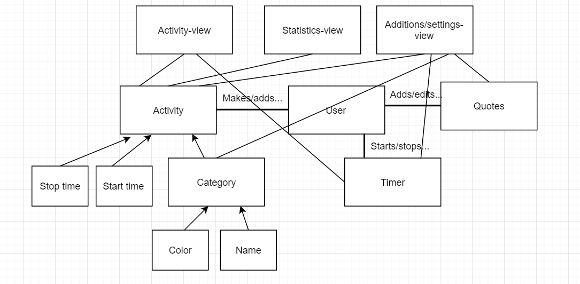

5 References