Requirements and Analysis Document for LEEP-Project

Version: 2.0

Date: 28/5-17

Author: Eli Knoph, Linnéa Bark, Evelina Salomonsson Stridsberg, Paulina Palmberg

This version overrides all previous versions.

**1 Introduction**

The LEEP app is an app for those who feel the need to ”log” the time they are spending on various activities. People who are curious what they actually are spending time on or people who need to increase the efficiency of their work are our domain people.

1.2 Definitions, acronyms, abbreviations

Log - To “log” is to determine a start and end time for an activity and to categorize the activity

**2 Requirements**

**2.1 User interface**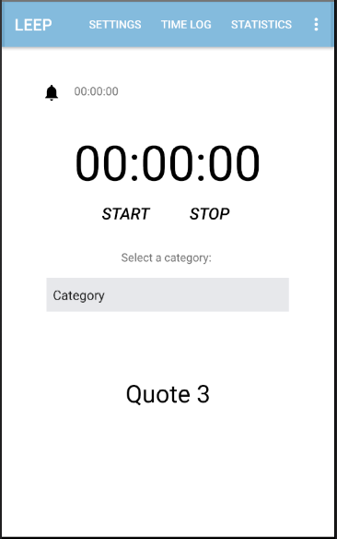

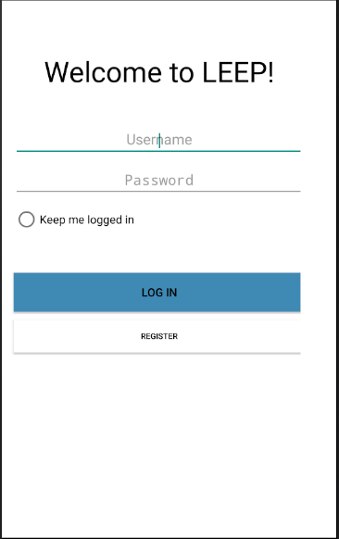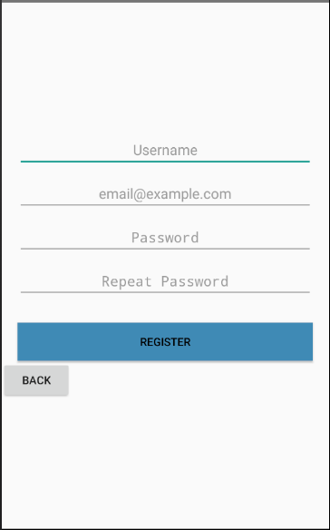

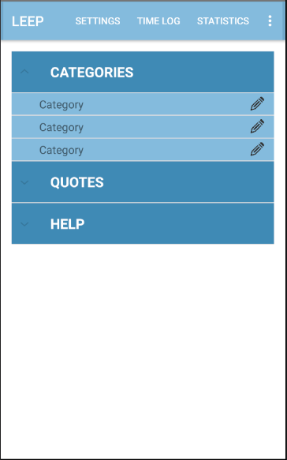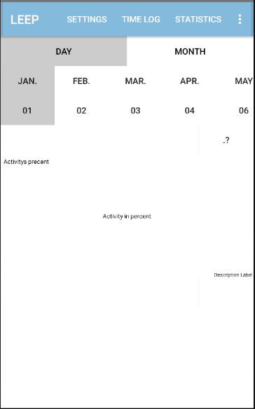

**2.2 Functional requirements**

* Log an activity (Start activity - Pause - Stop -> save activity)
* Register
* Log in
* Change view in app
* Start timer, end timer
* Edit categories
* Edit motivational quotes
* Log out

**2.3 Non-functional requirements**

* Can not add activities in the future - app is not a planning tool!
* Can not add activities afterwards (if you missed to log it when it occurred)
* You can only log one activity at a time.
* You cannot see statistics over all of your logs, only over a selected time.
* Can not add quotes or categories

**3 Use cases**

3.1 Use case listing

Log an activity

|  |  |  |
| --- | --- | --- |
|  | Actor | System |
| 1 | Press the menu button “time log” |  |
| 2 |  | Changes view to “time log” view |
| 3 | Press “select a category” |  |
| 4 |  | A dropdown shows up with all categories |
| 5 | Choose the category that describe what is representative for the time being. |  |
| 6 |  | Drop down closes |
| 7 | Press the “start”-button |  |
| 8 |  | The label in the middle of the screen starts ticking, it starts to count up the seconds. |
| 9 | When the activity is done presses the “stop”-button. |  |
| 10 |  | The label resets to 0 and the activity get stored. |

Register

|  |  |  |
| --- | --- | --- |
|  | Actor | System |
| 1 | User presses the “Register”-button |  |
| 2 |  | Changes view to the “register”-view |
| 3 | Enter the username, email and password times two |  |
| 4 | Presses the “Register”-button |  |
| 5 |  | Changes view back to the “log in”-view |

Log in with registered account

|  |  |  |
| --- | --- | --- |
|  | Actor | System |
| 1* | Enters the username and password. |  |
| 2 | Presses the “log in”-button. |  |
| 3 |  | The view changes to the “time log”-view |

Alternative on log in

|  |  |  |
| --- | --- | --- |
|  | Actor | System |
| 1.1 | Choose not to fill in to stay logged in. |  |
|  |  |  |
| 1.2 | Chooses to fill in to stay logged in. |  |

You can choose if you want to stay logged in or if you don’t.

Change view in app

|  |  |  |
| --- | --- | --- |
|  | Actor | System |
| 4.a.1 | Press the “settings” |  |
| 4.a.2 |  | Changes view and shows an expandable list. |
|  |  |  |
| 4.b.1 | Press the “time log” |  |
| 4.b.2 |  | Changes view and shows all that is needed to log a activity and start a timer. |
|  |  |  |
| 4.c.1 | Press the “statistics” |  |
| 4.c.2 |  | Changes view and shows a list over the last logged day activities |

Start timer

|  |  |  |
| --- | --- | --- |
|  | Actor | System |
| 1 | Press the “time log”-button in the menu |  |
| 2 |  | Change the view to “time-log” |
| 3 | Press the icon with a bell on it. |  |
| 4 |  | A pop up comes up with a timepicker |
| 5 | Choose how “long” the countdown is going to count |  |
| 6 | Press the “ok”-button |  |
| 7 |  | Closes the pop up and starts the timer. Shows by a label that ticks down besides the bell-icon |

Edit Categories

|  |  |  |
| --- | --- | --- |
|  | Actor | System |
| 1 | Press the “settings”-button in the top menu |  |
| 2 |  | Changes view to the settings view |
| 3 | Press the “categories”-button in the dropdown menu |  |
| 4 |  | Opens the menupart for categories |
| 5 | Press the pen-icon for the category you want to change |  |
| 6 |  | Open a pop up where you can write a new name |
| 7 | Delete the caracters for the last categoryname and enter what you want the category new name to be |  |
| 8 | Press the “save”-button |  |
| 9 |  | Closes the pop up and it changes the categoryname |

Edit Quotes

|  |  |  |
| --- | --- | --- |
|  | Actor | System |
| 1 | Press the “settings”-button in the top menu |  |
| 2 |  | Changes view to the settings view |
| 3 | Press the “quotes”-button in the dropdown menu |  |
| 4 |  | Opens the menupart for quotes |
| 5 | Press the pen-icon for the quote you want to change |  |
| 6 |  | Open a pop up where you can write a new text |
| 7 | Delete the characters for the last quote and enter what you want the new quote to be |  |
| 8 | Press the “save”-button |  |
| 9 |  | Closes the pop up and it changes the quote |

Log out

|  |  |  |
| --- | --- | --- |
|  | Actor | System |
| 1 | Press the button in the top right corner with three dots on. |  |
| 2 |  | A “menu” with only one alternative will show. Reads “log out” |
| 3 | Press “log out” |  |
| 4 |  | Changes to the “log in”-view and logout the user. |

4 Domain

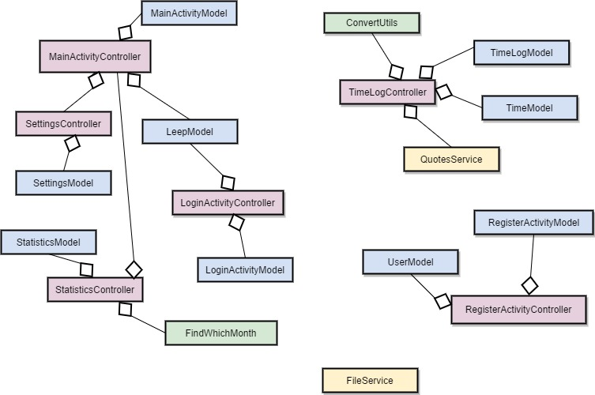

4.1 Class responsibilities

(See class diagram) As the user makes an account an User object creates with a username, password and email. When the user logs in, the LoginActivity reacts and compares the username and password in Leep, to (if the log in was successfull) start the activity MainActivity which holds the three fragments; Settings, Time Log and Statistics. The main part of the system is Time Log in which the user can start and stop/save an activity. The user starts an activity and the timer in the Time class reacts and updates the TextView in TimeLog. As the user stops the activity the activity is being saved in FileService where it’s saved into a text file in the internal storage of the android device.