All my current invitations

Dear Sir/Madam,
The International School of Provence (IBS of Provence) is pleased to invite you to our Annual University Fair, which will take place on Wednesday, February 4, 2026, from 1:30 PM to 5:00 PM on our campus in Aix-en-Provence (France).
Founded in 1984, IBS of Provence has grown into one of the largest International Baccalaureate (IB) schools in France, with over 400 high school students from more than 80 countries.
Every year, our University Fair provides our students with the unique opportunity to connect with university representatives and experts, helping them make well-informed decisions about their future studies.
Participation in the event is entirely free of charge, and we would be delighted to count you among our distinguished participants this year.
Please find attached your formal invitation letter.
We look forward to the possibility of welcoming you and are happy to provide any additional information.
Kind regards,
--
Kind regards,

Julia SHARIPOVA,

Event & Foreign languages coordinator

The International Bilingual School of Provence (IBS)
Domaine des Pins - Aix-en-Provence
500 Route de Bouc-Bel-Air
13080 Luynes FRANCE

Mob: + 33 (0) 6 65 219 547
Tel: +33 (0)4 42 240 340
Fax: +33 (0)4 42 240 981

www.ibsofprovence.com

This also
Registration for College Day Scandinavia is open, and we’d love to have you join us

Why should you join?

Efficient schedule: four cities in one week with minimal travel (Lund & Malmö are easy day trips from Copenhagen, ~1 hour by train)

Strong student audience: English-proficient students from IB/EB/Bilingual and top national programs

New fair in Lund: a major university town with great potential

Student financing: Swedish and Danish governments offer grants and loans for studies abroad

Experienced organizers: 20+ years in Europe, 13 years in the Nordics; clear logistics, pre-event and on-site support

Flexible participation: join in the cities that work for your schedule and recruitment goals

College Day Scandinavia March 9 – Stockholm | Campus Viktor Rydberg (Bilingual School)

College Day Scandinavia March 10 – Copenhagen | European School Copenhagen (EB School)

College Day Scandinavia March 11 – Lund | Katedralskolan Lund (IB School)

College Day Scandinavia March 12 – Malmö | Malmö Borgarskola (IB School)

Early-bird pricing is available through November 25. Spaces are limited, so register early!
And this

There is also this one

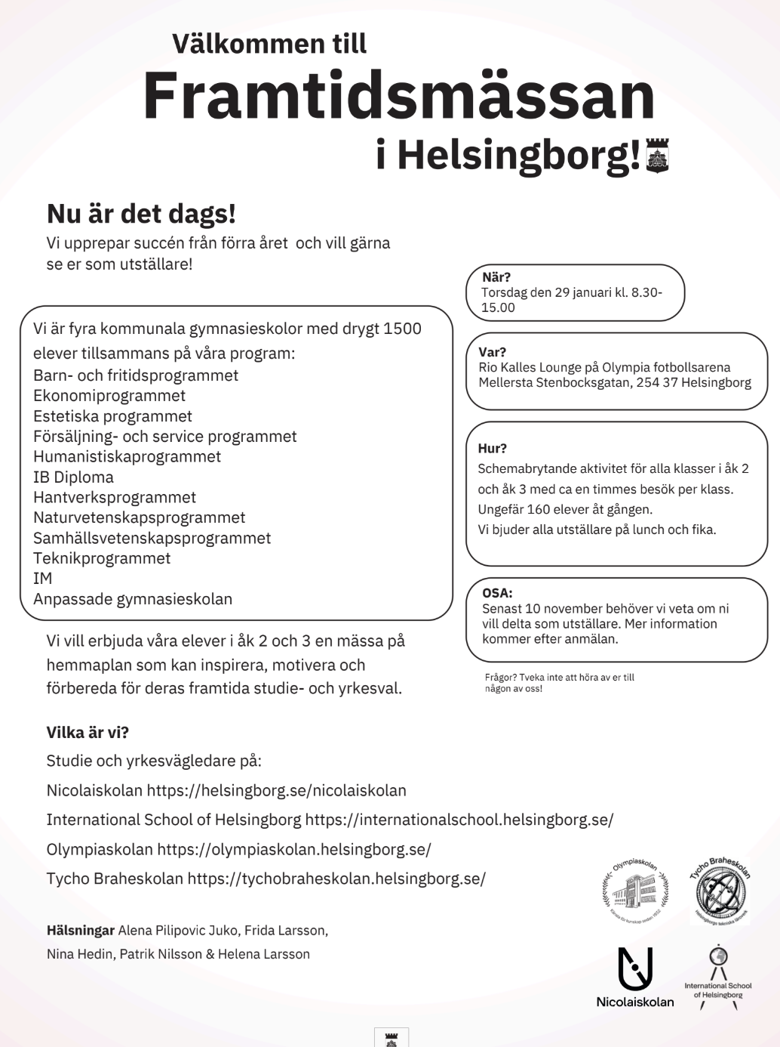
Framtidsmässan i Hälsingborg, Torsdag den 29 januari kl. 8.30-
15.00, Rio Kalles Lounge på Olympia fotbollsarena, Mellersta Stenbocksgatan, 254 37 Helsingborg.

Also this - event upcoming in the nordic region

Good afternoon,

We are so excited to announce the dates for the third annual Nordic University Tour -- 13-17 April, 2026.

HELSINKI Mon 13 April
STOCKHOLM Tues 14 April
COPENHAGEN Wed 15 April
STAVANGER Thurs 16 April
SKAGERAK/OSLO Fri 17 April

Here is the form to express interest and sign up for the tour.

Payment information will be available in the next few weeks and will be emailed out to all of you. We hope to build on the success of the Nordic University Tour and truly appreciate your continued support and involvement.

Representatives from all of the Nordic host schools will be at the CIS Conference in Seville, and we are looking forward to networking with all of you there. Look out for us!

We have decided to rotate the organisation of the tour amongst the hosting schools, and so this year's tour will be organised by Mark Kilmer from The International School of Helsinki (markk@ishelsinki.fi) and Yvonne Folan from Skagerak International School (Yvonne.Folan@skagerak.org). Please get in touch with either or both of us with questions and one of us will respond. 

We look forward to collaborating with you.

Regards,

Mark and Yvonne
---
Skagerak International School
High School.

Yvonne Folan
Head of Pastoral / Avdelingsleder
University & Careers Guidance
DP English Teacher
Framnesveien 7, 3222 Sandefjord
Norway

Telephone: +47 33456500
www.skagerak.org

