**CSC424 System Administration Lab Assignment 1**

Due on 02/06/2017 11:59PM

**Problems**

1. Enter these commands at the Linux prompt, and try to interpret the output. Explain the usage of each command. Please include screenshots of the execution with your explanation. Hint: Use manual pages (man) to check the usage of each command. (5 pts)
   * Free
     + This display the amount of free space and used space in the memory system.

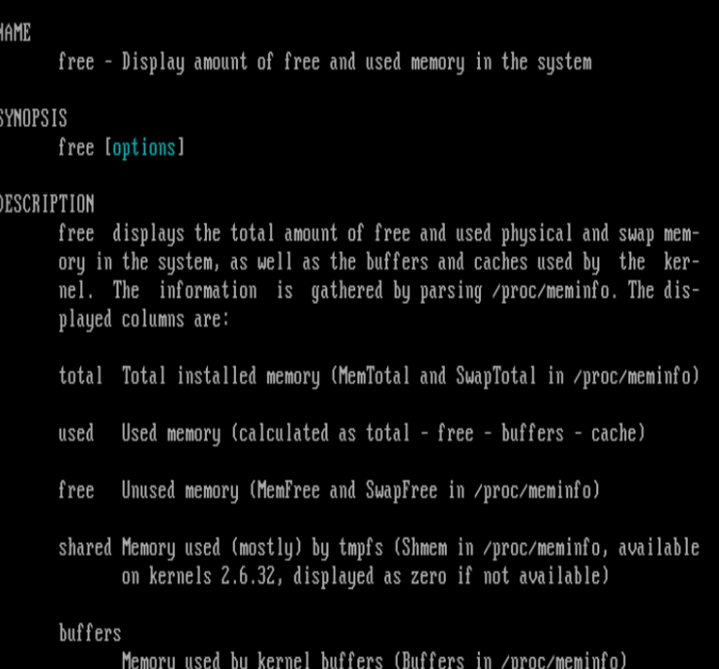

* + Passwd
    - This let the root user be able to change the password.

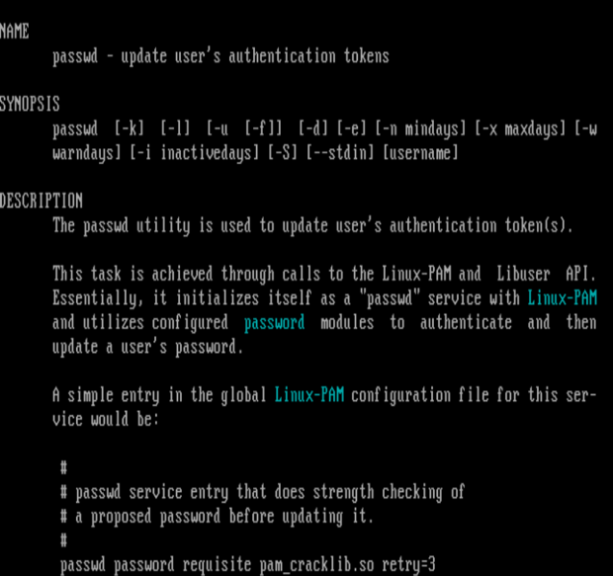

* + Hostname
    - This displays the name of the systems DNS and it set its hostname or NIS domain name.

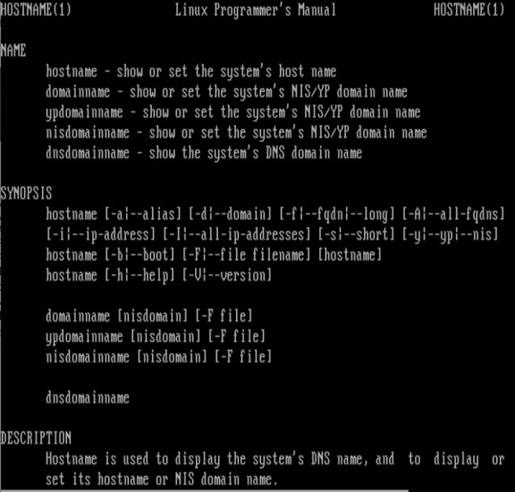

* + arch
    - prints the machine architecture.

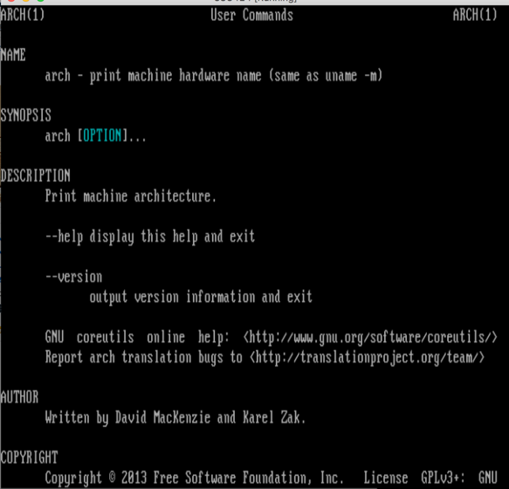

* + uname -a
    - prints all the system information.

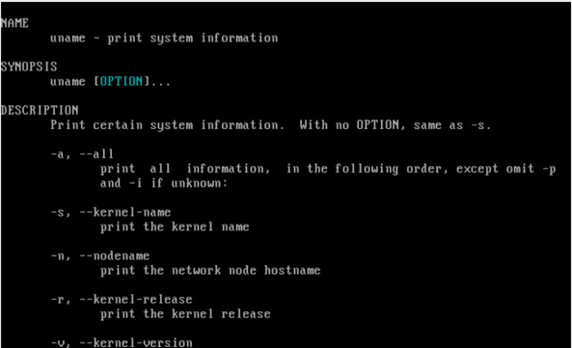

* + dmesg | more (press enter to scroll down, press q to quit)
    - uses to the examine and control the kernel ring buffer.

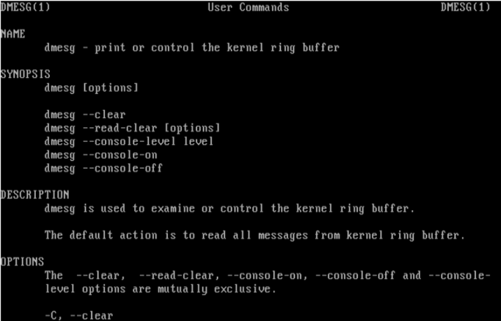

* + uptime
    - show uptime which mean that it shows how long the system has been running.

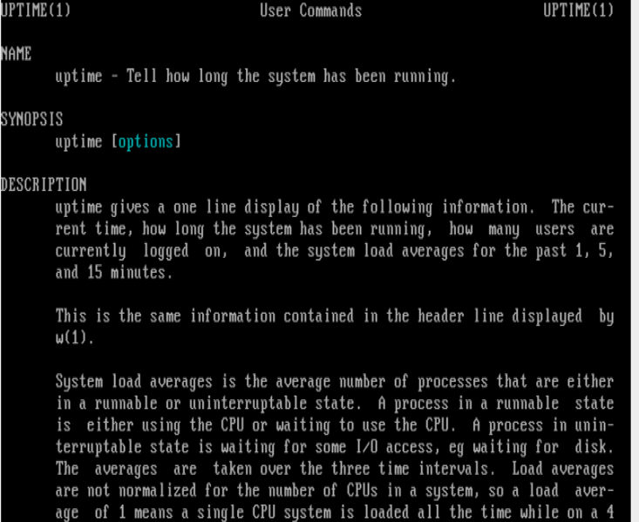

* + who am i
    - prints the current user id and name.

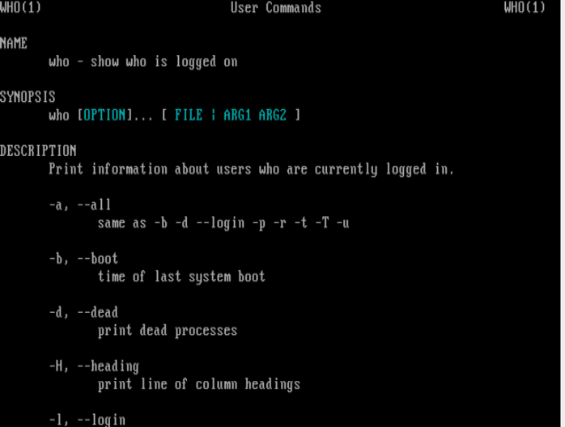

* + id
    - prints to the user and groups of id’s

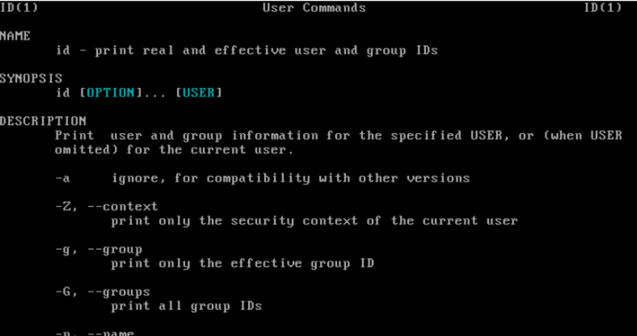

* + last
    - show the last long and searches of the user log

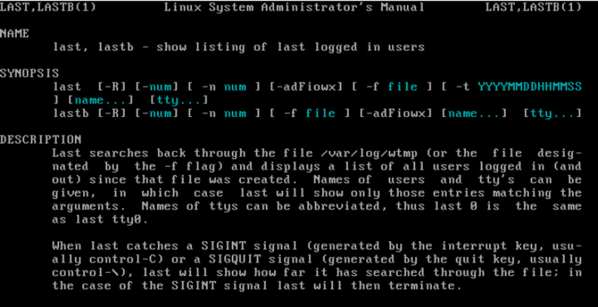

* + w
    - this show who is logged on and what they are doing.

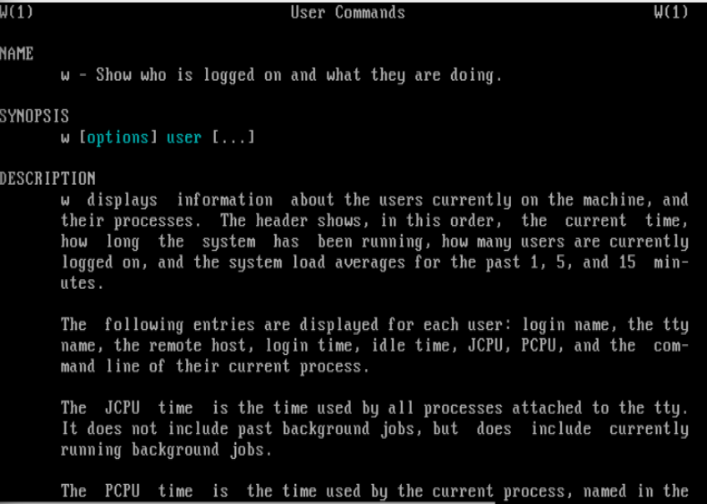

* + top (you may need to press q to quit)
    - this displays the linux processes

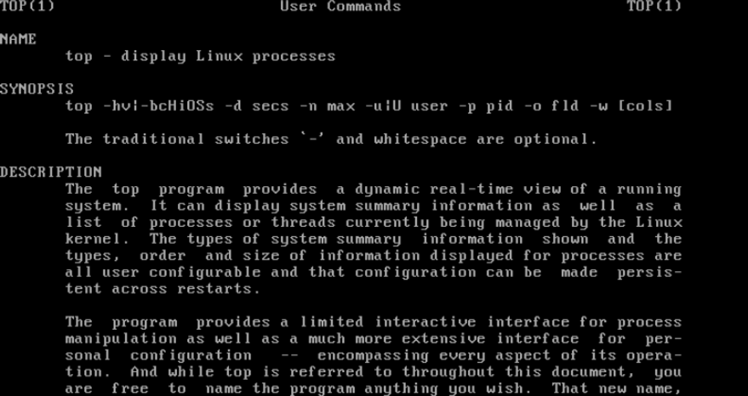

* + clear
    - This actually clear the terminal screen that let you have a clean screen.

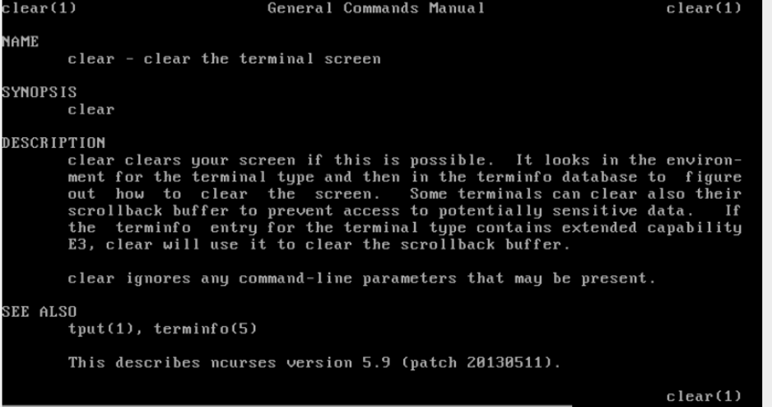

* + cal 2017
    - display the calendar of 2017

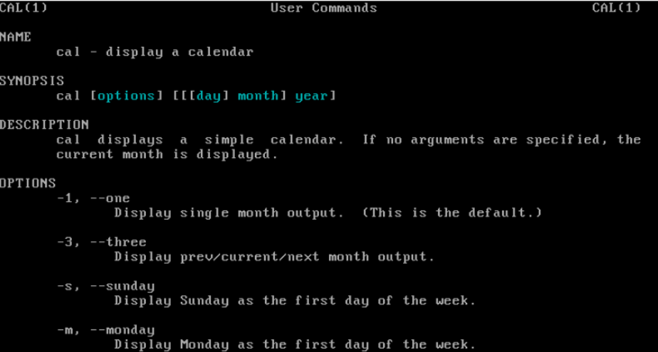

* + date
    - prints out or set the system date and time.

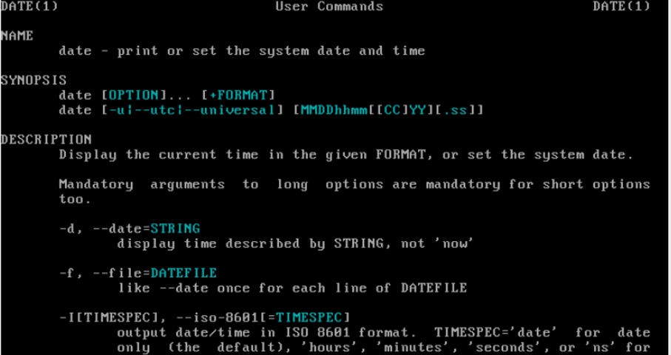

* + yes sir
    - output of the string will consciously repeat until it is killed.

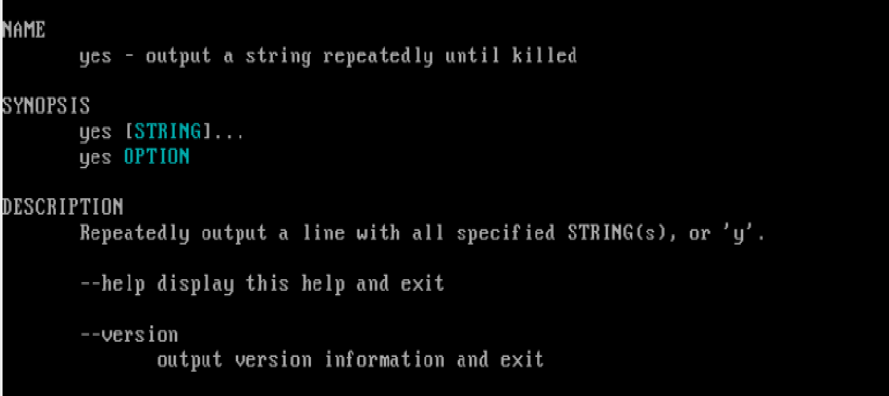

* + time sleep 10
    - set and delay the time that the computer can reboot.

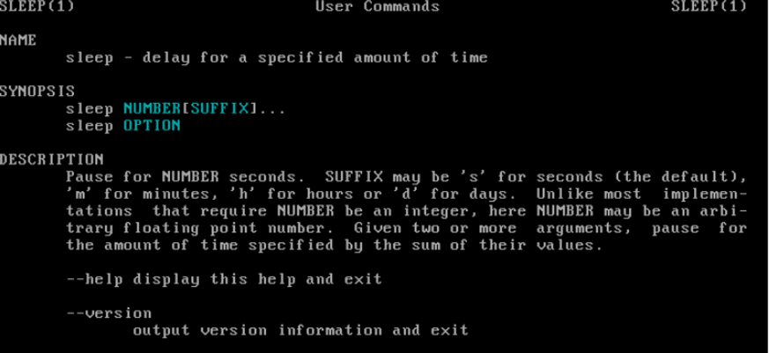

* + touch me
    - touch change the file timestamps.

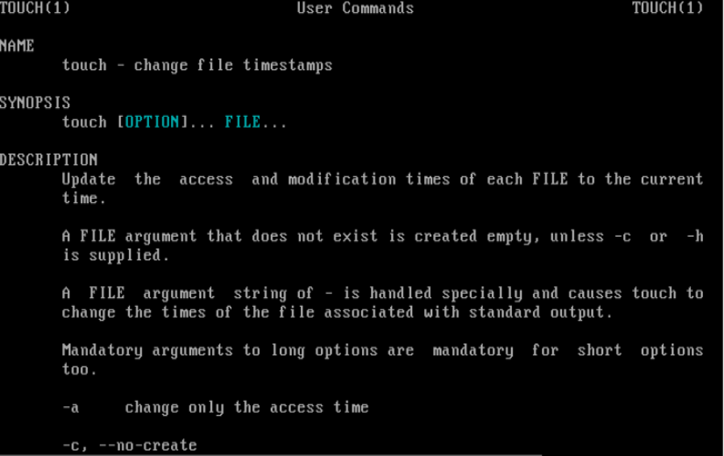

* + lscpu
    - lscpu displays the information about the architecture of the CPU.

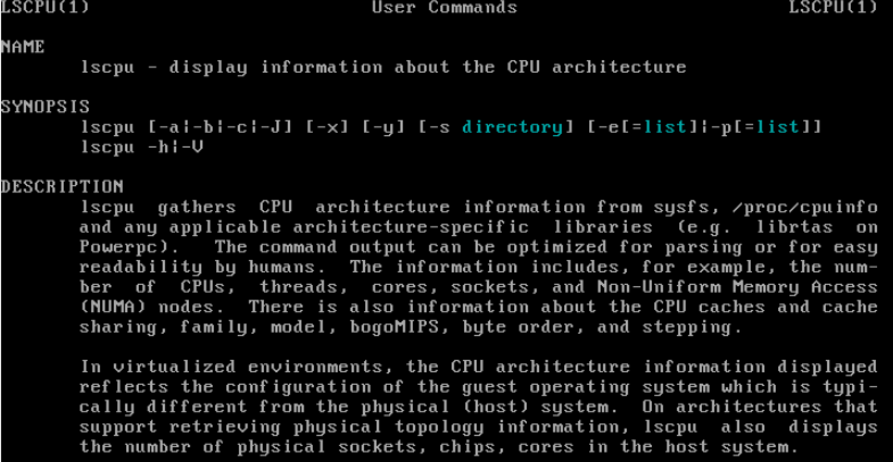

* + df -h
    - It is human readable report that report the file system disk space usage.

­­­­­­­ls

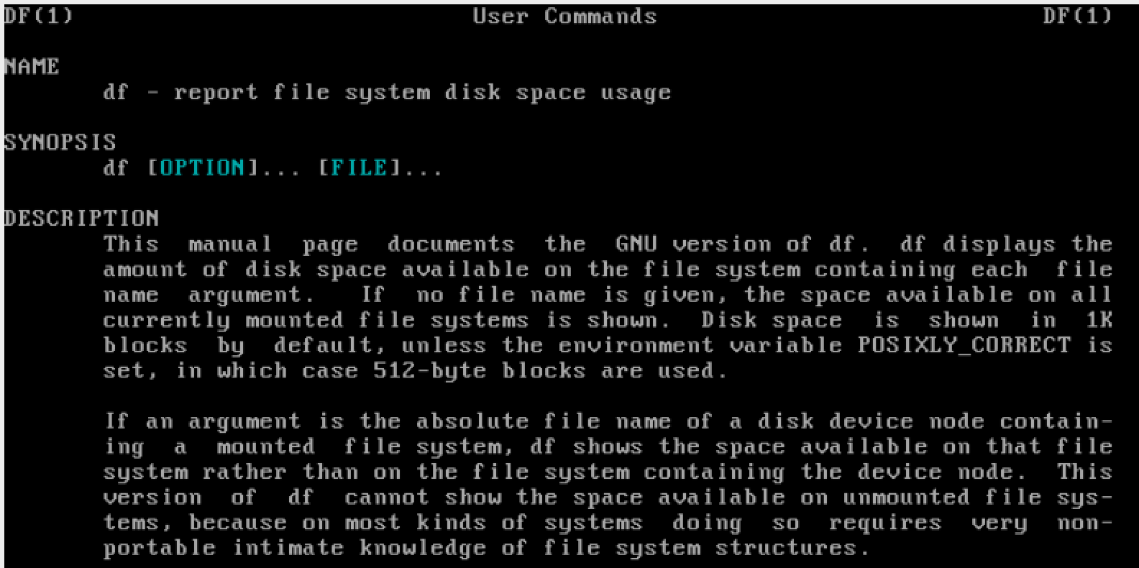

1. Create a log file using the command from problem 1 and the command you learned from class. The log file should include the following information:
   * The time when the log file is created
     + date >> hw1_log.txt
   * The user who creates the log file
   * id
   * How long has the system been running
     + date
   * CPU model name
     + Lscpu |head -13 |tail -1
   * CPU frequency
     + Lscpu |head -15 |tail -1
   * CPU architecture
     + Lscpu |head -1
   * OS kernel name
     + uname -s >> hw1_log.txt
   * OS kernel release
     + uname -r >> hw1_log.txt
   * Memory usage
     + free -m >> hw1_log.txt
   * Disk usage
     + df -h >> hw1_log.txt

Please provide all the commands you used to create the log file and a screenshot of the file. (use cat command to open the file) (5pts)

