|  |
| --- |
| Computer Programming Language |

【Fall, 2015】

Homework 3

**Program A： Calculation of *π* (25%)**

Write a program to calculate the value of the ratio of a circle's circumference to its diameter, π, using Leibniz series.

$\frac{π}{4}=\sum_{k=0}^{∞}{\frac{{(-1)}^{k}}{2k+1}}$

Calculate the π values for *k* = 1000, 10000, 100000, and estimate the errors by comparing a constant variable PI equals 3.141592653589793238463 in your program. What is the most accurate value of π you can obtain?

**Program B： Calculation of prime numbers (25%)**

A prime integer number is one that has exactly two different divisors, namely 1 and the number itself. Write, run, and test a C++ program that finds and displays all the prime numbers less than 1000. (*Hint*: For each number from 2 to 1000, find Remainder = Number % n, where n ranges from 2 to sqrt(Number). If n is greater than sqrt(Number), the number is not equally divisible by n. Why? If any Remainder equals 0, the number is not a prime number.)

**Bonus points (25%): (**This is an optional problem)

A pair of positive integer numbers are called twin primes if they are both prime numbers and the difference between them is 2, i.e., they are consecutive odd numbers and they are prime numbers. (3, 5), (5, 7) and (11, 13) are three examples of such pair of twin prime numbers. Write a program to display all the pairs of twin prime numbers that are less than 1000. What is the greatest twin primes you can obtain?

**Program C： Use of switch statement and repetition structure (25%)**

The international standard letter/number mapping found on the telephone is shown below:

|  |  |  |
| --- | --- | --- |
| **1** | **2** ABC | **3** DEF |
| **4** GHI | **5** JKL | **6** MNO |
| **7** PQRS | **8** TUV | **9** WXYZ |
|  | **0** |  |

Write a program that is capable of inputing a text string using the ten numeric keys (0~9). For example, by defining ‘1’ as ‘SPACE’ and ‘0’ as “END OF SINGLE CHARACTER INPUT”, a text string “HELLO WORLD” can be input by pressing a series of numeric keys “4403305550555066601090666077705550300”; a text string “GOOD MORNING” can be input by a series of numeric keys “4066606660301060666077706604440660400”. A consecutive input of ‘0’ means the termination of the text string input process.

**Program D：Use of function and nested loops (25%)**

The greatest common divisor of integers **x** and **y** is the largest integer that evenly divides both **x** and **y**. Write a function **gcd** that returns the greatest common divisor of **x** and **y**. Also write a C++ program that calls the **gcd** function repetitively to create a table of greatest common divisor of paired integers from 1 to 20, as the following figure shows.

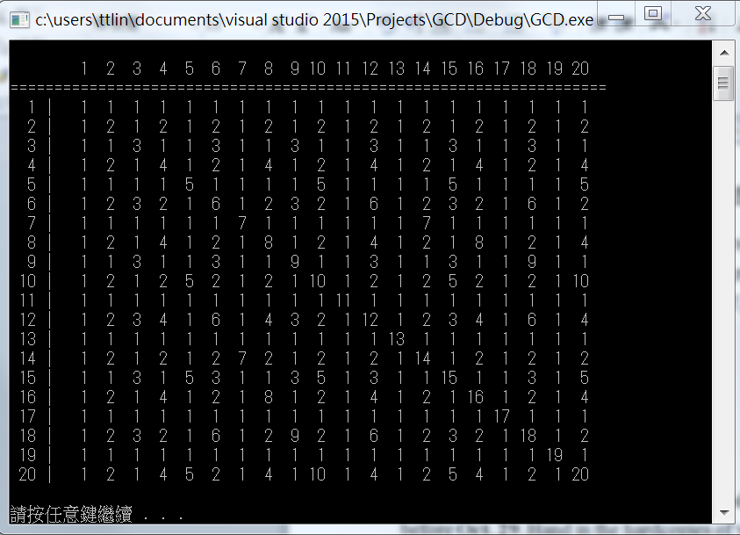

**Notes:**

1. Please submit your programs (source codes and execution files) to the CEIBA course website before **Oct. 29**. Hand in the hardcopies of your program codes in the class of **Oct. 29 (3:30PM)**.
2. Late submission will have a penalty of 10% discount per day of your grade toward a minimum score of 60. No late submission over a week will be accepted.
3. Criteria of grading include: (1) Program functionality; (2). User interface; (3). Structure of the program; (4). Suitable comments; (5). Programming style; (6). Creativity.