|  |
| --- |
| Computer Programming Language |

【Fall, 2015】

Homework 6

**Program A： Bridge card game (50%)**

In a typical card game, each player gets a hand of cards. The deck is shuffled and cards are dealt one at a time from the deck and added to the players' hands. Bridge uses a pack of 52 playing cards. There are 4 suits (spades, hearts, diamonds, clubs) each of 13 cards: 1 (the Ace) to 10 and Jack, Queen, King. The Ace is the highest card, followed by the King, Queen, down to the 2.

You are requested to design a program to simulate dealing cards to 4 players. The program needs to simulate at least three times of card shuffling and dealing and saves the results into a file as well as displaying the results on the screen. Your program should also calculate and show the total high-card points of each player. High-card points are counted as follows: A = 4 points, K = 3 points, Q = 2 points, and J = 1 point.

**Bonus Points (10%~30%):**

You may obtain bonus points by implementing a better display of simulation results using the Console class for the standard input, output, and error streams for console applications. You may check the MSDN website for more detailed description of the usage of Console class (<http://msdn.microsoft.com/en-us/library/system.console(v=vs.110).aspx>).

Note: 1. You need to create a “CLR Console Application” project (not an Win32 Console Application) for your program in order to use the Console class.

2. You need to add the “using namespace System;” before main().

**Program B： Morse code (50%)**

Perhaps the most famous of all coding schemes is the Morse code, developed by Samuel Morse in 1832 for use with the telegraph system. The Morse code assigns a series of dots and dashes to each letter of the alphabet, each digit and a few special characters (such as period, comma, colon and semicolon). In sound-oriented systems, the dot represents a short sound, and the dash represents a long sound. Other representations of dots and dashes are used with light-oriented systems and signal-flag systems. Separation between words is indicated by a space, or, quite simply, the absence of a dot or dash. In a sound-oriented system, a space is indicated by a short period of time during which no sound is transmitted. The international version of the Morse code is shown in the following table.

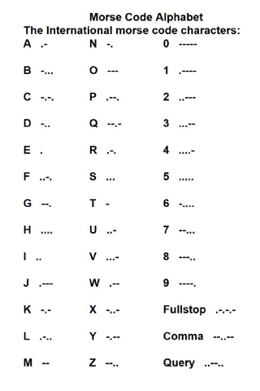

Write a program that reads a file named MorseCode.txt and convert it into Morse code. Use one blank between each Morse-coded letter and three blanks between each Morse-coded word. Display the result on the screen and save the converted Morse code into a file named MorseCode.dat. You may also play the sound of Morse code with your program. The file MorseCode.txt has the content as below

Morse code is one of several adapted computer access methods and alternative communication techniques that can be effective in helping enhance the lives of persons with special needs. Those without the ability to speak, sign, or use keyboards may benefit from this proven system of communication.

Some information about Morse code can be found in the following link:

<http://morsecode.scphillips.com/>

**Notes:**

1. Please submit your programs (source codes and execution files) to the CEIBA course website before **Dec. 17**. Hand in the hardcopies of your program codes in the class of **Dec. 17 (3:30PM)**.
2. Late submission will have a penalty of 10% discount per day of your grade toward a minimum score of 60. No late submission over a week will be accepted.
3. Criteria of grading include: (1) Program functionality; (2). User interface; (3). Structure of the program; (4). Suitable comments; (5). Programming style; (6). Creativity.