CSC3320 System Level Programming Lab Assignment 2 - Part 1 (In-Lab)

# Instructor: Dr. Rao Casturi

**Purpose**: Learn use the **man** utility to get help on using other Unix utilities. Practices on the basic utilities for managing files and directories in a terminal.

Note: Please follow the instructions below step by step, and finish the required task **before the lab session ends and ask the lab instructor to grade your work in the lab**. Then write a **report by answering the questions and attaching the required screenshots in part B** and upload the report (named as Lab2_Part1_FirstNameLastName.pdf or Lab2_Part2_FirstNameLastName.doc) to the folder "**Lab2_P1_InLab**" of the Dropbox in the iCollege system. You can upload the screenshots later (with 10% penalty) but no later than **11:59 pm on the date you are taking this lab session**.

**Please add the Program Challenge number and your name at the top of your file sheet.**

Before you start, please connect to snowball by typing the following command and press "Enter".

**ssh** [**CampusID@snowball.cs.gsu.edu**](mailto:CampusID@snowball.cs.gsu.edu)

# Part A: Try to use the man utility.

The man utility can provide the on-line copies of the original UNIX documentation for the other utilities. In the manual page, the first part is the functionality of a utility, the second part is the synopsis, the third part is the description and lists different features of a utility with different options. Then please follow the steps to learn some options provided by **cat.**

1. Check the manual page cat by typing the command below and press "Enter".

**man cat**

1. The terminal only displays one window of the manual page. You can scan through the whole manual page by press "**f**" or **SPACE** to forward one window, and "**b**" to backward one window. Or you can press "**h**" to find out more commands to scan through the manual page.
2. Check the description for option **-n**. You may find the description as below:

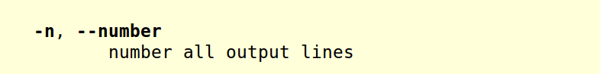

1. Check the description for option **-s**. You may find the descption as below:

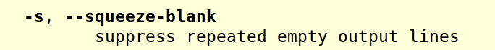

1. Quit the manual page by press "**q**"

# Part B: Unix basic commands on managing the files and directories.

1. Make sure that you have been connected to the snowball server successfully. Then go to your home directory by typing the following command and press "Enter".

**cd ~**

1. Display current working directory by typing the following command and press "Enter".

**pwd**

* Question A): What is the current working directory? Please write down the absolute path to it.

/home/lpham34

1. List the content in current working directory by typing the following command and press "Enter".

**ls**

1. Create a new directory named as "LAB" under your home directory by typing the following command and press "Enter".

**mkdir LAB**

1. Repeat step (3).

* Question B): Can you find some difference in the output compared to the output from step (3)? If yes, please describe what the difference is.

The LAB directory is created and listed.

1. Go to the new created directory "LAB" by typing the following command and press "Enter".

**cd LAB**

(9) Create a new directory named as "lab_2" in current working directory.

* Question D): What command should be typed?

mkdir lab_2

1. Go to the new created directory "lab_2".

* Question E): What command should be typed?

cd lab_2

1. Display current working directory.

* Question C): What command should be typed?

pwd

1. Copy "hello.java" from the instructor's **public** folder to your **lab_2** directory by typing the following command and press "Enter".

**cp /home/ncasturi1/public/hello.java hello.java**

Then please use **ls** to check the existence of "hello.java" in your current working directory.

1. Create a new file named as "myLab2.txt" and put your own name in this file by typing the command below:

**cat > myLab2.txt <Enter>**

My name is FirstName LastName **<Enter>**

**<Enter>**

My email address is [campusID@student.gsu.edu](mailto:campusID@student.gsu.edu) **<Enter>**

**<Ctrl-D>**

***Note*** : *<Enter> means press the* ***Enter*** *key; <Ctrl-D> means hold* ***Ctrl*** *and press* ***D***

* Question F): There is a special character ">" between "cat" and "myLab2.txt". What does this special character do? And why we need to press "Ctrl-D" at the end of input? The symbol is for creating the file. Ctrl-D is to close the file.

1. Display the content in "myLab2.txt" with line numbers by typing the command below and press "Enter".

**cat -n myLab2.txt**

* Question G): Attach a screenshot of the output. 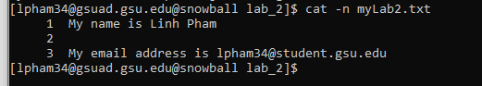

1. Display the content in "myLab2.txt" with line numbers and suppress empty lines by typing the command below and press "Enter".

**cat -n -s myLab2.txt**

* Question H): Attach a screenshot of the output. 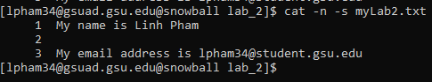

(13) Go to your home directory using the absolute path by typing the command below and press "Enter".

**cd <Answer from step(2>**

***Note*** : *Please replace the blue part with the answer from step (2)*

* Question I): Then issue the command **pwd** again. And attach a screenshot of the output.
* 