1.

Commands: spark-submit --master local[*] ~/spark/examples/src/main/python/pi.py 1000

spark-submit: command to submit a Spark job

--master local[*]: allow spark to use all cores of CPU of the local machine

~/spark/examples/src/main/python/pi.py 1000: location of the python script

Outputs: Show system setup, task execution, and potential warnings

Expected output: 

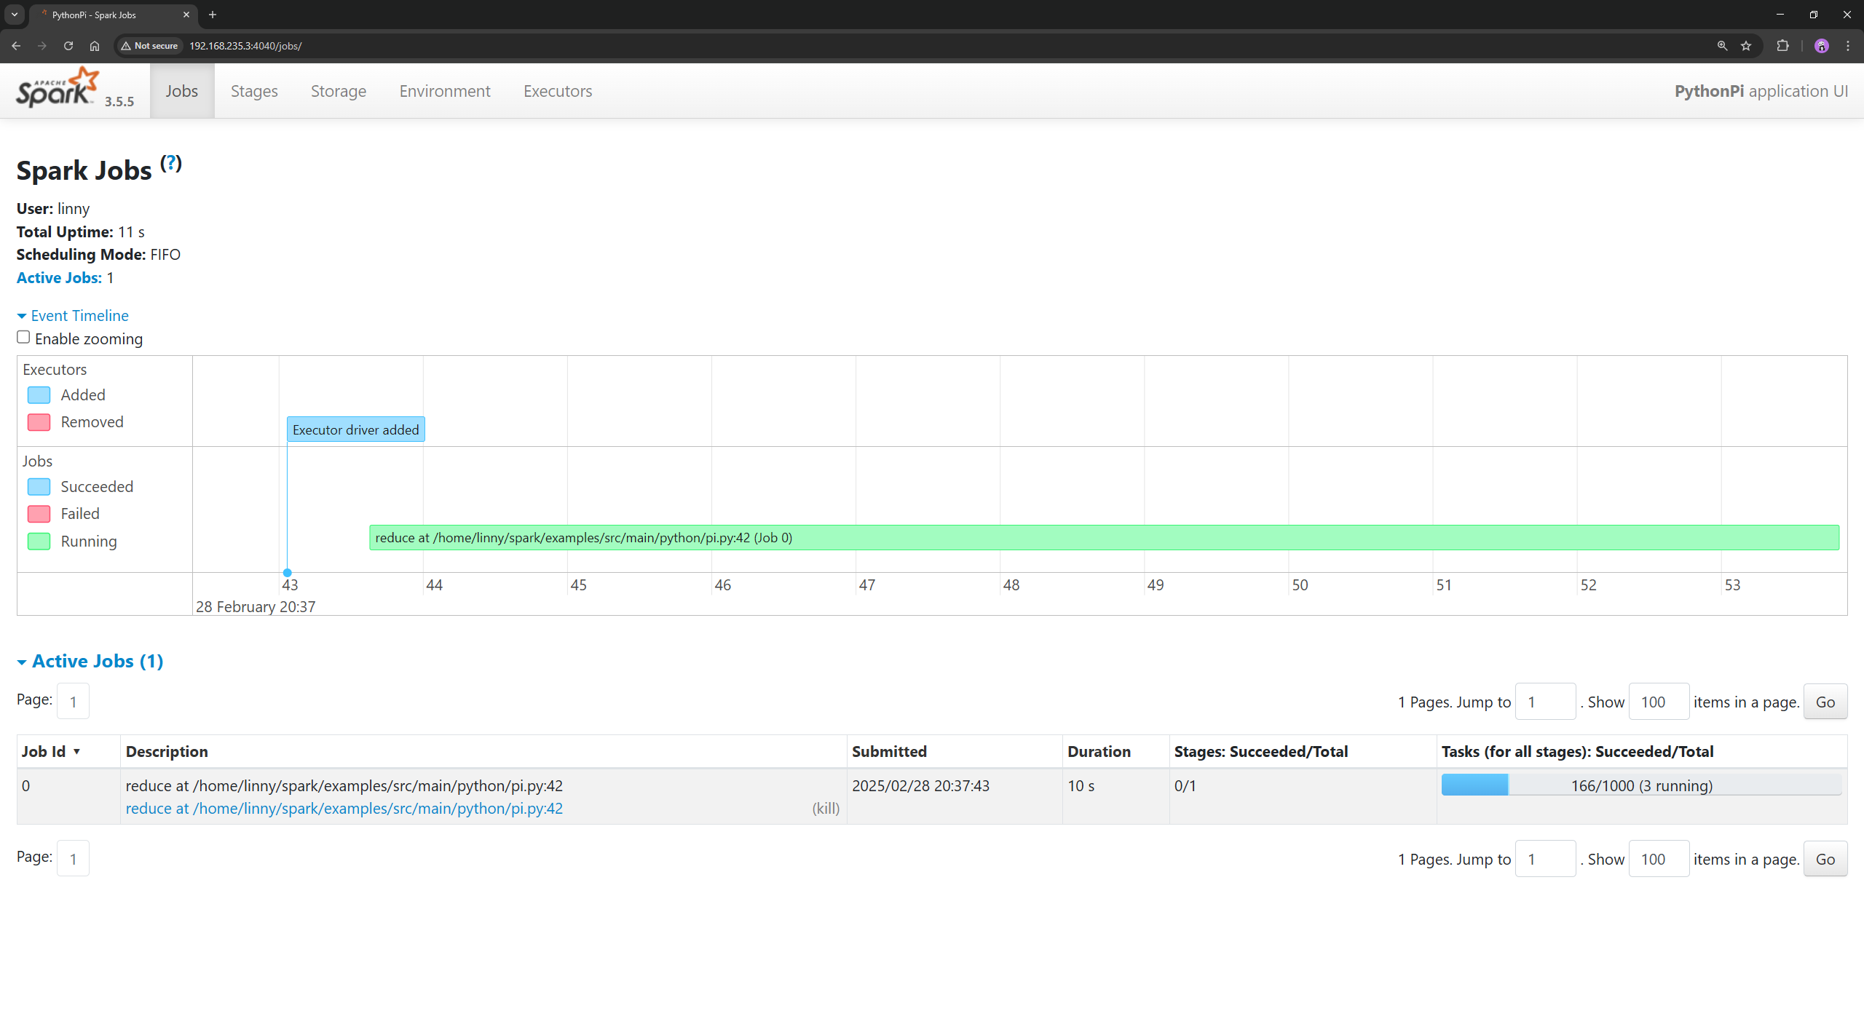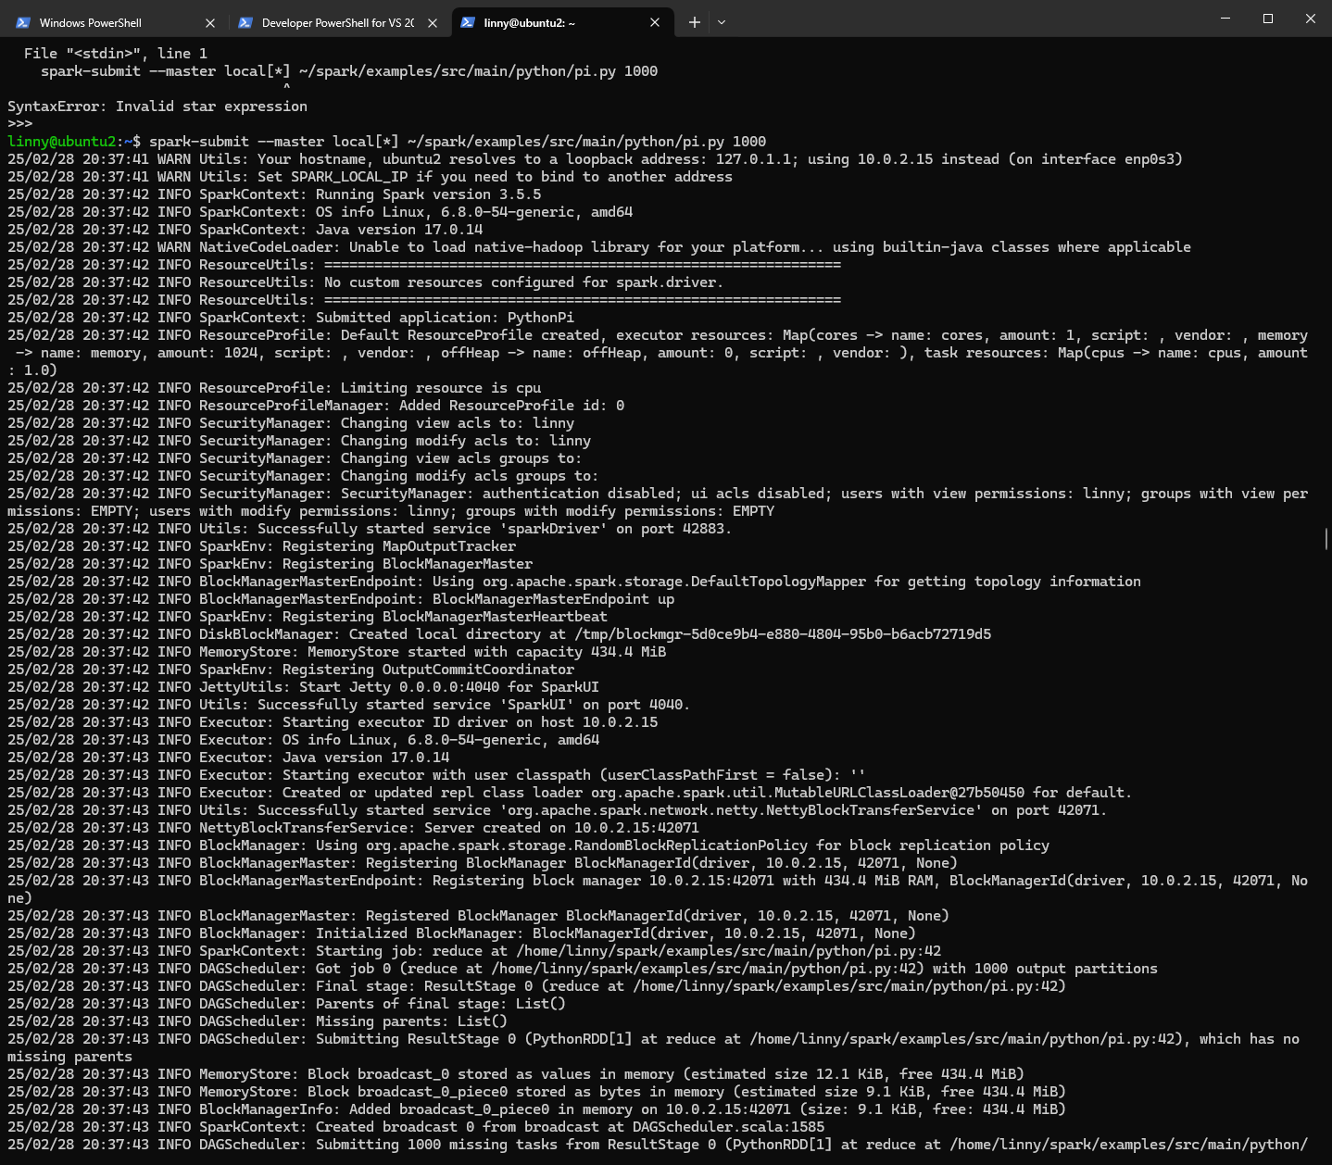

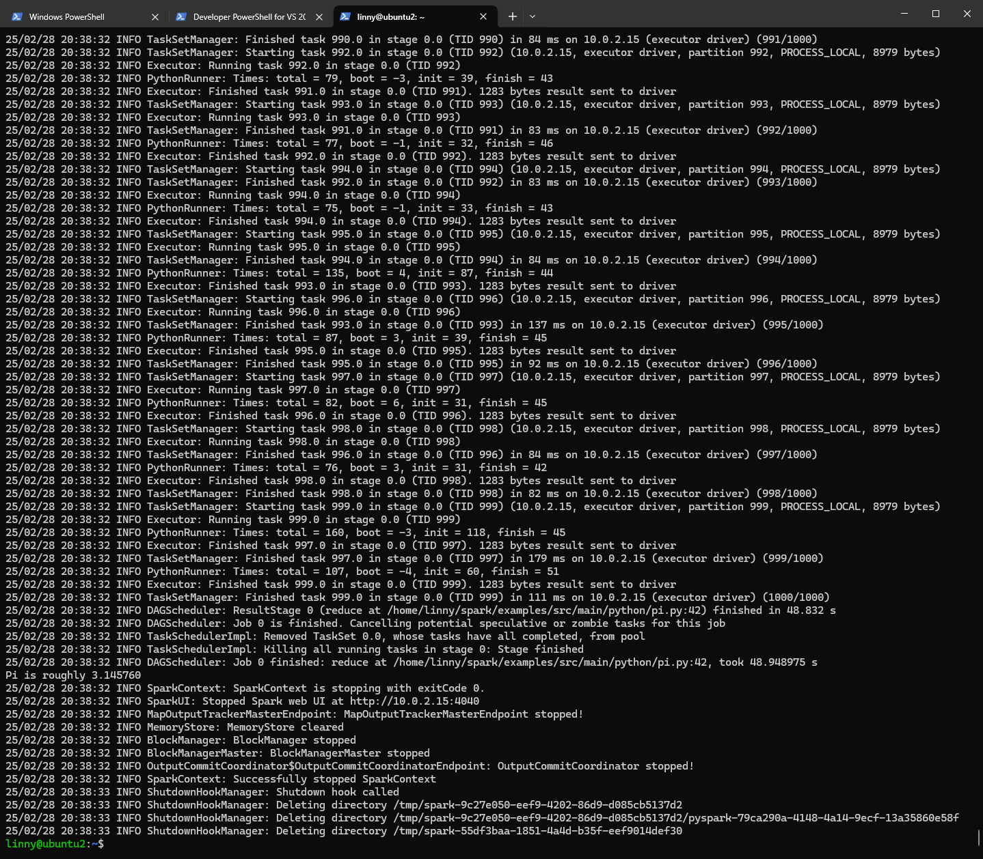

2.

Commands: python3 ./monte_carlo_pi.py

run the file monte_carlo_pi.py using python3

outputs: % progress until the job is done

expected output: 

