1. 1 core: 8.2 seconds, pi=3.142 (N=1000000)

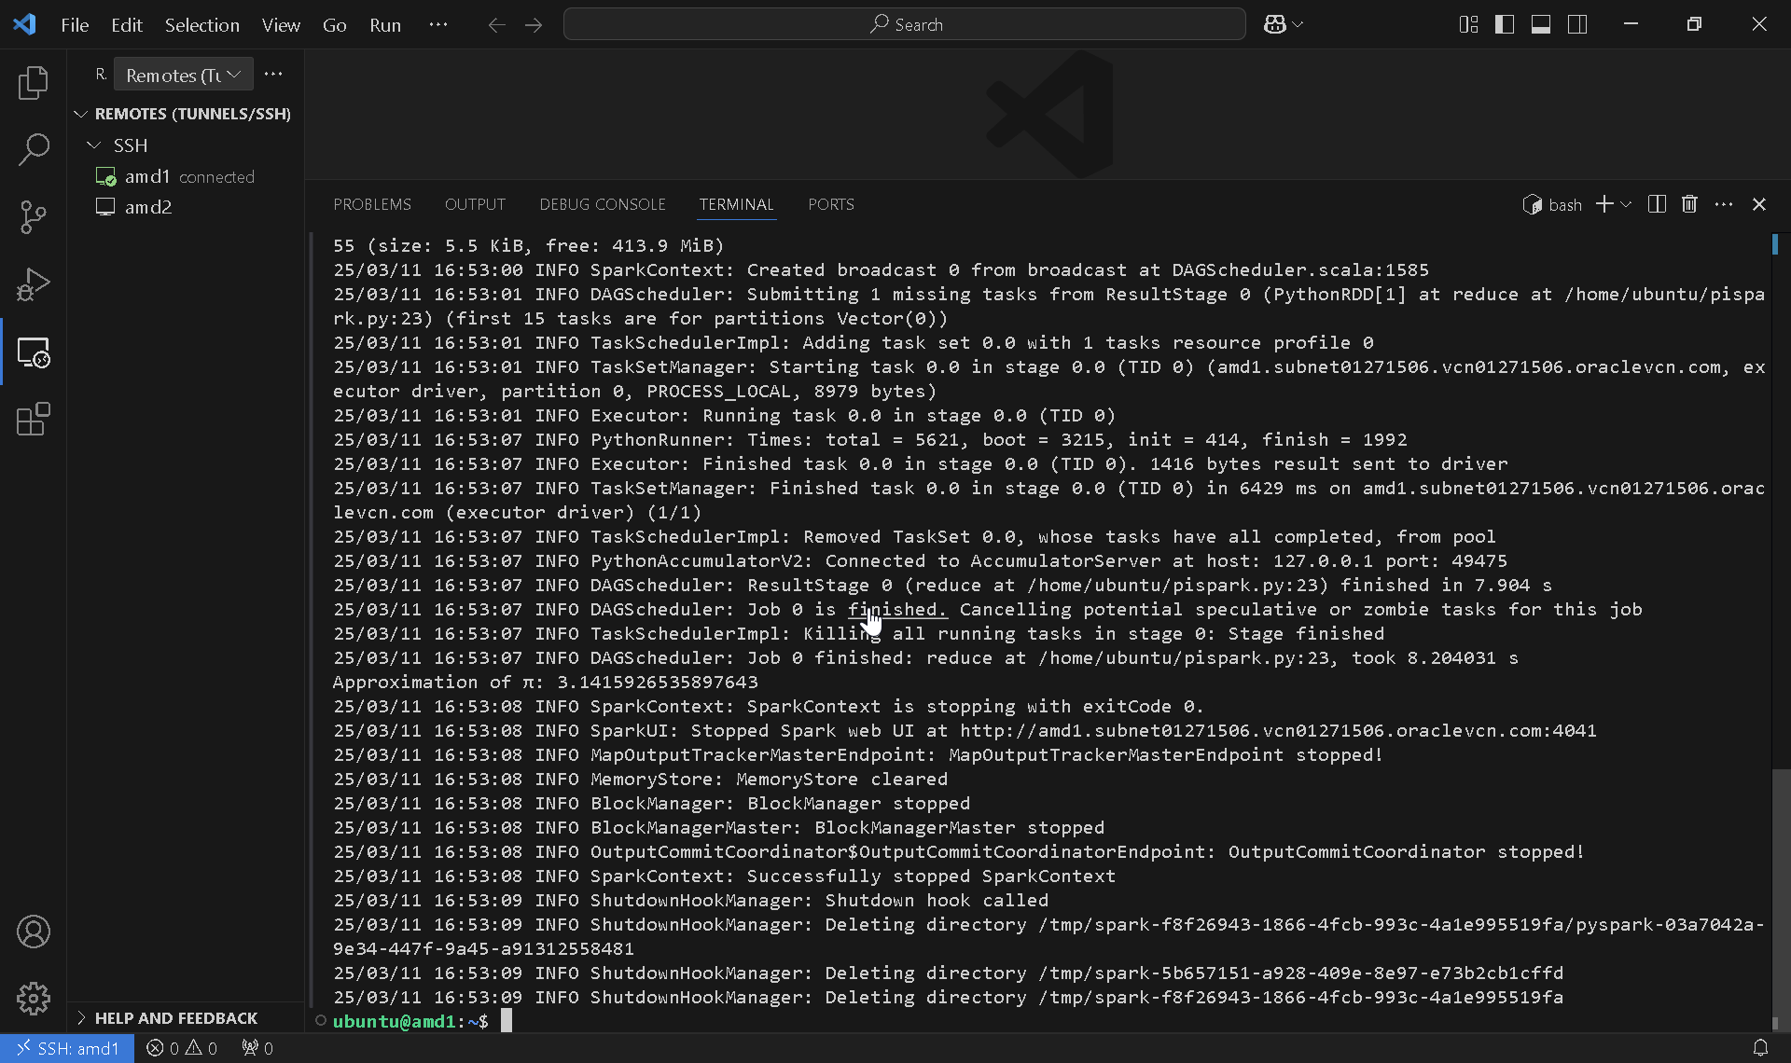

1 core: 5.5 seconds, pi = 3.142 (N=100000)

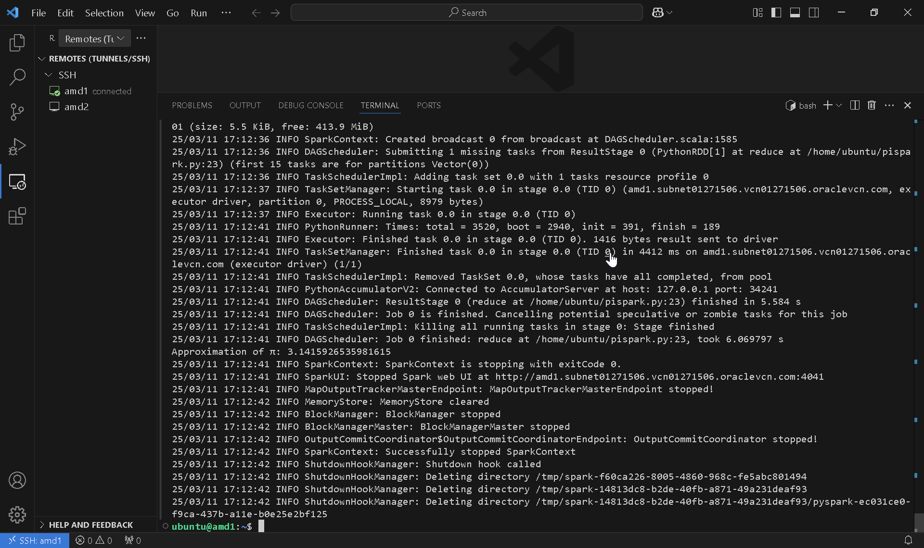

1 core: 5 seconds,3.142 (N=10000)

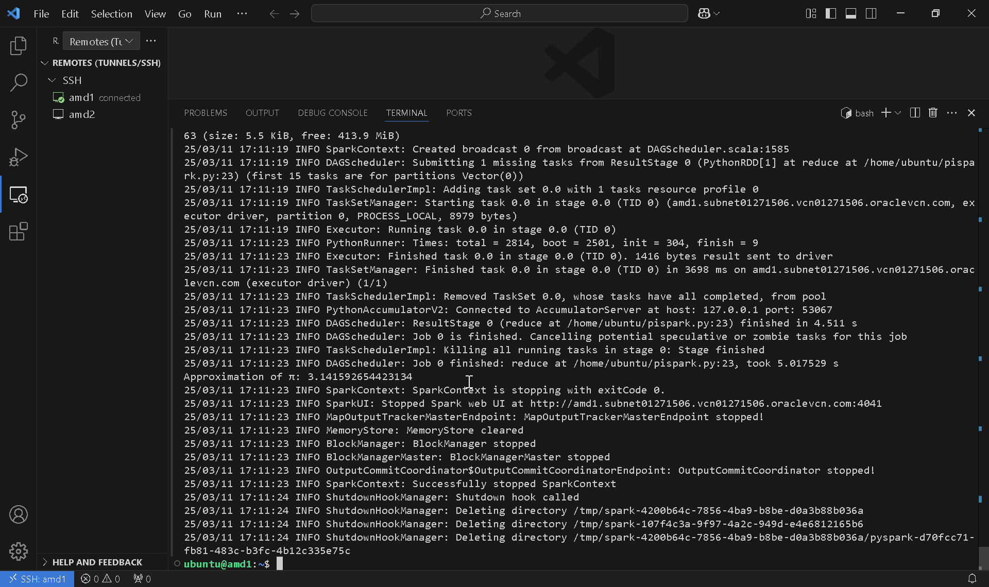

1 core: 4.9 seconds, 3.142 (N=1000)

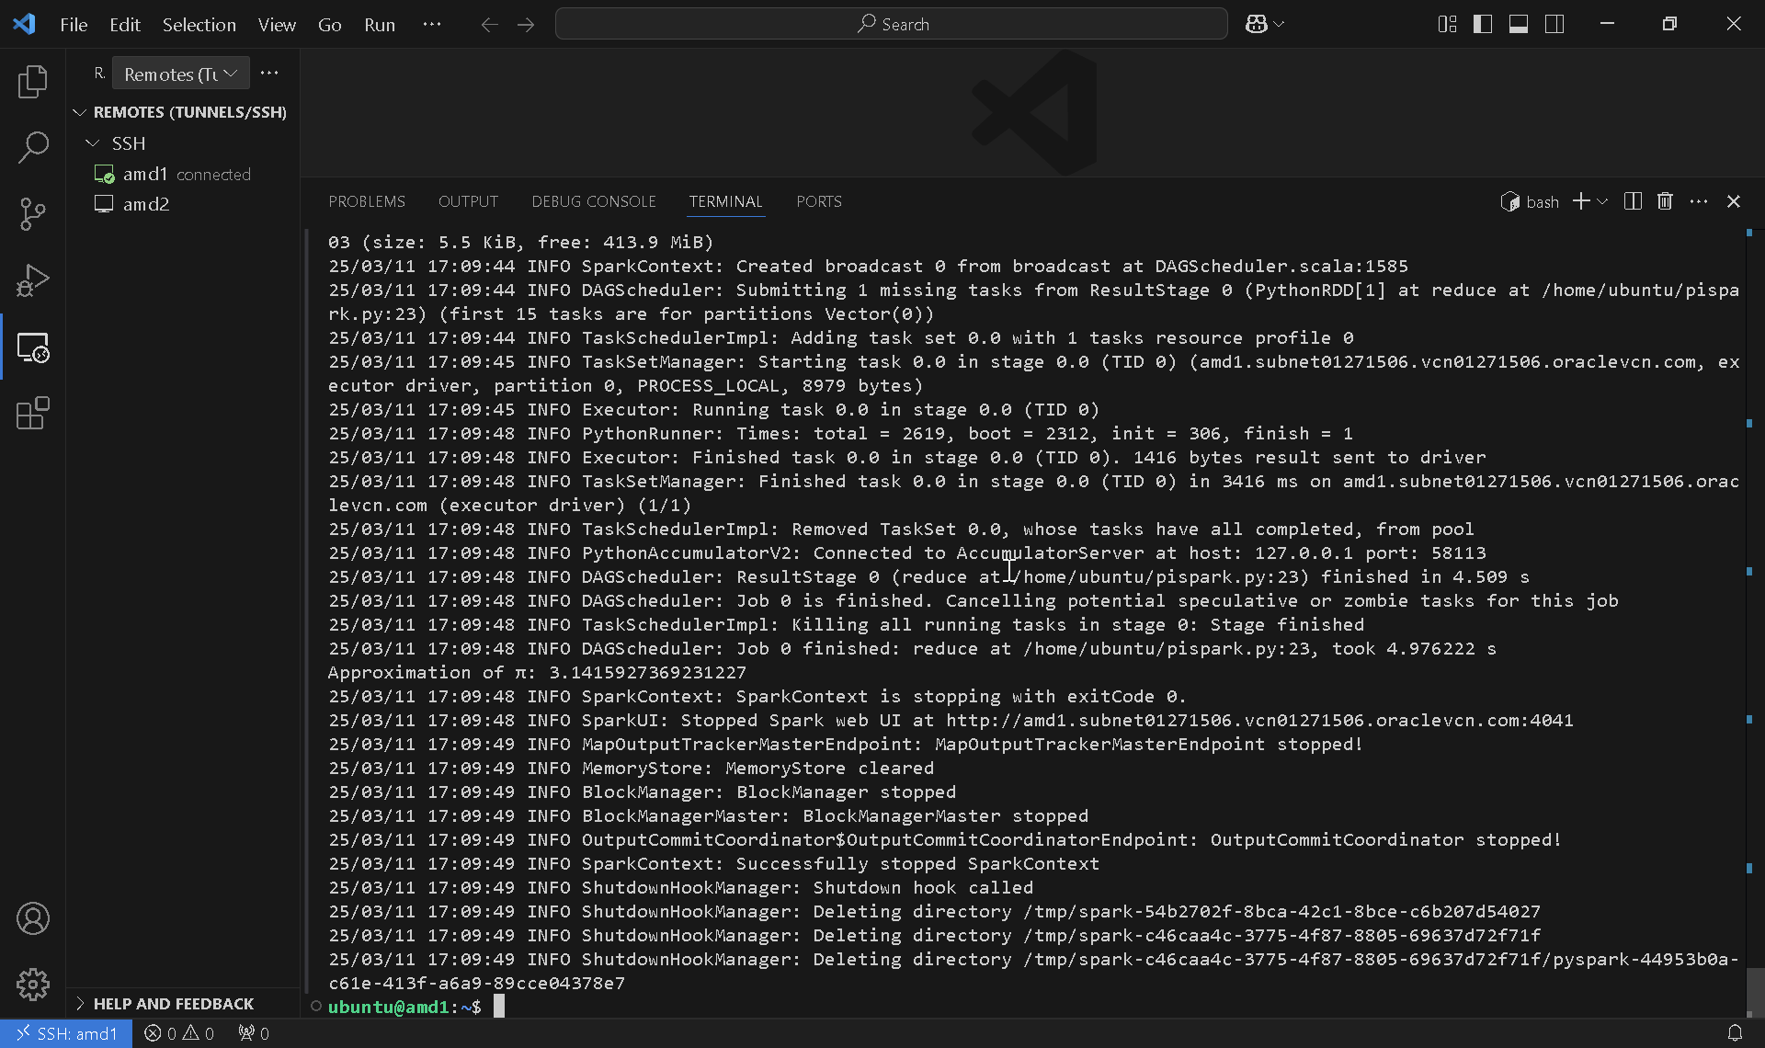

2 cores: 1.33 seconds, 3.142 (N=1000000)

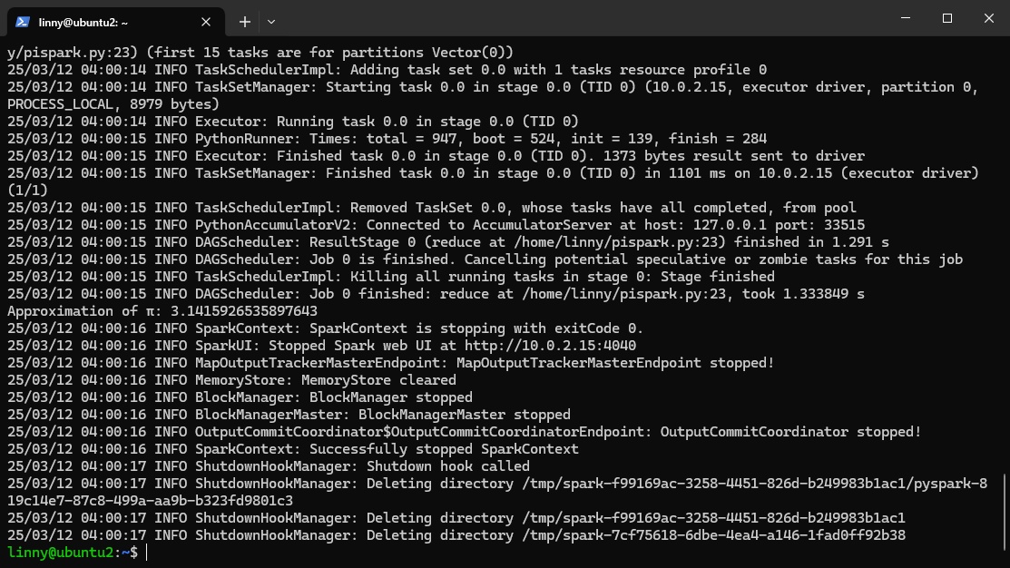

2 cores: 0.69 seconds,3.142 (N = 100000)

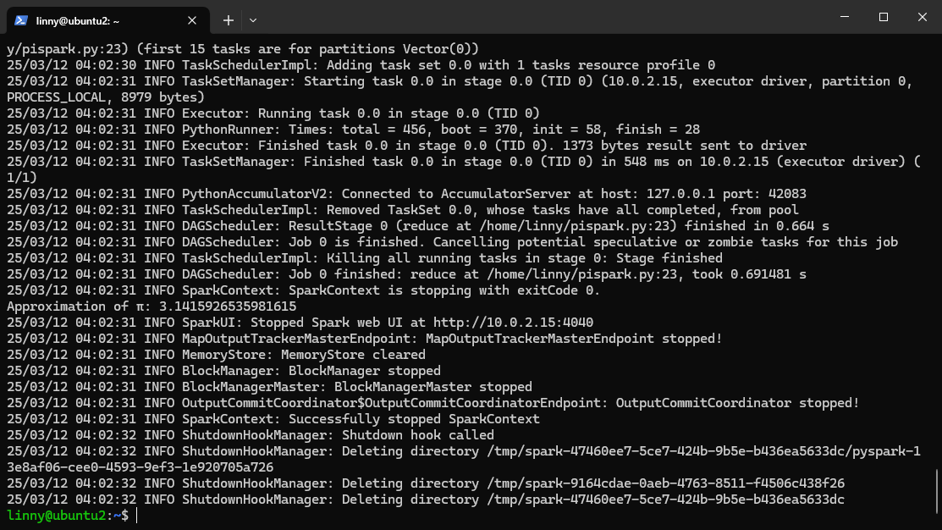

2 cores: 0.65 seconds, 3.142 (N = 10000)

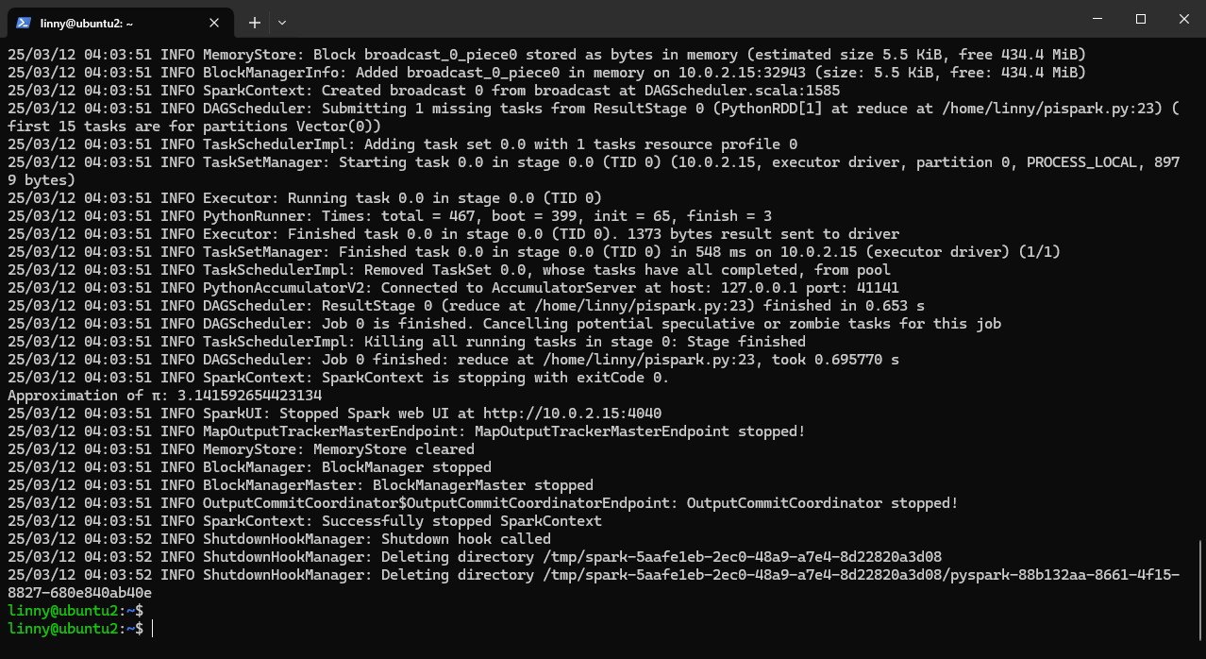

2 cores: 0.63 seconds, 3.142 (N = 1000)

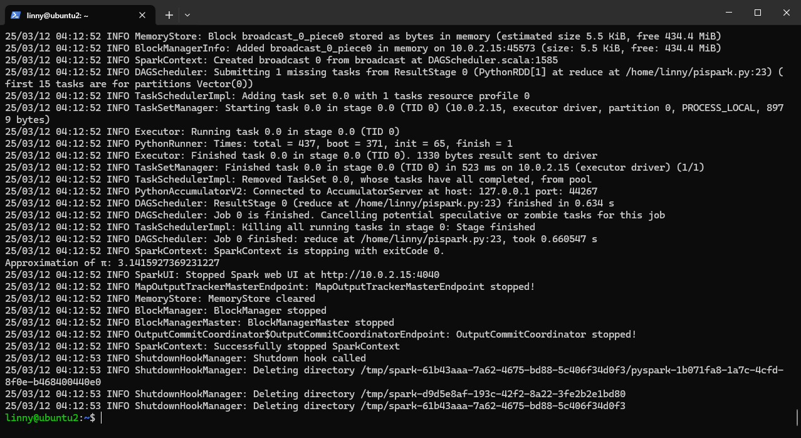

2.

2 nodes: 9.57 seconds, 3.142 (N=1000)

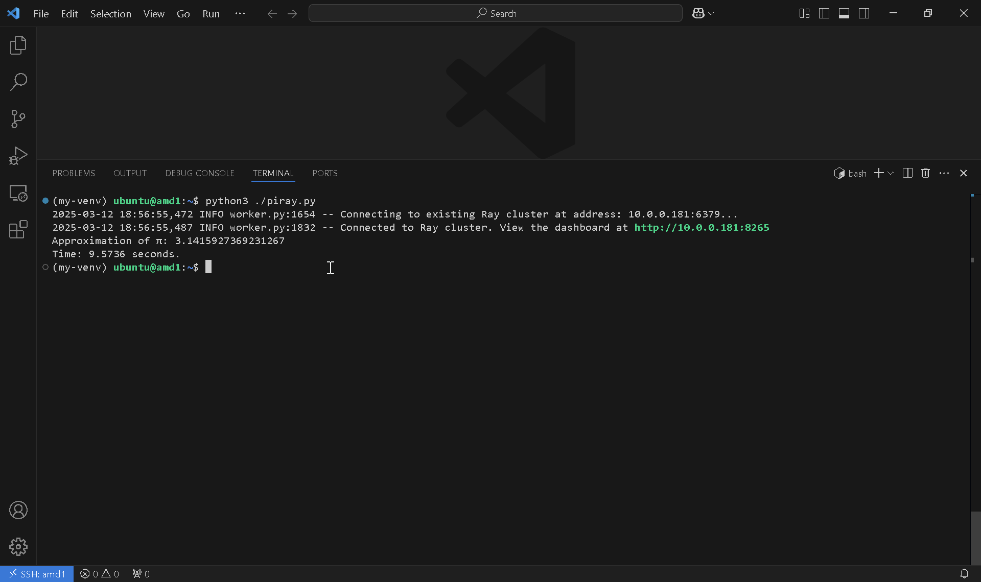

2 nodes : 45.61 seconds, 3.142 (N=10000)

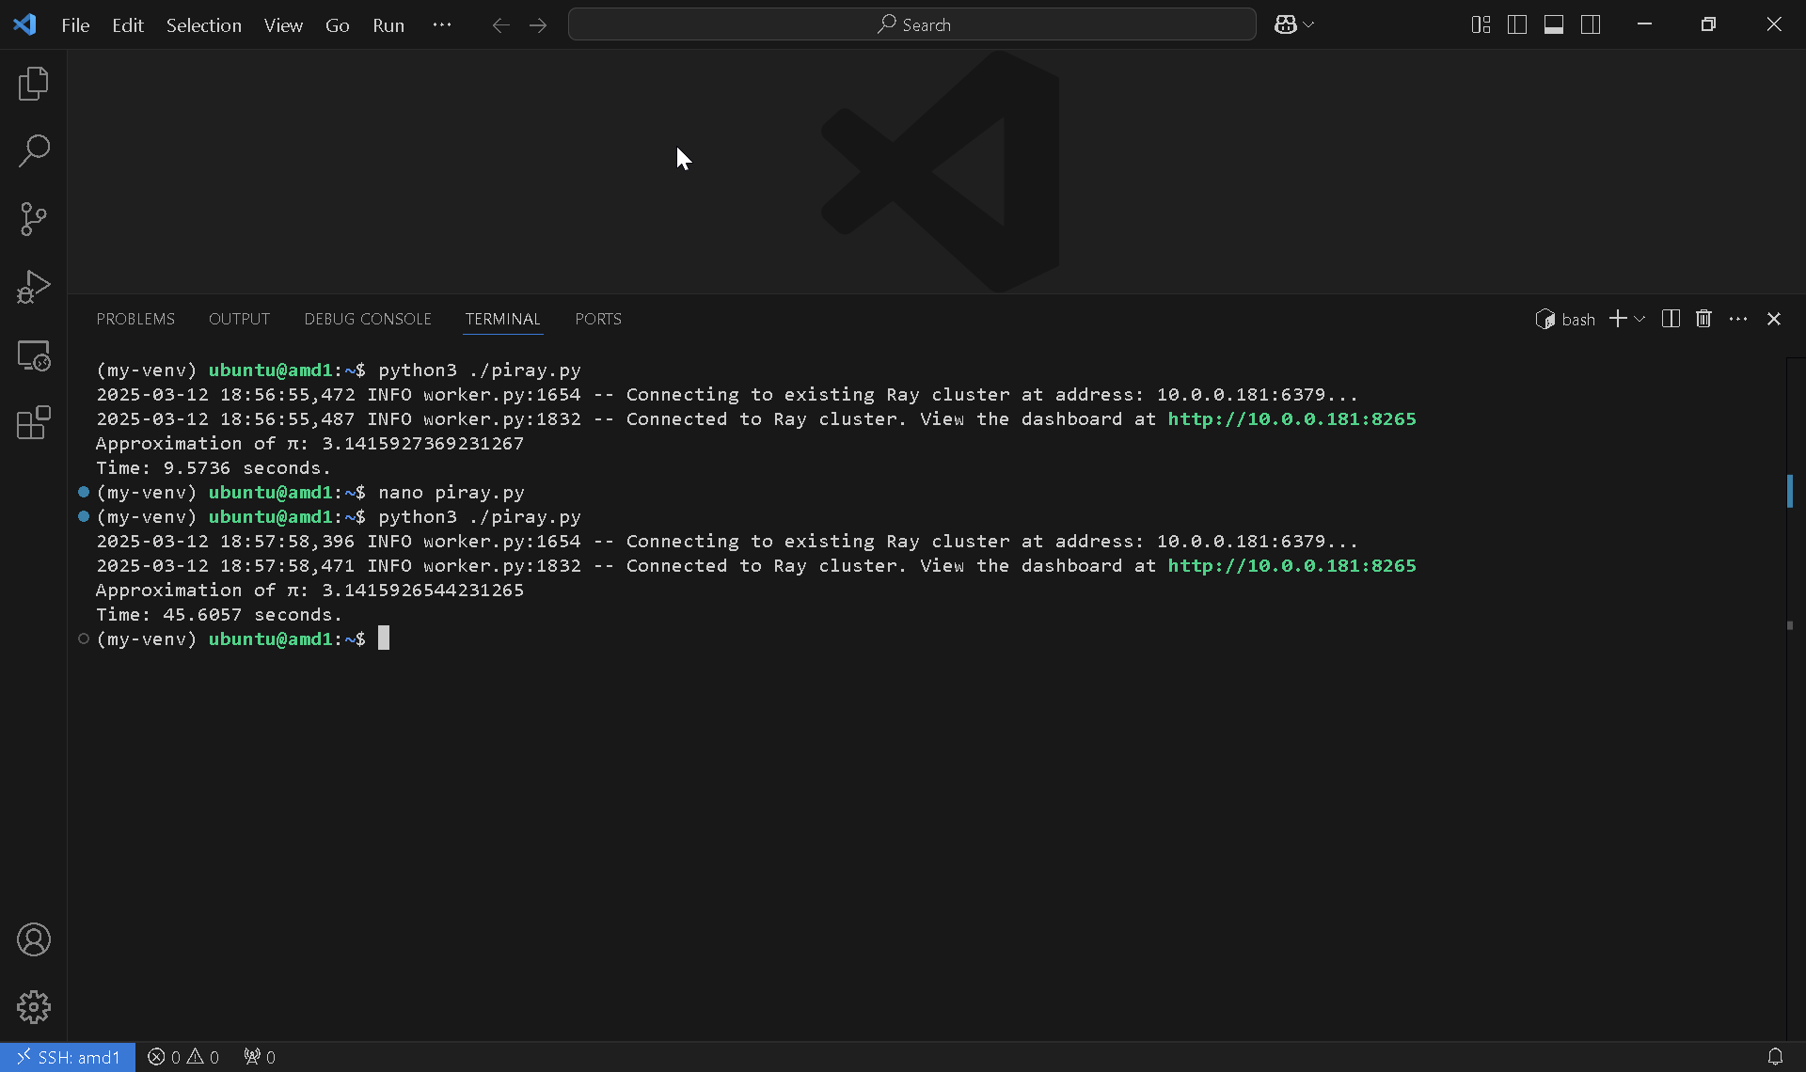

2 nodes: 958.69 seconds (N=100000)

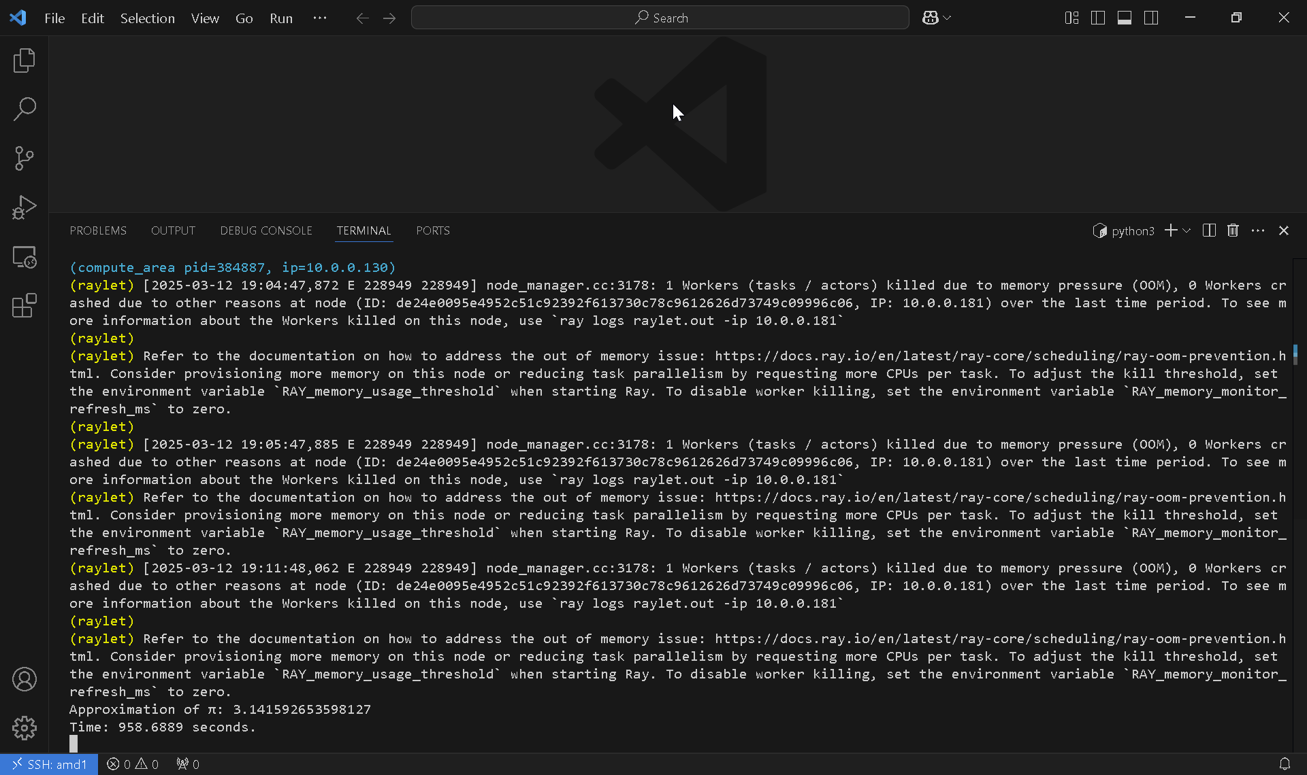

1 node: 48.70 seconds (N=1000)

