1. Report: The results was expected. Using more cores, or with less calculation, results in faster time.

1 core: 8.2 seconds, pi=3.142 (N=1000000)

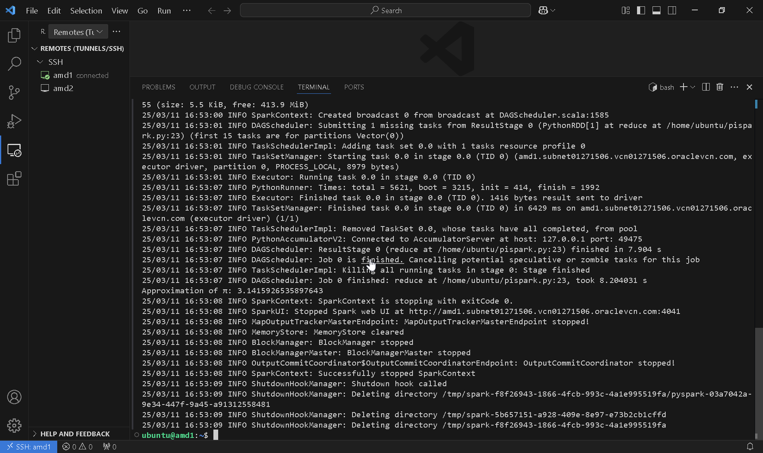

1 core: 5.5 seconds, pi = 3.142 (N=100000)

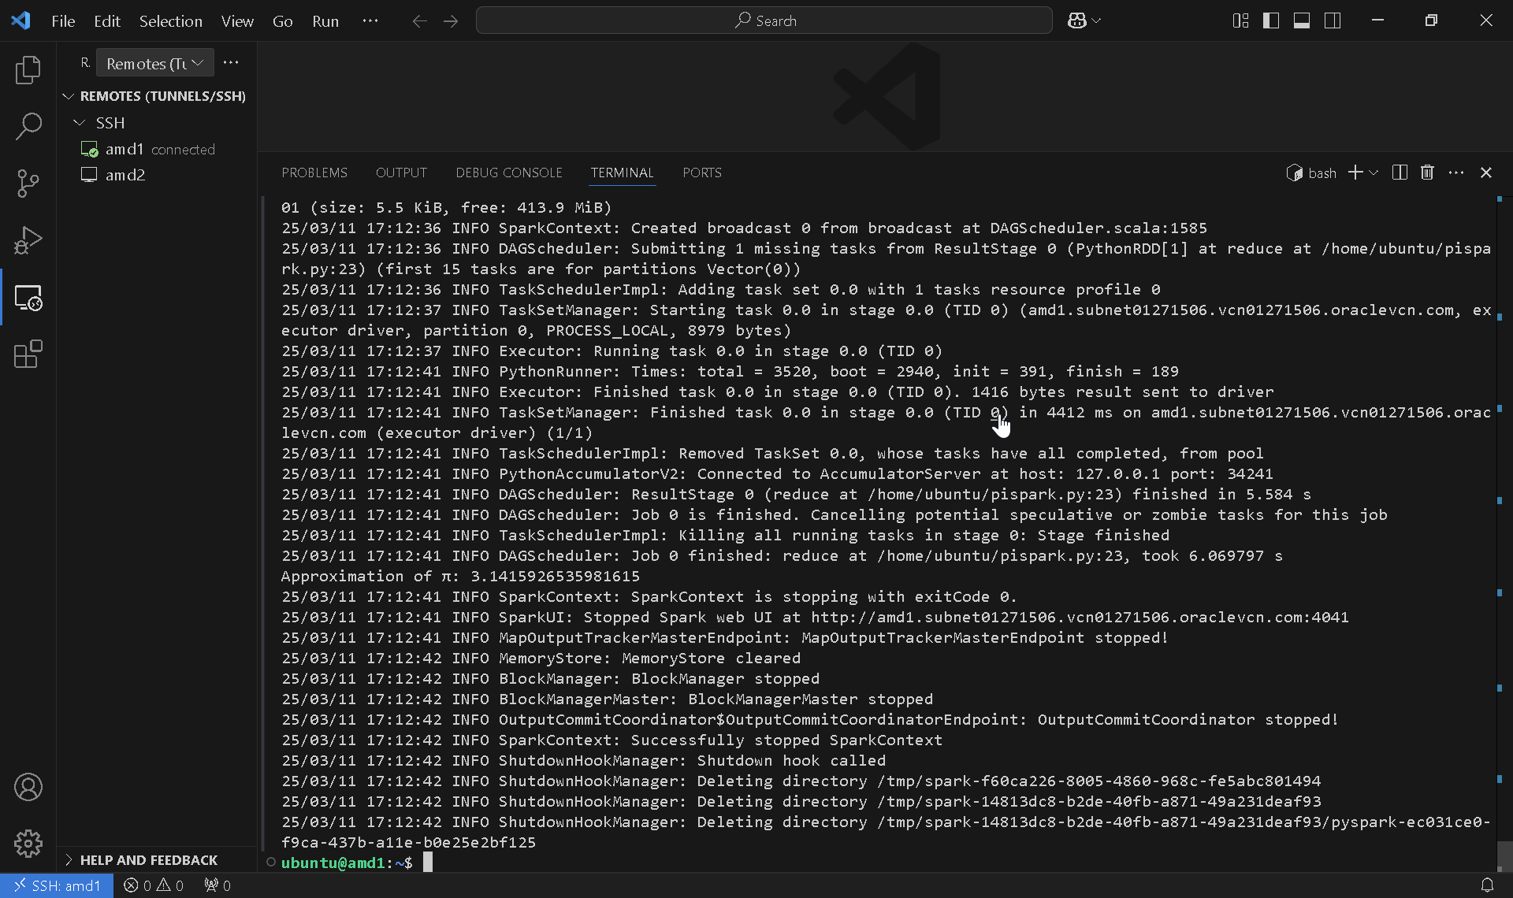

1 core: 5 seconds,3.142 (N=10000)

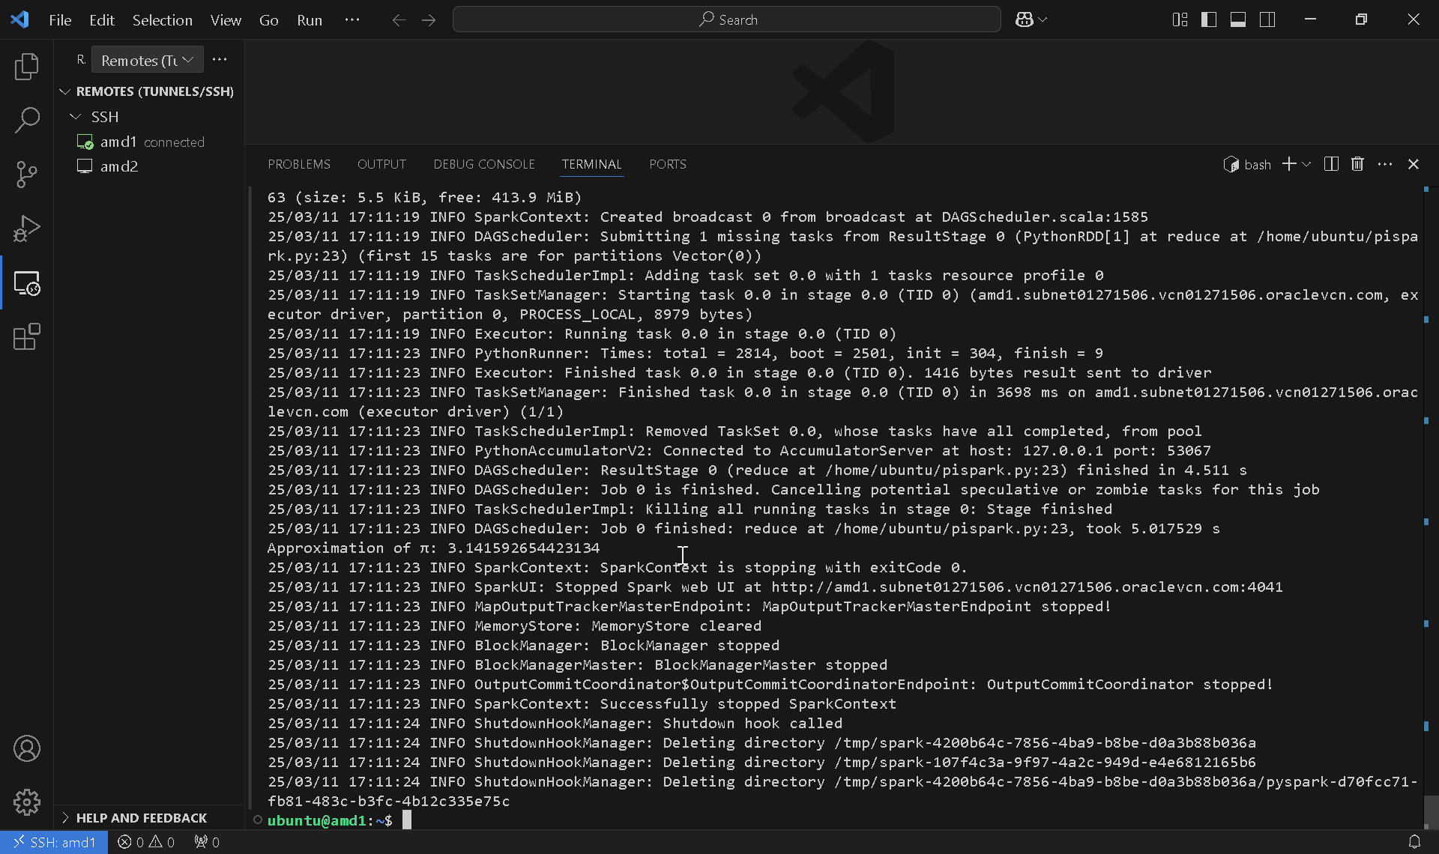

1 core: 4.9 seconds, 3.142 (N=1000)

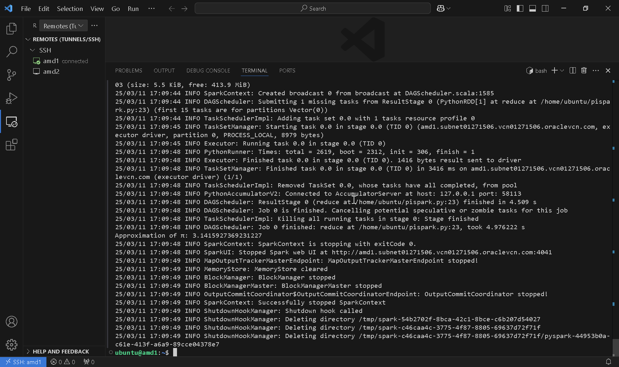

2 cores: 1.33 seconds, 3.142 (N=1000000)

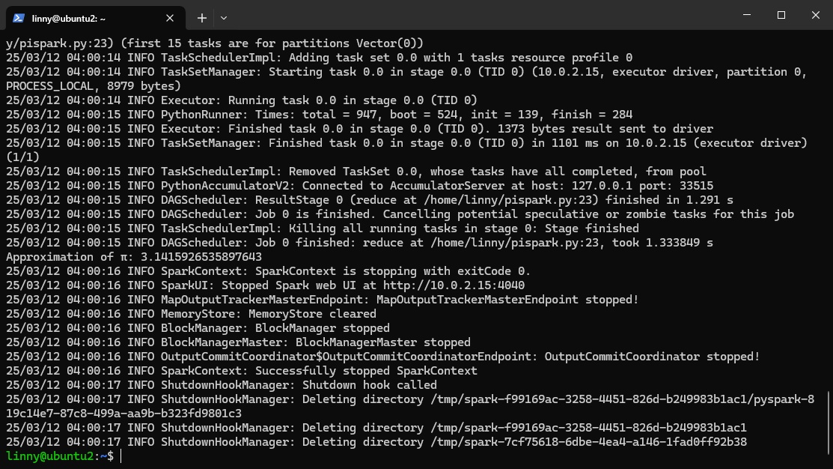

2 cores: 0.69 seconds,3.142 (N = 100000)

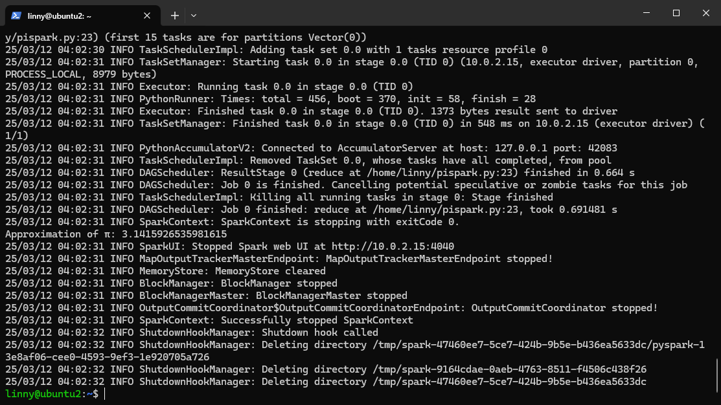

2 cores: 0.65 seconds, 3.142 (N = 10000)

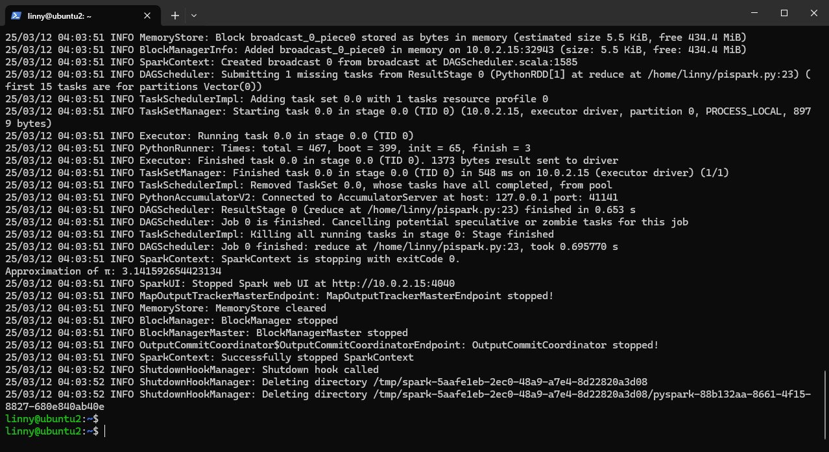

2 cores: 0.63 seconds, 3.142 (N = 1000)

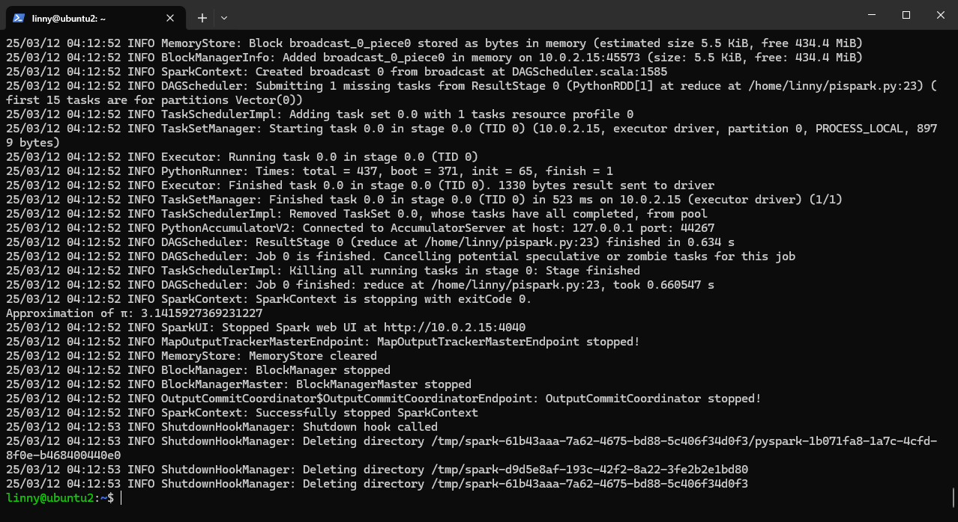

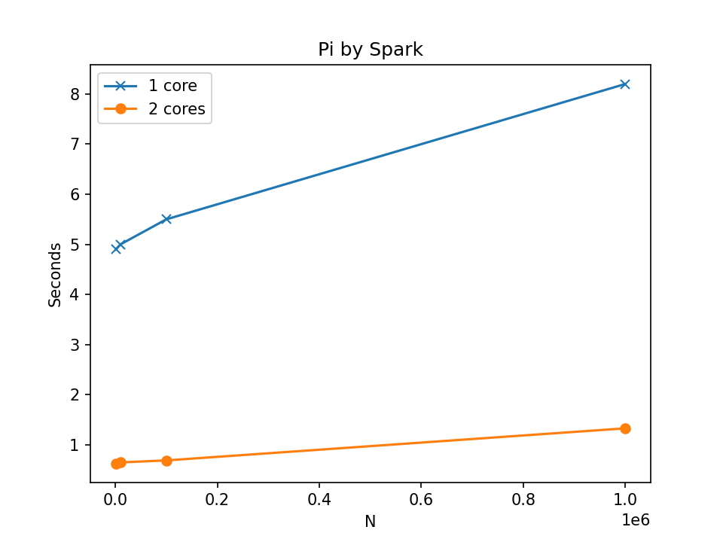

1. Report: Hardware is not able to perform N=1000000 without crashing. Results are unexpected. 2-nodes cluster seem to performs worse than 1-node cluster. Could be an Oracle hardware issue.

2 nodes: 8.68 seconds, 3.142 (N=1000)

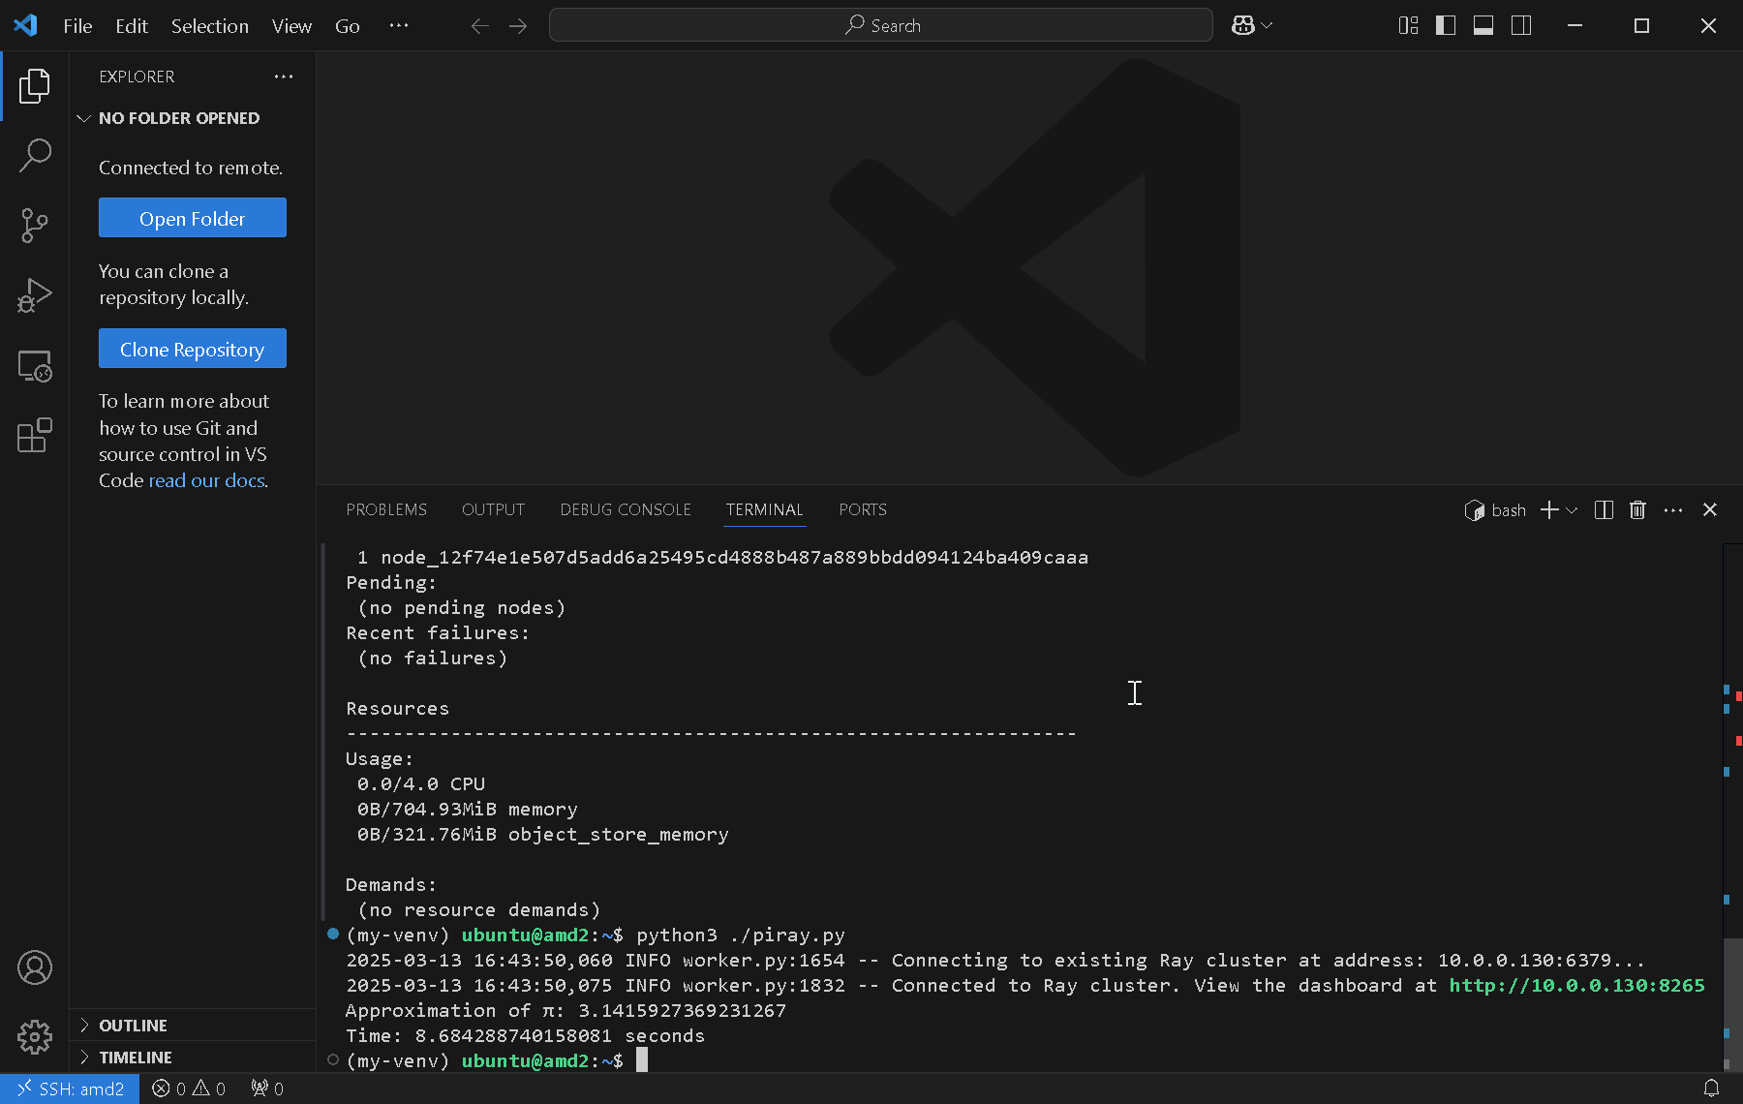

2 nodes : 56.19 seconds, 3.142 (N=10000)

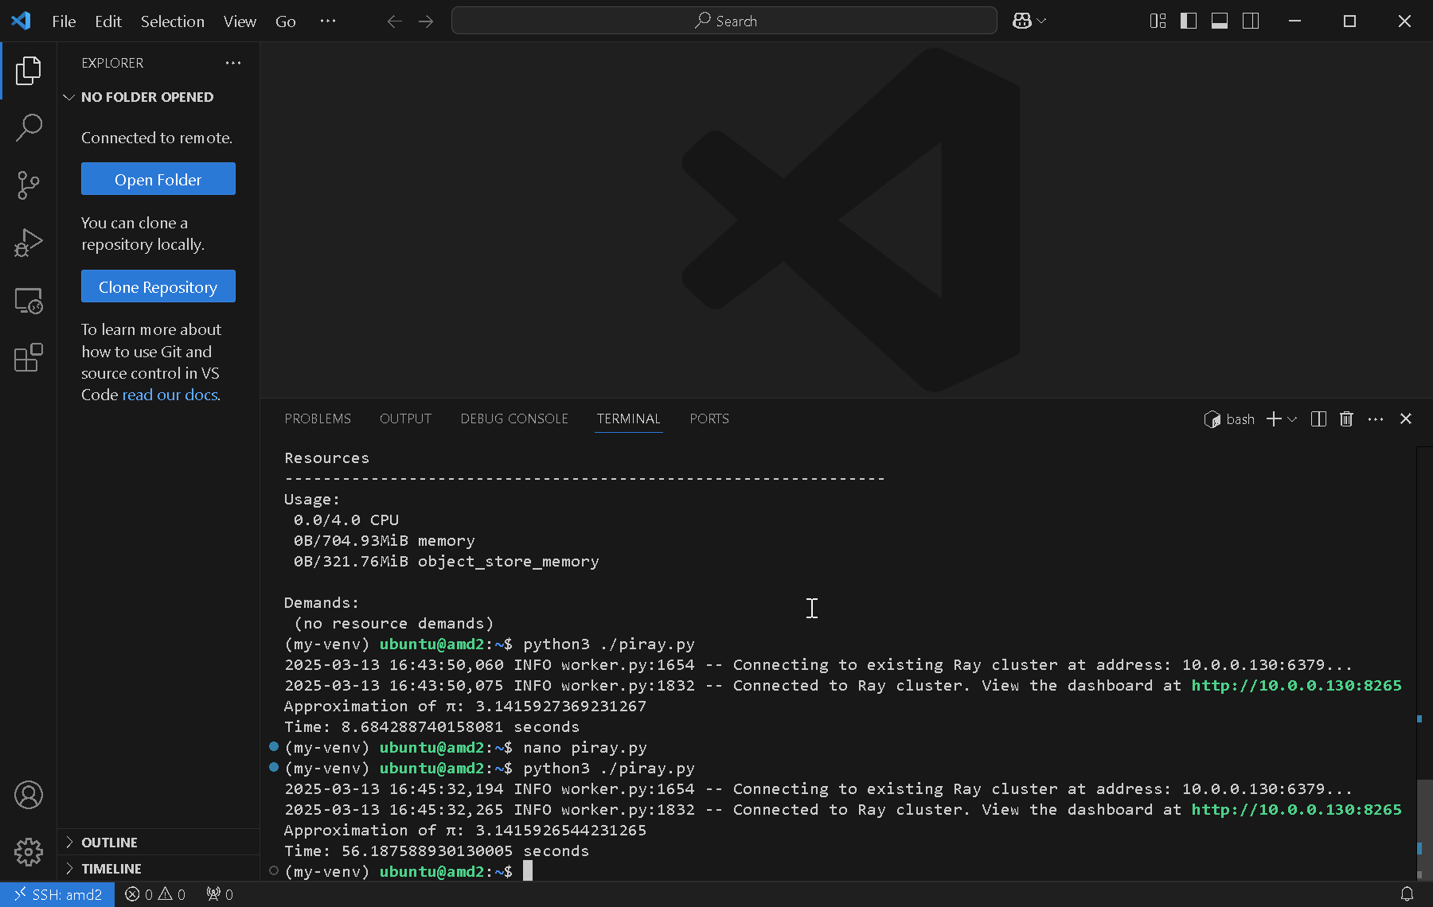

2 nodes: 808.60 seconds, 3.142 (N=100000)

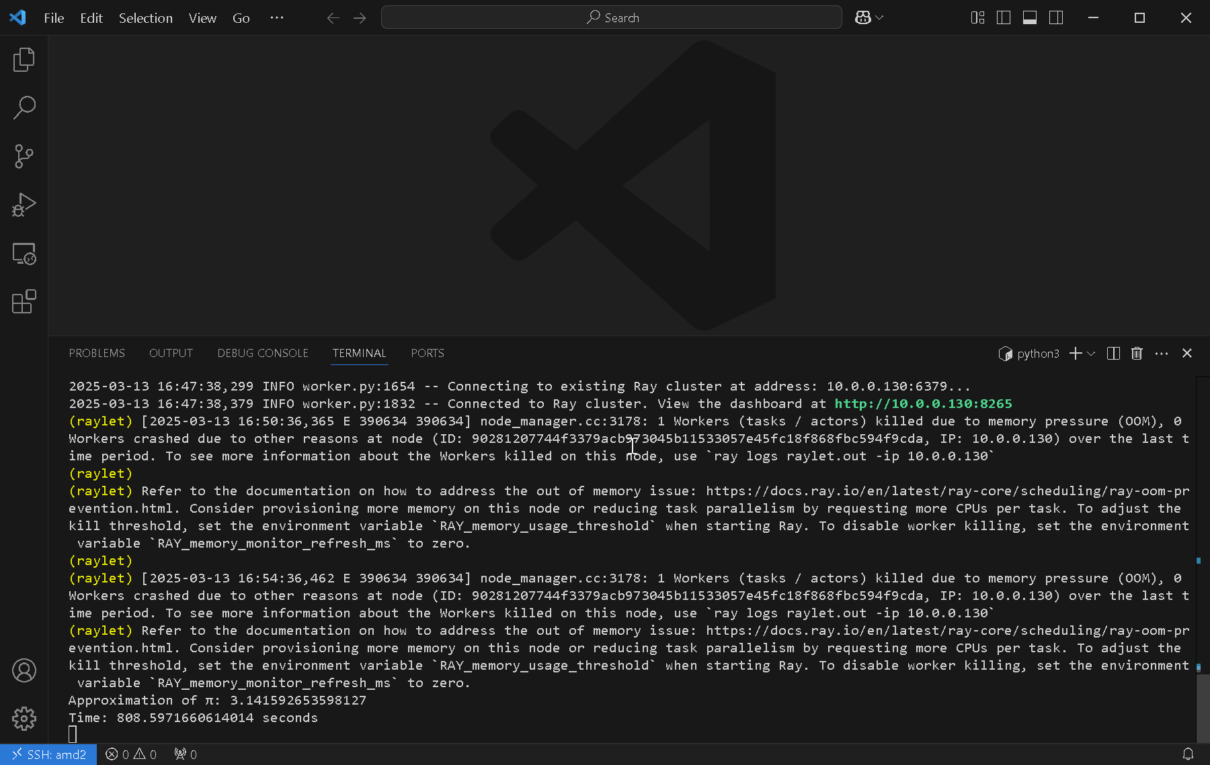

1 node: 16.32 seconds, 3.142 (N=1000)

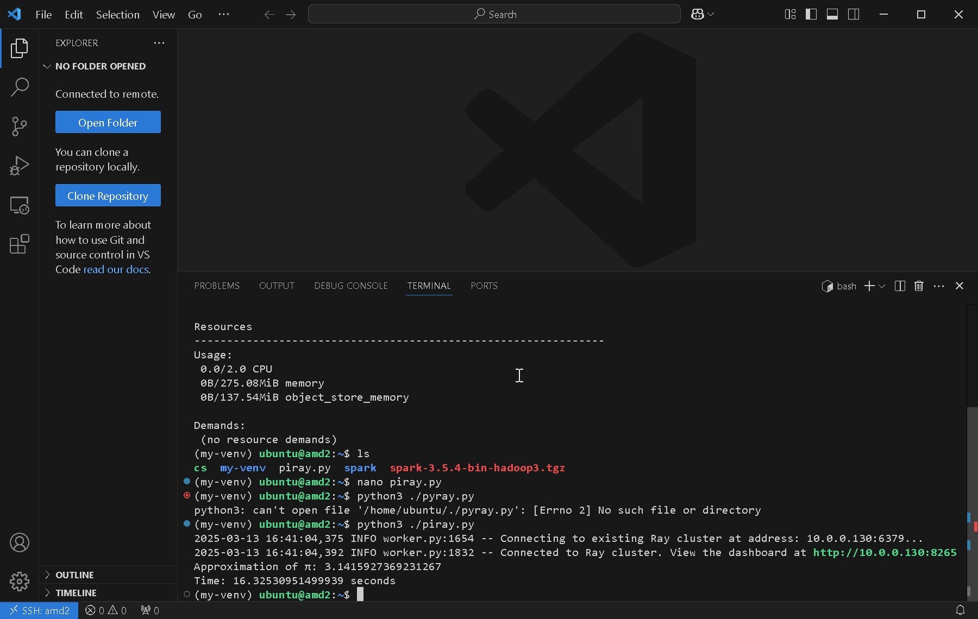

1 node: 56.78 seconds (N=10000)

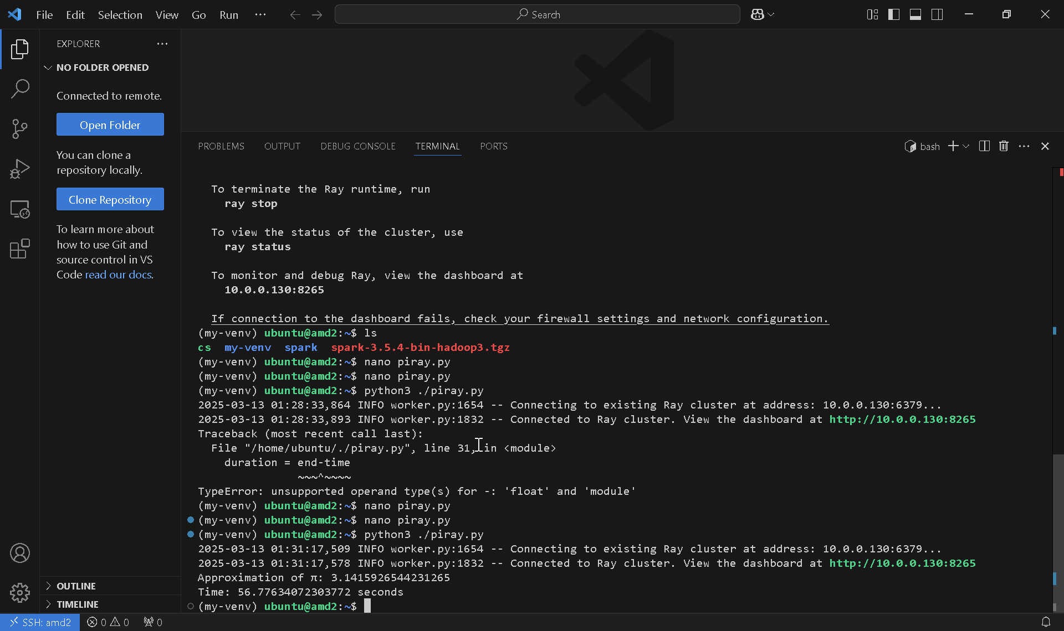

1 node: 643.48 seconds (N=100000)

