1.

A.

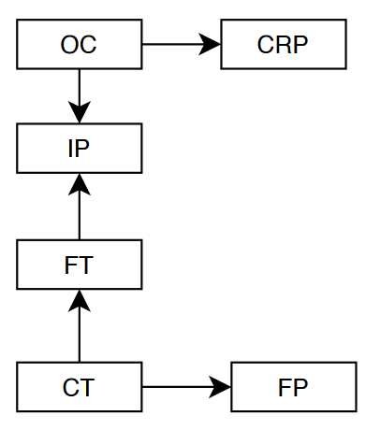

P(OC = TRUE) = 0.8

P(CT = TRUE) = 0.05

P(CRP | OC = TRUE) = 0.1

P(CRP | OC = FALSE) = 0.001

P(FT | CT = TRUE) = 0.01

P(FT | CT = FALSE) = 0.004

P(FP | FT, CT = TRUE) = 0.9

P(FP | FT = TRUE, CT = FALSE) = 0.1

P(FP | FT = FALSE, CT = FALSE) = 0.01

P(IP | FT = TRUE, OC = TRUE) = 0.15

P(IP | FT = FALSE, OC = TRUE) = 0.1

P(IP | FT = TRUE, OC = FALSE) = 0.051

P(IP | FT = FALSE, OC = FALSE) = 0.001

B.

-Prior probability of fraud:

P(FT) = P(FT | CT = TRUE) \* P(CT) + P(FT | CT = FALSE) \* P(CT = FALSE)

= 0.01 \* 0.05 + 0.004 \* 0.95 = 0.0043

-Probability of fraud:

P(FT = T | FP = T, IP = F, CRP = T)

= P(FP = T, IP = F, CRP = T | FT = T) \* P(FT = T) / P(FP = T, IP = F, CRP = T)

C.

P(FT = T | FP = T, IP = F, CRP = T, CT = T)

= P(FP =T, IP = F, CRP = T ∣ FT = T, CT = T) \* P(FT = T ∣ CT = T) / P(FP = T, IP = F, CRP = 1, CT = T)

2.

a.



b.

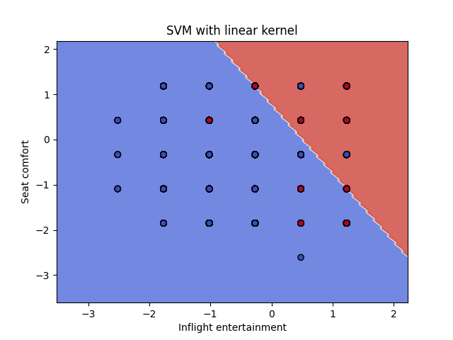

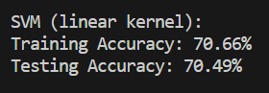

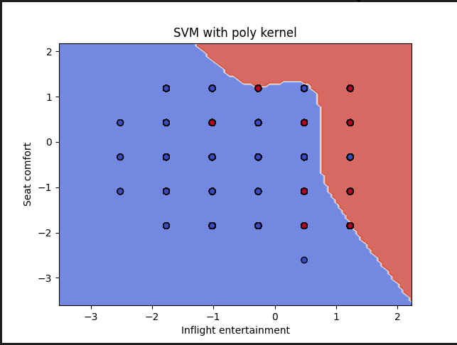

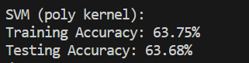

3.

The model achieved moderate accuracy. The results are varied based on different parameters.

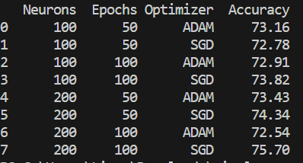

4.

