Discovering Lino using your debugger

In my daily work , I am using Pycharm as my favorite IDE .It is very efficient when debugging Python code and have many useful features. Let’s see who I use it to debug Lino base code to fix issues or add new code.
The next steps assume that you have Pycharm installed in your machine.

1) Creating a new Pycharm project
Lino code base lives in its official repository in Github. First of all , you need to clone lino project to your github account to be able to commit your change. This is done in the github website.
Once this is done , you need to fetch the code from your new repository and then install it within your virtual python environment.

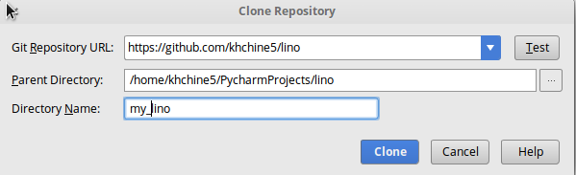

-Git Repository URL : the URL of your project.
-Parent Directory : Where your project will be copied in your machine.
After this, the project will be opened in Pycharm projects section
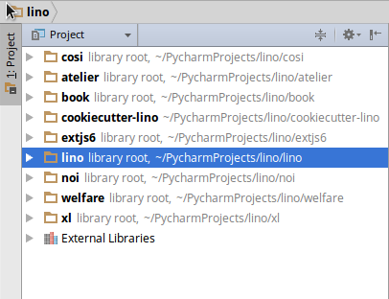

2)Add your virtual python environment to Pycharm
Open you Pycharm setting and search for project interpreter
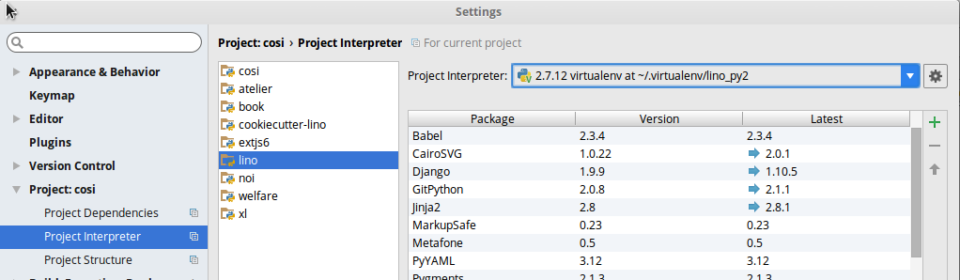

3) Creating your Run/debug configurations

At this step, we will try to run a Lino project under Pycharm. Thus, we need to clone and fetch (Step 1 and 2) the book project . I picked this project because it contains several demo projects. You need also to install it within your virtual python environment.
Once the book project is ready , we choose the ‘min1’ project as a sample.
We create the a run configuration, by right clicking the file in the project menu selecting the 'create “manage”...' option and filling out the configuration with a run parameter of 'runserver'.
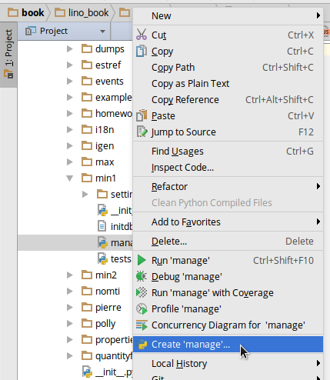
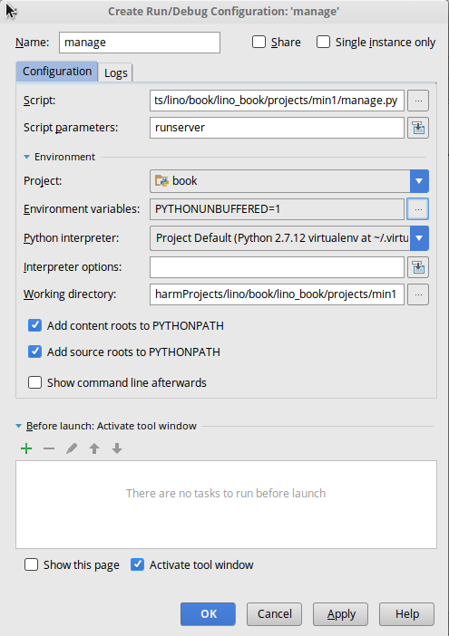

As you can see, this Run configuration will use our configured Python interpreter in Step 2.
4) Run a demo project
Once you create this configuration, you will be able to run and debug your project by clicking on the green arrow (at the right of ‘manage’) or the debugger-icon next to the arrow is the debugger (shaped like a bug)
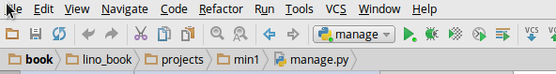

And you will get a similar output in your console
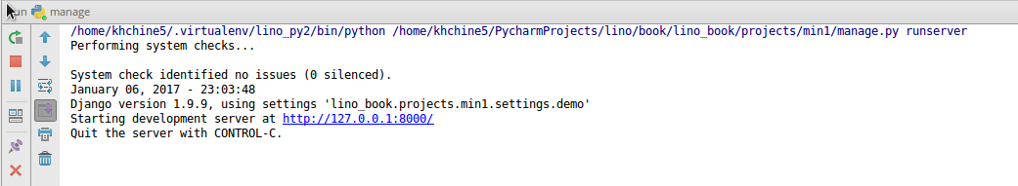
Before opening our browser, we need to populate our database the demo data by going to the book project and run the following command:
‘inv prep’

Now , we can open our browser at this link http://127.0.0.1:8000 and we get our first demo project running.
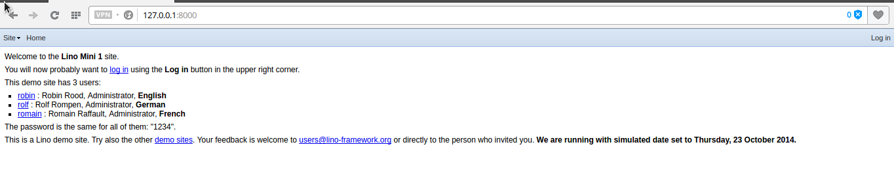
5) Debug the demo project
Let’s for example debug the “About” window. We can found this window by opening the menu Site>About.
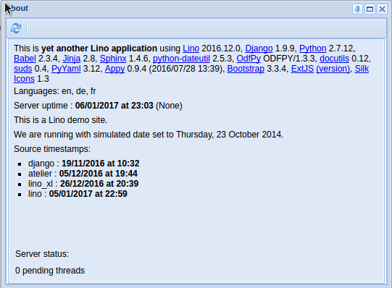

For fun, let’s debug the simulated date in this demo project.
In Pycharm ,we open the file lino/lino/modlib/about/models.py
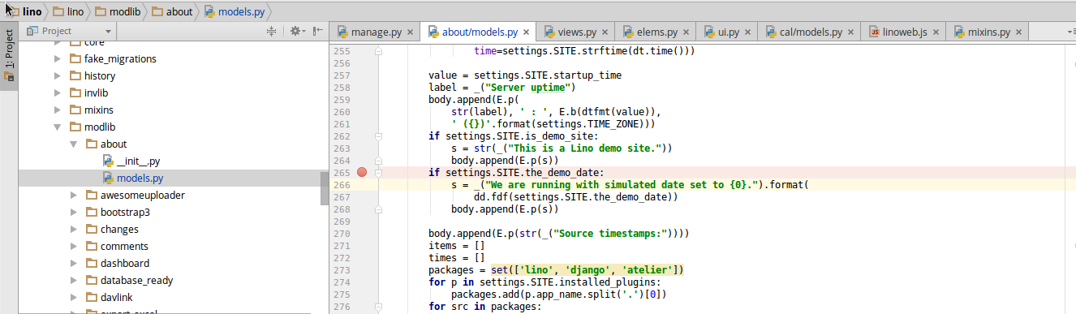
I added a new breakpoint at the line 265 , I have stopped the run of my application and I started the debug mode by clicking on the bug-button at the right.
I open again my “About” window and the execution stop in my breakpoint

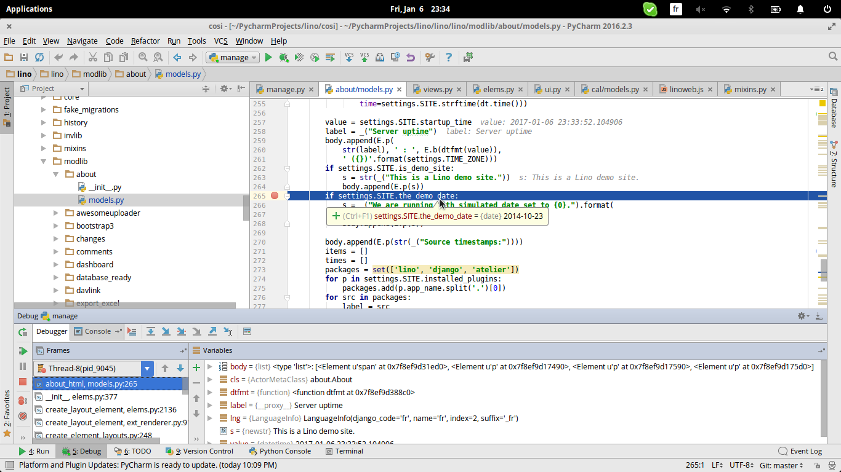

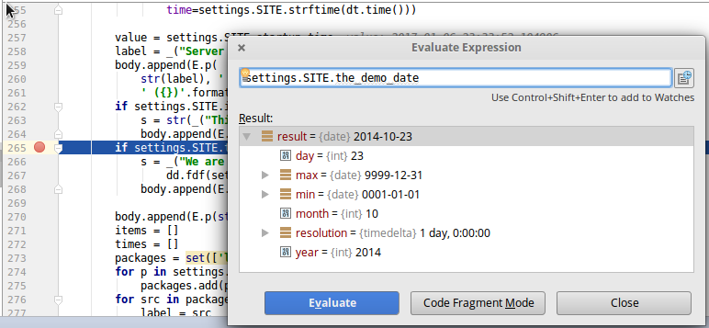
You can use the Evaluate Expression feature by pressing Ctrl+U,
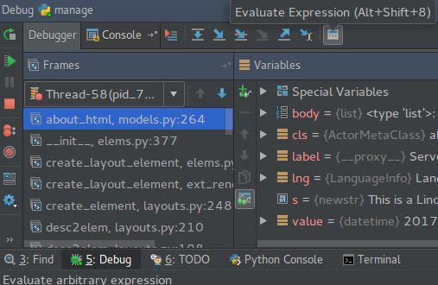
Please note that on some key-binding-sets Ctrl+U is not default, you can find out what your binding is by either hovering over the icon for evaluate expression in the debug tab (Alt-5) or in the key-bindings settings.

