Howdy All

VRChat is a great VR application (http://www.vrchat.net).  Many enthusiasts and developers meet up in there after Cymatic Bruce's Sunday afternoon stream.  This last week I've had the priviledge of working with it's creator Graham Gaylor on a new feature.  It's one of the corner stones of virtual reality and any cyberpunk offshoot... Customization.

I don't want any limit on who or what I can be in virtual reality.  I like skiing (check out http://snowdrift.jespionage.com) and so I want to look like a down hill skier. Maybe I'd even put my game's logo on my back.  I've used a bunch of character creation schemes in the past but none have the level of customization I want.  Sure, City of Heroes came close but it still had limitations imposed by the developers on what I could look like.

You might say "that sounds good Jesse, but short of a full model importer that's as good as you're going to get!", to which I would reply "Challenge Accepted!".

You now have the ability to use any existing model you like as your avatar in VRChat.

For the first version of this tool you need to have Unity Pro, or a friend with Unity Pro. Hopefully there will be enough interest to expand this feature to other formats in the future.  You'll also need somewhere to host your file so it can be downloaded by the other people who connect to VRChat who can see you.  This should be any normal web hosting environment.

Here's how you make it work...

**Building your Custom Model Package**

1. Load your model into the latest version of unity.  Make sure the import scale and settings are such that the model is the correct height in meters.  It should be about 1.5 to 2 game units tall.  1.5m is pretty short and 2.0m is pretty tall.  For most models your import scale will be 0.01.

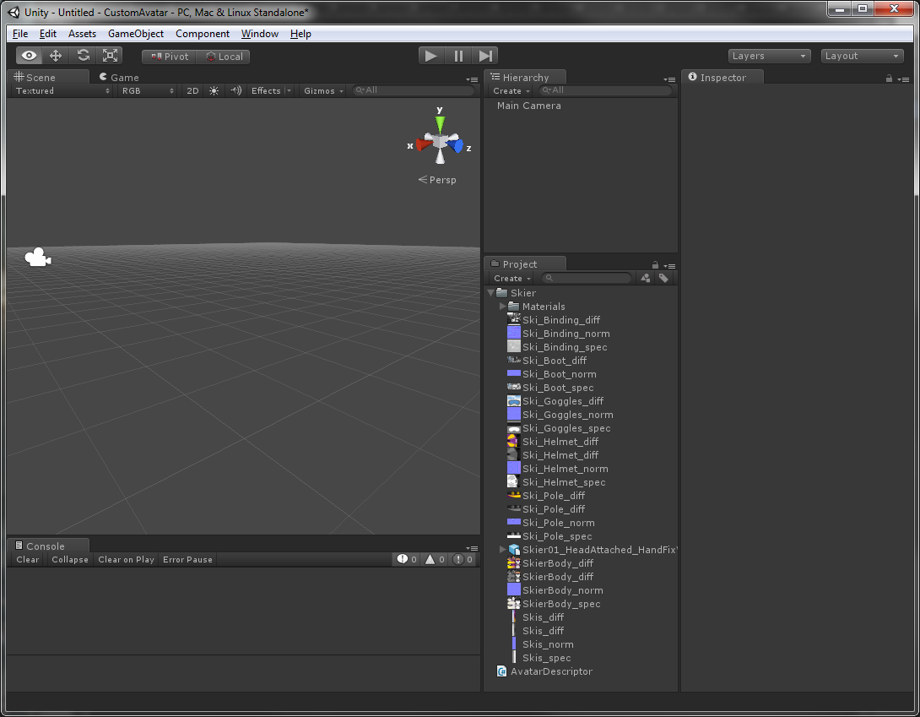

1. In your model import settings, set the rig type to "humanoid".

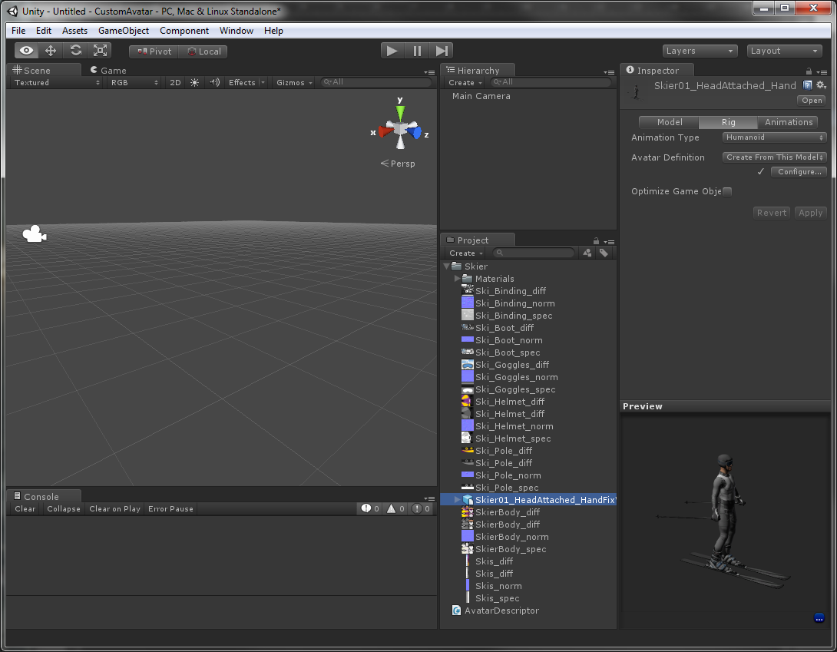

1. Instantiate your model into your scene.

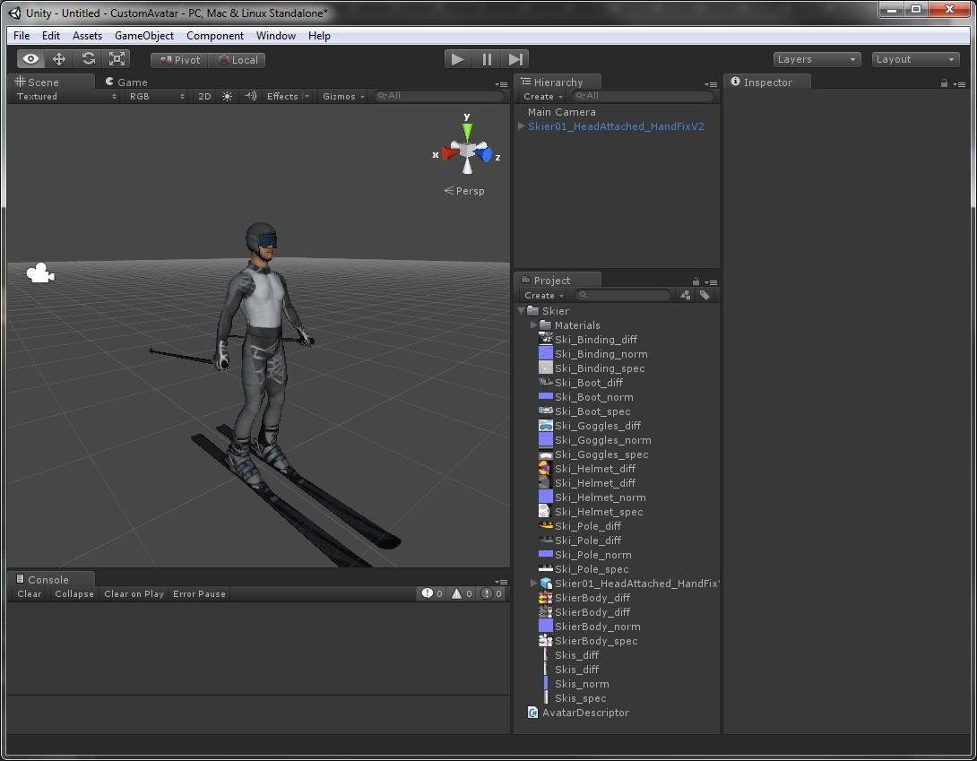

1. Add the [AvatarDescriptor.cs file included here](http://jespionage.com/avatars/AvatarDescriptor.zip)to your project (after unzipping) and drag it onto your player.

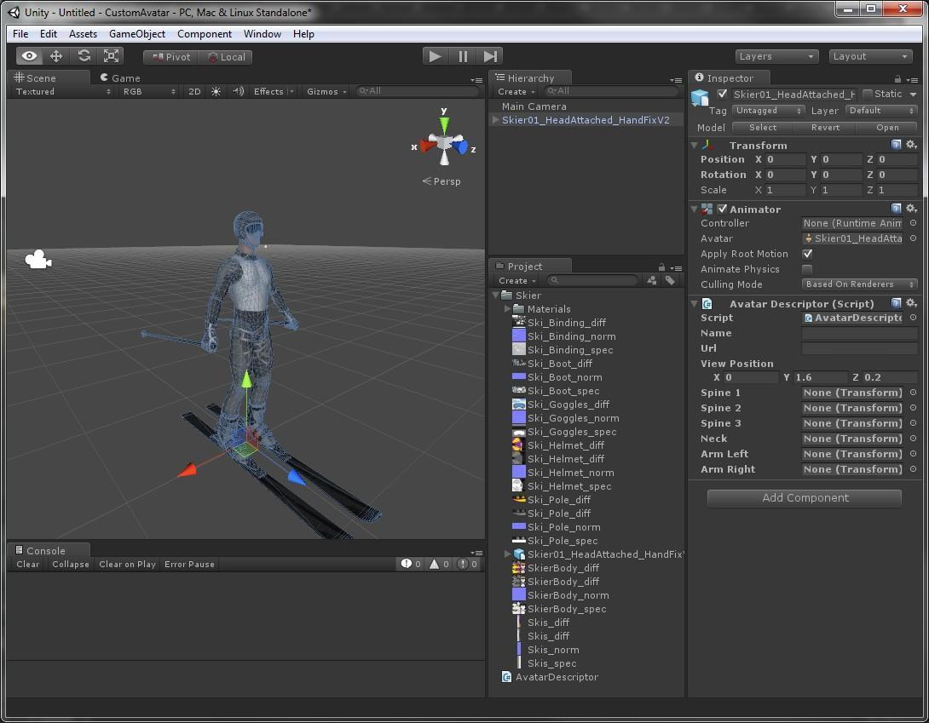

1. Change the view position field until the little sphere is hovering about 15cm in front of your model's eyes.

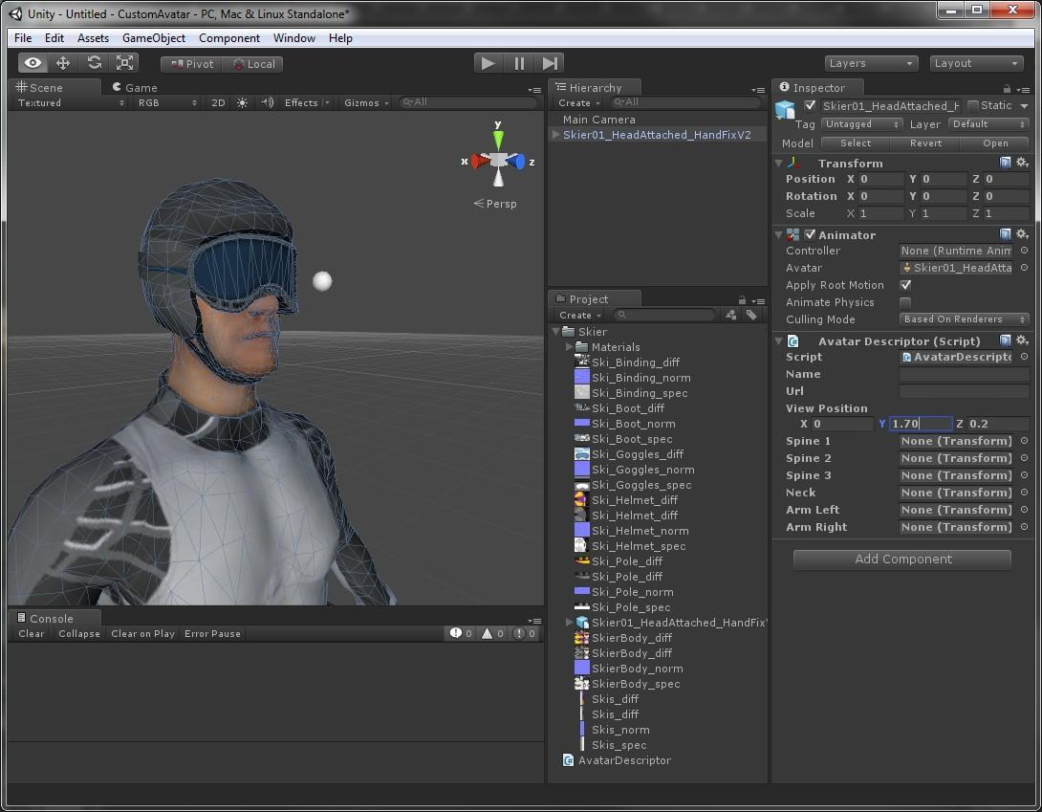

1. Now for the technical part, setting up the AvatarDescriptor object.
   1. Add three bones from your player's spine to spine 1, 2 and 3 in order from bottom to top to the Avatar Descriptor (see pic).

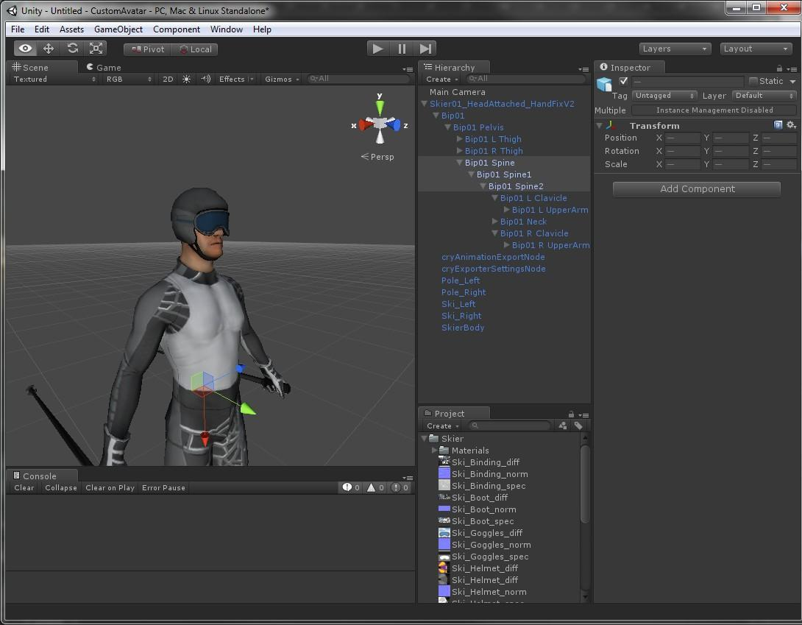

* 1. Also add the character's neck.

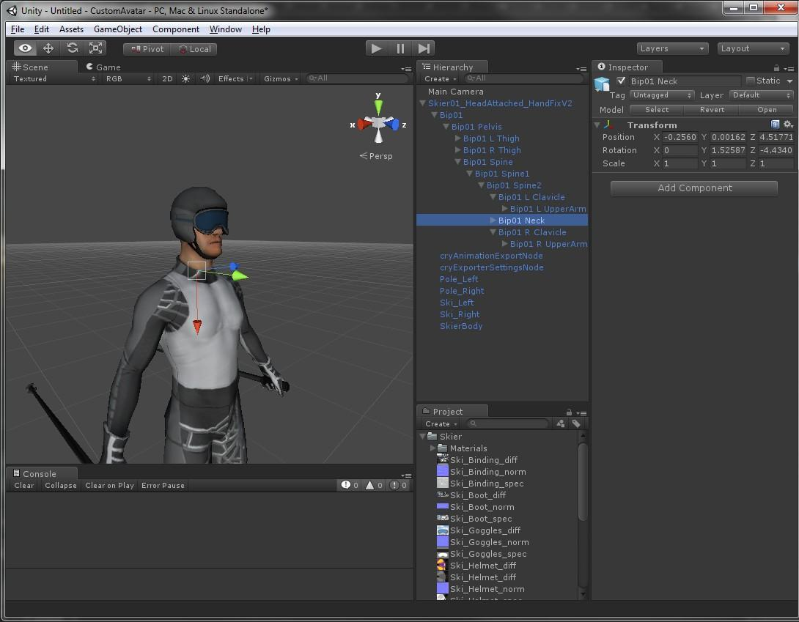

* 1. And the left and right arm.  The arms should be the bones that have a pivot at the character's shoulder.

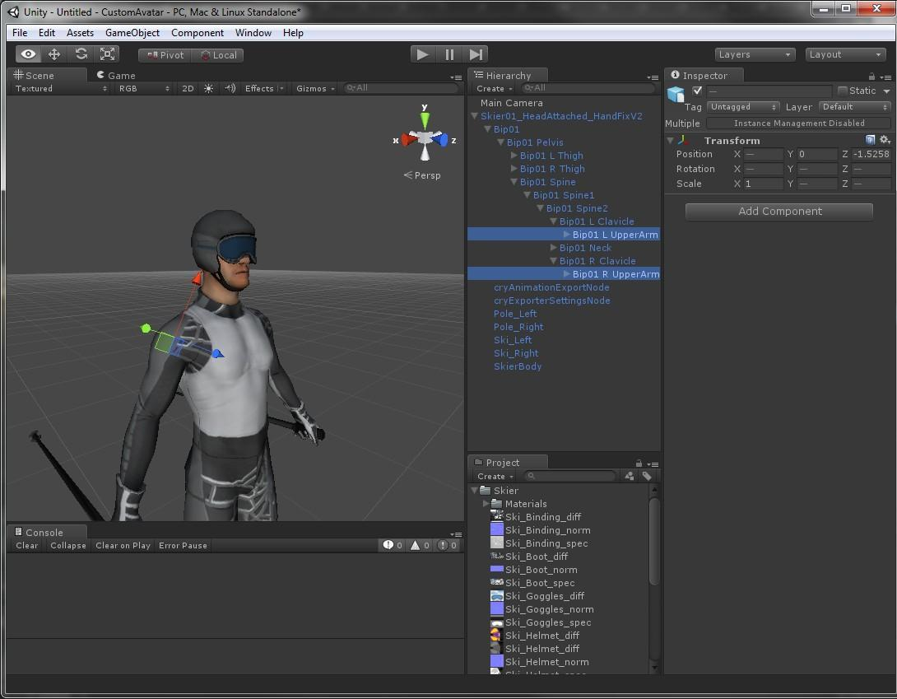

* 1. Fill in a name for your character and leave the URL blank and you're done.  Here's what the Avatar Descriptor should look like.

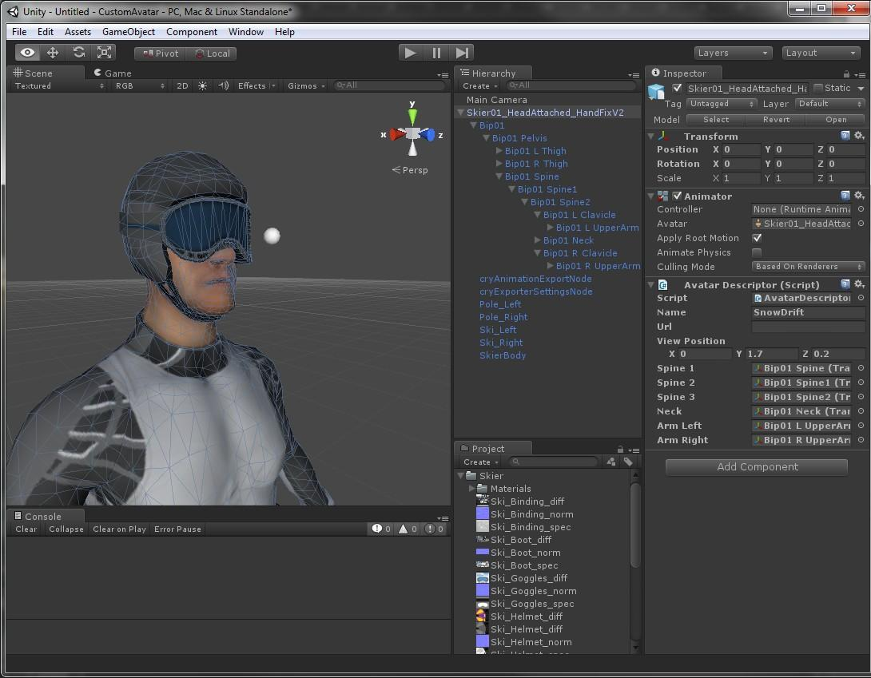

1. Create a blank prefab to hold your model, name it as you wish and drag your model (and the attached script) onto it, creating a prefab of the whole package.

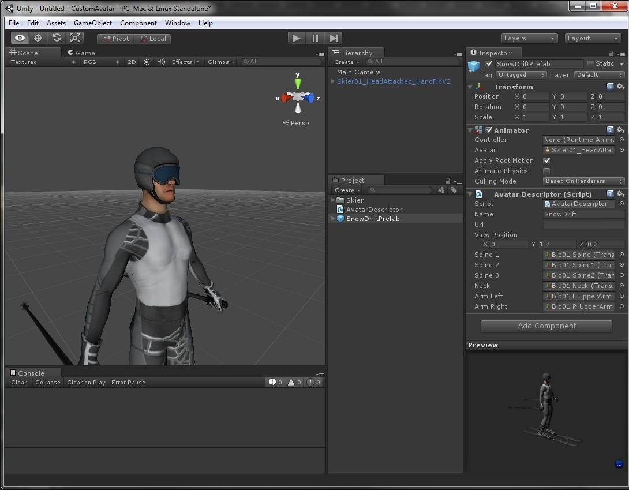

1. Select the prefab in your asset hierarchy. Select the menu item "**VRChat/Build Avatar from Selection**" and save the *.unity3d file onto your computer. Note: If you build your asset bundle in any other way, it will not work in VRChat. We do this to make sure no random asset bundle is loaded into the game.

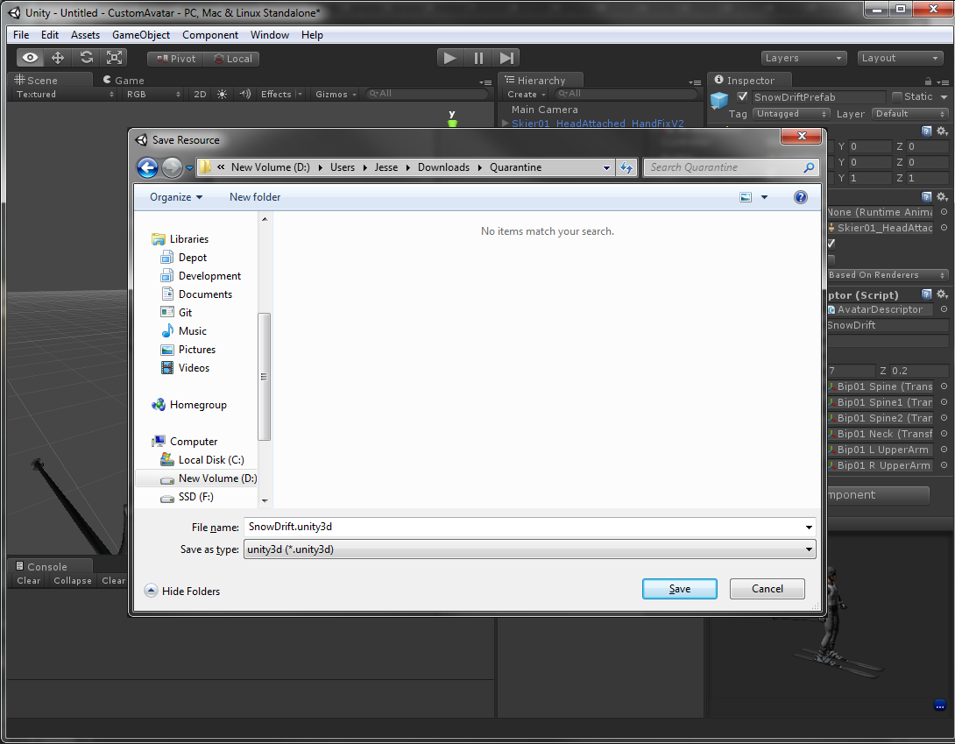

**Using your Custom Model**

1. Upload your model to a web site that's visible from the internet.
2. Copy this[crossdomain.xml file](http://jespionage.com/avatars/crossdomain.zip) into the same directory after unzipping.
3. Launch VRChat.
4. bring up the console (` key) and type "**/setavatar http://**<url>**/**<package name>**.unity3d"**
5. After a little download time you should be wearing your new avatar.
6. You may share the URL of your avatar if you'd like to make it available to other people to use.

# Custom Animations

When you create your avatar you can select in the drop down whether you want him or her to play the default male or female animation set for locomotion. But you can also do so much more.

Included in the VRChatSDK is a sample animation controller object that has a layout compatible with our internal system. It has two default variables that control the locomotion animation, MovementX and MovementZ. They control sideways and front/back motion respectively. This controller is already configured with animations supplied by unity in their sample scenes.

You can replace these animations with any animations you like and drag your fully configured animation controller onto your avatar’s Animator component. If you supply your own animation controller then VRChat will not use the default male or female animation set and will just trust that you’ve supplied all the animation you want.

# Character Physics

Seriously, just skip this section. It’s really complicated and I’m not going to explain it well. If you don’t already know a lot about this then this section won’t help.

Still here? You must be pretty bright.

Unity has a reasonably powerful physics engine. However there is a challenge when creating character physics. Some physics objects work better when they are not part of a character hierarchy and don’t inherit the characters positions and orientations.

I’m not going to explain to you how to build character physics for your model, that’s an advanced technique that is beyond the scope of this document. However I can explain how to place your physics objects into the world and out of your character's hierarchy.

Create a game object under your character and put all the physics objects into it that you wish to move into the world root then attach the VRC_PhysicsRoot script. This script will move all the objects under it to the global _PhysicsRoot object when you run the game or load your avatar.

**FAQ:**

* Can you please host my model?
  + Probably not. That would likely open us up to legal responsibilities associated with distributing this material.
* Why Unity Pro?
  + Unity pro is required to build the asset bundles that models are distributed in.
* Can't you just import my model at run-time?
  + Hopefully soon, but not yet, no.
* I can see my model on my body, but it's not animating.
  + You probably forgot to set the avatar type to humanoid, or perhaps you're not using the latest version of unity.
* I'm in the chat room but my body is invisible to other people
  + The other people in the chat may be still downloading your avatar file, or perhaps they are having problems with the link.
* My model is live and the url is correct but no-one can download it in the app.
  + Make sure you have a valid crossdomain.xml file.
* Can I make my avatar a naked man or woman?
  + Yes, but please don't. Virtual Reality is in it's early stages and we need to be accepting and tolerant of cultures, genders, sexes, races and orientations.  We're trying to grow a community and everything we do that reduces the speed of that growth will hurt us all.
* All those directions look difficult. I only understood half of it. I really want to have a custom avatar though.
  + Find someone with Unity Pro, give them a link to these instructions, your model and $10.
* Can I host my character on dropbox or google drive?
  + I haven't tested it, but I'm told that Dropbox works.
* Where can I find a model to use if I'm not an artist
  + Try http://tf3dm.com/3d-models/characters or http://3dmodel.domawe.com/ There's a wide selection there.  But let's keep it PG people.  Also some hobbyist models are just technically bad.  Try them out in the default world before you commit to using it in a chat.
* Isn't the barrier to entry kinda high?
  + Yes, for now.  Hopefully we'll be able to relax some of these restrictions in the near future.
* My avatar used to work, but now it doesn’t?!
  + Please be sure you are exporting your avatar using the “VRChat/Build Avatar from Selection” menu option.