Results:

As a first step, I wanted to closely examine the patterns of neuronal activity that emerge when the mice get reward, during a simple task that combines (?) the use in place cells., as a marker for spatial memory. For this I used previously published data (Rubin & Geva et al., 2015) and some unpublished data that was collected by Nitzan Geva from the lab, which imaged, using previously described calcium imaging routine (Rubin et al., 2015; Ziv et al., 2013), hippocampal CA1 pyramidal cells in freely behaving mice that repeatedly explored one or two familiar environments. Each session consisted of five to eight 3-min trials in one environment, and one 3-min bucket trial before and after the session. To maximize the perceived differences between the environments, Geva et al constructed linear tracks (environments A and B), at a length of 96 cm that differed in shape, floor texture, surrounding proximal and distal visual cues, odor, and flavor of the water reward at the edges of the track. The bucket trials didn’t contain any reward. The unpublished data has the same structure per session, but contains only environment A. the imaging data was processed using commercial software (Mosaic, version 1.1.1b, Inscopix) and custom MATLAB routines into vectors of activity for each neuron, which specify the peak of every calcium event, and the location and velocity of the mice on the track in every frame.

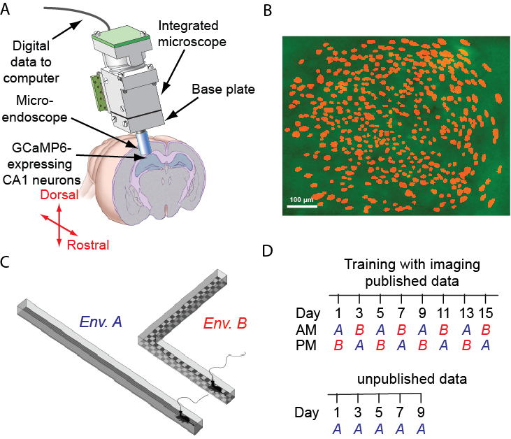

In order to find a possible pattern of neuronal activation, to be used as a feedback for the memory based BMI, I looked at the neuronal activity at rest epochs, where the mice get a reward .previous work has shown that temporal spike sequences from hippocampal place cells recurred at rest epochs in reverse or forward order(Diba and Buzsáki, 2007; Pfeiffer and Foster, 2013). Inspired by that work, I wanted to see; to what extent the activity at the edges represents the activity during the run epochs. To do so, I divided each trial to segments of run and rest epochs, according to the mice place on the track; the frames on which the mice were up to 16 cm far from each of the edges of the track were defined as rest epochs, while rest of the frames were defined as run epochs. . I then analyzed separately the epochs in which the mouse was at the edges with respect to either the running epoch that came before or the one that after the rest epoch. Then we calculated for each neuron the conditional probability to be active at the rest epoch given the activity in the run epoch (active\not active) for each 15-minute session. To test the difference between the two conditional probabilities, we conducted a matched T-test for each session, and calculated the effect size of the difference between them. As seen in fig. 2A, for most of the sessions that were conducted on an environment A (n=X out of Y sessions from 9 mice), the activity during run epoch was not significantly associated with the activity during rest epoch before\after the run. Also, the effect size is smaller than 0.4 SD for both cases (fig 2B). For environment B we see that many sessions (n=X out of Y sessions from 4 mice) show significantly higher probability to be active at edge given lack of activity during run epoch (fig 2C, D). This analysis suggest that the activity at the edge is mainly unique to those bins, and may be related to the reward itself or to the representation of the edges of the track, rather than reflecting a forward or reverse replay activity.

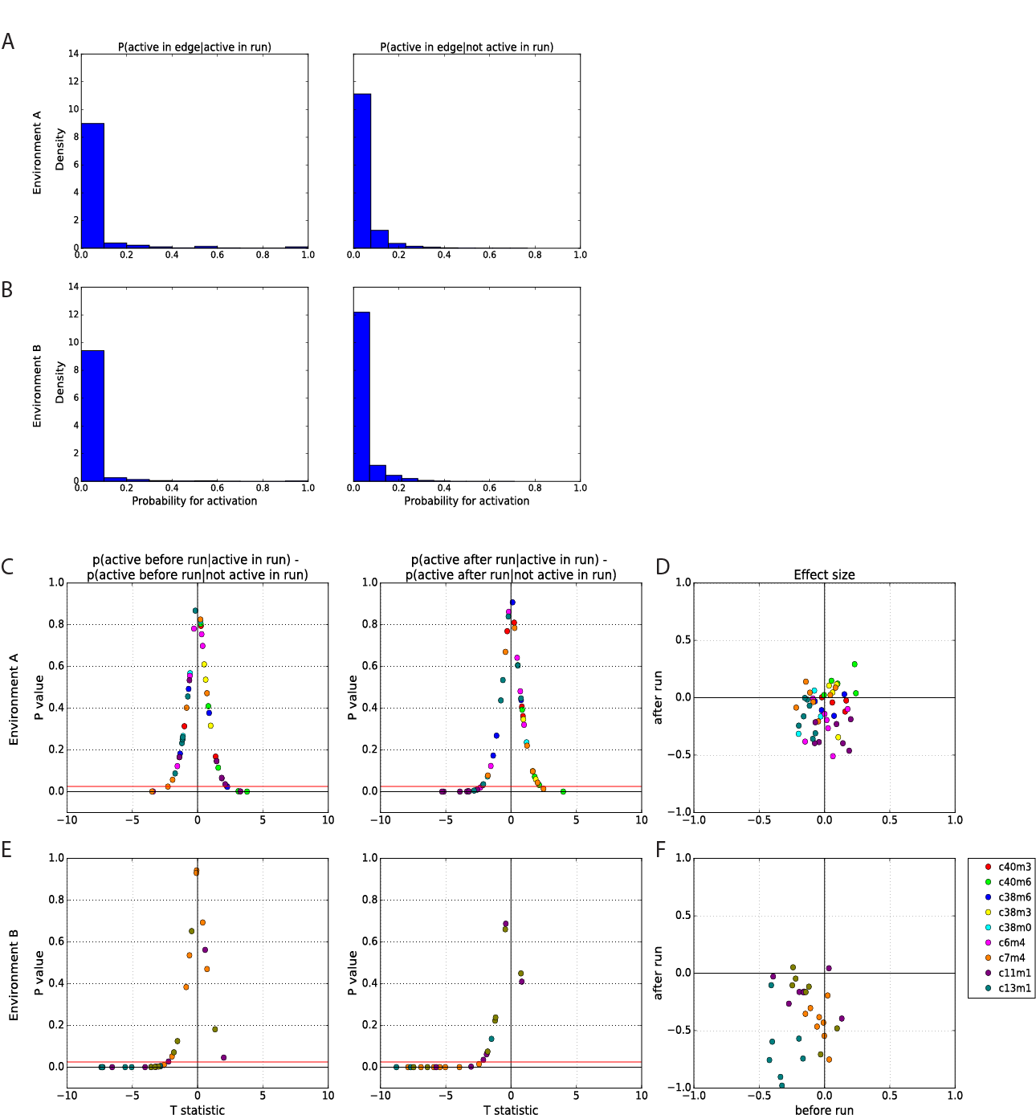

Another approach to investigate the neuronal activity at rest epochs is based on synchronous calcium events (SCE), as described in previous calcium imaging experiments on head fixed mice using two photon microscopy (Malvache et al., 2016). These SCEs are significant peaks of synchronous neuronal activity during immobility periods. Malavache et al found that sequences that appeared when mice were running on a cue-less treadmill were reactivated during SCEs. I wanted to find whether SCEs in one photon data from freely behaving mice show the same pattern of activation. At each rest epoch I counted the number of events in a sliding time window at a length of 200 ms. Time windows that had number of events above chance level (which I calculated by shuffling in time the activity for each session separately) were labeled as SCE. I then looked for the shared neurons that were active both in SCE and the following run (fig 2 D-E as positive example), and found that each SCE had only few to none of these (Fig 2c). This further suggested that the majority of activity seen at the edges don’t carry information about the run epochs, and may be informative about the reward.

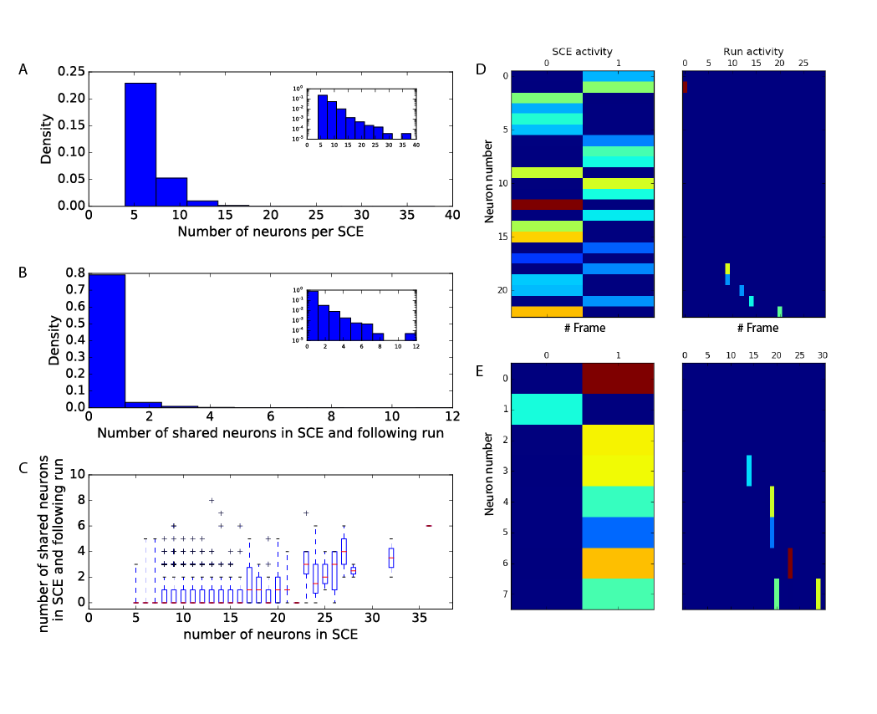

The next step was to see if I can detect this edge activity on another environment which isn’t linked with the reward (off-context), in purpose of condition this activity with reward given by the memory based BMI. This could further prove that the BMI is indeed based on memory representation of the reward, since the mice would activate it off-context to get it. For this I used a memory-less maximum likelihood estimation decoder. First, the location of the track was binned into 8 cm bins and the activity of place cells from all trials in both environments on the same day, was used to calculate the [joint probability function](https://en.wikipedia.org/wiki/Probability_density_function#Densities_associated_with_multiple_variables) for all bins observations, assuming that the neurons activity is independent:



Where  is the activity of the i'th neuron, either 1 for active neuron or 0 for not active. Is the bin number, which varies from 0 to 11, and  is the environment type; A or B. Then, for each frame in the test trial, I maximize the log-likelihood function to estimate the bin and environment of the activity vector:



One can see in figure 3A the performance of the decoder on the linear track itself, where on each session one trial was left out from the calculation of the joint probability function and was tested later.

I then tested the decoder on the bucket trials, which proximate to either of the environments. To see to what extent the bucket trial’s activity tells us about the environment it is proximate to, I calculated the fraction of frames which their estimation of environment matched to the proximate one (Fig 3B), it was significantly higher then chance level in both environments. In addition I calculated the distribution of the estimated bins in the bucket, compared to the natural distribution of their occupancy on the linear tracks (fig 3E-F). I found that the representation of the edges is significantly higher than their natural occupancy (Kolmogorov-Smirnov test, p ≈ 0). This means that I can condition this representation off-context with water reward given by the memory based BMI. Furthermore, the frames that were estimated as edge bins were frames with mean positive activity of one neuron in them (Fig 3C-D). I could therefore give up the use of maximum likelihood estimation on real-time decoding, and use much simpler approach to save feedback time.