**Homework 8: Social Network**

In lectures 8-2 and 9-1 we began discussing *Object Oriented Programming*, introducing a new terminology and many new concepts. This exercise practices everything that was discussed in these lectures, and more. After completing it, you will have a solid grasp of object-oriented programming. The exercise implements a social network, using a more realistic architecture than the one used in the midterm exam.

**Users**

Each user in the network is represented as an instance of a User class. The User class has three *fields*: the user’s name (a string), a follows array, representing a maximal number of names that the user can follow (each name is a string), and fCount, an int variable that stores the *actual* number of names that the user follows. Below are examples of two typical User objects:

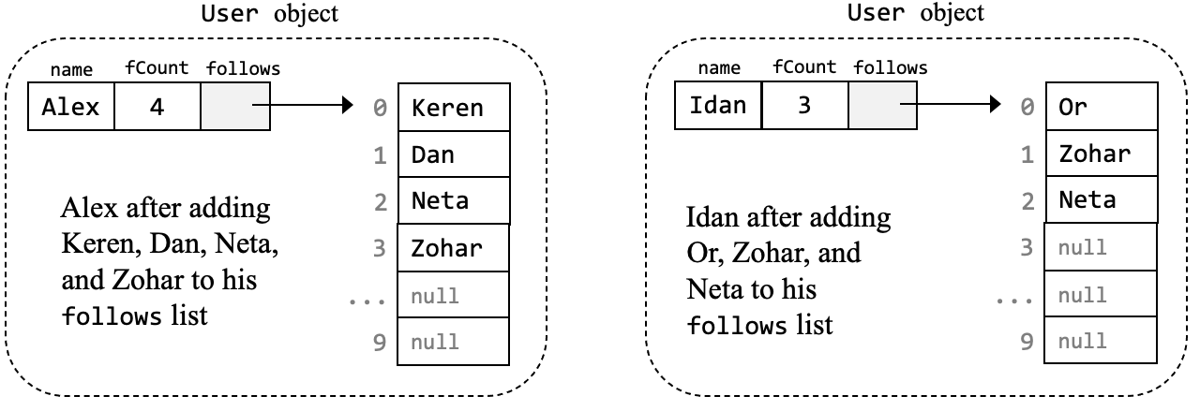

Because arrays have a fixed size, we must decide in advance how many names each user can potentially follow. In this example we decide that maxfCount is 10, implying that each user can potentially follow at most 10 names. Here is the beginning of the User class declaration, specifying how User objects are represented, and how they are constructed:

/** Represents a user in a social network. A user is characterized by a name, a list of

* user names that the user follows, and the list's size. */

public class **User {**

// Maximum number of users that a user can follow

static int maxfCount = 10;

private String name; // name of this user

private String[] follows; // array of user names that this user follows

private int fCount; // actual number of followees (must be <= maxfCount)

/** Creates a user with an empty list of followees. */

public User(String name) {

this.name = name;

follows = new String[maxfCount]; // fixed-size array for storing followees

fCount = 0; // initial number of followees

}

// More User methods come here...

} // End of the User class declaration

The requirement that each user follows at most 10 names sounds like an arbitrary and inflexible restriction. Indeed it is, and soon in the course we will learn how to overcome this limitation.

Back to our network architecture: To add a new user to the network, we construct a new User object. According to the rules of the game, the new object will include a fixed-sized array of 10 strings. Each element in the array will be automatically initialized (by Java) to the value null. The new User object will also include the number of names that the user *actually* follows, which is initialized to 0. Notice that name, fCount, and follows are all *fields*, also known as *private variables* (the fact that one of these fields is an array is not a problem at all).

Below is the client code that created the two users shown in the previous page:

// Creates a new User

User alex = new User("Alex");

System.out.println(alex); // Outputs: Alex ->

// Adds followees (names that the user follows)

alex.addFollowee("Keren");

alex.addFollowee("Dan");

alex.addFollowee("Neta");

alex.addFollowee("Zohar");

System.out.println(alex); // Outputs: Alex -> Keren Dan Neta Zohar

// Creates a new User

User idan = new User("Idan");

System.out.println(idan); // Outputs: Idan ->

// Adds followees

alex.addFollowee("Or");

alex.addFollowee("Zohar");

alex.addFollowee("Neta");

System.out.println(alex); // Outputs: Idan -> Or Zohar Neta

...

**The toString() method** that produced the outputs shown above is part of the User class. Here is the code of this method, which is given:

/** Returns this user's name, and the names that s/he follows (part of the **User** class). */

public String toString() {

String ans = name + " -> ";

for (int i = 0; i < fCount; i++) {

ans = ans + follows[i] + " ";

}

return ans;

}

**Adding and removing followees:** What happens when a user decides to start, or stop, following another user? To add a new followee, we store the followee’s name in the next available element in the follows array. Importantly, we also have to remember to do fCount++. As a result of this storage strategy, the names of the followees are always stored one after the other, forming a contiguous block within the array. How to remove a name from the user’s follows list? In that case we move all the array elements below this name one position “up”. And, we must remember doing fCount--. The top of the next page depicts this technique.

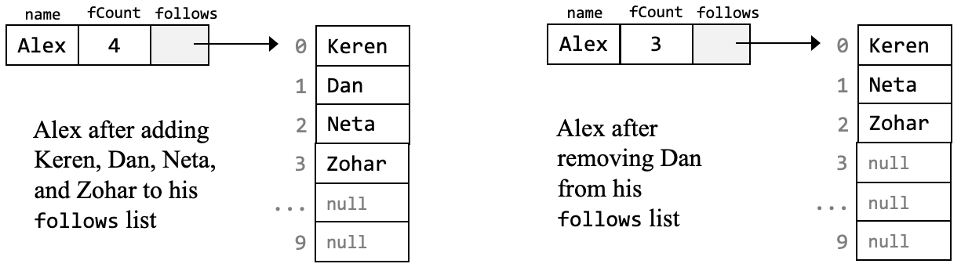

Notice, once again, that the names of the followees must always form a contiguous block within the follows array. That’s why we have to work hard to “close the gap” whenever a name is removed from the list.

**Implementing the User class**

The skeletal User class is given, along with a complete UserTest class that tests it. Start by reviewing the code of the User class, following the guidelines below.

**The User(String,boolean) constructor:** This overloaded constructor creates a user and then fills its follows list with a few dummy names. This constructor is mostly useless, having one purpose only: Allowing testing the toString and follows methods before implementing anything else. Read and understand the constructor’s code. Constructor overloading and the this() call are explained in Lecture 9-1, slide 30.

**getName, getFollows, getCount**: The code of these trivial getter methods is given, so there is no need to implement them. These getter methods are not used at all in the User class, so for now you can ignore them.

**Getting started:** Read the UserTest class code, up to, and not including, the “serious testing” part. Then compile the User class and the UserTest class, and execute UserTest. Notice that at this stage, only the beginning of the test makes sense; The “serious testing” produces mostly empty results, since it calls skeletal methods that do nothing.

**The toString()** method is the first method called by the UserTest class (it is called implicitly, when the statement System.out.println(dummy) is executed). Read and understand the UserTest code that creates and prints the dummy user. The toString method is given, so you don’t have to implement it.

**Comparing strings:** To check if two string objects have the same contents, use the boolean method call str1.equals(str2). This general practice must be used whenever you have to check the equality of two strings, throughout this exercise, and other exercises.

**Implement the User class methods,** in the order in which they appear below.

**follows**: This method searches a given string in an array of string values. It’s a relatively simple method, so it’s a good way to get you started. Implementation tips:(1) Suppose that arr is an array of String values. Following the advice just given: To compare the array’s i-th element to some string str, use the method call arr[i].equals(str). (2) The fact that the method name (follows) is the same as the name of the searched array (follows) is meaningless. It simply makes things more readable. (3) Read the beginning of the UserTest class and understand the code that creates the dummy user and tests the toString and follows methods.

**addFollowee**: The method’s operation is described in its API documentation. In addition to the documented actions, the method displays relevant feedback messages, which are important for debugging purposes. These messages are not documented; To figure out what to print after each action, see the relevant outputs of the UserTest class. Implementation tip: In general, we cannot allow following “names” (arbitrary strings). Rather, we must first verify that the network includes users that have such names. We will worry about this later, when we implement the Network class. For now, don’t worry about these validity tests, and happily add any given name.

**removeFollowee**: Everything that was said above about addFollowee is also applicable to this method. The main difference is that here we have to implement the “closing the gap” logic described earlier. Implementation tips: (1) Don’t use the follows method; you will end up iterating the array twice, which makes no sense. Instead, use a single loop to search the follows array; when you’ll reach the name that has to be removed, you will also have the i-th location at which the “closing the gap” logic must start. (2) After ending the “closing the gap” logic, set the array element that is no longer relevant to null. For example, in the figure shown above, notice that after closing the gap, follows[3] was set to null. In general: When an object (and strings are objects) is no longer needed, set the variable that refers (points) to it to null.

**countMutual**, **isFriendOf**: These methods are self-descriptive. Read their documentation, read carefully and understand the UserTest code that tests them, and implement them.

* * *

The homework description continues on the next page

**Network**

A social network consists of users who follow each other. In the midterm exam we described these relationships using a matrix. In this exercise we use a more realistic architecture. Here is an example of a social network that uses this architecture:

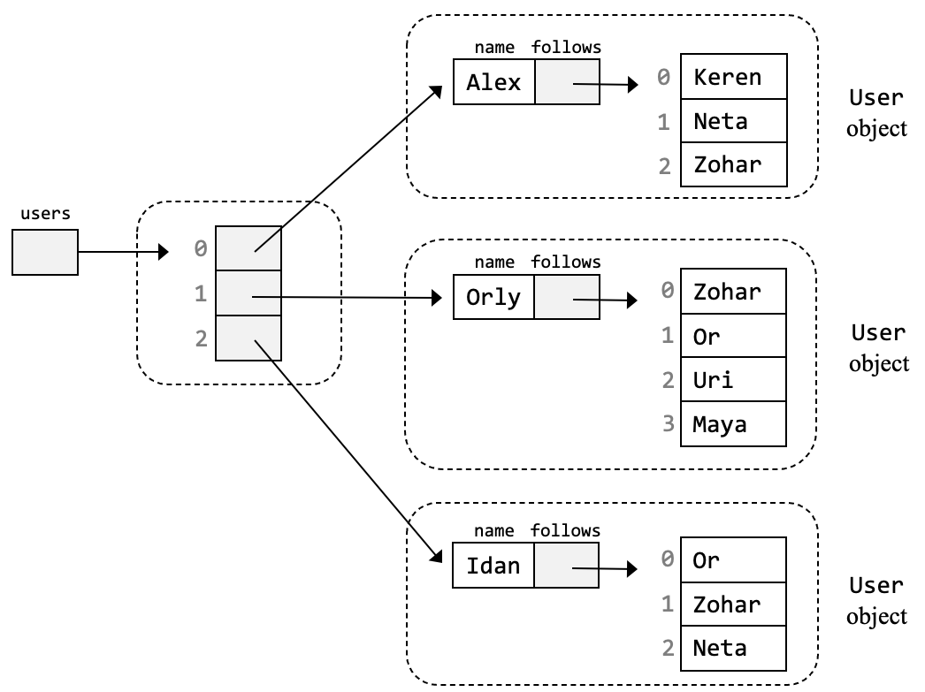

To create such a network, we use the following client code:

// Creates a network with a maximum capacity of 1000 users

Network net = new Network(1000);

// Adds Users and follows relationships

net.addUser("Alex");

net.addUser("Orly");

net.addUser("Idan");

net.addUser("Keren");

net.addUser("Neta");

...

net.addFollowee("Alex", "Keren");

net.addFollowee("Alex", "Neta");

net.addFollowee("Alex", "Zohar");

net.addFollowee("Orly", "Zohar");

...

**The Network fields and constructors**: The users list of this network is implemented similarly to the follows arrays implementation, with one difference: Instead of fixing the array size for all possible social networks, we allow the code that creates a new network to determine the maximal number of users in the network. This logic is implemented by the Network constructors. Similarly to the User class, we provide a constructor for creating a dummy network. This constructor is used only for testing purposes.

**Implementing the Network class**

**Getting started:** The skeletal Network class is given, along with a complete NetworkTest class that tests it. Start by reviewing the code of these classes. Then compile the two classes, and execute NetworkTest. At this stage the tests will produce mostly empty results, since they call skeletal methods that do nothing.

**The toString()** method is the first method called by the NetworkTest. Read the code that creates and prints the dummy network, and understand it. Then implement the toString method. Since the users in the dummy network follow no one, expect to see this output:

Network:

Foo ->

Bar ->

Baz ->

Tip: In the implementation of the toString() method of the Network class, have each user print itself. This is the spirit of object-oriented programming: Objects should take care of themselves.

**Implement the rest of the Network class methods**, in the order in which they appear below.

**getUser**: Read the beginning of the NetworkTest class, and understand the code that tests the getUser method (the “ternary if” used in this test is explained in Lecture 2-1, slide 14). Implementation tip: The logic of this method is similar to that of the User class’s follows method, with one major difference: follows returns a boolean value; getUser returns a User object, or null.

**addUser**: The logic of this method is similar to that of the User class’s addFollowee method.

**addFollowee**: This method gets two parameters: name1 and name2. Implementation tips: Call the User class’s addFollowee(name2) on the user whose name is name1. Notice that at least three things can go wrong: name1 is not a user in this network, name2 is not a user in this network, or trying to make the former follow the latter fails.

**recommendWhoToFollow**: This method iterates through all the users in the network, searching for a most recommended user to follow. Implementation tips: (1) Since we have to return a User object, you can get started with a statement like User mostRecommendedUserToFollow = null;  
(2) The method processes each user in the network, except for the user on which it was called. The processing of this user must be skipped. How to skip an iteration in a loop? One way to do it is using Java’s continue statement. This statement is [described here](https://docs.oracle.com/javase/tutorial/java/nutsandbolts/branch.html#:~:text=The%20continue%20statement%20skips%20the,of%20the%20letter%20%22p%22.), along with a nice usage example.

**mostPopularUser**: Implementation tip: Start by implementing and testing the helper method followeeCount. Then use it for implementing the mostPopularUser method.

**Endnote**

If this homework assignment will make you sick each time you see a social network again, then, Mazal Tov. There are better things to do in life than following social networks, like climbing mountains and reading books.