# Exercise 1: CT Reconstruction

### Overview

In this assignment you will explore the basic principles of image reconstruction in computed tomography (CT), in particular filtered back projection and iterative reconstruction. You will use functions to convert an image into radon space and create a sinogram, a synthetic projection per radon or fanbeam (corresponding to parallel or fanbeam geometry respectively). Then utilizing those synthetic projections, you will reconstruct the original image.

### What to hand in for this assignment:

Submit your notebook solutions (code)+ written explanations/ descriptions in word/pdf.

### References

<https://www.youtube.com/watch?v=rKh_XIpsuc4> : General   
<https://www.youtube.com/watch?v=q7Rt_OY_7tU>: Sinogram

<https://www.youtube.com/watch?v=MA2y_2YySq0&t=3s>: Radon Transform  
<https://www.youtube.com/watch?v=pZ7JlXagT0w> : FBP  
<https://www.youtube.com/watch?v=r5ZIzog2JlE>

<https://www.youtube.com/watch?v=gu0lcxdFO1Q>: Algebraic reconstruction

<https://www.youtube.com/watch?v=moWou9zNl1w>: SIRT

<https://www.youtube.com/watch?v=YIvTpW3IevI>: Fourier Slice Theorem

### Steps :

Step 1:

Create a head phantom or use the Shepp-Logan head phantom. The bright ellipse corresponds to the skull and the structures inside correspond to the various brain tissues and lesions. Calculate the synthetic projection using radon transform (parallel beam geometry) for the head phantom and the geometric images and explain your results.

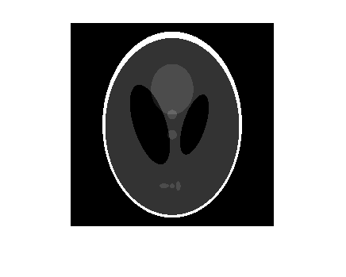

Step 2:

Vary the number of projection angles (18,24,90,... ) and perform a reconstruction for each angle increment. Explain the effect of varying the angles.

Step 3: Demonstrate the difference of performing back projection and filtered back projection.

Step 4: Apply & describe an algebraic iterative reconstruction technique such as SIRT/ CGLS/ another.

Good luck on Exercise 1!