Matplotlib Assignment

Q1 Name the library of which the pyplot is an interface

Q2 Write the function to show the legends on a plot.

Q3. Write the output of the following python code

import matplotlib.pyplot as plt

months =['jan','feb','march','april']

attendance =[70,80,75,95]

plt.plot(months,attendance)

plt.show()

Q4. Write commands to add title for x-axis and y-axis.

Q5 Write commands to add grid and chart title of the above chart

Q6. Write python code to produce line chart for the following data ( use grid, title, legend, color and marker )

|  |  |  |  |  |  |
| --- | --- | --- | --- | --- | --- |
| **Student name** | **English** | **Business** | **IP** | **Accounts** | **Eco** |
| Prashant | 80 | 89 | 78 | 57 | 56 |
| Mukul Rai | 56 | 67 | 89 | 57 | 86 |
| Tanush | 78 | 67 | 78 | 57 | 56 |

Q7 Write Python commands to produce the following graph

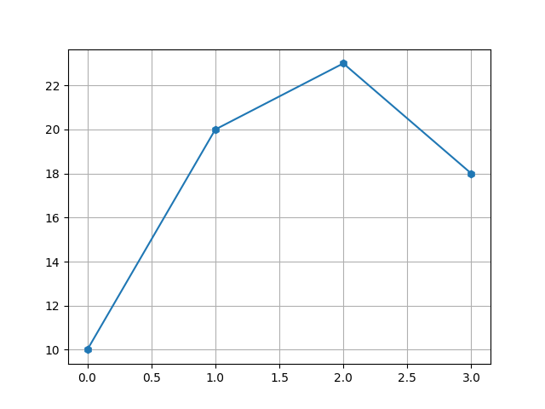

Q8 Create a bar chart for the following data

Student names =[‘prashant’,’tanush’,’khushi’,’prakhar’,’oieshik’]

Marks obtained in Ip =[45,67,78,34,67]

Also provide title, labels, grid and color to each bar.

Q9. Write python code to produce Bar chart for the following data ( use grid, title, legend, color)

|  |  |  |  |  |  |
| --- | --- | --- | --- | --- | --- |
| **Student name** | **English** | **Business** | **IP** | **Accounts** | **Eco** |
| Prashant | 80 | 89 | 78 | 57 | 56 |
| Mukul Rai | 56 | 67 | 89 | 57 | 86 |
| Tanush | 78 | 67 | 78 | 57 | 56 |