数据处理代码与流程
> CIC-IDS2017 的处理是六阶段审计：每一步都有实现代码、输入输出与发布证据，原始 2 830 743 行最终落到研究总体。本表同时给出流程截图、运行记录截图与关键代码摘录；所有计数取自 results_data_audit_cic_natural_v3b/data_processing_audit.json。

一、流程与运行记录（截图）
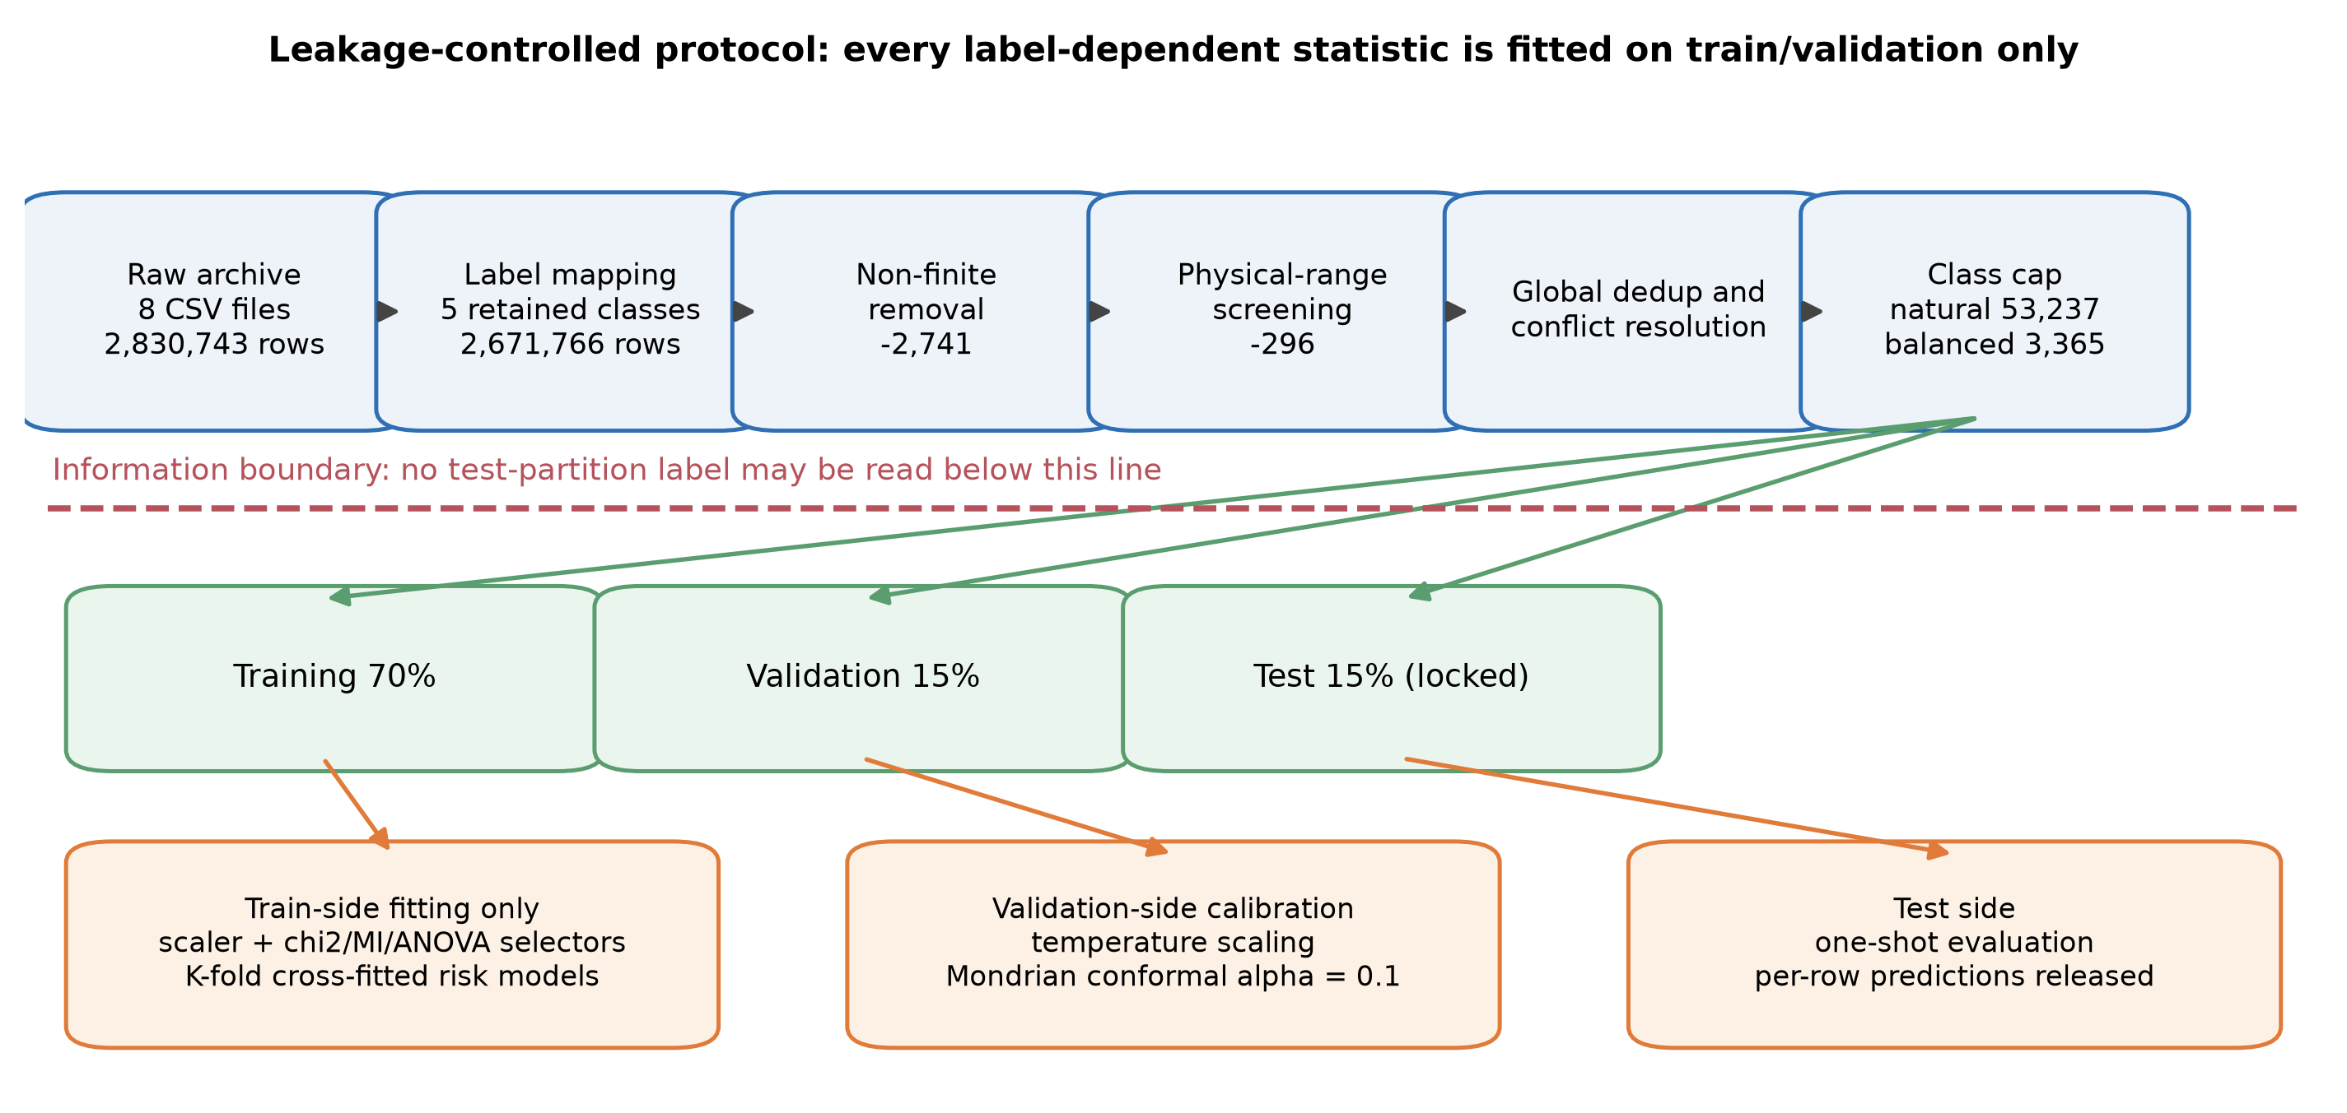
图 1 协议流水线（正文图 1）
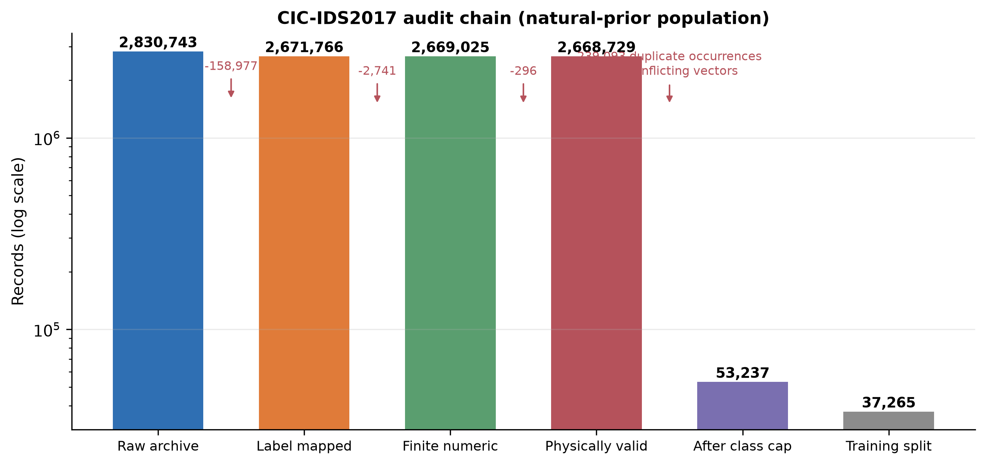
图 2 数据瀑布：从原始文件到研究总体（正文图 2）
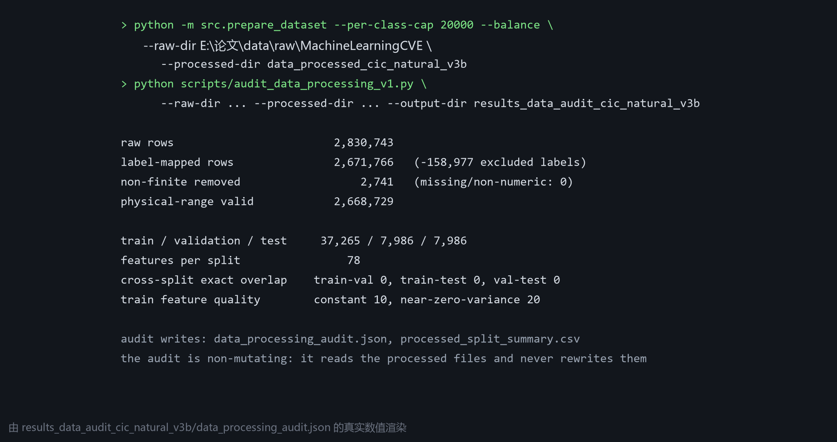
图 3 本次处理与审计的运行记录（由真实审计输出渲染）

二、阶段 → 代码 → 证据
阶段 | 实现 | 输入 → 输出 | 发布证据
S1 标签映射 | src/data_pipeline.py · map_attack_label | 2,830,743 → 2,671,766（排除 158,977 条非保留标签） | S02、表 3、data_processing_audit.json
S2 非有限值清理 | src/prepare_dataset.py · collect_balanced_sample | 移除 2,741 条（缺失 0 条） | 同上
S3 物理范围筛查 | src/data_pipeline.py · cic_physical_valid_mask | 保留 2,668,729 条（时长/速率/长度/段大小不可为负） | 同上
S4 全局去重 | src/prepare_dataset.py（前向/反向双哈希指纹） | 精确重复行在划分前全局剔除，审计见 dedup_audit.json | S21（近重复审计）
S5 分层划分 | src/prepare_dataset.py · prepare_dataset | 70/15/15 分层：37,265 / 7,986 / 7,986；跨划分精确特征重叠 0 | S03、S05、表 3
S6 训练侧特征选择 | src/feature_selection.py | 仅在训练侧拟合卡方/互信息/ANOVA，取前 60 维；其余视图保留全特征 | S04、图 3
审计 | scripts/audit_data_processing_v1.py | 只读地重算每一阶段，写出审计 JSON 与划分汇总 | results_data_audit_*、S02/S03

三、代码清单（SHA-256 前 12 位，生成时计算）
文件 | 大小 | SHA-256 | 作用
src/data_pipeline.py | 3.4 KB | a158b6744d33 | 标签映射与物理范围掩码
src/prepare_dataset.py | 12.8 KB | ac5c2ea3c075 | 分块读取、去重、按类上限、平衡与分层划分
src/feature_selection.py | 3.5 KB | dd48bd452ce1 | 训练侧特征选择（卡方 / 互信息 / ANOVA）
scripts/audit_data_processing_v1.py | 7.7 KB | c98952971ea1 | 非改写式处理审计与阶段计数
scripts/hash_external_data.py | 0.7 KB | 33fd889ddc12 | 外部数据集校验和记录
scripts/check_audit_chain_numbers_v1.py | 4.1 KB | ca4d8e81ff7c | 阶段计数与正文数字的一致性检查

> 数据获取本身不是脚本：四个语料由人工从公开来源下载，URL、检索日期、快照与校验和记录在 S01 与《数据与资料来源总表》，再由上述代码处理。

四、关键代码摘录（摘自当前仓库）
S1 · 标签映射（src/data_pipeline.py）
def map_attack_label(label: object, include_other: bool = False) -> Optional[str]:
"""Map a raw CIC-IDS2017 label to the paper's class scheme.

The source CSVs contain leading spaces and, in some encodings, a replacement
character in the en-dash used by Web Attack labels. Matching is therefore
intentionally based on normalized lowercase substrings.
"""
if label is None or (isinstance(label, float) and np.isnan(label)):
return None
raw = str(label).strip()
key = raw.lower().replace("–", "-").replace("—", "-")

if key == "benign":
return "Normal"
if key == "bot":
return "Bot"
if key == "ddos" or key.startswith("dos ") or key.startswith("dos-"):
return "DoS/DDoS"
if key in {"ftp-patator", "ssh-patator"}:
return "Brute Force"
if "web attack" in key and "brute" in key:
return "Brute Force"

S3 · 物理范围掩码（src/data_pipeline.py）
def cic_physical_valid_mask(frame: pd.DataFrame):
"""Return a conservative physical-range mask for CICFlowMeter fields.

The CIC files contain a small number of malformed negative values. The
two TCP initial-window fields legitimately use ``-1`` as an unavailable
value, so that sentinel is retained; other duration, rate, length and
header fields must be non-negative. Missing columns are ignored to keep
the helper usable with reduced test fixtures.
"""
rules = {
"Flow Duration": 0.0,
"Total Fwd Packets": 0.0,
"Total Backward Packets": 0.0,
"Total Length of Fwd Packets": 0.0,
"Total Length of Bwd Packets": 0.0,
"Flow Bytes/s": 0.0,
"Flow Packets/s": 0.0,
"Flow IAT Mean": 0.0,

S4 · 去重指纹与按类上限（src/prepare_dataset.py）
# removed before model CSVs are written and never enter features.
numeric["_source_file"] = path.name
numeric["_source_path"] = str(path.relative_to(raw_dir))
numeric["_source_row_id"] = source_row_ids
numeric["_source_label"] = source_labels
kept_hashes = [row_hashes[i] for i, keep_row in enumerate(unique_mask) if keep_row]
numeric["_dedup_hash_forward"] = [int(item[0]) for item in kept_hashes]
numeric["_dedup_hash_reverse"] = [int(item[1]) for item in kept_hashes]
for label in numeric["target"].unique():
group = numeric.loc[numeric["target"] == label].copy()
buckets.setdefault(label, []).append(group)
audit["unique_rows_before_conflict"] = int(len(seen_hashes))
audit["conflicting_feature_hash_count"] = int(len(conflict_hashes))
audit["rows_in_conflicting_groups"] = int(sum(hash_row_counts[key] for key in conflict_hashes))
audit["unique_rows_removed_for_conflicts"] = int(len(conflict_hashes))
audit["cross_label_conflict_hashes"] = int(len(conflict_hashes))

S5 · 分层划分与产物写出（src/prepare_dataset.py）
def prepare_dataset(raw_dir: Path, processed_dir: Path, config: dict):
frame, features, audit = collect_balanced_sample(raw_dir, **config)
provenance_cols = ["_source_file", "_source_path", "_source_row_id", "_source_label"]
train, temp = train_test_split(frame, test_size=0.30, stratify=frame["target"], random_state=config["seed"])
valid, test = train_test_split(temp, test_size=0.50, stratify=temp["target"], random_state=config["seed"])
processed_dir.mkdir(parents=True, exist_ok=True)
for split_name, split_frame in [("train", train), ("validation", valid), ("test", test)]:
split_frame.reset_index(drop=True)[["target", *provenance_cols]].assign(processed_row_id=lambda d: np.arange(len(d))).to_csv(processed_dir / f"{split_name}_source_provenance.csv", index=False, encoding="utf-8-sig")
train = train.drop(columns=provenance_cols)
valid = valid.drop(columns=provenance_cols)
test = test.drop(columns=provenance_cols)
train.to_csv(processed_dir / "train.csv", index=False, encoding="utf-8-sig")
valid.to_csv(processed_dir / "validation.csv", index=False, encoding="utf-8-sig")
test.to_csv(processed_dir / "test.csv", index=False, encoding="utf-8-sig")
mapping = {
"Normal": ["BENIGN"],
"DoS/DDoS": ["DDoS", "DoS ..."],
"Brute Force": ["FTP-Patator", "SSH-Patator", "Web Attack ... Brute Force"],
"Web Attack": ["Web Attack ... XSS", "Web Attack ... Sql Injection"],
"Bot": ["Bot"],
"excluded_main": ["PortScan", "Infiltration", "Heartbleed"],
}

审计入口（scripts/audit_data_processing_v1.py）
def main() -> None:
ap = argparse.ArgumentParser()
ap.add_argument("--raw-dir", type=Path, required=True)
ap.add_argument("--processed-dir", type=Path, required=True)
ap.add_argument("--output-dir", type=Path, required=True)
args = ap.parse_args(); args.output_dir.mkdir(parents=True, exist_ok=True)
files, totals = audit_raw(args.raw_dir)
processed = audit_processed(args.processed_dir)
result = {"raw_dir": str(args.raw_dir), "processed_dir": str(args.processed_dir), "raw_totals": totals, "raw_files": files, "processed": processed, "protocol_notes": ["Raw invalid rows are classified as excluded-label, infinite, or missing/non-numeric.", "Processed sidecar provenance is metadata only and is excluded from model features.", "Cross-split overlap is checked on exact processed feature vectors."]}
(args.output_dir / "data_processing_audit.json").write_text(json.dumps(result, ensure_ascii=False, indent=2), encoding="utf-8")
flat_files = []
for row in files:
flat = {k: v for k, v in row.items() if k not in {"class_counts", "raw_label_counts", "feature_columns", "file_hash"}}
flat["class_counts"] = json.dumps(row["class_counts"], ensure_ascii=False)
flat["raw_label_counts"] = json.dumps(row["raw_label_counts"], ensure_ascii=False)
flat["feature_count"] = row["feature_count"]

五、同一份代码生成四个 CIC 总体
总体 | 关键参数 | 结果 | 配置记录
自然先验（主） | --per-class-cap 20000（平衡度按自然先验保留） | 53,237 条 | data_processed_cic_natural_v3b/preprocess_config.json
平衡控制 | --balance（各类等量） | 3 365 条 | data_processed_cic_balanced_v3b/preprocess_config.json
规模阶梯 | --per-class-cap 200000 | 413 209 条 | data_processed_cic_natural_v4_scale200k/preprocess_config.json
全去重语料 | 取消上限（--per-class-cap 极大） | 2 429 503 条 | data_processed_cic_natural_v4_full/preprocess_config.json

六、复现命令
$py = "E:\论文\.venv\Scripts\python.exe"
& $py -m src.prepare_dataset --raw-dir E:\论文\data\raw\MachineLearningCVE `
--processed-dir data_processed_cic_natural_v3b --per-class-cap 20000
& $py scripts\audit_data_processing_v1.py `
--raw-dir E:\论文\data\raw\MachineLearningCVE `
--processed-dir data_processed_cic_natural_v3b `
--output-dir results_data_audit_cic_natural_v3b
& $py scripts\check_audit_chain_numbers_v1.py # 与正文表 3 逐项比对

七、核验
- 阶段计数链 2 830 743 → 2,671,766 → 2,669,025 → 2,668,729 → 划分/去重/截断，与正文表 3 及 S02 一致（check_audit_chain_numbers_v1.py 入闸门）；
- 跨划分精确特征重叠为 0；训练侧特征质量（常数列与近零方差列）记录在审计 JSON；
- 全语料与规模总体的划分计数由 check_audit_chain_numbers_v1.py、audit_full_corpus_data_v1.py 持续复核。

