基于训练集交叉验证与卡方特征选择的随机森林网络入侵检测研究
[作者姓名] [学校/学院/专业]
通信作者：[姓名]；E-mail：[待填写]

摘要
针对网络入侵检测中类别不均衡、特征冗余和实验流程易发生数据泄漏等问题，本文构建了一套训练集内预处理、交叉验证选参和独立测试评估的可复现实验流程。以CIC-IDS2017为主数据集，经过标签映射、无效值清理、全局去重、跨标签冲突剔除和分层划分后，比较决策树、支持向量机、ExtraTrees、χ²特征随机森林及验证集加权随机森林。统一配置（χ²保留60个特征、100棵树、min_samples_leaf=2）下，χ²随机森林在平衡五分类子集测试集上取得95.97%的Accuracy和95.98%的Macro-F1。重复分层划分显示该结果具有较好的稳定性，但χ²筛选增益有限；等权投票与验证集加权投票逐样本结果一致，差异未达到统计显著水平。进一步在NSL-KDD上进行独立基准测试，并评估离线推理性能和扰动敏感性。结果显示，模型对随机特征屏蔽相对稳定，但对连续值高斯噪声较敏感。
关键词：网络入侵检测；CIC-IDS2017；随机森林；卡方特征选择；交叉验证；数据泄漏审计

Title, Abstract and Keywords
Leakage-Safe Cross-Validation and Chi-Square Feature Selection for Random-Forest Network Intrusion Detection
Abstract: This paper develops a reproducible network intrusion detection workflow with fold-local preprocessing, chi-square feature selection, cross-validated hyperparameter tuning, and an untouched test set. Experiments on CIC-IDS2017 compare decision trees, SVM, ExtraTrees, chi-square random forests, and validation-score-weighted random forests. Under the locked protocol (60 chi-square-selected features, 100 trees, and min_samples_leaf=2), the chi-square random forest achieves 95.97% accuracy and 95.98% macro-F1 on the balanced five-class subset. The weighted voting variant does not yield a statistically significant improvement. An independent NSL-KDD benchmark, offline inference measurements, and perturbation tests further show that random feature masking has limited impact, whereas continuous Gaussian noise causes a substantial performance decrease.
Keywords: network intrusion detection; CIC-IDS2017; random forest; chi-square feature selection; cross-validation; leakage audit

4.1 数据处理与审计
CIC-IDS2017原始8个CSV共包含 2,830,743 条记录。标签映射后保留 2,671,766 条，其中 2,741 条因缺失、无穷或非数值特征被清除，有效数值记录为 2,669,025 条。全局特征向量去重后得到 2,429,924 个唯一向量，剔除 133 个跨标签冲突向量后剩余 2,429,791 条。应用每类最多20,000条上限后保留 53,237 条，按五类最小规模平衡后得到 3,365 条样本，每类 673 条。最终训练、验证和测试集分别为2,355、505和505条。

4.2 无泄漏参数选择
统一最终实验协议固定为：χ²保留60个特征，随机森林、加权随机森林与ExtraTrees均使用100棵树、min_samples_leaf=2；决策树使用χ²60、最大深度10；SVM使用全部78维、C=100。超参数选择仅在训练集内通过5折分层交叉验证完成，每个折单独拟合MinMaxScaler和χ²排序。三个随机种子固定同一训练/验证/测试划分，仅改变模型随机状态，因此均值±标准差主要反映模型随机性，不代表跨数据划分方差。

4.3 CIC-IDS2017主结果
在三个随机种子下，χ²随机森林取得最高平均Accuracy 95.97%±0.11%和Macro-F1 95.98%±0.11%；同配置78维全特征随机森林的平均Accuracy为95.78%±0.23%、Macro-F1为95.79%±0.23%，两者差异约0.20个百分点。决策树、ExtraTrees和SVM的平均Macro-F1分别为 95.12%±0.12%、94.90%±0.31%和93.44%±0.00%。该结论限定于本研究构建的平衡五分类子集，不外推为CIC-IDS2017全量性能。

4.4 加权随机森林与统计检验
加权随机森林使用验证集上的单树平衡准确率计算权重。其平均Accuracy为 95.97%±0.11%，Macro-F1为 95.98%±0.11%，与普通随机森林接近。v2配对McNemar检验和配对置换检验是在逐样本Accuracy层面进行的，均未显示加权模型相对普通随机森林存在统计显著差异，因此加权投票仅作为探索性机制报告；不能据此宣称Macro-F1差异也完成了显著性检验。

4.5 置信区间与类别级分析
逐样本预测用于计算测试集Bootstrap置信区间，采用百分位法、95%置信水平和3,000次重采样，并保存于相应结果表。正式正文应同时报告各类别Precision、Recall和F1，重点讨论Brute Force与Web Attack等困难类别，不以单一Accuracy替代宏平均指标。

4.6 离线推理性能
部署实验测量模型核心predict调用的离线延迟、吞吐率和模型文件大小，不包含原始流量解析和特征提取。统一配置下，χ²随机森林在batch=1时的单样本延迟约为17.17 ms，batch=512时约为0.057 ms/样本。正文还应给出CPU、内存、Python/sklearn版本、线程数、预热和重复次数；该结果仅反映当前个人电脑环境下的相对性能，不能等同于已完成校园网关部署。

4.7 扰动鲁棒性
随机特征屏蔽1%和5%时，χ²随机森林Macro-F1分别约为0.961和0.960；加入1%和5%高斯噪声后，Macro-F1分别降至约0.679和0.463。模型对随机特征屏蔽相对稳定，但对连续值噪声较敏感，不能笼统宣称具有良好鲁棒性。

4.8 不平衡敏感性
在不进行五类等量平衡、仅保留每类上限的数据上，统一配置随机森林的Macro-F1约为89.3%，低于平衡子集结果，说明类别分布会显著影响评价结果。

4.9 外部公开数据集与限制
NSL-KDD采用官方KDDTrain+和KDDTest+划分，独立构建Normal、DoS、Probe、R2L和U2R五类任务。三列类别特征的独热编码仅在训练集拟合，并将测试集列对齐到训练集列空间；本次数据检查未发现测试集独有类别水平。NSL-KDD 主比较仅纳入使用完整官方 KDDTrain+ 训练集的模型；加权随机森林因需要额外验证集，不纳入该主表。该任务的特征体系和标签定义与CIC-IDS2017不同，只能作为独立公开基准，不能解释为未经对齐的跨数据集迁移。U2R和R2L少数类识别困难，说明类别分布会显著影响Macro-F1。CIC-IDS2017按原始文件切分存在类别覆盖不足问题，当前仅作泛化风险审计，不报告不满足类别覆盖条件的伪五分类结果。

4.10 重复划分、等权消融与特征稳定性
为避免固定划分带来的偶然性，进一步将去重平衡样本按70%/15%/15%进行三次独立分层划分。RF全特征的Accuracy均值为95.38%±1.32%，χ²60 RF为95.45%±1.24%，两者Macro-F1分别为95.37%±1.34%和95.44%±1.25%。χ²筛选在重复划分下保持相近性能，但提升幅度有限，不能表述为稳定的大幅增益。
等权投票消融将普通RF概率平均作为基线，并与基于验证集平衡准确率的树权重进行逐样本比较。三次划分下两种策略的Accuracy、Macro-F1均完全相同（均值Accuracy 95.45%，Macro-F1 95.44%），说明当前数据和参数下加权策略没有改变最终类别决策，应作为适用性和负结果证据报告。
特征稳定性在每次训练集内进行五折分层交叉验证，并计算各折Top-k集合的两两Jaccard相似度。Top-10、Top-20和Top-60的平均相似度分别为0.851、0.915和0.957；较大的k具有更高稳定性，但这不等价于每个特征都具有因果意义。

4.11 结论边界
本章结果支持：严格折内预处理、训练集特征选择、交叉验证选参和数据泄漏审计能够构成可复现实验流程；随机森林在当前平衡抽样任务上性能最高；加权投票未产生稳定显著收益。结果不支持97%准确率、真实网关部署或跨数据集泛化已被证明等表述。

主要结果表
model | accuracy_mean | accuracy_std | macro_precision_mean | macro_precision_std | macro_recall_mean | macro_recall_std | macro_f1_mean | macro_f1_std | train_seconds_mean | train_seconds_std | predict_seconds_mean | predict_seconds_std
decision_tree_chi2 | 0.9511551155115512 | 0.0011432678597814 | 0.9514020253802538 | 0.0012293019239605 | 0.9511551155115512 | 0.0011432678597814 | 0.9511970097716042 | 0.0011862253329029 | 0.0248402333236299 | 0.0011464684700583 | 0.0007159999998596 | 4.31697791323871e-05
extra_trees_chi2 | 0.9491749174917492 | 0.0030248024389147 | 0.9512118657681188 | 0.0030905283852349 | 0.9491749174917492 | 0.0030248024389147 | 0.9489758782326332 | 0.0030533851449315 | 0.1282427666592411 | 0.0099470084100493 | 0.0284692666803797 | 0.00168159289513
random_forest_chi2 | 0.9597359735973596 | 0.0011432678597814 | 0.960890960777624 | 0.0012943889964121 | 0.9597359735973596 | 0.0011432678597814 | 0.9598422584936084 | 0.0011444400414558 | 0.2367471666754378 | 0.0251048473603384 | 0.0278340333413022 | 0.0012554908415003
svm_all | 0.9346534653465348 | 0.0 | 0.9371670946754352 | 0.0 | 0.9346534653465346 | 0.0 | 0.9343796304491964 | 0.0 | 0.0393046666771018 | 0.0008482158704997 | 0.012840000000627 | 0.0005156830498314
weighted_rf_chi2 | 0.9597359735973596 | 0.0011432678597814 | 0.960890960777624 | 0.0012943889964121 | 0.9597359735973596 | 0.0011432678597814 | 0.9598422584936084 | 0.0011444400414558 | 0.358388333338856 | 0.0110340222122735 | 0.0138077666633762 | 0.0009557556836701
model | seed | accuracy | accuracy_ci_low | accuracy_ci_high | macro_f1 | macro_f1_ci_low | macro_f1_ci_high | test_samples
decision_tree_chi2 | 42 | 0.9524752475247524 | 0.9326732673267328 | 0.9702970297029704 | 0.9525665774074704 | 0.933781056978246 | 0.9690053664287414 | 505
decision_tree_chi2 | 2024 | 0.9504950495049505 | 0.9306930693069309 | 0.9683168316831684 | 0.9505307707241312 | 0.9306239432609044 | 0.96819779656906 | 505
decision_tree_chi2 | 3407 | 0.9504950495049505 | 0.9306930693069309 | 0.9683168316831684 | 0.9504936811832108 | 0.9295965693039614 | 0.968083819519735 | 505
svm_all | 42 | 0.9346534653465348 | 0.9128712871287128 | 0.9544554455445544 | 0.9343796304491964 | 0.9125754973177388 | 0.9550184049834594 | 505
svm_all | 2024 | 0.9346534653465348 | 0.9108910891089108 | 0.9564356435643564 | 0.9343796304491964 | 0.9123859194778 | 0.9554274153576549 | 505
svm_all | 3407 | 0.9346534653465348 | 0.9128712871287128 | 0.9544554455445544 | 0.9343796304491964 | 0.9116990127270366 | 0.9544750469237938 | 505
extra_trees_chi2 | 42 | 0.9465346534653464 | 0.9267326732673268 | 0.9643564356435644 | 0.9463054609104636 | 0.9255355369191296 | 0.9642337882947252 | 505
extra_trees_chi2 | 2024 | 0.9524752475247524 | 0.9326732673267328 | 0.9702970297029704 | 0.9523047805355248 | 0.9321773343741336 | 0.9695325360368906 | 505
extra_trees_chi2 | 3407 | 0.9485148514851484 | 0.9306435643564358 | 0.9663366336633664 | 0.9483173932519116 | 0.927748543277354 | 0.9659648968582096 | 505
random_forest_chi2 | 42 | 0.9603960396039604 | 0.9425742574257424 | 0.9762376237623762 | 0.9605030012596144 | 0.942766342550136 | 0.976549124813999 | 505
random_forest_chi2 | 2024 | 0.9603960396039604 | 0.9425742574257424 | 0.9762376237623762 | 0.9605030012596144 | 0.942666157680147 | 0.9762363156546612 | 505
random_forest_chi2 | 3407 | 0.9584158415841584 | 0.9405940594059404 | 0.9742574257425742 | 0.9585207729615968 | 0.9392857082299176 | 0.9744791825660868 | 505
weighted_rf_chi2 | 42 | 0.9603960396039604 | 0.9425742574257424 | 0.9762376237623762 | 0.9605030012596144 | 0.942766342550136 | 0.976549124813999 | 505
weighted_rf_chi2 | 2024 | 0.9603960396039604 | 0.9425742574257424 | 0.9762376237623762 | 0.9605030012596144 | 0.942666157680147 | 0.9762363156546612 | 505
weighted_rf_chi2 | 3407 | 0.9584158415841584 | 0.9405940594059404 | 0.9742574257425742 | 0.9585207729615968 | 0.9392857082299176 | 0.9744791825660868 | 505
seed | comparison | a_only_correct | b_only_correct | p_value | accuracy_delta_b_minus_a | permutation_p_value
42 | weighted_rf_chi2_vs_random_forest_chi2 | 0 | 0 | 1.0 | 0.0 | 1.0
42 | extra_trees_chi2_vs_random_forest_chi2 | 11 | 4 | 0.1184692382812499 | -0.0138613861386138 | 0.1208939553022348
2024 | weighted_rf_chi2_vs_random_forest_chi2 | 0 | 0 | 1.0 | 0.0 | 1.0
2024 | extra_trees_chi2_vs_random_forest_chi2 | 9 | 5 | 0.4239501953125 | -0.0079207920792079 | 0.4196790160491975
3407 | weighted_rf_chi2_vs_random_forest_chi2 | 0 | 0 | 1.0 | 0.0 | 1.0
3407 | extra_trees_chi2_vs_random_forest_chi2 | 10 | 5 | 0.3017578124999999 | -0.0099009900990099 | 0.3000349982500875
model | accuracy | macro_precision | macro_recall | macro_f1 | train_seconds | predict_seconds | feature_count | n_estimators | min_samples_leaf | test_samples
rf_all | 0.7452980837473385 | 0.7769655122638823 | 0.4913274834520046 | 0.5119148508675198 | 2.371445400000084 | 0.059536399989156 | 122 | 100.0 | 2 | 22544
rf_chi2 | 0.7498225691980128 | 0.7640475431715412 | 0.5005291847318264 | 0.5277707811812772 | 1.9106408999941775 | 0.0442646000010427 | 60 | 100.0 | 2 | 22544
extra_trees_chi2 | 0.7799414478353442 | 0.7561530602795502 | 0.5706523491593728 | 0.5990662620123777 | 2.1887945999915246 | 0.0445996999915223 | 60 | 100.0 | 2 | 22544
decision_tree_chi2 | 0.7560326472675657 | 0.6082226460286205 | 0.5246673682979552 | 0.5401073172510455 | 0.6654031999933068 | 0.0065460999903734 | 60 |  | 2 | 22544
Unnamed: 0 | precision | recall | f1-score | support
DoS | 0.9636921090850412 | 0.8007508715473317 | 0.874697912852435 | 7458.0
Normal | 0.6898555042454938 | 0.9537637730408814 | 0.8006223797380818 | 9711.0
Probe | 0.7802829354553492 | 0.7290375877736472 | 0.7537903053598121 | 2421.0
R2L | 0.9649122807017544 | 0.1997095134350036 | 0.3309265944645006 | 2754.0
U2R | 0.3820224719101123 | 0.17 | 0.2352941176470588 | 200.0
accuracy | 0.7799414478353442 | 0.7799414478353442 | 0.7799414478353442 | 0.7799414478353442
macro avg | 0.7561530602795502 | 0.5706523491593728 | 0.5990662620123777 | 22544.0
weighted avg | 0.8210273444577841 | 0.7799414478353442 | 0.7577048419823779 | 22544.0
Unnamed: 0 | DoS | Normal | Probe | R2L | U2R
DoS | 5972 | 1376 | 110 | 0 | 0
Normal | 58 | 9262 | 366 | 16 | 9
Probe | 167 | 488 | 1765 | 0 | 1
R2L | 0 | 2155 | 4 | 550 | 45
U2R | 0 | 145 | 17 | 4 | 34
model | seed | accuracy | macro_precision | macro_recall | macro_f1 | train_seconds | predict_seconds | feature_count | test_samples
random_forest_all | 42 | 0.9782118707738544 | 0.8647484084891902 | 0.9538968500409044 | 0.8921649502180676 | 0.8715498999808915 | 0.0437282999919261 | 78 | 7986
random_forest_chi2 | 42 | 0.9787127473077888 | 0.8678688971490548 | 0.9523088235065964 | 0.8935651139924344 | 0.7819164999818895 | 0.0305762999923899 | 60 | 7986
extra_trees_chi2 | 42 | 0.9650638617580768 | 0.8306916895743303 | 0.9623225812821156 | 0.8620833446551351 | 0.4309541000111494 | 0.0312400999828241 | 60 | 7986
weighted_rf_chi2 | 42 | 0.9787127473077888 | 0.8678688971490548 | 0.9523088235065964 | 0.8935651139924344 | 2.0297276999917813 | 0.1486831000074744 | 60 | 7986
random_forest_all | 2024 | 0.9775857751064364 | 0.8633293248175523 | 0.9512966674562536 | 0.8894412762592889 | 0.7445766000018921 | 0.03186730001471 | 78 | 7986
random_forest_chi2 | 2024 | 0.9784623090408214 | 0.8675776401039592 | 0.9541479263674556 | 0.8941173831321747 | 0.7948307000042405 | 0.0296245000208728 | 60 | 7986
extra_trees_chi2 | 2024 | 0.9655647382920112 | 0.8323676053255433 | 0.9626481527898392 | 0.8633519678215082 | 0.4544068000104744 | 0.0308270999812521 | 60 | 7986
weighted_rf_chi2 | 2024 | 0.9783370899073378 | 0.8671982688150432 | 0.9540223770893638 | 0.8936995928509421 | 2.094303300022148 | 0.1389482000085991 | 60 | 7986
random_forest_all | 3407 | 0.9775857751064364 | 0.8644712319275181 | 0.9530923891272748 | 0.8902585584391159 | 0.7533244000223931 | 0.0313557000190485 | 78 | 7986
random_forest_chi2 | 3407 | 0.9783370899073378 | 0.8661003246879693 | 0.9482817608003258 | 0.8912074267284449 | 0.8127629000227898 | 0.0327838000084739 | 60 | 7986
extra_trees_chi2 | 3407 | 0.9656899574254946 | 0.8321528877083992 | 0.9628914006018846 | 0.8634821168707921 | 0.4107504000130575 | 0.0398391999769955 | 60 | 7986
weighted_rf_chi2 | 3407 | 0.9784623090408214 | 0.8668001916987113 | 0.9502619588201278 | 0.8921995954536577 | 2.0753767999995034 | 0.1319885999837424 | 60 | 7986
model | accuracy | accuracy | macro_precision | macro_precision | macro_recall | macro_recall | macro_f1 | macro_f1 | train_seconds | train_seconds | predict_seconds | predict_seconds
Unnamed: 0_level_1 | mean | std | mean | std | mean | std | mean | std | mean | std | mean | std
rf_all | 0.9537953795379538 | 0.0131848081554047 | 0.955859973549302 | 0.0130409138988788 | 0.9537953795379538 | 0.0131848081554047 | 0.9536706286169656 | 0.0133529856567496 | 0.2287908333237283 | 0.0140670392856037 | 0.0283691999987543 | 0.0008500522890366
rf_chi2 | 0.9544554455445544 | 0.0123663326700958 | 0.9564313844913158 | 0.0119019325606377 | 0.9544554455445544 | 0.0123663326700958 | 0.9543653038775174 | 0.0124969327632153 | 0.2082962333321726 | 0.0081820534885773 | 0.0416652666657076 | 0.0229261222601222
weighted_rf_chi2 | 0.9544554455445544 | 0.0123663326700958 | 0.9564313844913158 | 0.0119019325606377 | 0.9544554455445544 | 0.0123663326700958 | 0.9543653038775174 | 0.0124969327632153 | 0.3461588000063784 | 0.0209031218949375 | 0.0130291000047388 | 0.0007578508360152
weight_strategy | accuracy | accuracy | macro_precision | macro_precision | macro_recall | macro_recall | macro_f1 | macro_f1
Unnamed: 0_level_1 | mean | std | mean | std | mean | std | mean | std
equal_weight | 0.9544554455445544 | 0.0123663326700958 | 0.9564313844913158 | 0.0119019325606377 | 0.9544554455445544 | 0.0123663326700958 | 0.9543653038775174 | 0.0124969327632153
validation_balanced_accuracy | 0.9544554455445544 | 0.0123663326700958 | 0.9564313844913158 | 0.0119019325606377 | 0.9544554455445544 | 0.0123663326700958 | 0.9543653038775174 | 0.0124969327632153
k | jaccard_mean | jaccard_mean
Unnamed: 0_level_1 | mean | std
10 | 0.8505050505050505 | 0.1294664240000979
20 | 0.9151515151515152 | 0.0157518661460261
60 | 0.9567760402239516 | 0.0036350488035764
Unnamed: 0 | precision | recall | f1-score | support
Bot | 0.9805825242718448 | 1.0 | 0.9901960784313726 | 101.0
Brute Force | 0.967032967032967 | 0.8712871287128713 | 0.9166666666666666 | 101.0
DoS/DDoS | 0.99009900990099 | 0.99009900990099 | 0.99009900990099 | 101.0
Normal | 1.0 | 0.9603960396039604 | 0.9797979797979798 | 101.0
Web Attack | 0.8672566371681416 | 0.9702970297029704 | 0.9158878504672896 | 101.0
accuracy | 0.9584158415841584 | 0.9584158415841584 | 0.9584158415841584 | 0.9584158415841584
macro avg | 0.9609942276747888 | 0.9584158415841584 | 0.9585295170528598 | 505.0
weighted avg | 0.9609942276747888 | 0.9584158415841584 | 0.9585295170528598 | 505.0
Unnamed: 0 | Bot | Brute Force | DoS/DDoS | Normal | Web Attack
Bot | 101 | 0 | 0 | 0 | 0
Brute Force | 0 | 88 | 0 | 0 | 13
DoS/DDoS | 0 | 0 | 100 | 0 | 1
Normal | 2 | 0 | 1 | 97 | 1
Web Attack | 0 | 3 | 0 | 0 | 98

图表
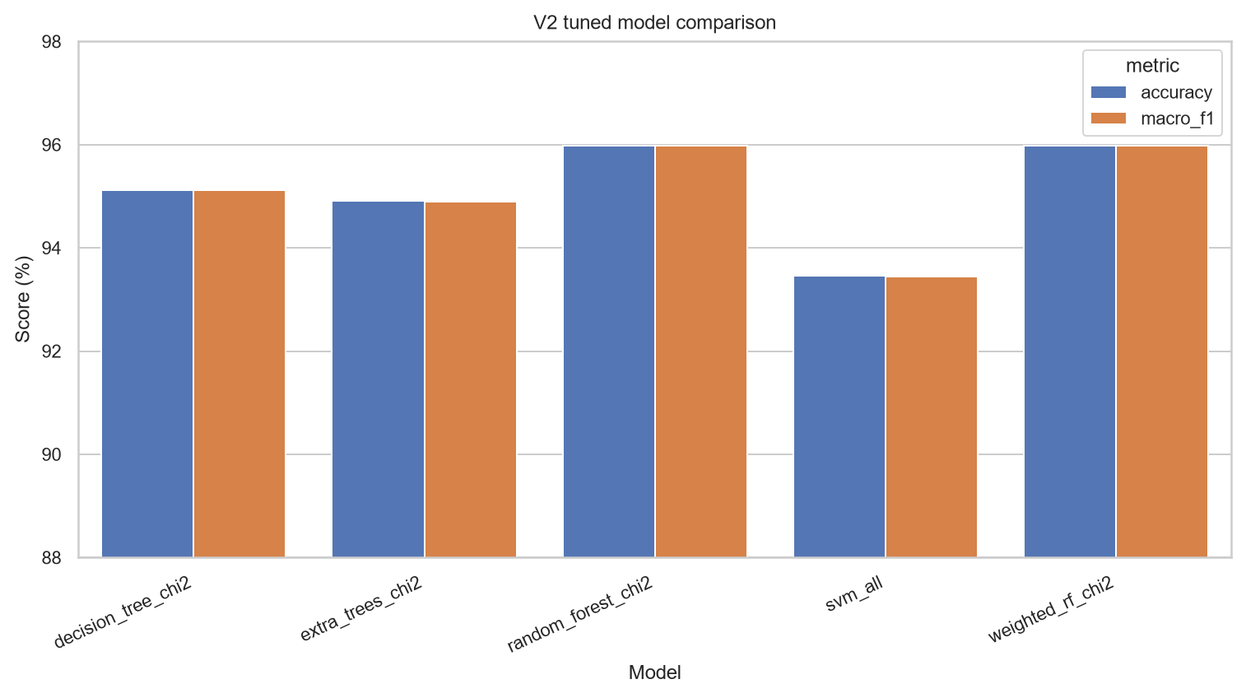
图1 v2统一调参模型性能对比
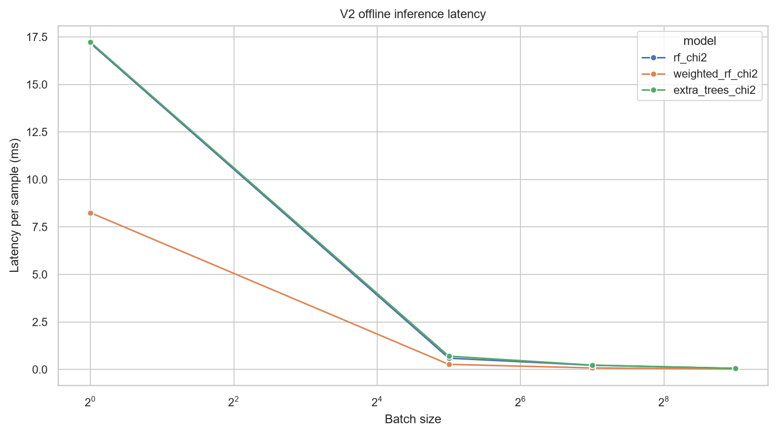
图2 v2离线推理延迟
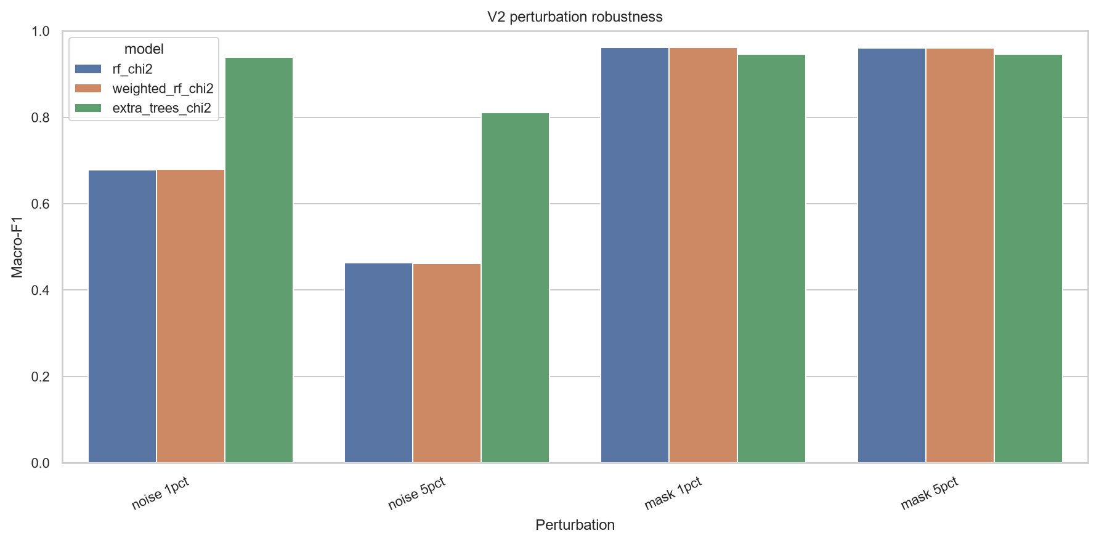
图3 v2扰动鲁棒性结果
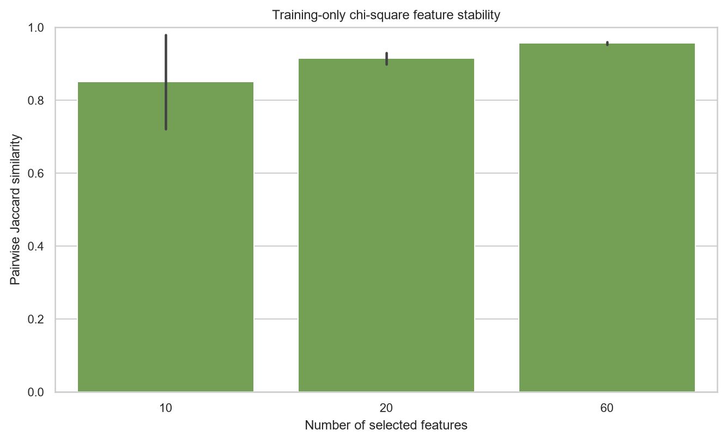
图4 训练集内χ²特征集合稳定性

结论
本文形成了训练集内缩放、折内χ²评分、交叉验证选参、独立测试及数据审计相结合的网络入侵检测实验流程。CIC-IDS2017平衡五分类研究子集上，χ²60随机森林获得95.97%的平均Accuracy和95.98%的平均Macro-F1；重复分层划分实验显示模型平均Macro-F1为95.44%±1.25%，但相对全特征RF的改进幅度较小。等权投票与验证集性能加权投票在当前实验中给出相同预测，统计检验亦未支持加权机制具有显著优势。NSL-KDD官方划分上的独立基准进一步揭示R2L、U2R等少数类仍是主要困难。后续工作应优先开展覆盖完整类别的时间/文件外验证，研究面向极端不平衡类别的代价敏感学习，并在真实流量特征提取链路上评估端到端时延。

参考文献
[1] SHARAFALDIN I, LASHKARI A H, GHORBANI A A. Toward generating a new intrusion detection dataset and intrusion traffic characterization[C]//Proceedings of the 4th International Conference on Information Systems Security and Privacy. 2018: 108-116. DOI:10.5220/0006639801080116.
[2] TAVALLAEE M, BAGHERI E, LU W, et al. A detailed analysis of the KDD CUP 99 data set[C]//2009 IEEE Symposium on Computational Intelligence for Security and Defense Applications. 2009: 1-6. DOI:10.1109/CISDA.2009.5356528.
[3] BREIMAN L. Random forests[J]. Machine Learning, 2001, 45(1): 5-32. DOI:10.1023/A:1010933404324.
[4] LIU H, SETIONO R. Chi2: Feature selection and discretization of numeric attributes[C]//Proceedings of the 7th International Conference on Tools with Artificial Intelligence. 1995: 388-391. DOI:10.1109/TAI.1995.479783.
[5] BUCZAK A L, GUVEN E. A survey of data mining and machine learning methods for cyber security intrusion detection[J]. IEEE Communications Surveys & Tutorials, 2016, 18(2): 1153-1176. DOI:10.1109/COMST.2015.2494502.
[6] RING M, WUNDERLICH S, GRUDL D, et al. A survey of network-based intrusion detection data sets[J]. Computers & Security, 2019, 86: 147-167. DOI:10.1016/j.cose.2019.06.005.
[7] KHRAISAT A, GONDAL I, VAMPLEW P, et al. Survey of intrusion detection systems: techniques, datasets and challenges[J]. Cybersecurity, 2019, 2: 20. DOI:10.1186/s42400-019-0038-7.
[8] MCNEMAR Q. Note on the sampling error of the difference between correlated proportions or percentages[J]. Psychometrika, 1947, 12: 153-157. DOI:10.1007/BF02295996.
[9] EFRON B, TIBSHIRANI R J. Improvements on cross-validation: the .632+ bootstrap method[J]. Journal of the American Statistical Association, 1997, 92(438): 548-560. DOI:10.2307/2965703.
[10] 郭健忠, 王灿, 谢斌, 等. 面向车联网DoS攻击的混合入侵检测系统[J]. 计算机系统应用, 2025, 34(3): 85-93. DOI:10.15888/j.cnki.csa.009821.
[11] 刘小龙, 邢东辉, 蔡婷婷, 等. 基于改进差分进化算法的堆叠自编码器网络入侵检测[J]. 计算机系统应用, 2025, 34(11): 95-106. DOI:10.15888/j.cnki.csa.009976.
[12] 谭书志, 周传, 黄世元. 基于深度学习的入侵检测方法[J]. 计算机系统应用, 2025, 34(9): 170-179. DOI:10.15888/j.cnki.csa.009953.
[13] 李贵玲, 龚琼, 邓华山, 等. 融合GRU与CNN的网络入侵检测模型[J]. 计算机系统应用, 2023, 32(8): 162-170. DOI:10.15888/j.cnki.csa.009194.
注：上述条目已由论文/期刊页面和DOI候选记录核验；正式投稿前仍须按《计算机系统应用》最新模板复核作者截断规则、英文大小写及标点，并在完整第一至三章中建立逐条正文标引。

作者与投稿信息（待填写）
作者、单位、通信地址、邮编、联系电话、E-mail、基金项目和作者简介须由作者提供真实信息。本文档尚未套用《计算机系统应用》官方Word模板。

