Lab #4
Conducted Monday, 5/21/12
Due Friday, 5/25/12 (in Lecture)

Bootstrap Calculation of Confidence Intervals for Estimated Parameters

Reference reading: pp. 458—464 for bootstrapping in general and pp. 529—536 for bootstrapping in nonlinear regression.

For this Lab, work in groups of three or four students. Each group will turn in a single group assignment.

The Problem: For linear regression and other simple model fitting methods, we have exact analytical expressions for the standard errors of the estimated model parameters and the predicted response. The standard errors are very important in interpreting the model, because they:

- Tell us how accurately the parameters were estimated and whether the estimated values are statistically significant (if so, then we know the parameter belongs in the model).
- Allow confidence intervals for the parameters to be calculated, e.g. 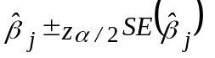 for linear regression.
- Allow confidence intervals on the predicted response to be calculated, e.g. 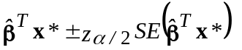 for linear regression.

For other slightly-more-complicated methods (e.g. logistic regression), we have approximate analytical expressions for the standard errors, which we can use to calculate approximate confidence intervals. However, a huge class of modeling methods (e.g., neural networks) are too complicated to yield any useful approximate results for standard errors and confidence intervals.

The Solution (Bootstrapping): Recall that earlier in the course we had a similar problem when we wanted to compare different models to see which one would do the best predicting the response for a new test set of data, independent of the training set. Analytical measures like Mallows' C_{p} are approximate results that only apply to simple methods like linear regression. Our solution there was to use cross-validation (CV), which is computationally intensive, but is completely general, being based on no assumptions, and can be applied to any type of model. Our solution here is to use a technique commonly referred to as bootstrap resampling, or bootstrapping for short. Bootstrapping is a computationally intensive, but completely general, simulation procedure for calculating standard errors and confidence intervals for estimated model parameters, no matter how complicated and nonlinear the model is.

Because bootstrapping is so general, we will present it in the context of a problem that is quite different from fitting nonlinear models such as neural networks. For one of your homework assignments, you will use bootstrapping to calculate confidence intervals for the parameters of a nonlinear least squares model.

Example: This was a problem that arose in a consulting project, in which Kodak was suing Agfa over alleged patent infringements in producing film for X-ray medical imaging. The suit was for roughly $1,000,000,000, which considered roughly 30 years of film production! Photographic film is a thin sheet of plastic coated with an emulsion containing microscopic light-sensitive silver halide crystal grains. The tunneling electron microscope photograph below shows what typical grain look like at high magnification. Kodak's patent covered grains with very specific thickness, area and aspect ratio characteristics. Kodak had measured quite a few samples of grains from various film produced by Agfa. For each sample, a hole punch was taken from the film. The emulsion on the film was then dissolved and placed on plates, to be viewed under a microscope. The diameters and thicknesses of the individual grains were then measured under the microscope. For each sample, about 100 grains were typically measured. Kodak claimed that summary statistics calculated from certain samples indicated that their patent was violated. However, considering that each sample contained roughly only 100 grains, whereas there are billions of grains on a single sheet of film, the natural question was "How much uncertainty is there in the summary statistics?" Is there so much uncertainty that Kodak cannot use them to convincingly argue that the patent was violated?
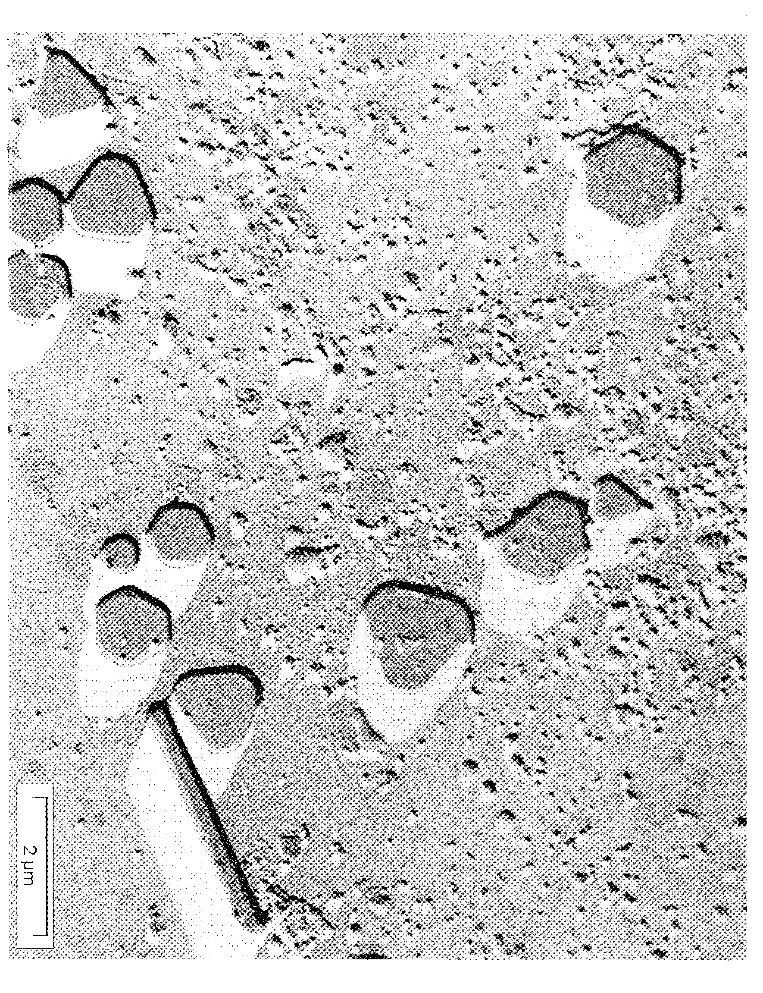

The "Original Sample" worksheet of Lab_4_Data.xls contains the measurements for a single sample with n = 126 grains. The data are as follows, with t_{i} and D_{i} in units of micrometers (μm).

A_{i} = area of grain #i in the sample (measured directly)
t_{i} = thickness of grain #i in the sample (measured directly)
D_{i} = equivalent diameter of grain #i in the sample, calculated via A_{i} = πD_{i}²/4
R_{i} = aspect ratio of grain #i in the sample, calculated via R_{i} = D_{i}/t_{i}

The specific details of the patent claim are as follows. Define:

Pop₀ = population of all grains
Pop₁ = population of all grains with both t_{i} < 0.3 and D_{i} > 0.6
μ_{R} = E[R| crystal ∈ Pop₁] = mean aspect ratio for all grains in Pop₁
f = 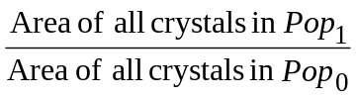 = fraction projected area of grains in Pop₁

The patent is violated if both of the following hold:

f > 0.5 AND μ_{R} > 8

1) From the single, original sample of data in the "Original Sample" worksheet, calculate point estimates of f and μ_{R}. For a point estimate of f (call it 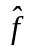), you can use the total area of all grains in the sample with t_{i} < 0.3 and D_{i} > 0.6, divided by the total area of all n grains in the sample. For a point estimate of μ_{R} (call it 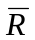), you can use the average aspect ratio for all grains in the sample with t_{i} < 0.3 and D_{i} > 0.6. Do the point estimates fall into the region for which the patent is violated?

2) Use the template in the "Bootstrap Samples" worksheet to generate B = 100 bootstrap samples (each of size n = 126 grains) and calculate and for each bootstrap sample. You can denote them by {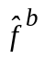 and 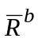: b = 1, 2, . . ., B}. This step will go faster if you have each person in your group generate some of the samples. To generate each new bootstrap sample, you need to run Data Analysis >> Random Number Generation, specify 126 observations of 1 variable with a uniform distribution from 0 to 126, and save the results in the random # column. NOTE: You would normally choose B much larger than 100 (e.g., B = 10,000) when bootstrapping and use software like Matlab to implement it.

3) Calculate the bootstrap estimates of the standard errors of and :

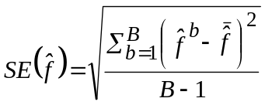 and
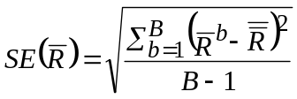, with

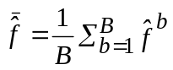, and
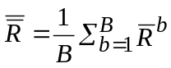.

4) Construct histograms of { and : b = 1, 2, . . ., B}. Does the spread of the histogram look consistent with the standard errors you found in Problem 3? Explain.

5) Based on the standard errors from Problem 3, calculate crude 95% confidence intervals for the true (population) values f and μ_{R}:

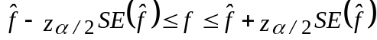 and
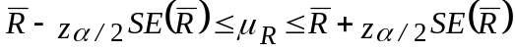,

where and are the point estimates from Problem 1 (NOT the 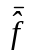 and 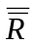 from Problem 3).

6) Calculate the more accurate 95% confidence intervals (at least, they would be more accurate than those in Problem 4 if you were using a much larger B than 100) using the upper and lower α/2 percentiles of the sample distribution of { and : b = 1, 2, . . ., B}:

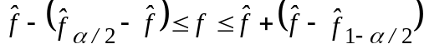 and
,

where 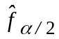 and 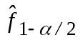 denote the upper and lower α/2 percentiles, respectively, of the sample distribution of {: b = 1, 2, . . ., B}, and likewise for 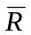. Indicate where , , 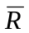, 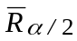 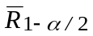 fall on the histograms that you constructed in Problem 4.

7) Based on the confidence intervals, discuss (be specific and detailed) whether Kodak can argue that their patent is violated.

