> # ############################################################################

> # Title: MSIA 400 - Assignment 1

> # Date: 10/20/14

> # Author: Steven Lin

> ##############################################################################

>

>

> # Setup ####

>

> # My PC

> main = "C:/Users/Steven/Documents/Academics/3_Graduate School/2014-2015 ~ NU/"

>

> # Aginity

> #main = "\\\\nas1/labuser169"

>

> course = "MSIA_400_Analytics for Competitive Advantage"

> datafolder = "Lab/Assignment_01"

> setwd(file.path(main,course, datafolder))

>

> # Import data

> filename = "redwine.txt"

> redwine = read.table(filename, header=T)

>

>

> # Look at data

> names(redwine)

> head(redwine)

> nrow(redwine)

> summary(redwine)

>

# > # Problem 1

>

> # Calculate the averages of RS and SD by ignoring the missing values

> RS_avg = mean(redwine$RS, na.rm = T)

> SD_avg = mean(redwine$SD, na.rm = T)

> RS_avg

[1] 2.537952

> SD_avg

[1] 46.29836

# > # Problem 2

>

> # Create vectors of SD.obs and FS.obs by omitting observations

> # with missing values in SD

>

> # T/F of missing values of SD

> missing_SD = is.na(redwine$SD)

>

> # Create vectors for SD and FS

> SD.obs = redwine$SD[!missing_SD]

> FS.obs = redwine$FS[!missing_SD]

>

> # Fit regression

> fit1 = lm(SD.obs ~ FS.obs)

> summary(fit1)

Call:

lm(formula = SD.obs ~ FS.obs)

Residuals:

Min 1Q Median 3Q Max

-54.489 -13.530 -7.155 7.252 197.587

Coefficients:

Estimate Std. Error t value Pr(>|t|)

(Intercept) 13.18551 1.11502 11.82 <2e-16 ***

FS.obs 2.08608 0.05867 35.56 <2e-16 ***

---

Signif. codes: 0 ‘***’ 0.001 ‘**’ 0.01 ‘*’ 0.05 ‘.’ 0.1 ‘ ’ 1

Residual standard error: 24.39 on 1580 degrees of freedom

Multiple R-squared: 0.4445, Adjusted R-squared: 0.4441

F-statistic: 1264 on 1 and 1580 DF, p-value: < 2.2e-16

>

> # Coefficients

> fit1$coeff

(Intercept) FS.obs

13.185505 2.086077

# > # Problem 3

> # FS values of the observations with missing SD values.

> FS.obs_missing_SD = redwine$FS[missing_SD]

> FS.obs_missing_SD

[1] 15.0 12.0 11.0 12.0 40.5 1.0 7.0 35.0 15.0 36.0 23.0 12.0 8.0 7.0 15.0 18.0 5.0

> length(FS.obs_missing_SD)

[1] 17

>

> # Estimated SD values using the regression model

> SD.est = predict(fit1,data.frame(FS.obs =FS.obs_missing_SD))

> SD.est = as.vector(SD.est)

> SD.est

[1] 44.47667 38.21843 36.13236 38.21843 97.67164 15.27158 27.78805 86.19821 44.47667

[10] 88.28429 61.16528 38.21843 29.87412 27.78805 44.47667 50.73490 23.61589

>

> # Impute missing values of SD using the created vector.

> redwine.imputed = redwine

> redwine.imputed$SD[missing_SD] = SD.est

> # Print out the average of SD after the imputation

> mean(redwine.imputed$SD)

[1] 46.30182

# > # Problem 4

> # T/F of missing values of RS

> missing_RS = is.na(redwine.imputed$RS)

>

> # Impute missing values of RS using the average value imputation method

> redwine.imputed$RS[missing_RS] = RS_avg

> summary(redwine.imputed)

>

> # Print out the average of RS after the imputation

> mean(redwine.imputed$RS)

[1] 2.537952

# > # Problem 5

> # Build multiple linear regression model for the new data set

> # and save it as winemodel.

>

> winemodel = lm(QA ~ .,redwine.imputed)

>

> # Print out the coefficients of the regression model.

> coeff = winemodel$coeff

> coeff = as.matrix(winemodel$coeff)

> colnames(coeff) = 'Coefficient'

> coeff

Coefficient

(Intercept) 47.202815335

FA 0.068406796

VA -1.097686420

CA -0.178949797

RS 0.025926958

CH -1.631290466

FS 0.003530106

SD -0.002854970

DE -44.816652166

PH 0.035996993

SU 0.944871182

AL 0.247046550

# > # Problem 6

>

> # Printout the summary of the model.

> summary(winemodel)

Call:

lm(formula = QA ~ ., data = redwine.imputed)

Residuals:

Min 1Q Median 3Q Max

-2.78010 -0.36249 -0.06331 0.44595 1.98828

Coefficients:

Estimate Std. Error t value Pr(>|t|)

(Intercept) 4.720e+01 1.782e+01 2.649 0.008151 **

FA 6.841e-02 1.872e-02 3.654 0.000267 ***

VA -1.098e+00 1.213e-01 -9.053 < 2e-16 ***

CA -1.789e-01 1.474e-01 -1.214 0.224954

RS 2.593e-02 1.419e-02 1.827 0.067944 .

CH -1.631e+00 4.097e-01 -3.982 7.14e-05 ***

FS 3.530e-03 2.159e-03 1.635 0.102262

SD -2.855e-03 7.248e-04 -3.939 8.54e-05 ***

DE -4.482e+01 1.789e+01 -2.505 0.012329 *

PH 3.600e-02 4.409e-02 0.816 0.414413

SU 9.449e-01 1.136e-01 8.321 < 2e-16 ***

AL 2.470e-01 2.265e-02 10.906 < 2e-16 ***

---

Signif. codes: 0 ‘***’ 0.001 ‘**’ 0.01 ‘*’ 0.05 ‘.’ 0.1 ‘ ’ 1

Residual standard error: 0.6491 on 1587 degrees of freedom

Multiple R-squared: 0.3584, Adjusted R-squared: 0.354

F-statistic: 80.6 on 11 and 1587 DF, p-value: < 2.2e-16

>

> # Pick one attribute that is least likely to be related to QA based on p-values.

> p = as.matrix(sort(summary(winemodel)$coeff[-1,c("Pr(>|t|)")]))

> colnames(p)="p-value"

> p

p-value

AL 9.316541e-27

VA 3.978528e-19

SU 1.859395e-16

CH 7.144969e-05

SD 8.544428e-05

FA 2.669015e-04

DE 1.232865e-02

RS 6.794396e-02

FS 1.022624e-01

CA 2.249543e-01

PH 4.144133e-01

>

> # CA, RS, FS and PH are insignificant at 0.05 level since p-values > 0.05,

> # suggesting that the coefficients are not significantly different than zero

> # and the effects on QA are insignificant

>

> # PH has the largest p-value = 0.414, indicating that is the attribute that

> # is least likely to be related to QA based on p-values ("the most insignificant")

# > # Problem 7

>

> # Calculate the average and standard deviation of the selected attribute

> PH_avg = mean(redwine.imputed$PH)

> PH_sd = sd(redwine.imputed$PH)

> PH_avg

[1] 3.306202

> PH_sd

[1] 0.3924948

>

> # boxplot(redwine.imputed$PH)

>

> # Create a new data set after removing observations that is outside of the

> # range [ m - 3s;m + s3] and name the data set as redwine2.

>

> redwine2 = subset(redwine.imputed, (PH > PH_avg - 3*PH_sd) & (PH < PH_avg + 3*PH_sd))

>

> # Print out the dimension of redwine2 to know how many observations are removed.

> dim(redwine2)

[1] 1580 12

> dim(redwine2)[1]-dim(redwine)[1]

[1] -19

>

> # 19 observations removed

# > # Problem 8

>

> # Build regression model winemodel2 using the new data set from Problem 7

> winemodel2 = lm(QA ~ . , redwine2)

>

> # print out the summary.

> summary(winemodel2)

Call:

lm(formula = QA ~ ., data = redwine2)

Residuals:

Min 1Q Median 3Q Max

-2.68933 -0.36336 -0.04368 0.45221 2.01272

Coefficients:

Estimate Std. Error t value Pr(>|t|)

(Intercept) 19.036170 21.211609 0.897 0.3696

FA 0.024613 0.026019 0.946 0.3443

VA -1.072147 0.122031 -8.786 < 2e-16 ***

CA -0.178017 0.148120 -1.202 0.2296

RS 0.012955 0.014968 0.866 0.3869

CH -1.902552 0.420766 -4.522 6.60e-06 ***

FS 0.004421 0.002182 2.026 0.0429 *

SD -0.003145 0.000738 -4.261 2.16e-05 ***

DE -14.973653 21.652465 -0.692 0.4893

PH -0.424704 0.192653 -2.205 0.0276 *

SU 0.913456 0.114860 7.953 3.46e-15 ***

AL 0.282744 0.026553 10.648 < 2e-16 ***

---

Signif. codes: 0 ‘***’ 0.001 ‘**’ 0.01 ‘*’ 0.05 ‘.’ 0.1 ‘ ’ 1

Residual standard error: 0.6475 on 1568 degrees of freedom

Multiple R-squared: 0.3629, Adjusted R-squared: 0.3585

F-statistic: 81.21 on 11 and 1568 DF, p-value: < 2.2e-16

>

> # Compare this model with the model obtained in Problem 6 and decide

> # which one is better.

>

> # compare r squared

> summary(winemodel)$r.sq

[1] 0.3584256

> summary(winemodel2)$r.sq

[1] 0.3629441

>

> # both r.squared are too low, but model 2 has higher r-squared,

> # meaning it explains more variation in QA

>

> # both have 4 insignificant attributes at 0.05 level

> # model 1: CA, RS, FS, PH

> # model 2: FA, CA, RS, DE

>

> # both model have p-value < 2.2e-16 for the overall fit

>

> # looking at residuals

> plot(winemodel)

# leverage plot shows a higher influence of some data points in model 1

> # from the above discussion, both models are not very good, but

> # model 2 seems better than model 1.

>

> # Pick 5 attributes that is most likely to be related to QA based on p-values

> as.matrix(sort(summary(winemodel2)$coeff[-1,c("Pr(>|t|)")]))

[p-values]

AL 1.298628e-25

VA 3.987768e-18

SU 3.461990e-15

CH 6.597172e-06

SD 2.158380e-05

PH 2.763384e-02

FS 4.292722e-02

CA 2.296053e-01

FA 3.443096e-01

RS 3.868817e-01

DE 4.893255e-01

> # The attributes with 5 lowest p-values (most signficant effect on QA) are:

> # AL, VA, SU, CH, SD

Model 1

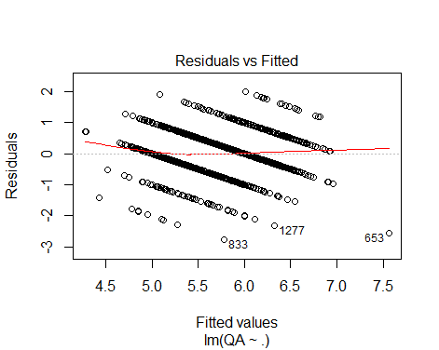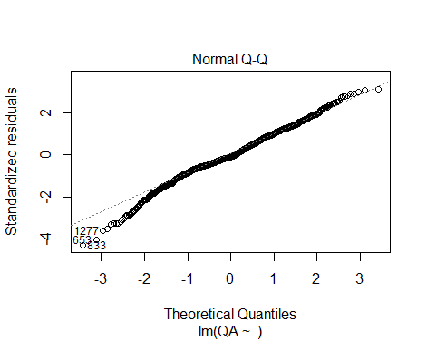

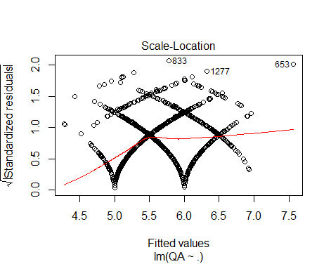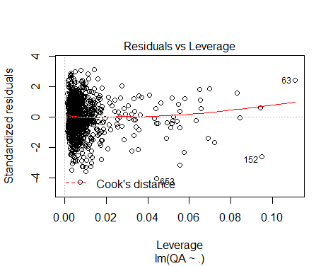

Model 2

