13th ICAMDATA

Sep.15-19, 2024, Lanzhou, China

# Home

The International Conference on Atomic and Molecular Data and Their Applications (ICAMDATA) is a continuing series of international conferences that promotes the use of atomic and molecular (AM) data in various fields of science and technology, providing a forum for interaction of AM data producers and users and for information exchange on AM data needs and availability, and fostering the cross-disciplinary cooperation between the AM data producers and users and the coordination of AM data activities and databases worldwide.

The topics covered by the Conference are

1. Application and needs of atomic and molecular data

* Astrophysics and atmospheric physics
* Inertial and magnetic fusion
* Low and high temperature laboratory plasma and industrial plasmas
* Lighting sciences and technology
* Biomedicine and biophysics
* Combustion and environmental sciences and technology
* Surface physics, gaseous electronics, solid state optics and spectroscopy, optoelectronics, etc.

1. Atomic and molecular data production

* Data collection, assessment, exchange and dissemination
* Standardization of data formats
* AM databases, activities of data centers

1. Experimental and theoretical methods for atomic and molecular data generation

* Atomic and molecular structure, spectroscopy and radiative processes
* Electron and photon collisions with atoms and molecules
* Heavy particle collisions
* Particle-surface interactions.

The scientific programme will include invited and contributed talks in the regular sessions, a poster session and special sessions devoted to uncertainty quantification and database demonstrations.

13th ICAMDATA, hosted by the NWNU (Northwest Normal University, China) in Lanzhou, China, is organized in cooperation with the International Atomic Energy Agency (IAEA).







(赞助商信息暂时可以不放)with the patronage of the Institute for Plasma Science and Technology (ISTP), of the Polytechnic of Bari and of the Municipality of Mola di Bari, and the event is sponsored by Smithsonian Astrophysical Observatory (SAO) and the MDPI Journal Entropy.

# Committees

International Program Committee

|  |  |
| --- | --- |
| James Babb, US | Jelle Kaastra, Netherlands |
| Beatriz Barbuy, Brazil | Annarita Laricchiuta, Italy (Past Chair) |
| Jacek Bieroń, Poland | Daiji Kato, Japan |
| Dmitry Fursa, Australia | Nobuyuki Nakamura, Japan |
| Nancy Brickhouse, US | Yong Wu, China |
| Stuart Loch, US | Gerry O'Sullivan, Ireland |
| Chenzhong Dong, China(Chair) | Juliet Pickering, UK |
| Zong-Chao Yan, Canada | Alexander Kramida, US |
| Andrey Surzhykov, Germany | Iouli Gordon, US (Acting Secretary) |
| Mi-Young Song, Korea | Christian Hill, IAEA |
| Inga Tolstikhina, Russia | Valdas Jonauskas, Lithuania |
| Duck-Hee Kwon, Korea |  |

Local Organizing Committee

|  |  |
| --- | --- |
| Chenzhong Dong,NWNU, China(Chair) | Xiaobin Ding,NWNU, China(Acting Secretary) |
| Denghong Zhang, NWNU, China | Maogen Su, NWNU, China |
| Luyou Xie, NWNU, China | Jun Jiang, NWNU, China |
| Duixiong Sun, NWNU, China | Qi Min, NWNU, China |
| Maijuan Li, NWNU, China | Guoding Zhang, NWNU, China |
| Yulong Ma, NWNU, China | Shiquan Cao, NWNU, China |
| Zhongwen Wu, NWNU, China | Lei Wu, NWNU, China |
| Xinwen Ma, IMP, China | Jianguo Wang, IAPCM, China |
| Jun Yan, IAPCM, China | Yong Wu, IAPCM, China |
| Jiguang Li, IAPCM, China |  |

# Programme

## Invited Speakers

## DataBase

<http://www.camdb.ac.cn/e/> China Research Association of Atomic and Molecular Data (CRAAMD)

## Schedule

## Poster Session

## Best Poster Awards（*）

## Satellite Meeting

## ICAMDATA Collections

12th ICAMDATA Collection

Invited speakers and all presenters contributing to the Conference scientific programme are invited to submit a regular paper in the Topical Issue of the [European Physical Journal D](https://www.springer.com/journal/10053)

Atomic and Molecular Data and Their Applications: ICAMDATA2022

Guest Editors: C Z Dong, X B Ding, (and others)

-----------------------------------------------------------------------------------------------------------------------------

Past ICAMDATA Conference Proceedings and Collections

1997. Gaithersburg, Maryland. AIP Conf. Proc. 434

Peter J. Mohr and Wolfgang L. Wiese, eds. (AIP, Woodbury, NY, 1998)

poster papers in NIST Special Pub. 926, Wolfgang L. Wiese and Peter J. Mohr, eds. (US GPO, Washington, DC, 1998).

2000. Oxford, England. AIP Conf. Proc. 543

Keith A. Berrington and Kenneth Bell, eds. (AIP, Melville, NY, 2000).

2002. Gatlinburg, Tennessee. AIP Conf. Proc. 636

David R. Schultz, Predrag S. Krstic, and Fay Ownby, eds. (AIP, Melville, NY, 2002).

2004. Toki, Japan. AIP Conf. Proc. 771

Takako Kato, Hisamichi Funaba and Daiji Kato, eds. (AIP, Melville, NY, 2005)

contributed papers in J. Plasma Fusion Res. Ser. (JPFS-R) 7 (2006), T. Kato, H. Funaba, C. Suzuki, T. Minami, eds.

meeting summary by R. K. Janev and T. Kato, Phys. Scr. 72, C6 (2005).

2006. Meudon, France. AIP Conf. Proc. 901

Evelyne Roueff, ed. (AIP, Melville, NY, 2007).

2008. Beijing, China. AIP Conf. Proc. 1125

Shaoping Zhu and Jun Yan, eds. (AIP, Melville, NY, 2009).

2010. Vilnius, Lithuania. AIP Conf. Proc. 1344

A. Bernotas, R. Karazija, and Z. Rudzikas, eds. (AIP, Melville, NY, 2011).

2012. Gaithersburg, Maryland. AIP Conf. Proc. 1545

John D. Gillapsy, Wolfgang L. Wiese, and Yuri A. Podpaly, eds. (AIP, Melville, NY, 2013).

2014. Jena, Germany. Phys. Scr. 90 (5), 050201 (2015)

Stefan Schippers, Andrey Surzhykov, and Stephan Fritzsche, eds.

2016. Gunsan, South Korea. Eur. Phys. J. D (Topical Issue) (2017-2018)

Gordon W. F. Drake, Jung-Sik Yoon, Daiji Kato, and Grzegorz Karwasz, eds.

2018. Cambridge, Massachusetts. Atoms 7 (2019)

James F. Babb and Nancy Brickhouse, eds.

contributed abstracts

2022. Mola di Bari, Italy. Eur. Phys. J. D (Topical Issue) (2023)

Annarita Laricchiuta, Iouli E. Gordon, Christian Hill, Gianpiero Colonna and Sylwia Ptasinska (Guest editors)

# Venue

## Gansu Province

Gansu is a province located in northwest China, known for its rich cultural and historical heritage. One of its most famous attractions is the Mogao Caves in Dunhuang, also known as the "Caves of the Thousand Buddhas". These caves contain some of the finest examples of Buddhist art and architecture in the world, dating back to the 4th century AD.(配图敦煌)

Another notable site in Gansu is the Maijishan Mountain, which features a series of cliff-side grottoes containing Buddhist statues and murals. The area also offers stunning views of the surrounding landscape, making it a popular destination for nature lovers and hikers.(配图麦积山)

Additionally, the vast grasslands of Gannan offer a unique opportunity to experience the beauty of China's natural environment and traditional nomadic culture.(甘南草原)

Overall, Gansu is a fascinating destination for anyone interested in Chinese culture and history, and would make a great addition to any international academic conference itinerary.

## Lanzhou

Lanzhou, the capital of Gansu Province, is located in the geometric center of China's land map, and is an important central city, industrial base and comprehensive transportation hub in Northwest China, as well as a core node city of the Silk Road Economic Belt. With a history of over 2,000 years, it has a rich cultural heritage that attracts many tourists every year. One of the most famous historical sites in Lanzhou is the White Pagoda Mountain, which features a towering white pagoda that was built during the Tang Dynasty (618 to 907 A.D). The Gansu Provincial Museum, which houses many ancient artifacts and exhibits that showcase the region's history and culture, is also famous. (配图白塔山，省博)

In addition to its historical sites, Lanzhou is also known for its natural scenery. Lanzhou is the only provincial capital where the Yellow River passes through the city, provides a beautiful backdrop for visitors. The Bingling Temple Grottoes, located just outside of Lanzhou, are also a must-see for tourists. (配图黄河与炳灵寺石窟)

Lanzhou is a city that offers a unique blend of history, culture, and natural beauty. We hope you enjoy the trip to Lanzhou and NWNU.

## Northwest Normal University

Northwest Normal University (NWNU) is a key university jointly constructed by the People's Government of Gansu Province and the Ministry of Education. Its predecessor is the National Beiping Normal University, which was founded in 1902 as the Normal Hall of the Peking Normal University, changed to the "National Beijing Higher Normal School" in 1912, and changed to the "National Beiping Normal University" in 1923. It moved to Lanzhou in 1941. In 2020, the school was listed as a provincial university supported by the People's Government of Gansu Province to enter the construction of the first-class universities in the country.

Since its independent establishment, more than 290,000 students had been trained and grown up. The university enrolls students from 31 provinces (autonomous regions and municipalities directly under the central government) in China, and there are currently 29,586 students enrolled in various types of schools, including 18,105 ordinary undergraduates, 865 doctoral students, 10,170 master's degree students, and 446 international students. There are 2,627 faculty members in the university, with 375 full senior titles, 887 associate titles, 990 with doctoral degrees and 935 with master's degrees. Among them, 1,739 are full-time teachers, 351 are professors and 703 are associate professors.

## Accommodation

The ICAMDATA conference will be held in the International Academic Exchange Center of Northwest Normal University.

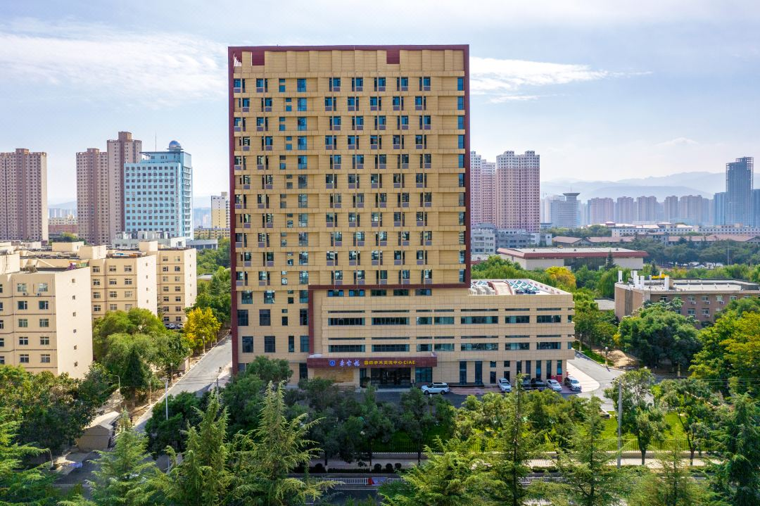

Detailed information about the accommodation will be updated soon.

Single room



Double room



## Travel Info

**How to Reach Lanzhou**

The closest airport is the Lanzhou Zhongchuan International Airport (IATA Code：LHW), located at approximately 56 km Northwest from the Northwest Normal University. The airport is connected by domestic flights to the international airports of Beijing, Shanghai, Xian, Guangzhou and some other cities.

**From the Airport to Northwest Normal University**

The local organizing committee will offer FREE shuttle bus to pick you up at the airport from 10 a.m. until 9 p.m. in Sep. 15. The detailed time schedule of the shuttle bus will be updated later. It will depend on the participants’ arriving time.

Shuttle Bus Time Table

|  |  |  |  |  |  |  |
| --- | --- | --- | --- | --- | --- | --- |
|  |  |  |  |  |  |  |
|  |  |  |  |  |  |  |

## Social Programme

# Registration

Registration will be open at March 1, 2024.

# Dates

Important Date

|  |  |
| --- | --- |
| October 28, 2023 | First Announcement, Conference web on-line |
| March 1, 2024 | Registration Open and Abstract Submission |
| May 1, 2024 | Student Grant application deadline  IAEA support application deadline |
| June 15, 2024 | Abstract Submission deadline |
| July 20, 2024 | Abstract Acceptance Notification |
| September 15-19, 2024 | ICAMDATA conference |
| December 15, 2024 | deadline for the submission to the Topical Issue of the European Physical Journal D Atomic and Molecular Data and Their Applications: ICAMDATA2022 |
|  |  |

ICAMDATA Chapter(外部链接)

<https://physics.nist.gov/Icamdata/Homepage/charter.html>

# History(外部链接)

<https://physics.nist.gov/Icamdata/Homepage/icamdata.html>