1. Description of our project

Our project is an online toolbox system. After registration, user can log in and choose our toolbox items. The user can use the tool once he bought it.

At first, user needs to log in to our system.

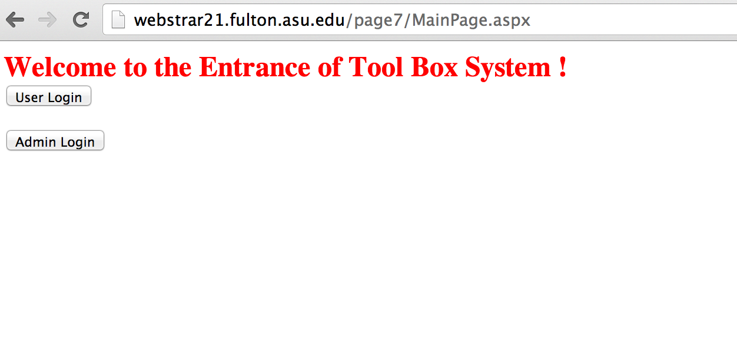

If you are administrator, choose the admin login. The username and password of Administrator stores in the root web.fig file.The default usernames and password are :admin(123456) and root(654321).The admin login page support cookies.

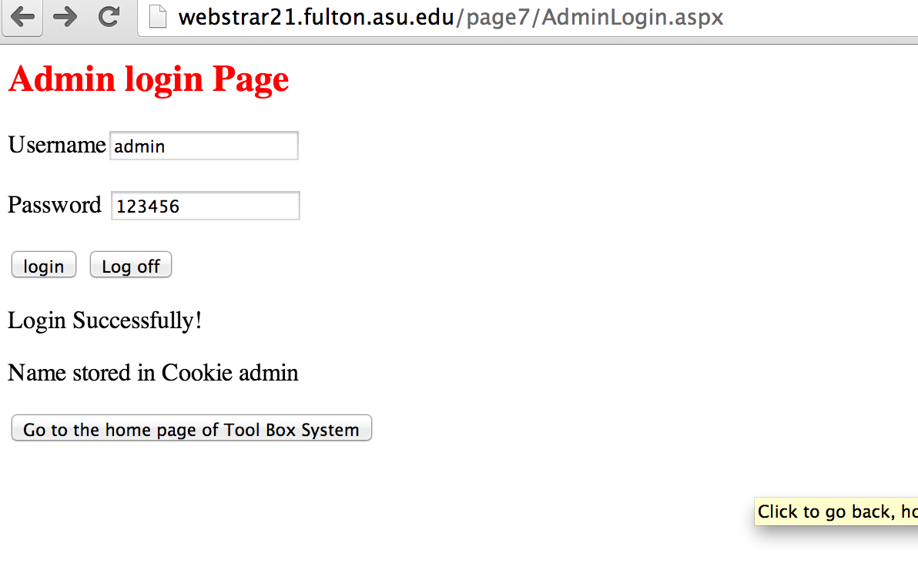

Now the admin login to the home page, can use this system

If you are a user,please choose the user login page.This is user 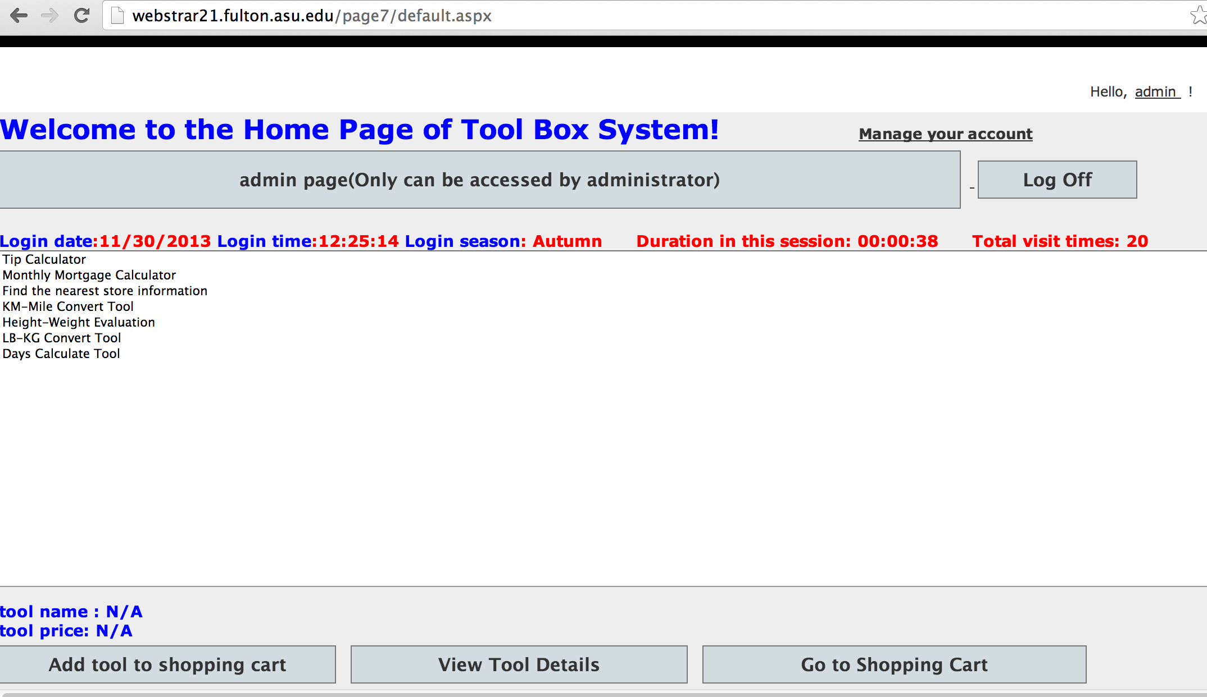login page.If you don’t have an account,please register first.

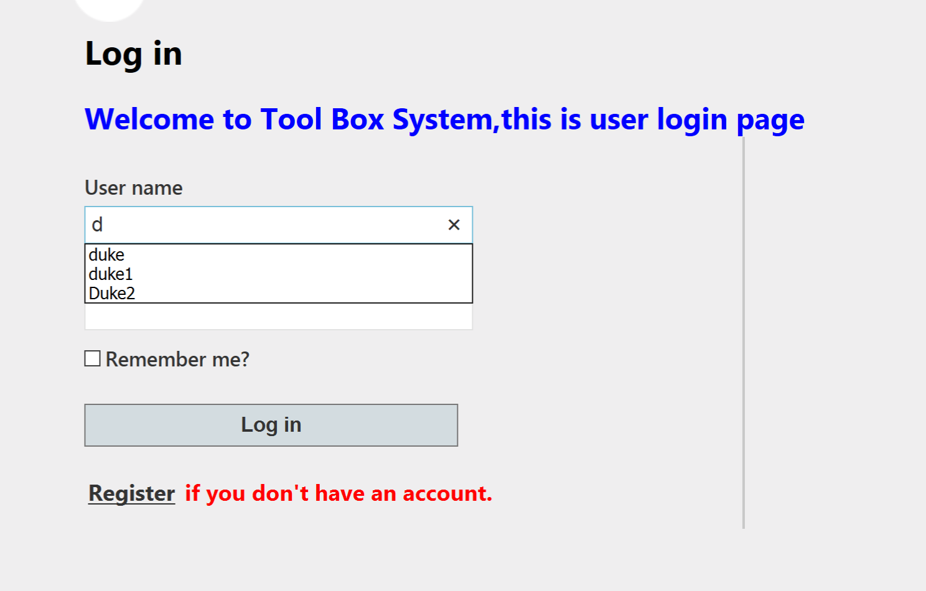

This register page.

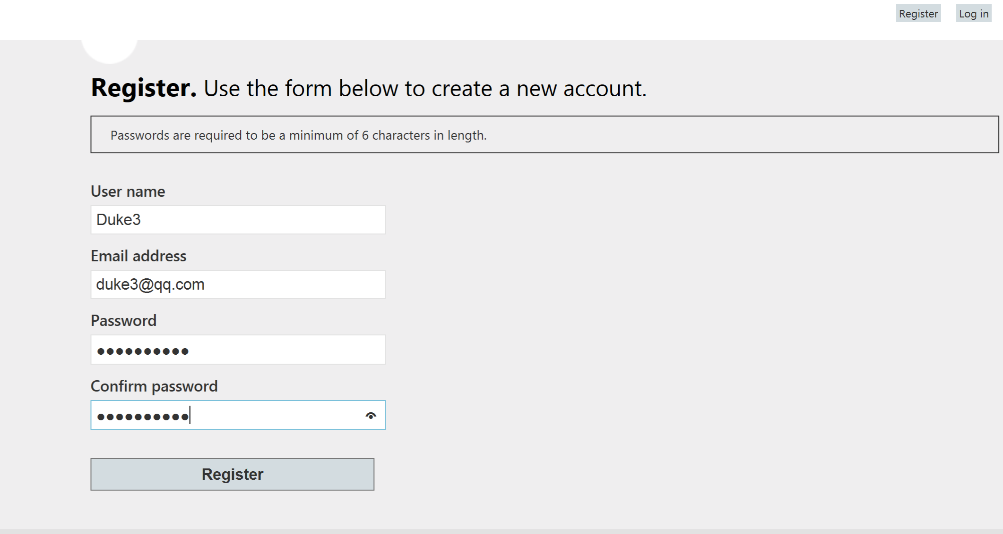

Once log in successfully , you can see the home page of our system.Here is the home page once the after logging in. User can choose the toolbox item and add the tool to shopping cart. Once the user finished choosing items, he can click the “Go to Shopping cart” button.

The admin page can be accessed by admin and root only,users can not access in this page.

Users can change password by click “manage your account”

If you want to log off ,click the “log Off” button

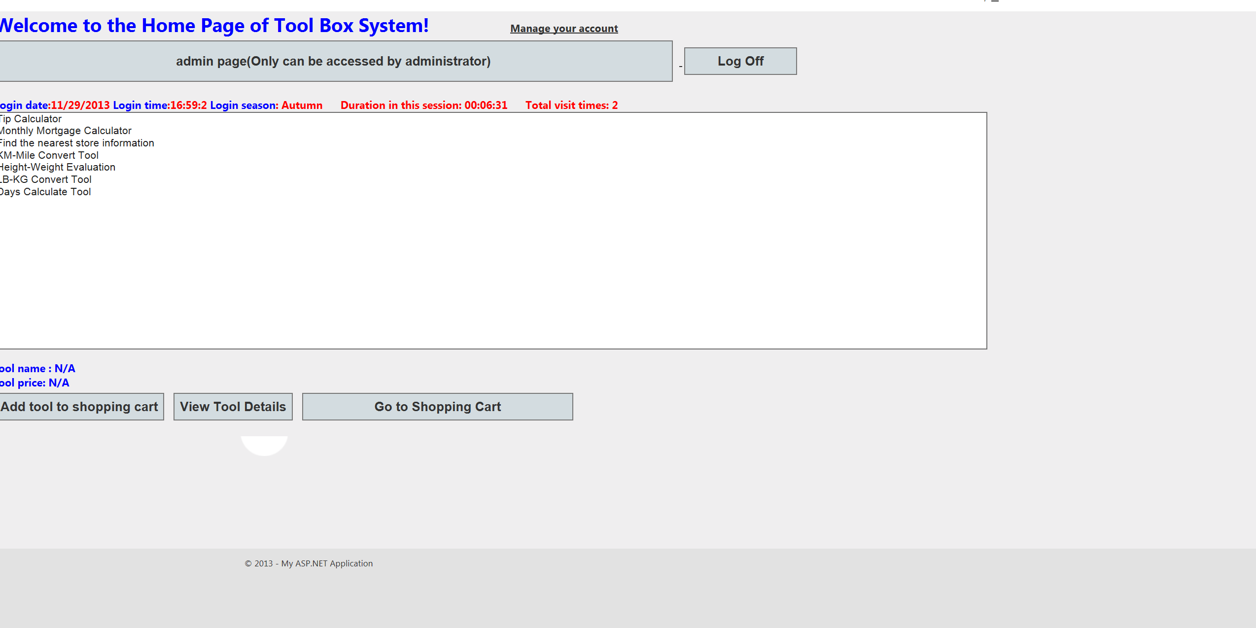

User can continue shopping and checkout.After checking out, user can use the online tool.

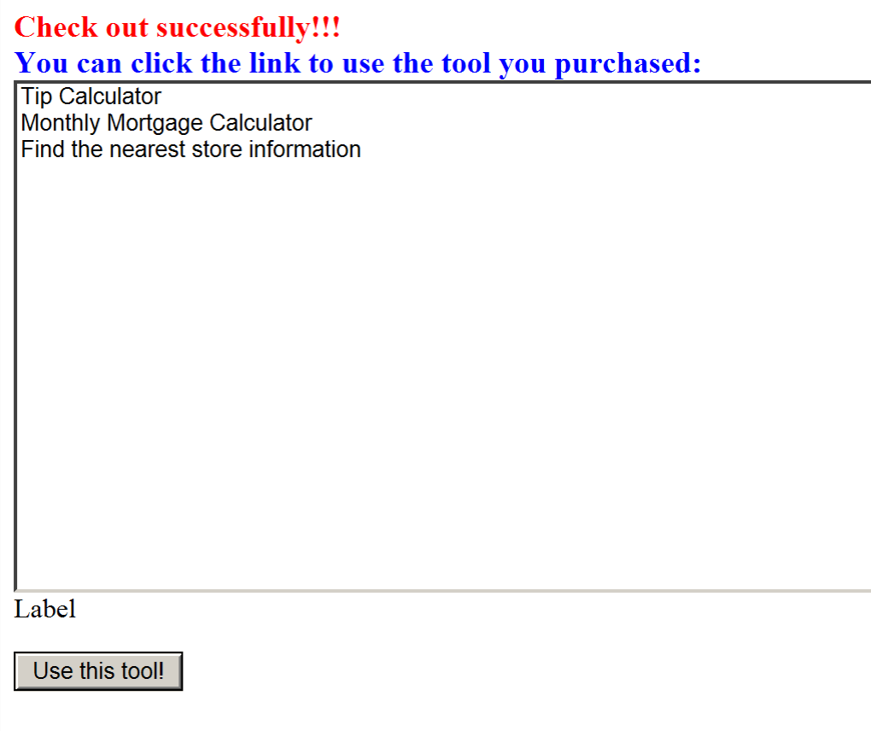

The username.xml in app_Data/Users folder represent the User purchased tools information.If username is t, then the system will automatically create t.xml

The functions

1. ASPX Pages:

(1) Public Pages: MainPage.aspx, Login.aspx, AdminLogin.aspx.

(2) User authorization Page: Default.aspx, ShoppingCart.aspx, CheckOut.aspx, all TryIt pages.

(3) Administer authorization Page: admin.aspx.

2. Local component:

(1) ASCX user controls: show season, show date, and show time.

(2) DLL class library modules: convert LB/KG, convert mile/km and tip calculator/ mortage.

3. Remote Service:

(1) Self-developed: Calculate days between two dates, Health calculator about height and weight.

(2) Discover service: Find Nearest Store.

4. Data Management:

(1) Permanent states: xml file to store user’s toolists, txt file to store total visiting times.

(2) Cookie: Used in Login.aspx and AdminLogin.aspx.

(3) Session State: Used in Default.aspx, ShoppingCart.aspx, and CheckOut.aspx.

5. Global.asax:

used Application_Start() and Session_Start() to get Session Duration and total visit times.

2. Diagram

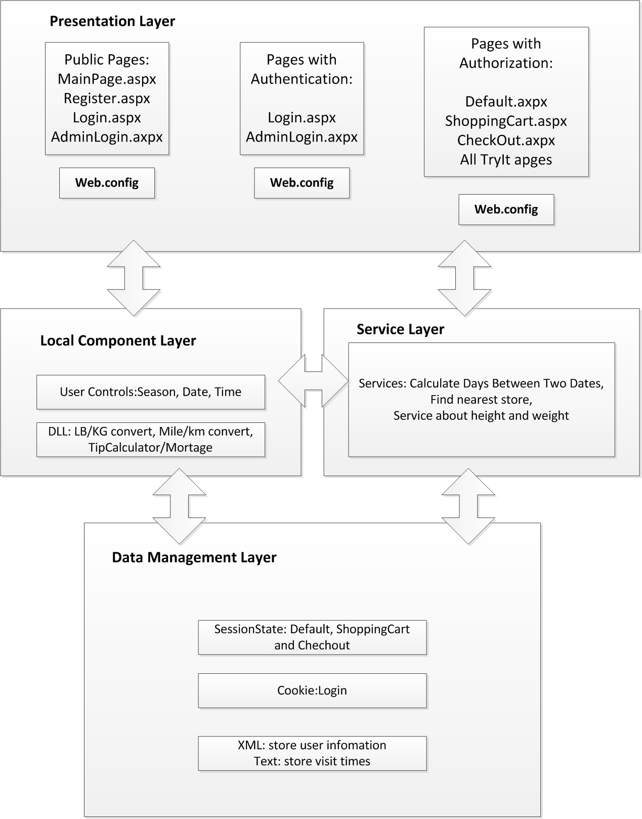

3. URL

http://webstrar21.fulton.asu.edu/page7/MainPage.aspx

4. Percentage of the contribution to Part 2. The total must add to 100%. You must fill out this table even if the percentages are equal.

Name: _Ersi Zha___________________Percent _33.33%____

Name: _Jiaqi He___________________Percent _33.33%____

Name: _Daqi Yin__________________Percent _33.33%____