**CSE591-Assignment2**

Name: Ersi Zha Id:1206169363

In this assignment, I use Excel to analyze the data set and create the statistical graphics.

(1) A box and whisker graphic comparing the inflation adjusted gross with respect to the studios (combine both years of movies for this exercise)

In the top 50 movies of the 2012 and 2013 movie season, there are 14 different studios .In my box and whisker graphic, I removed some studios with few data like Relativity and FilmDistrict. Also, I combined some studios data. For example, Tris and Segm are belong to Sony/Columbia and PD/W is belong to Paramount. Finally, after analyzing the data set, I compare the adjusted gross with respect to 8 studios.

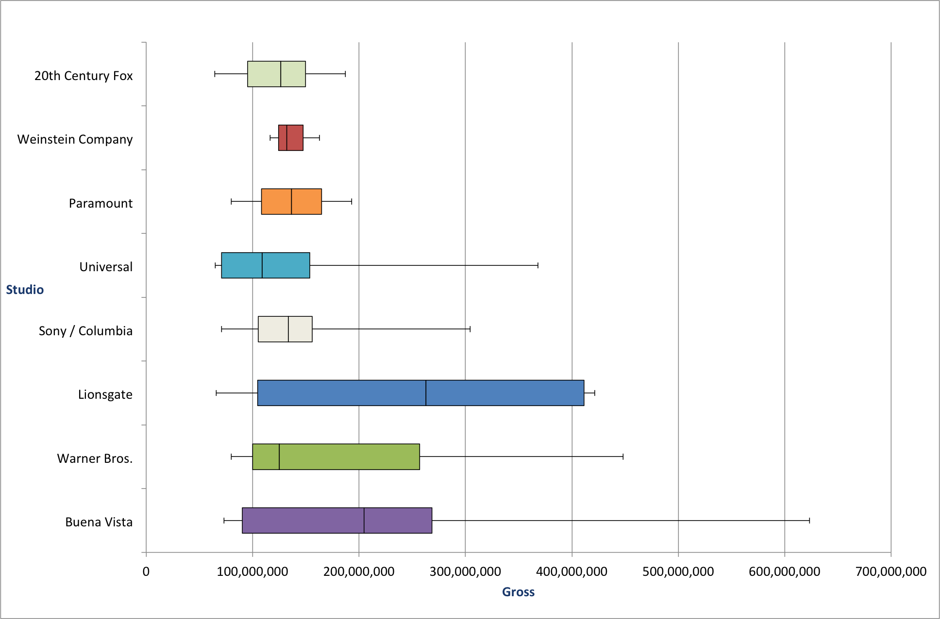

(2) Create two histograms showing the distribution of weekend grosses in the year 2012 and 2013 respectively (x-axis is in weekend gross, y-axis is number of movies with a given gross)

The following two histograms present the distribution of weekend gross in 2012 and the distribution of weekend gross in 2013 by analyzing the top50 movies in 2012 and 2013 season. I decided to use 40,000,000 as the bin width because I want to ensure that the number of movies wouldn’t be zero in some bins. As shown in the histograms, the distribution in 2012 and 2013 are similar. For both of the 2012 and 2013 season, the weekend gross of 30 movies are under $40,000,000. 2012 season has 2 movies in the range between $80,000,000-$120,000,000, while 2013 season has 5 movies.

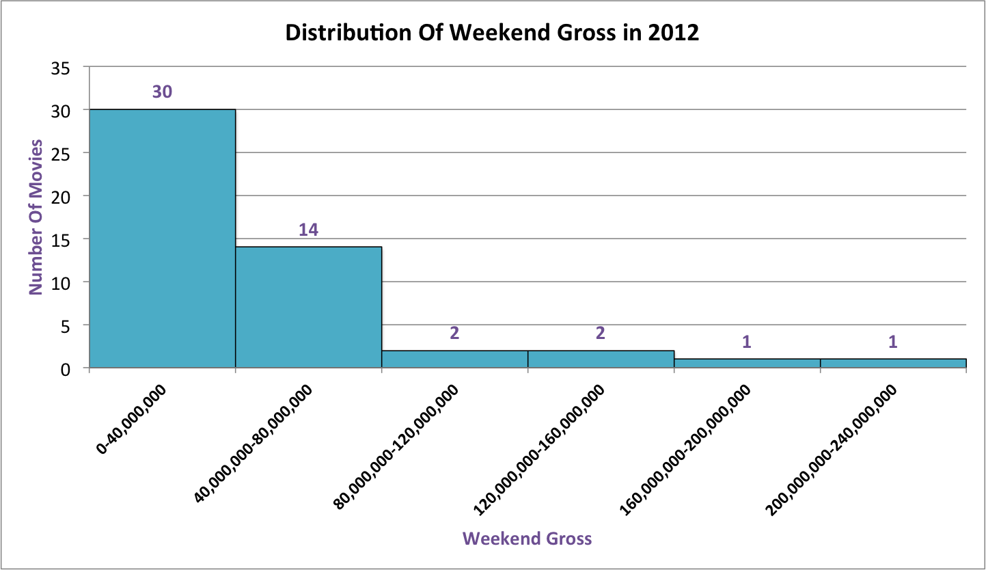

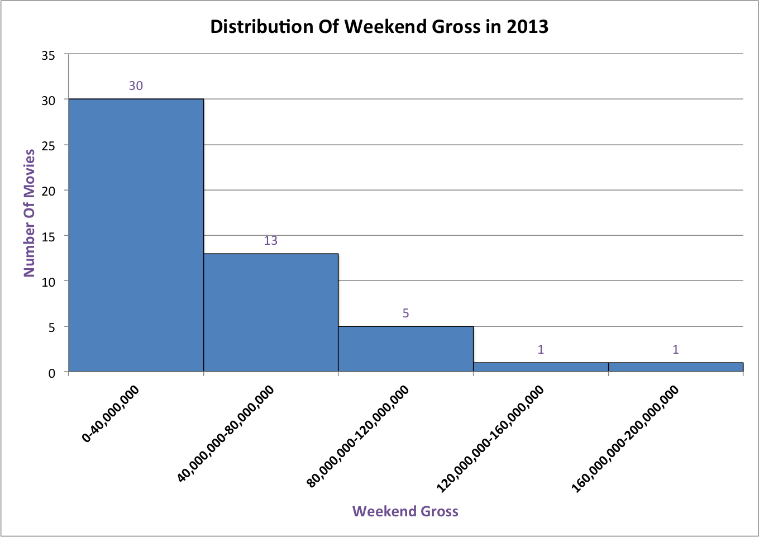

(3) Use statistical graphics to answer two questions of your own making

First question: Analyzing the top 50 movies of the 2012 and 2013 movie season, how did the number of movies of different studios in 2012 compare to the number of movies of different studios in 2013?

As shown in the histogram, the movies produced by Warner Bros, Sony/Columbia and Universal occupy the most part in the total number of movies. Compared to 2012, Buena Vista, Warner Bros, Paramount and FilmDistrict experienced a growth in the number of movies in 2013,while Lionsgate, Universal, Weinstein, Fox and Relativity experienced a decline in the number of movies in 2013.

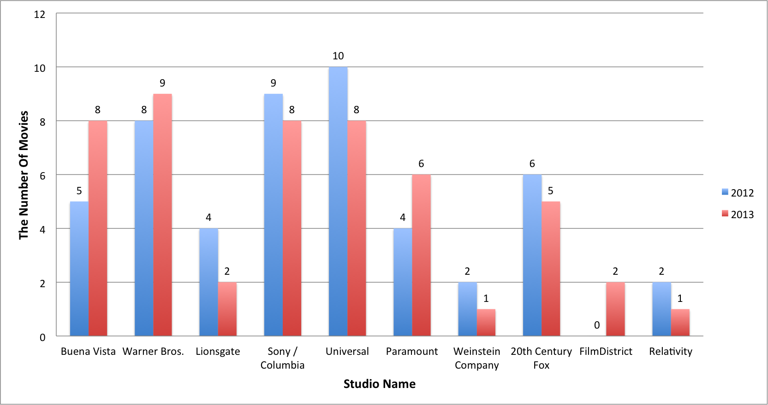

Second question: Analyzing the top 50 movies of the 2013 movie season, how did the total sum gross of studios compare to each other?

As for the total gross , Buena Vista ,Warner Bros and Universal are the top3 in 2013.

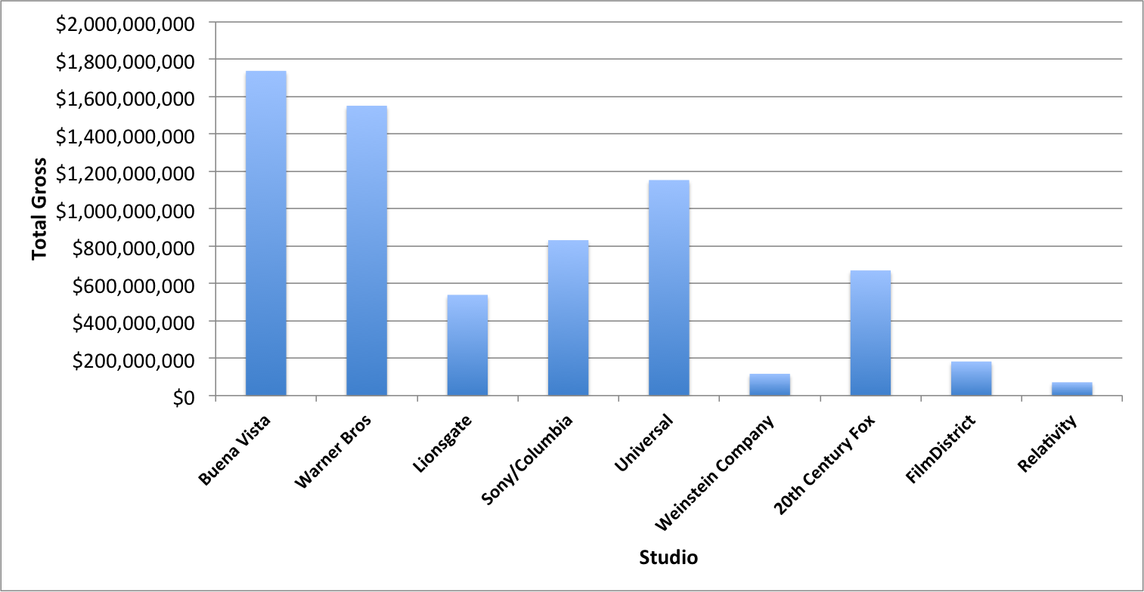

(4) Compare the average gross distribution of each category nominees between 85th and 86th academy awards.

As shown in the histogram, the Best Visual Effects nominees are the most popular movies in both years. And compared to 85th,the average gross of Best Animated Feature nominees has a significant improve in 86th. Overall, compared to 85th, the average gross in all of the other categories experienced a decline in 86th except Best Original Song, Best Animated Feature, Best Director and Best Actress. Therefore, we can simply conclude that the 85th academy awards nominees are more popular with audiences.

