**CSE591 Assignment4**

**Name:Ersi Zha Id:1206169363**

**Dataset:**

I utilized excel to normalize the given data. I found the census data from the Arizona’s government workforce web site:

<http://www.workforce.az.gov/pubs/demography/April1_2010Population.pdf>

My final dataset contains these following variables: the country name, the total marriage number per month, the marriage rate per month, the total marriage number per county, the total population per county and the total marriage rate per county. And the reason why I added AZ after the county name is that there are some counties in other states have the same name with some counties in Arizona.

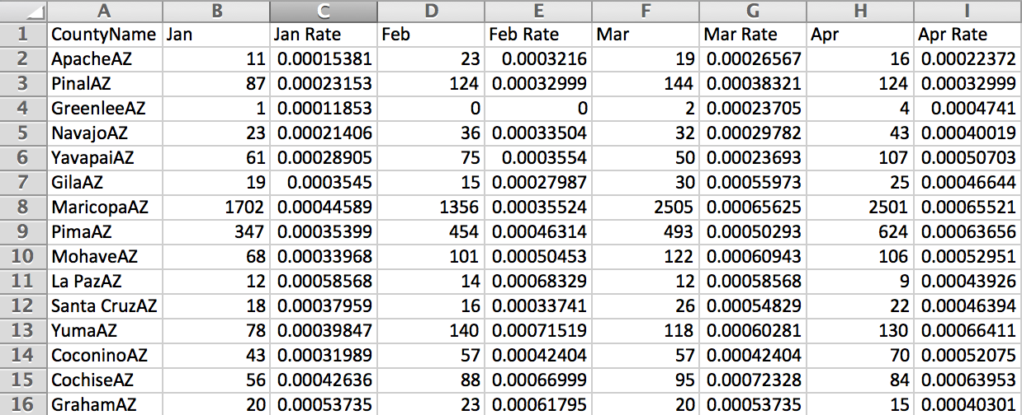

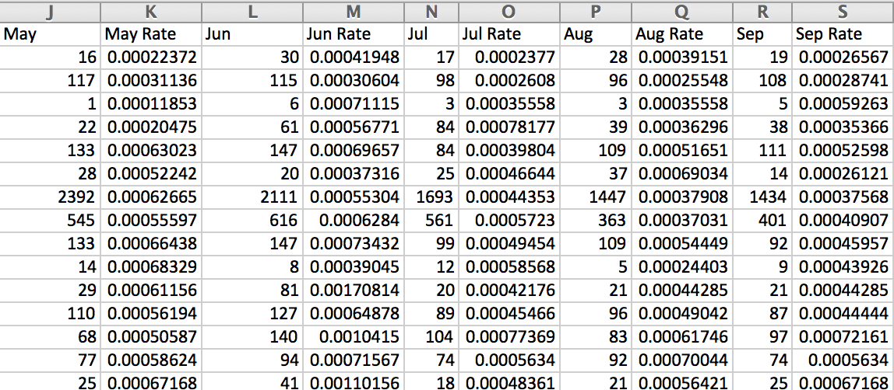

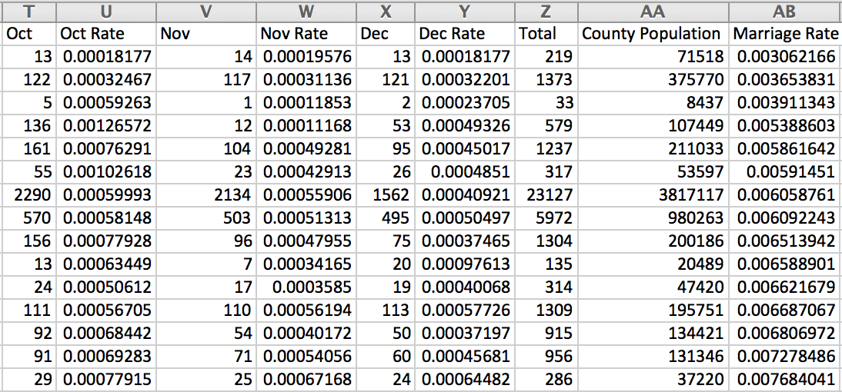

**Question1:**

I utilized GeoCommons to upload my normalized data to generate the choropleth map and I chose equal interval classification as the classification scheme.

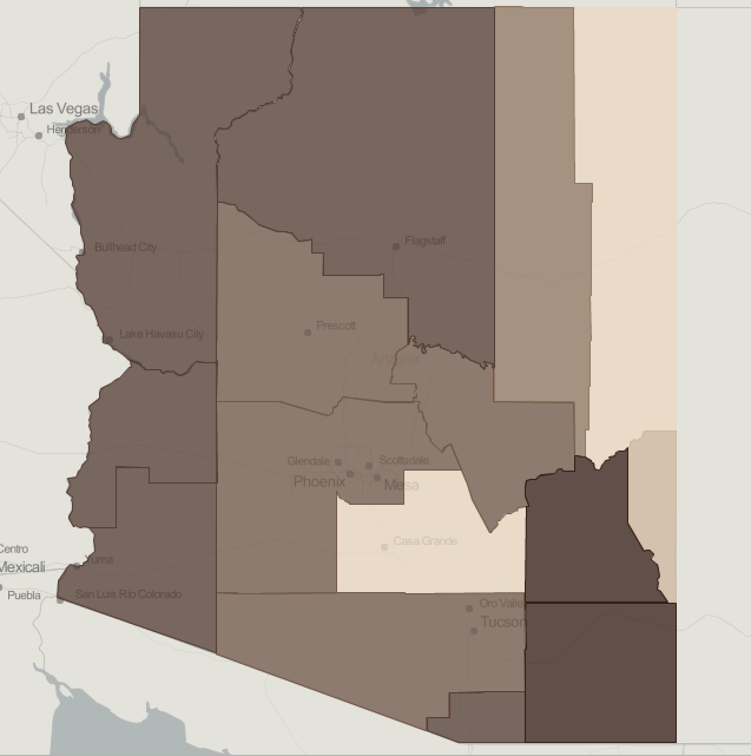

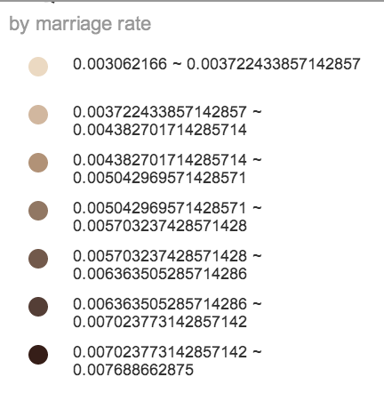

**Question2:**

I utilized GeoCommons to upload my normalized data to generate the choropleth map and I chose quantile classification as the classification scheme.

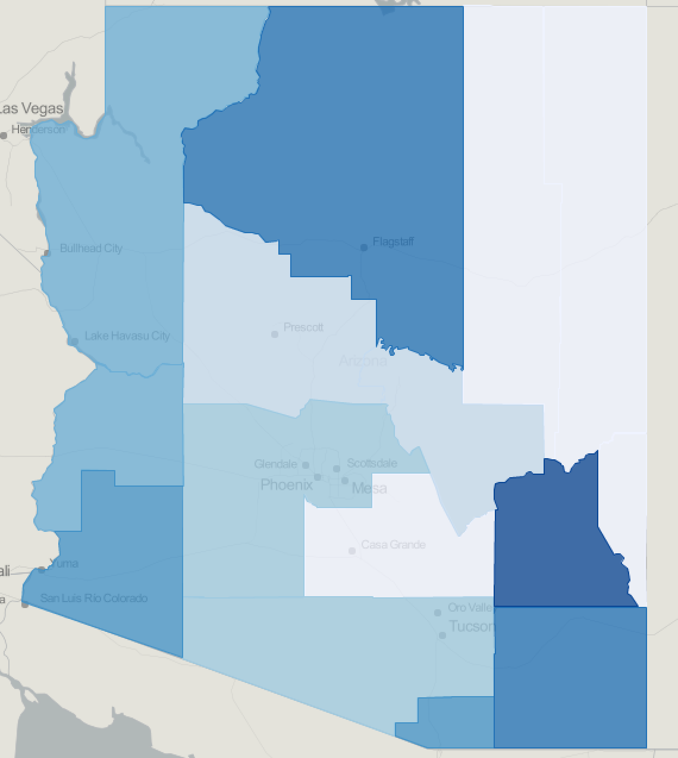

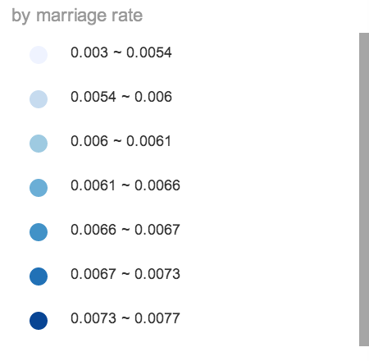

**Question3:**

For question 3 I chose equal interval classification to classify the data. How did I classify the data given the temporal nature? I calculated the marriage rate per month for each county in excel and used the dataset to generate 12 choropleth maps to show the marriages per month.

Why did I choose equal interval classification over quantile classification? I found that the data (marriages rate per month of different counties) are familiar. In my opinion, equal interval classification is better to classify familiar data ranges, whereas quantile classification is more useful for ordinal data.

