1. **Milestone4 video on Youtube:**

<https://www.youtube.com/watch?v=yDXeoGSq8PU&feature=youtu.be>

2. **Working executables**:

Project environment: WebStorm 7.0+Chrome/Safari/Firefox

Generally, users can open the index.html in our source code to view our system in browser.

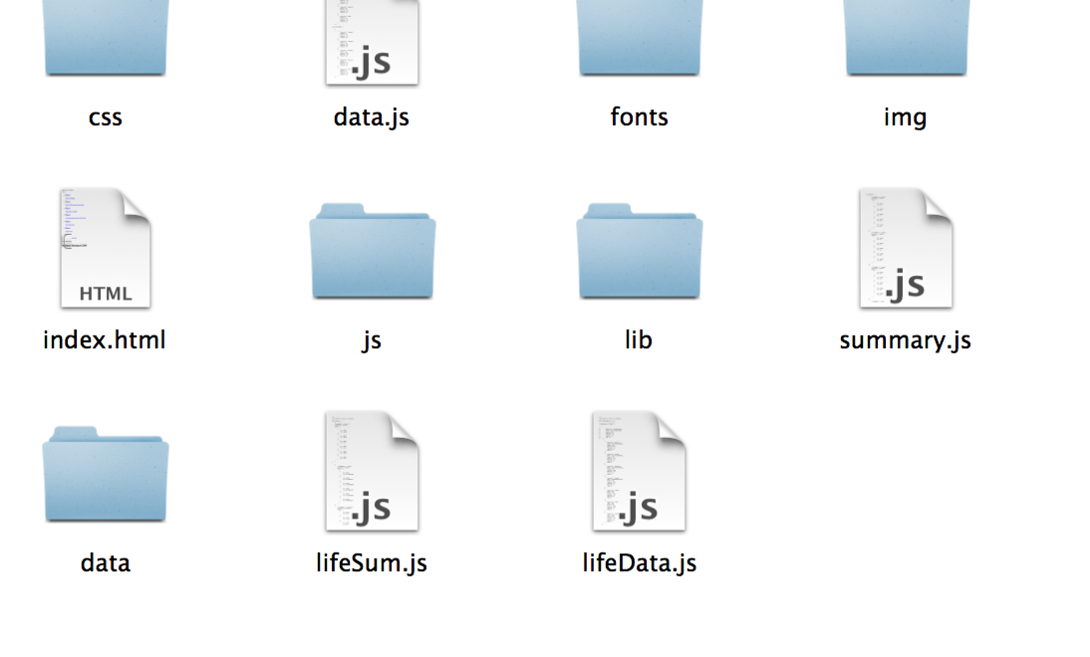

However, some animation in system can only be displayed by running in WebStorm environment:

1. In WebStorm: File->Open Directory->Choose our source code folder

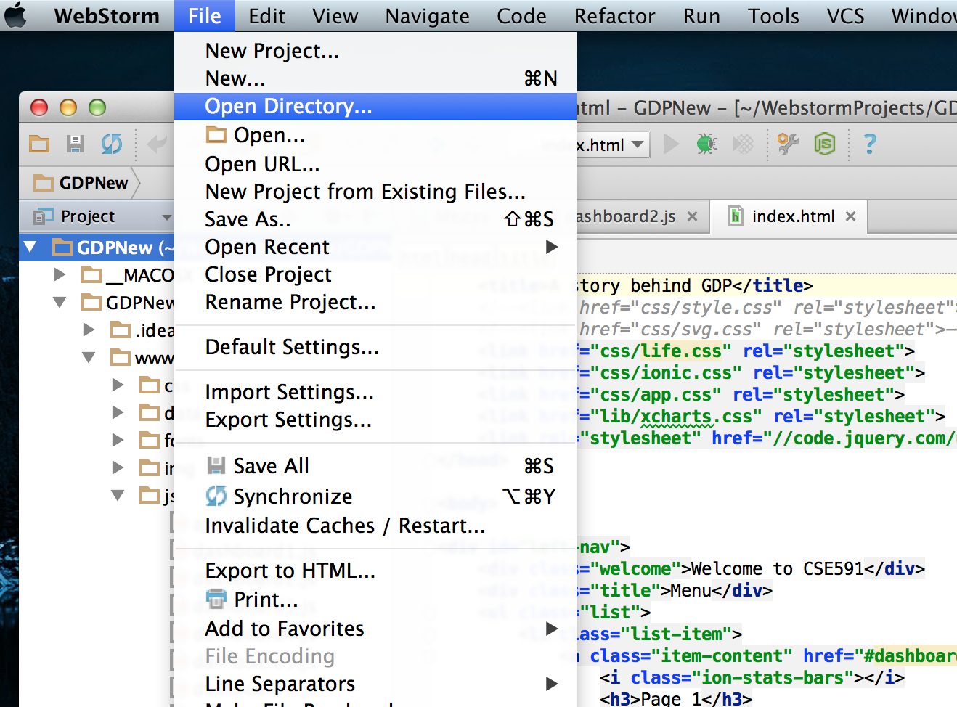

1. Choose index.html->Right click->Open in Browser

