LBSC 690 Final Exam Fall 2007

Name: ________________________________________________

You have 150 minutes to complete this exam. Time will begin as soon as you start reading the first question.

- You may use any material, including the text book, lecture slides, and notes. You may also use anything found on the Internet that existed before the exam started.
- You may NOT communicate with any other person during this exam.

As strategies for completing the exam, keep in mind the following:
- If you find a question to be ambiguous, make reasonable assumptions as you see fit, but write down your assumptions.
- You are more likely to get partial credit for a wrong answer if you show your work.
- Be careful not to get carried away and spend too much time on one question. Plan ahead, and don’t devote more time to a question than it is worth.

Please write your answers in the space provided.

Score Summary (for use by grader)
Question | Possible points | Actual points
1 | 10
2 | 15
3 | 25
4 | 10
5 | 20
6 | 20
TOTAL | 100

1. [10 points total] Multimedia. Let’s say you are shopping for digital cameras and are comparing 8 megapixel cameras to 10 megapixel cameras. You know what a pixel is (from Lecture 9) and you know that the megapixel rating describes the number of pixels in the sensor inside the camera that captures the image.

So, the more pixels, the better, right? You ask a friend for advice, and she says, “Nahh, if you’re just going to print standard 4x6 photos, 8 versus 10 megapixel cameras aren’t going to make much of a difference.”

A. [5 points] Is she right? Explain in terms of properties of the human perception system discussed in Lecture 9.

However, your friend is quick to add “But if you’re thinking of printing 8x10 photos or larger, then go with as many megapixels as you can afford.”

B. [5 points] Once again, is this good advice?

2. [15 points total] Information Retrieval. This question is about inverted indexes, which we discussed in Session 11. For any inverted index built from a collection of documents:

A. [3 points] How many rows are there going to be? (describe in terms of characteristics of the collection)

B. [3 points] How many columns are there going to be? (describe in terms of characteristics of the collection)

Let’s say I add one more document to the inverted index:

C. [4 points] How is the number of columns going to change?

D. [5 points] How is the number of rows going to change?

3. [25 points total] Database design.

A. [10 points] Design a relational database for storing bibliographic entries such as the following:

Dina Demner-Fushman and Jimmy Lin. Answering Clinical Questions with Knowledge-Based and Statistical Techniques. Computational Linguistics, 33(1):63-103, 2007.

To make the task more tractable, focus only on standard journals (with volume, number, pages, year). Sketch out your table structure with a few sample citations.

B. [5 points] Describe the SQL query you would execute to find out the titles of all of my publications.

C. [6 points] It would also be a good idea to assign topic descriptors to research articles. For example, consider the following fragment from a hypothetical topic hierarchy:

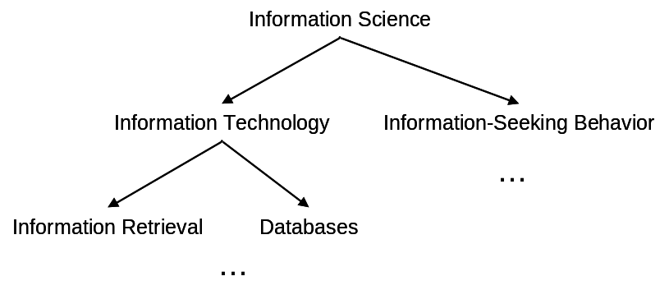
Design a database that would be able to store hierarchically-arranged topic descriptors such as the example above. Focus only on the hierarchy itself; don’t worry about the actual part of assigning topics to articles. HINT: you can do this with one table.

D. [4 points]
Describe the SQL query you would execute to find the parent of a particular descriptor.
Describe the SQL query you would execute to find the children of a particular descriptor.
4. [10 points total] Moving bytes around, again… Let’s say I’m able to move 1 MB of data from point A to point B in 10.2 seconds.

A. [4 points] If I know my latency is 0.2 seconds, what’s my transfer rate?
You can assume that 1MB = 1000KB.

B. [3 points] How long will it take to transfer a 5 MB file?

C. [3 points] How long will it take to transfer a 2 byte file? (it says, “Hi”)

6. [20 points total] XML, again. The Poughdunk County library system prides itself on being a technologically-sophisticated operation. For example, it uses an XML standard to store catalog records. Recently, Ben Bitdiddle, head of IT services, had the idea of augmenting the catalog records with the size of the books, to feed into some new fancy shelving algorithm. He came up with something like this:

<size>
<height>11 inches</height>
<width>8.5 inches</width>
<thickness>1.75 inches</thickness>
</size>

It seemed like a good idea until entries like the following started showing up in catalog records (excerpts):

- … <thickness>1 inches</thickness>…
- … <height>8.5 in</height>…
- … <height>14 ½ in.</height>…
- … <width>5’</width>…
- … <width>25 cm</width>…

You’ve been hired as a high-powered consultant (haha) to fix the problem.

A. [5 points] What is one problem with inconsistently-formatted values?

B. [5 points] You look at the Web-based interface for data entry designed by Ben Bitdiddle. It looks like this:

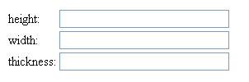
Why is this a poorly-designed interface?

C. [5 points] Describe a purely interface-based solution to the problem.

D. [5 points] Revise the above XML so that size can be captured in a more consistent manner. That is, show what a better XML standard might look like.

6. [20 points total] JavaScript.

The funny operator % (called “modulo”) gives you the remainder of a division operation. So, for example:

- 4 % 3 = 1, since you get one left over when you divide 3 into 4
- 5 % 3 = 2, since you get two left over when you divide 3 into 5
- 6 % 3 = 0, since 3 divides evenly into 6

A. [4 points] Consider the following function:

function bar(i) {
if ( i % 2 == 0 ) {
return true;
} else {
return false;
}
}

What is the result of bar(1)?
What is the result of bar(2)?
What is the result of bar(3)?
What is the result of bar(4)?

B. [2 points] The function bar tells you if the number is what? (That is, what property of the number does the function test for?)

C. [7 points] What is the output of the following code?

var i = 0;

for ( i=1; i<=10; i++ ) {
if ( bar(i) ) {
document.writeln("tock\n");
} else {
document.writeln("tick\n");
}
}

D. [7 point] Write a Javascript function to test if a number is evenly divisible by both 3 and 5.

