LBSC 690 Final Exam Spring 2007

Name: ________________________________________________

You have 150 minutes to complete this exam. Time will begin as soon as you start reading the first question.

- You may use any material, including the text book, lecture slides, and notes. You may also use anything found on the Internet that existed before the exam started.
- You may NOT communicate with any other person during this exam, either in person or using electronic means.

As strategies for completing the exam, keep the following in mind:
- If you find a question to be ambiguous, make reasonable assumptions as you see fit, but write down your assumptions.
- You are more likely to get partial credit for a wrong answer if you show your work.
- Be careful not to get carried away and run over the time limit by spending too much time on one question. Plan ahead, and don’t devote more time to a question than it is worth.

Please write your answers in the space provided.

Score Summary (for use by grader)
Question | Possible points | Actual points
1 | 10
2 | 10
3 | 25
4 | 20
5 | 10
6 | 25
TOTAL | 100

1. [10 points total] Search. In class, we discussed how polysemy is a problem in search. Is this problem more or less severe for multi-word queries, compared to single word queries?

2. [10 points total] Multimedia.

A. [5 points] Check out the following picture:

http://www.umiacs.umd.edu/~jimmylin/images/photos/stata-graduation.jpg

It is a picture from my graduation, where I was decked out in MIT regalia. The image is 800 by 600 pixels in 24-bit color (8 bits for R, 8 bits for G, and 8 bits for B, per pixel). To store all the information contained in this image without any compression, how much space would you need?

B. [5 points] In digitally-encoded video clips, do certain types of scenes require more storage than others? Assume you want constant quality.

3. [25 points total] Database design.

A. [8 points] The research productivity at CLIS has been steadily climbing. It would be a good idea to have a database that stores faculty publications. Design a relational database for storing bibliographic entries such as the following:

Dina Demner-Fushman and Jimmy Lin. Answering Clinical Questions with Knowledge-Based and Statistical Techniques. Computational Linguistics, 33(1):63-103, 2007.

Sketch out your table structure with a few sample citations.

B. [3 points] Describe the SQL query you would execute to find out all of my publications.

C. [10 points] It would also be a good idea to assign topic descriptors to research articles. For example, consider the following fragment from a hypothetical topic hierarchy:

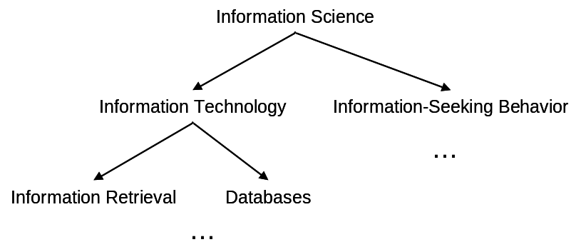

Design a database that would be able to store hierarchically-arranged topic descriptors such as the example above. (Focus only on the hierarchy itself; don’t worry about the actual part of assigning topics to articles). HINT: focus on the parent-child relationship.

D. [4 points]
Describe the SQL query you would execute to find the parent of a particular descriptor.
Describe the SQL query you would execute to find the children of a particular descriptor.

4. [20 points total] JavaScript.

The funny operator % (called “modulo”) gives you the remainder of a division operation. So, for example:

- 4 % 3 = 1, since you get one left over when you divide 3 into 4
- 5 % 3 = 2, since you get two left over when you divide 3 into 5
- 6 % 3 = 0, since 3 divides evenly into 6

A. [4 points] Consider the following function:

function bar(i) {
if ( i % 2 == 0 ) {
return true;
} else {
return false;
}
}

What is the result of bar(1)?
What is the result of bar(2)?
What is the result of bar(3)?
What is the result of bar(4)

B. [2 points] The function bar tells you if the number is what? (That is, what property of the number does the function test for?)

C. [7 points] What is the output of the following code?

var i = 0;

for ( i=1; i<=10; i++ ) {

if ( bar(i) ) {
document.writeln("tock\n");
} else {
document.writeln("tick\n");
}

}

D. [7 point] Write a Javascript function to test if a number is evenly divisible by both 3 and 5.

5. [10 points total] System Integration.

Check out Koha, which claims to be the “First Open Source ILS”:
http://www.koha.org/about-koha/

Its list of features is here:
http://www.koha.org/about-koha/features/index.html

If you read down the list, one of the bullet points is: “Use as a document manager or digital library.”

Is this feature a good idea in an ILS? Explain why or why not.

6. [25 points total] XML, again. The Poughdunk County library system prides itself on being a technologically-sophisticated operation. For example, it uses an XML standard to store catalog records. Recently, Ben Bitdiddle, head of IT services, had the idea of augmenting the catalog records with the size of the books, to feed into some new fancy shelving algorithm. He came up with something like this:

<size>
<height>11 inches</height>
<width>8.5 inches</width>
<thickness>1.75 inches</thickness>
</size>

It seemed like a good idea until entries like the following started showing up in catalog records (exerpts):

- … <thickness>1 inches</thickness>…
- … <height>8.5 in</height>…
- … <height>14 ½ in.</height>…
- … <width>5’</width>…
- … <width>25 cm</width>…

You’ve been hired as a high-powered consultant (haha) to fix the problem.

A. [4 points] First, what’s the problem with having size entered in a variety of formats?

B. [5 points] You look at the Web-based interface for data entry designed by Ben Bitdiddle. It looks like this:

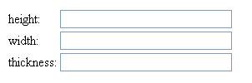

Why is this a poorly-designed interface?

C. [8 points] Describe a purely interface-based solution to the problem.

D. [8 points] Revise the above XML so that size can be captured in a more consistent manner. That is, show what a better XML standard might look like.

