網路概論 作業三

資工三乙

408262143

林采昕

ICMP:

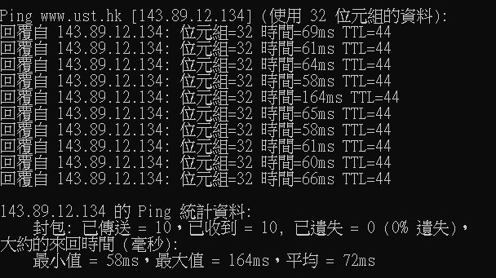

1. The IP address of my computer is 192.168.1.101.The IP address of the destination host is 143.89.14.34.

2. The ICMP packet does not have source and destination port numbers because it was designed to communicate network-layer information between hosts and routers, not between application layer processes. Each ICMP packet has a "Type" and a "Code". The Type/Code combination identifies the specific message being received. Since the network software itself interprets all ICMP messages, no port numbers are needed to direct the ICMP message to an application layer process.

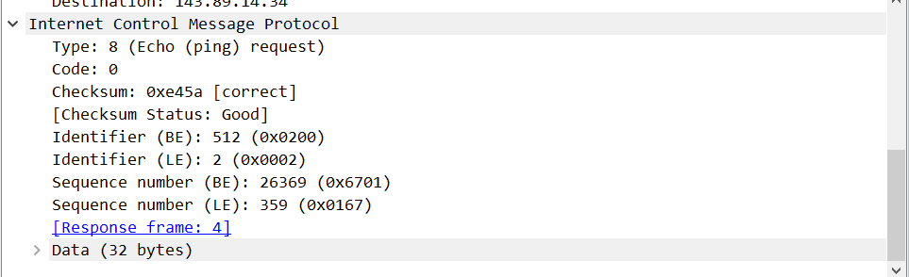

3. The ICMP type is 8, and the code number is 0. The ICMP packet also has checksum, identifier, sequence number, and data fields. The checksum, sequence number and identifier fields are two bytes each.

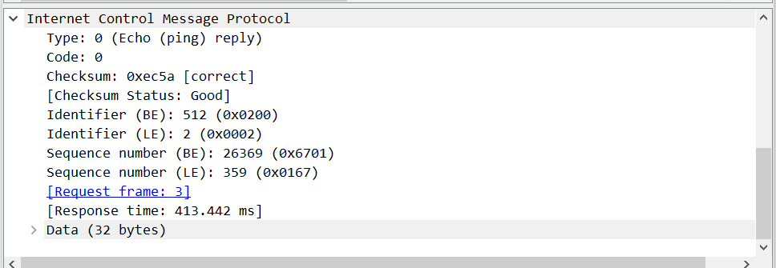

4. The ICMP type is 0, and the code number is 0. The ICMP packet also has checksum, identifier, sequence number, and data fields. The checksum, sequence number and identifier fields are two bytes each.

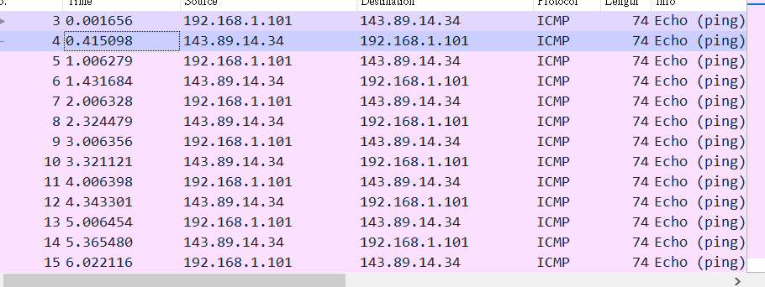

5. The IP address of my host is 192.168.1.101. The IP address of the destination host is 138.96.146.2.

6. No. If ICMP sent UDP packets instead, the IP protocol number should be 0x11

7. The ICMP echo packet has the same fields as the ping query packets.

8. The ICMP error packet is not the same as the ping query packets. It contains both the IP header and the first 8 bytes of the original ICMP packet that the error is for.

9. The last three ICMP packets are message type 0 (echo reply) rather than 11 (TTL expired). They are different because the datagrams have made it all the way to the destination host before the TTL expired.

IP:

1. The IP address of my computer is 192.168.1.101. 2.

The ICMP packet does not have source and destination port numbers because it was designed to communicate network-layer information between hosts and routers, not between application layer processes. Each ICMP packet has a "Type" and a "Code". The Type/Code combination identifies the specific message being received. Since the network software itself interprets all ICMP messages, no port numbers are needed to direct the ICMP message to an application layer process. The value in the upper layer protocol field is ICMP

3. the header length is 20 bytes and the total length is 56 bytes. Therefore, the payload of the IP datagram should be 36 bytes.

4. the more fragments bit = 0, so the data is not fragmented.

5. Time to live and Header checksum always change.

6. The fields that stay constant are: Version (since we are using IPv4), header length (since these are UDP packets), source IP (since all packets are sent from my computer), destination IP (since we are sending to the same host), Differentiated Services (since all packets are UDP), Upper Layer Protocol (since these are UDP packets) The fields that must stay constant are: Version (since we are using IPv4), header length (since these are UDP packets), source IP (since all packets are sent from my computer), destination IP (since we are sending to the same host), Differentiated Services (since all packets are UDP), Upper Layer Protocol (since these are UDP packets) The fields that must change are: Identification (IP packets have different ids), Time to live (traceroute increments each packet), Header checksum (since header changes)

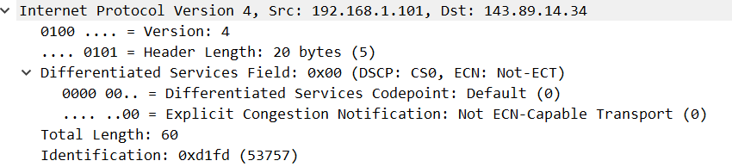

7. The first request, values in the identification: 53757

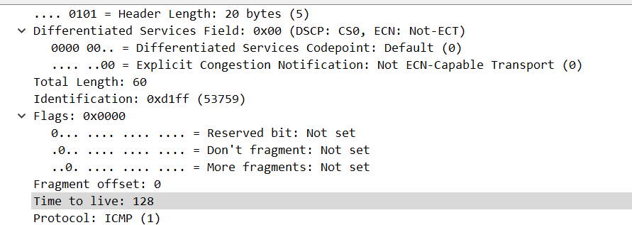

The second request, values in the identification: 53759

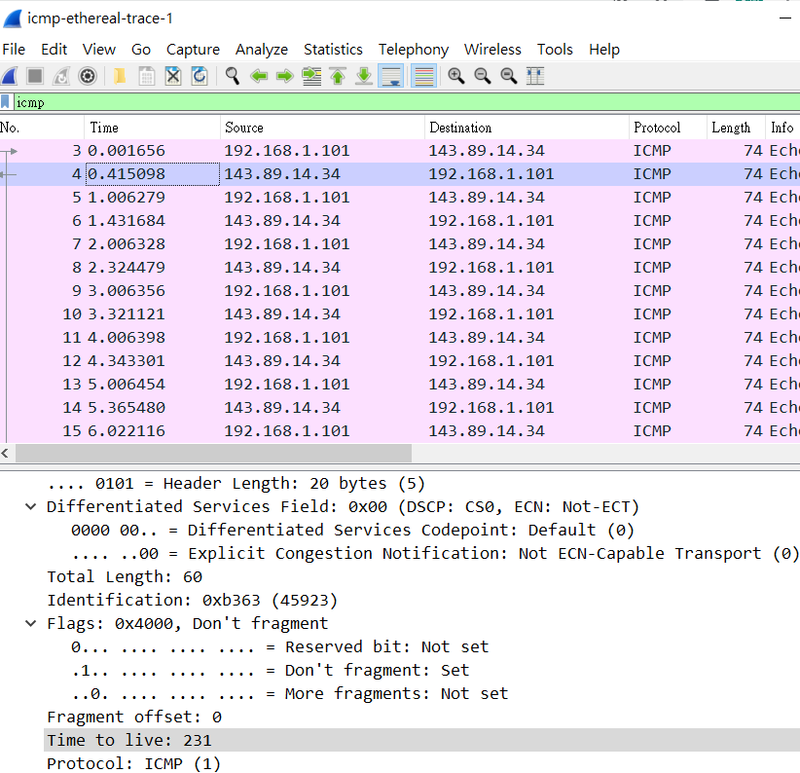

8. Identification: 45923, TTL: 231

