Predictive Analytics in Healthcare: A Stacking Ensemble Machine Learning Framework for Diabetes Classification

K Linu Priyanth, G Sivamani, R.Renugadevi, Y. Srinivas, V.Venkata Karthik , Mushini Srikanthakumari
1-5 Department of CSE, Vignan’s Foundation for Science Technology and Research, An-
dhrapradesh, India,522213
6 Department of Management Studies, Vignan’s Foundation for Science Technology and Re-
search, Andhrapradesh, India,522213
linupriyanth418@gmail.com, gurramsivamani743@gmail.com, rrd_cse@vignan.ac.in, yasarapusrinivas1207@gmail.com, mr.karthikvelpula@gmail.com,srikanthi.mushini@gmail.com

Abstract. Diabetes mellitus is an increasingly rising chronic metabolic disorder requiring immediate prediction of risks to avoid severe health implications. With the advent of more structured clinical data, machine learning techniques emerge as viable solutions in the design of intelligent health care screening systems. The present paper proposes the design of a stacking ensemble-based predictive model for the classification of risks of diabetes mellitus using significant physiological parameters such as glucose levels, body mass index, blood pressure levels, insu- lin levels, age, pregnancy count, and diabetes pedigree function. The paper pro- poses the design of an extensive preprocessing model for the enhancement of the reliability of the proposed model. The paper evaluates the performance of opti- mized ML models such as XGBoost, LightGBM, and Random Forests(RF). The experimental results show the proposed stacking XGB model performs the best with the maximum accuracy of 93.5%. The proposed model outperforms the per- formance of optimized ML models such as XGB, LightGBM, and RF with max- imum accuracy of 92.2%, 90.9%, and 90.9%, respectively. The proposed model ensures the accurate classification of diabetic patients with the help of the pro- posed model.

Keywords: Healthcare analytics, machine learning, ensemble models and dia- betes prediction

Introduction
Diabetes mellitus has come out as one of the most challenging chronic diseases in the 21st century. This disease affects all ages and all socio-economic backgrounds. Di- abetes can be defined as a disease resulting in abnormal glucose metabolism due to insufficient or improper functioning of insulin. This disease has now reached epidemic

proportions. According to global health projections, the number of people diagnosed as diabetic will increase to more than 643 million in 2030. This disease has many Long term complications, including impairment of cardiovascular functions, diabetic nephropathy, neuropathy, amputations, and vision loss. These alarming statistics high- light the importance of early detection and continuous monitoring to prevent disease progression. The traditional methods for detecting diabetes include fasting blood glu- cose levels, oral glucose tolerance tests, and HbA1c tests. These methods are used as gold standards in clinical environments for disease detection. However, these methods can only detect diabetes after significant physiological degradation. Moreover, these screenings may not be feasible for all people due to economic or awareness factors. How-ever, the digital revolution in healthcare services and the availability of structured medical data have opened new vistas for early and accurate risk prediction for diabetes using computational intelligence. ML has proven to exhibit remarkable potential in the field of healthcare analytics by revealing hidden information in complex datasets, ena- bling more accurate clinical decision support tools, and providing personalized risk evaluation tools. Recent advancements in the efficiency and accuracy of the pre-pro- cessing and feature engineering techniques, and the application of the ensemble learn- ing method, have also improved the efficiency and accuracy of the prediction tools. Recent research has proposed the application of classification algorithms such as Sup- port Vector Machines, Random Forest, Gradient Boosting, and Logistic Regression on different diabetes datasets and achieved remarkable accuracy levels. However, the lim- itations associated with the application and implementation of the proposed system in the field have been a concern. For instance, class imbalance, noisy features, and poor generalization have been the main challenges affecting the application and implemen- tation of the proposed system in the field.

In order to address the limitations associated with the application and implementation of the proposed system in the field, the study proposes a robust diabetes prediction system based on a combination of different supervised ML algorithms and the opti- mized stacking method. The proposed system will use different attributes such as age, body mass index, blood pressure, insulin levels, glucose levels, pregnancy count, and diabetes pedigree function. Comprehensive pre-processing and feature selection meth- ods will be used to enhance the accuracy and reliability of the proposed system. By using the proposed system, the accuracy and reliability of the proposed system will be improved. This study will contribute to the field by providing a more efficient and ac- curate diabetes prediction system. This study will provide a more efficient and accurate system for the prediction and management of diabetes in the modern healthcare system.

Related Work
The application of machine learning for predicting diseases like diabetes has become an area of significant interest with an increased incidence of chronic metabolic diseases. The initial studies conducted by Smith et al. [1] were based on predicting PIMA Indians'

diabetic diseases using an ADAP algorithm. The results showed its potential for pre- dicting diseases at an early stage. However, it was limited to a single approach without any enhancements to the preprocessing stage. Another study was conducted by Deepti and Sisodia [2] to explore various classification algorithms for predicting diseases like diabetes. The results showed its potential for predicting diseases like diabetes. How- ever, there was a lack of diversity in terms of methods and enhancements to prepro- cessing. Another study was conducted by Kavakiotis et al. [3] to explore various ma- chine learning and data mining approaches for predicting diseases. However, it was limited to theoretical knowledge without any experimental results.

In recent years, Choi et al. [4] demonstrated the effectiveness of machine learning for predicting diseases. The authors employed deep learning with recurrent neural net- works. Li et al. [5] and Verma and Arvind al. [6] demonstrated the effectiveness of boosting methods like XGBoost and LightGBM for predicting diseases with reduced complexity. Furthermore, the ensemble methods were further explored in the studies carried out by Alharbi and Alsubaie [7] and Padhy et al. [11], which were focused on improving the performance of the classifications. Further studies on comparative and analytical evaluations were carried out by Perveen et al. [8] and Khanam and Foo [9], which were focused on evaluating the performance of various ML algorithms.

Other studies were carried out on the development of automated systems for the detec- tion of diseases by Khanan et al. [10], the development of intelligent prediction models though not focusing on the incorporation of cross-validation. Another feature selection- based approach was developed by Renugadevi et al. [12] focused on the use of boosting algorithms for improving the precision of the results, though not focusing on the incor- poration of meta-learning methods. Finally, Hu et al. [13] focused on the use of stacked ensemble learning for improving the robustness of the results, though not focusing on the prediction of diabetes. From the above studies, it is clear that the ML methods were effective, though there was a need for improving the hybrid ensemble methods.

Problem Identification
Furthermore, diabetes mellitus has been recognized as one of the most important and prevalent chronic health conditions in the world, resulting in several complications like cardiovascular diseases, renal complications, neuropathy, and vision problems. Alt- hough the conventional approaches like the fasting plasma glucose test, glucose toler- ance test, and HbA1c test have been the most common and popular approaches for diagnosing diabetes mellitus, the aforementioned approaches have been able to detect the diseases in the latter stages. Thus, the prediction of the occurrence of the disease in the initial stages has been a major challenge, especially in countries where screening tests cannot be performed. With the increase in the number of EHRs and structured clinical data, the application of ML algorithms has gained significant importance in the domain of predictive healthcare analytics. Nevertheless, the existing research has been found to have several limitations. Most of the research works have been based on the application of a single classification algorithm like logistic regression, SVM, random

forest, etc., without considering the advantages of the application of multiple algo- rithms. Although some research works have been based on the application of multiple algorithms, the stacking architecture has been simple without any optimization. More- over, most of the research works have been based on several limitations like the lack of proper preprocessing techniques. Although the application of a single algorithm has been the most popular approach in the existing research, the evaluation parameters like accuracy have been based on a single criterion without considering the robustness and suitability of the proposed approach.

Contributions of the work
This paper has proposed a stacking ensemble machine learning model for the prediction of diabetic risks. The proposed model has the potential to overcome the limitations mentioned above. The stacking ensemble machine learning model has the potential to handle the complex nonlinear relationships and interactions in the clinical data domain with the help of the powerful machine learning models XGBoost, LightGBM, Random Forest, and Gradient Boosting with stacking XGB. Unlike the conventional model- based techniques, the stacking ensemble model architecture uses the outputs of the basic classifier model and the stacking ensemble model with the help of the logistic regression model. In addition, in order to enhance the quality of the data as well as the reliability of the model, the paper has proposed an extensive preprocessing stage. The stacking ensemble model is found to be more accurate compared to the individual mod- els in terms of accuracy, precision, recall, and F1 score. The comparative analysis is done in a methodological way. The proposed framework is found to have the potential to be used as a reliable decision-making model in the early stage of risk stratification as well as in the planning of preventive medicine because the model is proposed with applicability. The paper proposed an excellent predictive analytics model with the pur- pose of data-driven diabetes diagnosis in the present-day health sector. Proposed Meth- odology.

Proposed Methodology

Data Collection
The proposed framework, as shown in Figure 1, begins with collecting relevant health parameters from publicly available medical repositories such as Pima Indians Diabetes Dataset, etc. As shown in Figure 1, the data sources for patient information can be various wearable devices and sensors, which are utilized for continuous moni- toring of various parameters such as glucose level, insulin level, blood pressure, tem- perature, BMI, heart rate, etc. Upon integrating physiological parameters with demo- graphic information such as age, pregnancy count, and diabetes pedigree function, the dataset is utilized for predictive modeling. The dataset is then divided into two sets for model development and testing.

Data Preprocessing
Prior to the actual training of the model, there is an extensive phase of data prepro- cessing. This phase ensures data integrity, data consistency, and data suitability for analysis. Outliers in the data are identified and removed to prevent bias in the model. Missing values in the dataset are handled by applying appropriate statistical methods such as median or mean replacement. Numerical data is scaled using Min-Max normal- ization or Z-normalization methods. If categorical data is present in the dataset, label encoding is applied to make the data machine-readable. This phase is shown in the below figure 1, where patient data is properly preprocessed.
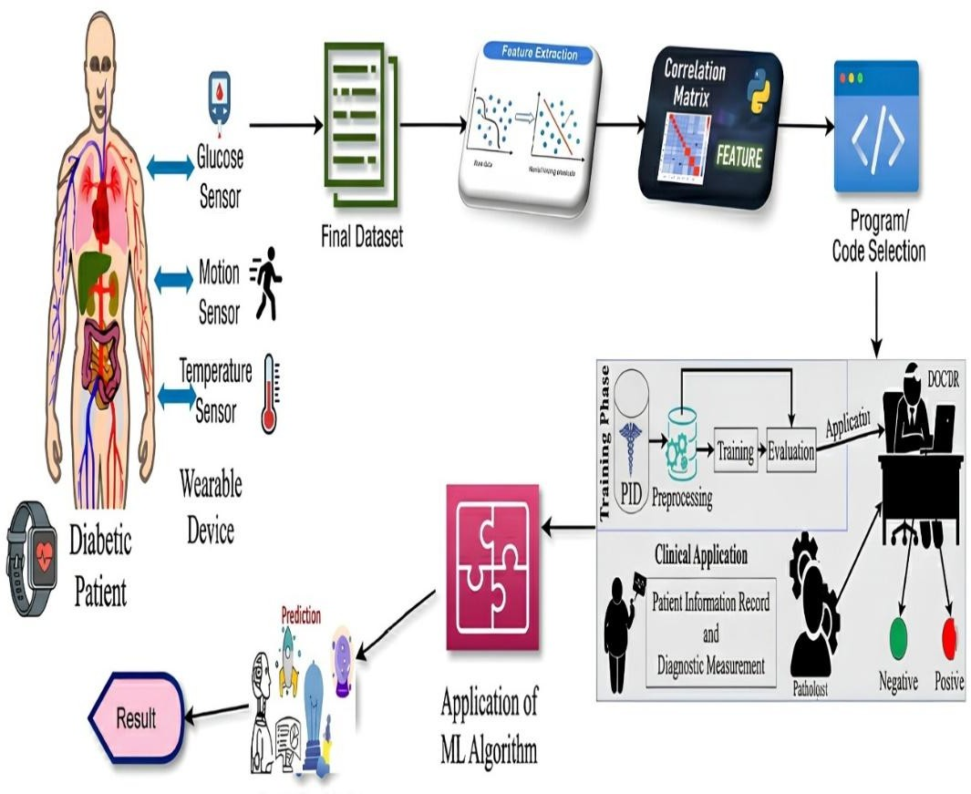
Fig. 1. Architecture of Proposed Model
In figure 1 the workflow involves Physiological parameters such as glucose concentration, body movements and body temperature are acquired from a patient with diabetes using a wearable sensor. This information is processed in the form of a database using feature extraction and correlation analysis methods in order to extract critical features. These processed features are then input into ML algorithms for modeling and evaluation of performance. Once the model has been trained, the algorithm is deployed in practice where doctors make predictions to diagnose patients as positive or negative.

Feature Extraction
This feature extraction method tries to find out the most important factors for pre- dicting diabetes. Recursive Feature Elimination (RFE), correlation methods, and tree- based methods for feature importance scoring are used for finding out the most im- portant clinical parameters such as glucose levels, BMI, insulin levels, and blood pres- sure. This way, the model remains computationally efficient while avoiding risks of overfitting and poor clinical interpretability by eliminating less important features.

Model Development and Training
Following feature selection, different supervised ML models are used to efficiently learn the intricate relationships between the patient attributes and diabetes-related out- comes. The different ML models used include XGBoost, LightGBM, Random Forest, Gradient Boosting, and stacking XGB. Each ML model used in the system has different learning capabilities. The hyperparameters in the system are optimized using cross-val- idation to efficiently learn the decision boundaries and prevent classification errors. As illustrated in the diagram above, the programming stage is the core of the system.

Ensemble Learning Model
In order to obtain significant improvements in robustness as well as the prediction accuracy, the stacking ensemble method is used. The stacking ensemble method com- bines the outputs of all the classifiers. In the case of the stacking ensemble method, the logistic regression classifier is used as the meta classifier. The logistic regression clas- sifier combines the outputs of the individual classifiers. The stacking ensemble method helps in removing the bias associated with the individual classifiers. The stacking en- semble method is essentially a fusion approach that will always work better in compar- ison to the individual classifiers for the purpose of predicting diabetes.

Evaluation and Validation
Accuracy, precision, recall, F1 score, and ROC-AUC score are employed to perform a complete evaluation of the model to ensure performance. Confusion matrix is employed to understand the results better. In order to ensure the stability of the model and avoid overfitting, k-fold cross-validation is incorporated while performing the overall evaluation. This will ensure the comparison of all the classifiers and prove the dominance of the stacked ensemble model.

Ethical Considerations
Furthermore, the data used in this research has been anonymized and meets the eth- ical and medical criteria. The privacy of the patients has been maintained during the entire process. Thus, the proposed approach has ensured the ethical usage of the ma- chine learning model in the medical domain. The proposed architecture for the predic- tion of diabetes has used various steps like data acquisition, preprocessing, feature en- gineering, multi-model learning, and ensemble-based inference. The physiological data acquired from the patients has been preprocessed, and the refined dataset has been ob- tained. In the proposed model, XGBoost, LightGBM, Random Forest, and Gradient Boosting have been used. The output obtained from the models has been combined using the ensemble method. In the ensemble method, the logistic regression model has been used for classification.

Innovation of the Proposed Framework
The proposed model presents a framework for a stacking ensemble method for pre- dicting diabetes risks in a structured and interpretable manner. Unlike traditional meth- ods for predicting diabetes risks based on a single classifier method, the proposed framework presents a comprehensive and integrated framework for a stacking ensem- ble method for predicting diabetes risks. However, the main contribution of the pro- posed model is based on the framework for applying and integrating the stacking ensemble framework for predicting diabetes risks. Unlike tra- ditional methods for applying machine learning algorithms for predicting diabetes risks, the proposed framework presents a comprehensive and integrated framework for applying and integrating machine learning algorithms for predicting diabetes risks. More- over, the proposed framework presents a comprehensive and integrated framework for applying and integrating different boosting algorithms for predicting diabetes risks. These algorithms include the application and integration of XGBoost and LightGBM algorithms for predicting diabetes risks. These algorithms present a comprehensive and integrated framework for applying and integrating the stacking ensemble framework for predicting diabetes risks. Additionally, the proposed framework provides a compre- hensive and integrated framework for the application and integration of the stacking ensemble framework. This framework considers the application and integration of the stacking ensemble framework in the prediction of diabetes risks. These algorithms pro- vide a comprehensive and integrated framework for the application and integration of the stacking ensemble framework in the prediction of diabetes risks. They also provide a comprehensive and integrated framework for the application and integration of the stacking ensemble framework in the prediction of diabetes risks. In addition, the pro- posed framework provides a comprehensive and integrated architecture for the appli- cation and integration of the stacking ensemble framework. This framework considers the application and integration of the stacking ensemble framework in the prediction of diabetes risks. These algorithms provide a comprehensive and integrated framework for the application and integration of the stacking ensemble framework in the prediction of diabetes risks. They also provide a comprehensive and integrated framework for the application and integration of the stacking ensemble framework in the prediction of diabetes risks.

Result and Discussion
The proposed diabetic prediction framework was implemented using the Python pro- gramming language. The implemented framework utilized the Scikit-learn library, XGBoost, LightGBM, Pandas, NumPy, and Matplotlib. Systematic data preprocessing techniques were applied to the data set. The techniques involved in the data prepro- cessing stage were missing data imputation, normalization, and feature selection. The data was then divided into the training/testing set in the proportion of 80:20. The per- formance of the model was evaluated using accuracy, precision, recall, F1 score, ROC AUC score, and 10-fold cross-validation.

Model Comparison Results

Several different supervised ML algorithms were implemented in the proposed dia- betic prediction framework. In figure 2, bar chart illustrates the performance analysis between the five machine learning models; which include Random Forest, Gradient Boosting, XGBoost, LightGBM, and the proposed Stacking XGB model. The performance measure is defined based on test accuracy, ROC-AUC, precision, recall, and F1 score. The boosting algorithms XGBoost and LightGBM were considered the most powerful in terms of prediction because they were capable of minimizing prediction error. The RF models were found to perform well with high resistance to noise. However, the accuracy was slightly compromised because the RF models used bagging rather than boosting. The Gradient Boosting models also performed well. However, the parameters of the model need to be optimized for better convergence.
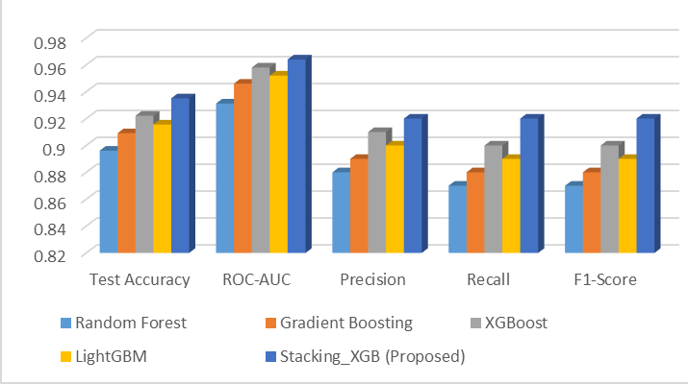
Fig.2. Performance comparison of ML model

The proposed Stacking XGB ensemble outperformed all individual models confirming that integrating heterogeneous learners enhances generalization performance and reduces variance. By combining complementary decision patterns from multiple algorithms, the ensemble achieved improved stability and predictive strength.

Classification Report of the Final Model
The effectiveness of the proposed ensemble model with the use of Stacking XGB is shown in table I. The proposed model based on the stacking model with the inclusion of the XGBoost, LightGBM, and the Random Forest algorithms. From the classifica- tion report shown in the table below, it is therefore clear that the proposed model was able to achieve an accuracy of 93.5%, with the F1-score of 0.92.
Precision and recall values for the class "diabetic" were found to be 92%, which shows high sensitivity to positive cases while maintaining the rate of false negatives low. This is because, in medical diagnostics, missing a case has severe health conse- quences. The Stacking_XGB model was found to have the highest accuracy, i.e., 93.51%, with the ROC-AUC score being 0.9637.

TABLE I. Classification Performance of the proposed model

Model | Test Accuracy | ROC-AUC | Precision | Recall | F1-Score
Random For- est | 0.8961 | 0.9312 | 0.88 | 0.87 | 0.87
Gradient Boosting | 0.9091 | 0.946 | 0.89 | 0.88 | 0.88
XGBoost | 0.9221 | 0.958 | 0.91 | 0.90 | 0.90
LightGBM | 0.9156 | 0.952 | 0.90 | 0.89 | 0.89
Stacking_XGB (Proposed) | 0.9351 | 0.964 | 0.92 | 0.92 | 0.92

TABLE II. Classification performance of the proposed model

Class | Precision | Recall | F1-score | Support
No Diabetes | 0.94 | 0.94 | 0.94 | 50
Diabetes | 0.89 | 0.89 | 0.89 | 27
Macro Avg | 0.91 | 0.91 | 0.91 | 77
Weighted Avg | 0.92 | 0.92 | 0.92 | 77

The classification report in table II shows the accuracy to be 92%. This was also con- firmed by the 10-fold cross-validation score, which was found to be 90.00% ± 2.72%.

Feature Importance and Influential Health Factors
The importance of features was analyzed by tree-based ensemble methods, and the importance was measured based on information gain and split contribution. From the obtained results, it was found that glucose concentration was the most important factor in the prediction of the risk associated with diabetes. This was because glucose concen- tration directly indicates the state of metabolism and is the major clinical indicator of diabetes. Body Mass Index (BMI) was the second most important factor in the predic- tion of the risk associated with diabetes. This was because of the effect of obesity and insulin resistance. Age was also a contributing factor in the prediction, and this was because the prevalence of diabetes increases with age. The function of diabetes pedi- gree indicated the hereditary susceptibility to the disease, and thus the importance of heredity in the prediction.
For instance, the cumulative effect of the high levels of glucose and the high BMI was observed to increase the chances of prediction of diabetes much more than the effects of the parameters separately. The facility to model the interactions between the param- eters makes the performance of the gradient boosting algorithm integrated with the stacking model quite robust.

Discussion and Key Insights
As may be observed from the experimental results, the integration of the structured preprocessing with the ensemble learning improves the predictive performance consid- erably in the context of the proposed approach to the problem of diabetes prediction. The stacking ensemble model has demonstrated high accuracy, ROC AUC, and bal- anced performance across classes. Moreover, the model has performed well in terms of

cross-validation. Also, the model has performed well in terms of low false negative rates in the diabetic class. This is very important in decision-making. The results ob- tained from the model show the dominance of the metabolic parameters over the effects of the demographic parameters. The proposed framework has the potential to be used as a robust tool in the early detection of the diabetic condition.

Conclusion
A robust stacking ensemble-based ML framework for the prediction of diabetic risk in humans based on structured clinical and physiological attributes has been proposed in this research. In fact, the proposed system has successfully managed to identify the complex non-linear relationships among different health indicators by utilizing a com- bination of different boosting-based and tree-based classifiers in a meta-learning frame- work, including XGBoost, LightGBM, Random Forest Gradient Boosting, and stacking XGB. In addition, the robustness and consistency of the proposed model have been enhanced by the application of methodical preprocessing steps, including feature selec- tion, normalization, and handling missing values. In fact, the proposed stacking ensem- ble has achieved better performance compared to individual classifiers, as validated in the experimental evaluation, in terms of robust ROC-AUC scores and high classifica- tion accuracy. In fact, the capability of the model in reducing false negatives, which is a crucial requirement for clinical screening purposes, has been validated by the high precision and recall values for both diabetic and non-diabetic classes.
From the experimental evaluation, it has been clearly demonstrated that the stacking ensemble method has outperformed the other classifiers in the context of high classifi- cation accuracy and high values of ROC-AUC scores. Additionally, the high values of precision and recall for the diabetic and non-diabetic classes confirm the capability of the model to minimize false negatives, which is a significant requirement for screening purposes. Based on the analysis of the importance of features, it has been identified that the glucose concentration and body mass index features have the highest impact on the model, followed by the age and genetic predispositions, which are well justified by medical science.
The proposed framework for the development of a predictive model for the early diagnosis of diabetes has been found to be highly reliable and useful for clinical prac- tice. This study has made a significant contribution to the development of a framework for the development of a predictive model for the early diagnosis of diseases such as diabetes using the proposed framework for the development of a predictive model in the context of healthcare analytics.

References
  - Smith JW, Everhart JE, Dickson WC, Knowler WC(1988). Using the ADAP Learning Al- gorithm to Forecast the Onset of Diabetes Mellitus. Proc Annu Symp Comput Appl Med Care. Nov 9:261–5.

  - Sisodia Deepti & Dilip Singh Sisodia,(2018). Prediction of Diabetes using Classification Algo-rithms, Procedia Computer Science, Volume 132, Pages 1578-1585,ISSN 1877-0509.
  - Kavakiotis I, Tsave O, Salifoglou A, Maglaveras N (2017). ML and Data Mining Methods in Diabetes Research. Comput Struct Biotechnol J. Jan 8;15:104-116.
  - Choi E, Schuetz A, Stewart WF, Sun J(2017). Using recurrent neural network models for early detection of heart failure onset. J Am Med Inform Assoc. Mar 1;24(2):361-370.
  - Li W, Peng Y, Peng K(2024). Diabetes prediction model based on GA-XGBoost and stack- ing ensemble algorithm. PLoS One. Sep 30;19(9):e0311222.
  - Seema Verma and Arvind Pandey(2025). Optimized LightGBM model for diabetes pre- diction, Journal of Scientific Progress and research, vol. 83,No 01, Issue 227.
  - A. Alharbi and N. Alsubaie(2021). Ensemble learning approach for diabetes classification, IEEE Access, vol. 9, pp. 78901–78912.
  - Padhy S, Dash S, Routray S, Ahmad S(2023). IoT-Based Hybrid Ensemble Machine Learn- ing Model for Efficient Diabetes Mellitus Prediction. Comput Intell Neurosci. May 18.
  - Sajida Perveen, Muhammad Shahbaz,Aziz Guergachi(2016). Performance analysis of data mining classification techniques to predict diabetes. Procedia Comput. Sci., vol. 82, pp. 115– 122.
  - S. Khanam and S. Y Foo(2020). A comparison of ML algorithms for diabetes prediction, ICT Express, vol. 6, no. 4, pp. 432–439.
  - Jobeda Jamal Khanam, Simon Y Foo(2018). A comparison of machine learning algorithms for diabetes prediction, CT Express, Volume 7, Issue 4,Pages 432-439.
  - Renugadevi. R, M. Bhargavi and S. Balakrishna (2024). Classifying Skin Lesions: A Survey of Approaches in Skin Cancer Diagnosis. ICPCSN, pp. 264-269.
  - Zhixu Hu, Hang Qiu, Ziqi Su(2020). A Stacking Ensemble Model to Predict Daily Number of Hospital Admissions for Cardiovascular Diseases. IEEE Access 8:138719-138729

