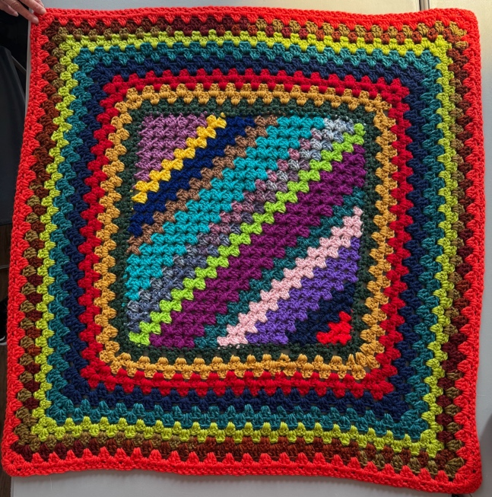
CORNER TO CORNER GRANNY-STITCH BLANKET
Inside a Square Blanket
February 2026 – Cheri Coffren

This is a crocheted blanket using a Double Crochet stitch and Granny Cluster. All are US terms, measures and definitions. This makes a square blanket center using diagonal rows for Granny Clusters, then doing a wide border made of granny rounds like a standard granny square. I used a “J” hook (size 10 or 6mm), and worsted-weight acrylic yarns. This is great for using leftover, colorful yarns.
Beginning / Increasing:
Magic ring, or chain 4; slip stitch to form ring.
Chain 3 (counts as first dc). Work 4 double crochets into circle. You now have 5 double crochets.
Chain 3, turn. Do 3 double crochets in the 1st space, then 4 double crochets in the next space. Chain 3, turn. Do 3 double crochets in the 1st space, in the next space do 3 double crochets (this is the granny cluster). You will do 3 double crochets in each space across the row.

NOTE: You will always have 4 double crochets on the sides or ends of your rows AND your chain 3 always counts as your 1st double crochet. Continue until you want to decrease. Measure your bottom horizontal line for a minimum of 22 inches or 56 centimeters for Project Linus blankets. When your sides are long enough, then you start to decrease.

Decreasing:
After completing a row, chain 3, turn, but instead of working into the 1st space, go into the next space and do the 3 double crochet cluster. At the end of that row do only 1 double crochet, instead of the 4 doubles, in the last space. Chain 3, turn, skip 1st space and do clusters across ending the row with 1 double instead of 4 doubles. Continue decreasing and complete the last granny cluster.

You can look and count to see that your row is reducing clusters on each side. Fasten off, weave in your yarn tails, which I do by leaving a minimum of 8-inch tails and weave in the blankets with a large-eyed tapestry needle.
Wide Border:
Attach a new strand of yarn on any side of your completed Corner-to-Corner center. Do approximately 2 single crochets in every hole around the edge. Some holes may require additional single crochets, that’s fine. At the corners, or where decreasing occurs, I do more single crochets to fit the curve. After single crocheting around, you can start a new color of yarn.

Attach your yarn on any side inside one single crochet and chain 3, work 2 double crochets in the same space. Skip over 2 single crochets and then do 3 doubles in the next single crochet cluster. Continue around, skipping 2 single crochets between clusters. At corners, I have done 2 double crochets, chain 1, then 2 double crochets to make the curve lay flat. You decide what works best.

You will continue using double crochet granny clusters for additional rounds that increase your border. Designate your 4 corners and do 3 double crochets, chain 1, then 3 more double crochets in the same hole. My borders are an average of 5 inches, adding a total of 10 inches (26 cm) to the 22-inch center square, yielding a 32” blanket (minimum size for the Annapolis chapter of Project Linus).

