HiMoDe ANR project - Stochastic reduced-order model for dynamical structures having a High Modal Density

PI: Anas Batou⁽¹⁾
Co-I: Evangéline Capiez-Lernout⁽²⁾, Olivier Ezvan⁽³⁾, Laurent Gargliardini⁽⁴⁾, Christian Soize⁽⁵⁾
Dates: 01/2013 to 11/2016

This Young Investigator project funded by the French National Research Agency (ANR) is interested in the dynamical behaviour of complex structures having a high modal density from the low- to the high-frequency band. As an example, an automobile may have about 20,000 elastic modes in the band [0, 2000] Hz. Two main problems arise when trying to construct a computational model for these structures. The first one concerns the construction of a low-dimension Reduced-Order Model (ROM), the use of the classical elastic modes being clearly prohibited for complex structures. The second problem is related to the presence, in the computational model, of inherent uncertainties that increase with the frequency.
In this project, a general multi-level stochastic ROM (SROM) method has been developed to tackle these issues. It allows to construct a low-dimension ROM for which the very localized non-contributing displacements are filtered. Furthermore, it allows the stochastic fluctuation related to each low-, mid- and high-frequency ranges to be controlled separately. This method has been applied to linear as well as non linear structures.
In collaboration with the company PSA, a SROM of an automobile has been constructed and the parameters of this model have been calibrated using experimental frequency responses measured on 20 vehicles from the same production line. The calibrated SROM allows a good prediction of the random dynamical response in the frequency band [0, 1000] Hz.
This project will terminate at the end of 2016. As possible future research to this project, the coupling of this approach with SEA-like methods could extend the domain of predictability of the SROM to very large frequencies.

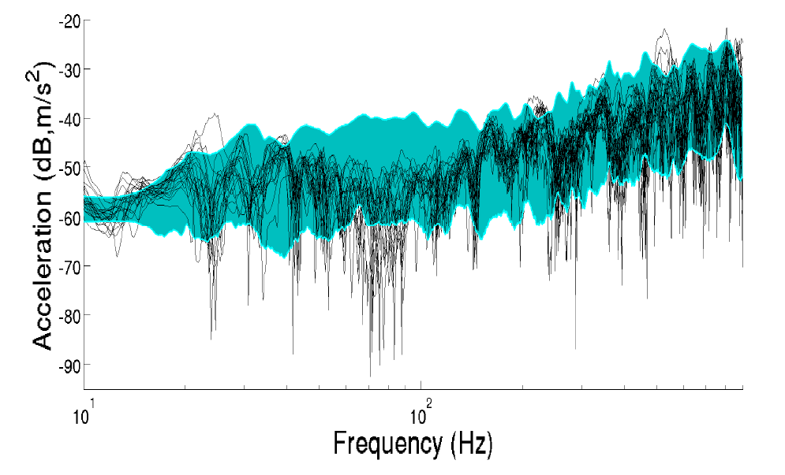
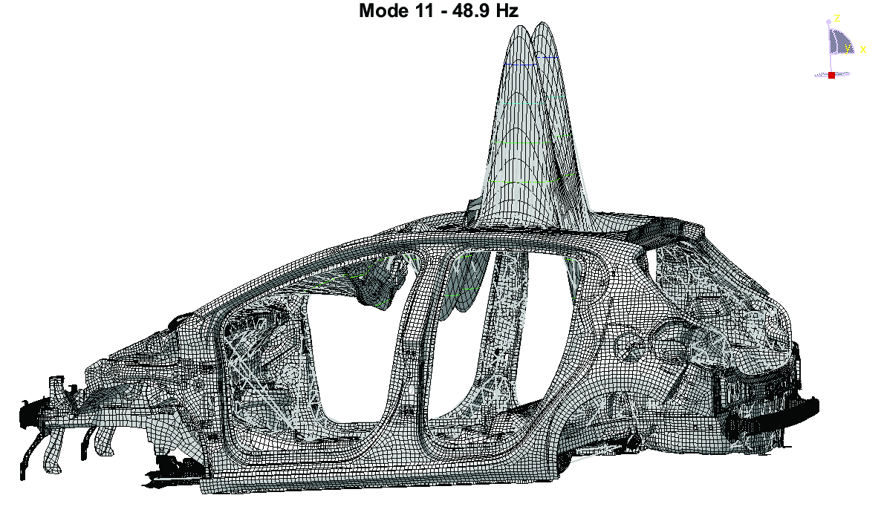
BIW automobile - Example of global mode belonging to the low-dimension Reduced-Order Basis
Experimental FRF measurements (black lines) and random FRF using the SROM (colored region)

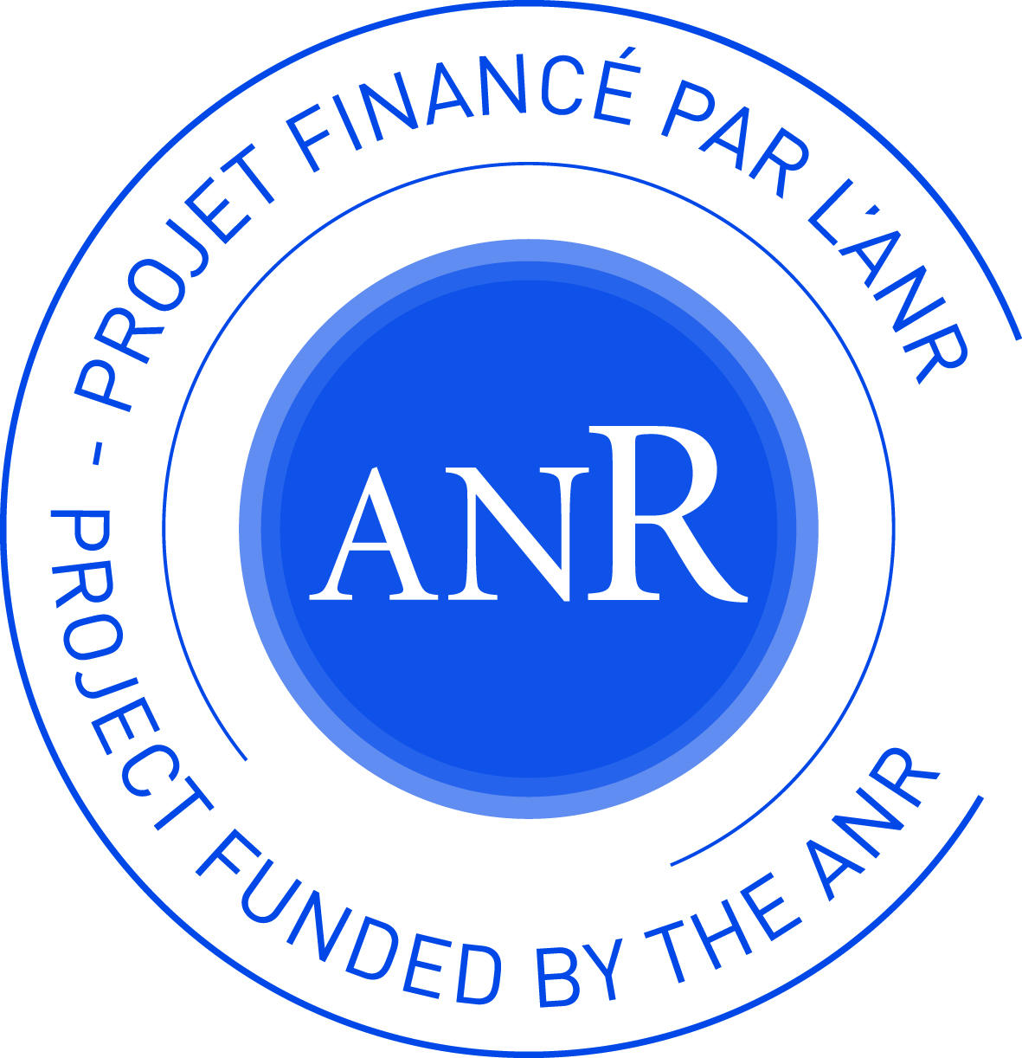

⁽¹⁾ Reader, University of Liverpool (prev. assistant professor, Université Paris-Est Marne-la-Vallée)
⁽²⁾ Assistant professor, Université Paris-Est Marne-la-Vallée
⁽³⁾ PhD student, Université Paris-Est Marne-la-Vallée
⁽⁴⁾ PhD, NVH expert, PSA Peugeot Citroën
⁽⁵⁾ Professor, Université Paris-Est Marne-la-Vallée

Bio :

Dr Anas Batou is member of Liverpool Insitute for Risk and Uncertainty. He gratuated in “Mechanical Engineering” at École Normale Supérieure de Cachan and École Centrale de Paris in 2005. He obtained his PhD at Université Paris-Est in 2008. From 2008 to 2016, he was assistant professor at Université Paris-Est where he got his Habilitation à Diriger des Recherches in 2014. In 2015, he obtained a six-months research associate grant at Centre National de la Recherche Scientific-CNRS. He joined the University of Liverpool in September 2016 as Reader at the School of Engineering.
His research activities are related to: Uncertainty quantification in structural and multibody dynamics, model-order reduction in structural dynamics, vibratory energy mitigation, generation of synthetic accelerograms. His researches include both theoretical aspects and industrial applications in automobile engineering and nuclear civil engineering.

