1. A comprehensive study of dynamic power management (Prateek Brinda) - 2013

The focus of this article is on the various modes of dynamic power management at system level. First of all, hardware parameters that drastically influence power consumption are described, then various methods of minimizing power consumption are detailed and compared.

In the past, three general DPM techniques were used: time out, where the hardware device is shut down depending on how long it is idle (this can be of two types, fixed and adaptive), predictive, where the device is shut down immediately after getting idle if it’s very likely it would otherwise stay so for a long time - under other circumstances it would become highly inefficient since switching the device on and off are energy hungry processes - and stochastic, where a polynomial function is inferred to approximate device’s operating regime, which is then used to optimize power consumption.

Regarding voltage scaling it is mentioned that CMOS gates consume way much more energy during transitions than throughout stable states. Moreover, the power consumed throughout transitions is highly positively influenced by Vdd. Thus, a reasonable approach would be to reduce Vdd, but this would lead to a massive increase in propagation delay which can have catastrophic effects. Therefore, here we encounter a tight trade-off between there parameters.

Regarding related works, two topics are approached.

Firstly, dynamic voltage scaling (DVS) which encompasses a couple of algorithms designed to reduce the power consumption by adapting the clock frequency according to currently running tasks intensity. The first and most important described method is “Adaptive DPM” which predicts by using the exponential moving average the idle time. Therefore, the clock rate is adjusted according to information offered by the DPM predictor. The DPM predictor itself is described as a synergy between three subsystems: counter (which counts the time elapsed between idle time slots), adjuster, which computes an adjusting factor useful for computing the exponential moving average, which is fed to the third module, the basic predictor, which “guesses” the idle time slots. The authors describe their method somewhat efficient since the power mitigation was between 10-27%.

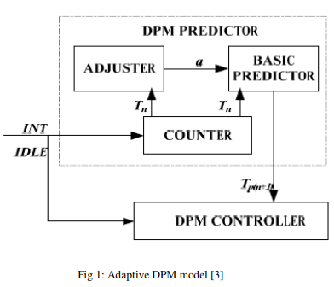

There are other methods described which propose techniques such as fiddling with both supply voltage and clock rate in order to gain a bit of advantage regarding energy consumption, but they are rather prototypes.

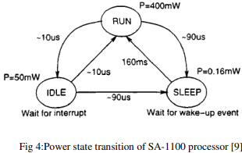

Secondly, dynamic voltage frequency scaling (DVFS), by changing dynamically physical parameters such as supply voltage or frequency in order to avoid energy waste. Within this approach a stretch-to-fit procedure was applied, namely, there is a trade-off between the clock speed and the time required for a batch of tasks to be carried out and the point is to pick up the right combination based on statistical observations.

In the end, all these approaches aim smoothing the workloads by adapting clock rates and/or supply voltages of the modules so that there are as few transitions from one power state to another as possible – when the workloads are overwhelming, the energy consumed by a task should be reduce and vice versa. Therefore, the key ingredient in all the propositions was to keep the CPU “intensity” uniform.

1. A Predictive Dynamic Power Management for LTE-Advanced Mobile Devices (Johnatan Ah Sue) - 2018

In this paper the authors propose a novel method by which LTE-Advanced and 5G mobile devices’ power consumption is mitigated by applying a priori techniques of data traffic predictions.

Up to that point, the vast majority of power consumption optimization methods that addressed data traffic prediction focused on a posteriori algorithms, i.e. static algorithms that did not take into account patterns inferred from previous traffic. In this paper, however, new traffic prediction methods using ML techniques have been introduced.

Beginning with LTE-Advanced which uses orthogonal frequency division multiplexing for communication, all the power management mechanisms are defined in the 3GPP standard, which specifies a useful feature for energy saving, DRX, i.e., discontinuous reception. The problem is DRX cannot be applied during transactions, even if many transactions have no use. For instance, BTS issues periodically signals which are called grants to all UEs (user equipment). How these grants are sent is established by the MAC scheduler whose algorithm isn’t available for UEs. These signals act like semaphores which tell UEs when are they allowed to send or receive data. To be more specific, grants are time schedulers required by OFDM transmission which is implemented by LTE-Advanced and 5G NR. The shortcoming of this method is that the UE cannot infer neither when a grant is going to arrive, nor the type of the grant – it could be either for uplink or downlink, and this information is crucial since switching from an idle state to an active state takes a couple of time, in order to avoid data loss, the UE, after receiving the grant, should keep it’s RF module on because if the freshly received grant alerts a future downlink, it should be prepared for receiving data immediately on the PDSCH (physical downlink shared channel). Therefore, one the one hand, even if the BTS is not sending any grant for a long period to a UE, since UE doesn’t know the MAC scheduler’s algorithm, it has to wait for these signals in vain, and, on the other hand, even if UE doesn’t upload any data, it has to keep alive its RF RX (radio frequency receiver). Thus, if predictive methods are used, UE don’t have to be awake if there are no grants, and, in addition, if an uplink grant is coming, after identifying it, it shouldn’t keep the RF module on after the grant receival. This is illustrated in the below diagram.

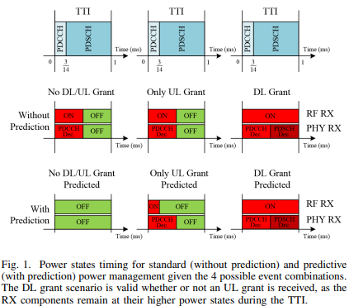

Even if we focused on RX, it is important to have a big picture of the entire system, including its TX, the more the transmission consumes more than the reception due to the power amplifier. To achieve this, the authors proposed the next FSM which encompasses almost all the mechanisms of a LTE-Advanced, and possibly, NR module, where those CTRL (control) states represent abstract components whose power state is always on, PUCCH is PHY (baseband physical layer) uplink control channel (requires less power), PUSCH is PHY uplink shared channel (requires more power since it encompasses all the user sent data).

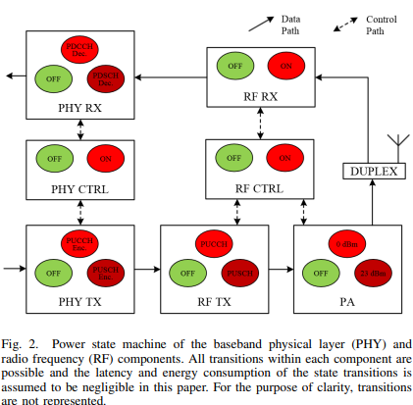

Since MAC scheduler’s algorithms are very complex and usually unavailable to the public, predicting their behavior requires complex ML models as well, such as (NN) neural networks and SVM (support vector machines). For this paper, three types of NN were used, namely, a simple feed forward neural network (a perceptron), an Elman RNN and SVM. Also, as dataset, the authors monitored entire LTE-Advanced networks with lots of UEs in order to avoid overfitting the models – factors such as the distance between the UE and the BTS, handover situations, geographical regions were considered. In the end, the improvement regarding the power mitigation was in some specific situations up to 12%.

1. Adaptive Predictive Power Management for Mobile LTE Devices (Peter Brand) - 2019

Mobile devices used in communications are powered by batteries. To extend the operating time between two battery charges, it is necessary to reduce the power consumption of the device. There are two ways to do this: reducing hardware component consumption and implementing energy management algorithms. The evolution of mobile devices results in increased energy consumption that is not covered by a similar evolution of energy sources (batteries). Moreover, it was found that 65% of the energy consumption is due to modems.

As mentioned in article [2], the monitoring of grants by the UE can be unnecessarily energy consuming as base station’s scheduling algorithms are not known to the UE, therefore UE must monitor in vain traffic coming from BTS. To avoid this, the authors proposed the use of ML algorithms which are trained during the use of the device. However, the training of live models is also power consuming, thus, lightweight, and partially pretrained models are used. As ML techniques the authors propose a supervised learning model on the one hand, and a reinforcement learning one on the other hand. In addition, the performance of the models is measured in this case not only by the accuracy of the classification, but also by the extra energy consumption.

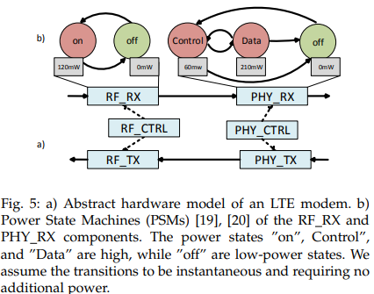

1. Application-driven power management for mobile communication (Robin Kravets) - 2000

At the time the paper was written, power management techniques focused on optimizing the power consumption of peripherals, with the most effective such techniques regarding setting devices idle for specific periods of time when they were not supposed to be used. The authors of this paper, however, considered the optimization of network devices as a priority. Thus, they studied similar power optimization methods applied to modems. Nonetheless, there is a major difference between network devices and ordinary peripherals, since if a mobile device doesn’t show up in the network for a longer time period it could on the one hand lose data which should have been received from other devices, and, on the other hand, the other mobile devices which are trying to reach that UE are wasting energy sending and even buffering radio signals in vain. Another novelty introduced by this paper was the focus on data receival, because up until that point, most transmission optimization techniques tackled data compression before transmission, but, in the end, data compression could consume so much extra energy that it almost overcomes the savings.

The proposed method is based on a master-slave system in which UE is the master and BTS is the slave. The UE must propose to the BTS an idle time schedule in accordance with both the requirements of the applications currently running on the UE and the BTS's MAC scheduler. If the UE stays in idle is too little time, less energy is saved, but, if the time UE stays in idle is too much, there is a risk that excessive data loads are received and since the BTS has no unlimited buffers, it will discard information. That’s why UE’s scheduling technique has to take into account both BTS’s MAC scheduler and current running software application’s behavior. More details regarding this protocol are depicted with the aid of the state diagram below, where IN is an input event which is either a message or a timeout, Q represents the state of the message queue, and OUT indicates outgoing messages.

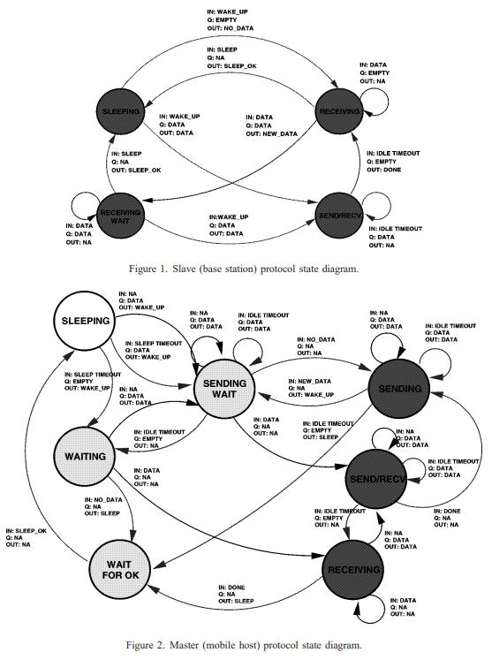

1. Traffic-Aware Techniques to Reduce 3G/LTE Wireless Energy Consumption -2012

The authors proposed a method to mitigate the energy consumption by avoiding keeping the network modem active even when it is not necessary (since it is active almost always if the networking services aren’t disabled). The improvements in terms of energy saving were between 51-66% for 3G carriers, and 67% for LTE carriers. Moreover, when delays were allowed, they were even bigger.

For solving this problem, previously approaches involved switching power states. Nevertheless, transitioning from one power state to another is not useful enough due two 3 main reasons: first, changing the current power state takes time, therefore, it is not feasible to do this if the action is not stable for at least a couple of seconds, second, this operation requires extra energy and eventually, it involves extra signaling (i.e., it is required to announce the BTS about the state change). Consequently, here, a different method is used, namely, distributing workloads in a balanced fashion without substantially degrading software applications’ performance.

Ultimately, this paper brought two contributions.

First, a traffic-dependent controller for power states which encompasses two main algorithms, “MakeIdle”, which uses probabilistic methods for traffic prediction and “MakeActive”, which according to the probability distribution determined by the previous algorithm, takes the decision to delay for a few seconds some activity sessions for some applications which need network access such that the time intervals when the modem needs to be either active or idle is longer, thus reducing the number of transitions and implicitly avoiding signaling and energy waste.

Second, a relevant evaluation of the method on real situations since the experiments were conducted on 9 different users throughout 28 days on 4 different carriers.

Below, we can see depicted the FSM of RRC (radio resource control). Here, t1 and t2 are timers for inactivity kept by the BTS, “Cell_DCH” is the active state, “Cell_FACH” is the high-power idle state, “Cell_PCH” and “IDLE” are known as idle states and RCC_CONNECTED and RCC_IDLE are the only two possible states for the LTE network whose names are self-explanatory. To be more specific regarding the state machine’s functioning, if the BTS sees no activity from a UE maintaining a dedicated channel (Cell_DCH state) for a period longer than t1 second, it will switch it to a low-speed shared channel (Cell_FACH state) which consumes a tiny amount of power. Eventually, if there is nothing active at all for another t2 seconds, BTS will switch the mobile device into either IDLE or Cell_PCH.

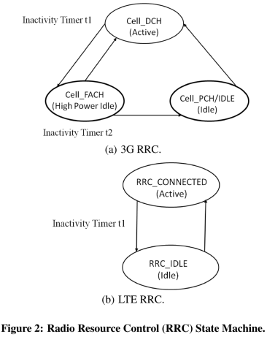

1. Exploiting Predictability in Dynamic Network Communication for Power-Efficient Data Transmission in LTE Radio Systems (Peter Brand) – 2017

The authors study the potential DPM mechanisms which don’t focus on reacting to certain signals, but rather predicts them by using reinforcement learning (the most appropriate ML model from authors’ point of view). The accuracy of the possible system is estimated as reaching a best case of 15% energy savings. As power model, they use a simplified LTE power management FSM as one can see in the figure below.

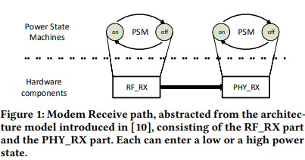

Authors’ motivation to exploit this strategy is fueled by the structure of the mobile data protocols such as LTE-Advanced (and even NR) which are based on a signaling system supported by BTSs which attention all the mobile devices from their areas information regarding metaparameters such as their available timeslots when they could transmit/receive data. The issue is since BTS’s signaling algorithm is not known by the mobile devices from its cell area, they must waste energy in order to listen to potential signals, although they may not arrive or even if they arrive, they don’t carry significant data, but only control messages - i.e., mobile devices must poll the BTS, which is not efficient at all. This idea is developed and implemented in papers [2] and [7] by the same authors.

1. Reinforcement Learning for Power-Efficient Grant Prediction in LTE (Peter Brand) – 2018

This paper is a sequel to [6] (which had no concrete implementation) and [2] (which did not focus on on-line generative methods such as reinforcement learning). It differs mainly from [2] in that it trains in principle live, on the fly, feature specific to any RL model, where the stimuli act like agents which learn to interact with the environment. Therefore, this method is more adaptive, it doesn’t need to be very linked to a specific BTS’s MAC scheduler, thus, the model isn’t necessary to be heavily pretrained on a specific equipment since it learns on the go.

Also, the power model is rather complex compared to the one presented in their first paper, [6].

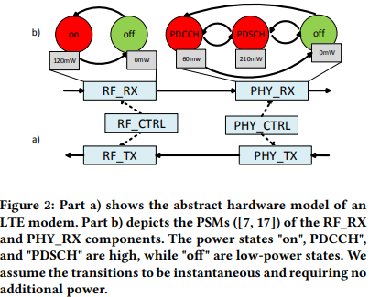

1. Middleware for efficient power management in mobile devices (Ashwini H.S.) – 2006

Within this paper the authors propose a dynamic power management model which has the following features: it’s generic, therefore it’s not tied to a specific hardware platform unlike the most of other DPM models proposed up until that time, it consists of many power states, it conserves the performance of the device and applications which run on the top of it and it varies along with the current battery level so that its optimization algorithm takes into account the remaining stored energy. The experiments conducted for this research topic were held on a mobile device which run a Windows CE version.

Even if DPM is performed by low level APIs which extract information regarding peripherals’ current workloads and power consumption, an interesting outlook would be an HDL implementation of a similar flow of states within an FSM.

1. Dynamic Power Management Using Machine Learning (Gaurav Dhiman) – 2006

This paper doesn’t use only one DPM policy, instead, it picks up the most appropriate one from a pool according to an ML algorithm in order to get the best performance. The authors experimented their methods on mobile devices such as HDDs and WLAN cards, but it should outperform very well on any other mobile device.

DPM represent the selective power down of idle components in order to save energy and depending how are those shut down moments and components chosen there are policies. In principle, there are two main directions regarding DPM policies, stochastic, which are efficient in terms of computational complexity and effectiveness for a specific set of workloads, and heuristic, which are simple to implement and more generic, but require heavy computation. Stochastic methods could vary a lot as well since for different workloads are appropriate different probability distributions. Therefore, the authors propose the use of an ML algorithm – called “controller” - which runs and decides depending on the circumstances what is the best choice – that choice being called “expert”.

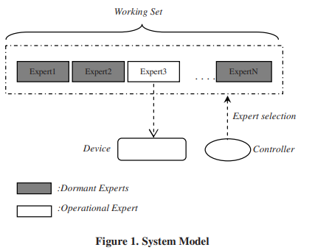

As controller, a Freund and Schapire’s on-line allocation algorithm is used, which is basically a regressional model.

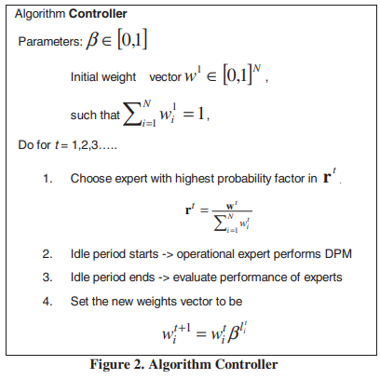

The performance of this approach is better than that of each expert applied as a unique policy for all the workloads.

1. Dynamic Power Management for Wearable Devices with Non-volatile Memory (Chi-Yuan Ha) – 2017

As the computing technology evolved, an increasement regarding both clock frequency and number of copmonents occured, but this facts also made power consumption explode – which involve heating issues as well. Nonetheless, it was noticed that the use non-volatile memory improved this aspects since essential data for application configuration could be stored up there, thus, when idle tasks wake up from dormant states, it takes less time and power to do this.

In order to save energy two main methods are used, DVFS (dynamic voltage/frequency scaling – it adjusts the supply voltage Vdd and the clock frequency according to the state of the CPU in order to reduce the power consumption while mantaining the running apps at almost the same performance) and DPM (which tackles with power state policies). The problem of DPM is that it cannot be applied to all the components of a computing system, therefore, some components as, for instance, DRAMs are still active even if the state of the rest of the system is idle and even if DRAMs are controlled by DPM this is not a very good solution either since it is considered slow. Thus, a good aproach would be the use of non-volatile memory to store those data during the idle states. In addition, the authors propose a simple scheduling algorithm which describes when is it feasible to switch the state in order to make use of non-volatile memory storage for power saving.

1. Conservation of Mobile Terminals’ Battery Life Using Dynamic Power Control Algorithm (Oyewobi S. S) – 2012

As mobile devices rely on batteries with limited power, the author of the papers considered a very important to study approaches to extend battery life and they used power control algorithms which are adjusted dynamically regarding the network’s conditions. To be more specific, the authors focused on analyzing the signal quality and consequently adapting mobile decive’s trnasmit power in an appropiate way. The approach was tested using simulators and a substantially improvement was noticed.

The proposed DPCA (dynamic power control algorithm) controls the power of the transmitted signal to be exactly (almost) as needed by the network within the mobile devices belongs to.

As simulator, the authors used OPNET. The simulations comprised the BTS and the mobile terminal, being based on a real life GSM simple network. The simulations constraints were a network hainv the coverage area 10x10 km, a mobile terminal located ad (0.5, 0.5) km coordinates and the BTS located at (1.5, 1.5) km. Also, the modeled process has three components: init state for initialization and registration, succeded by the packet-wait state which represents the abstraction of a buffer for packets which will be transmitted to the processor (which is the third component).

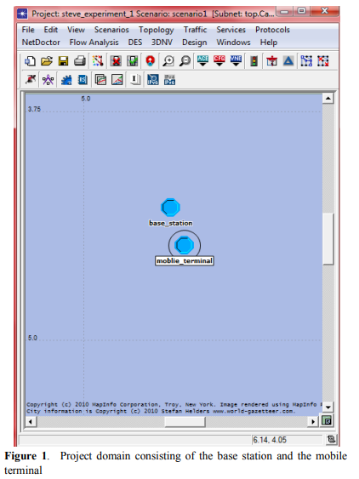

The DPCA needs the next inputs: Rxqual (receive quality), Rxlev (receive level) – these triggers the mobile modem’s power to increase if Rxqual or Rxlev is/are low and viceversa, if they are considered to be strong enough, modem’s power will decrease to save power.

1. Dynamic power management for faster, more efficient battery charging (Samuel Wong) – 2013

The authors study battery management systems so that they could handle several situations as fast and efficient charing without degrading significantly battery’s life and also quick power state switch.

Nowadays Li-ion batteris are used since they have an increased capacity. Even if this seems an advantage, it represents a challange too since it’s desired to charge faster. Moreover, there are other difficult challanges imposed by clients such as almost instant switching on/off a wearable device with an almost empty battery. These hitches require solving two big problems: fast charging on the one hand, and almost complete discharging on the other hand - obvioulsy, without degrading any component either of the charging computing system or the power soucre. To achieve this there are three possibilities proposed, but, we focus on the third one since it is very popular. This addresses especially the fluctuating current demand during charge/discharge.

As battery based devices absorb a fluctuating current due to their unpredictable operating mode, a classic DPM based on input current voltage is not enough since the mobile device’s peak power requires usually much more than the maximum charger’s capacity and therefore it could crash. One simple solution is to increase the charger’s power rating, but this doesn’t solve the issue entirely since it would cause its cost to explode as well. An “affordable” solution is to use a sort of dynamically low pass filter with feedback (controlled accordingly by Q4 MOSFET from the schematic below) which makes use of the previously accumulated excess of energy within the capacitor (also, the feedback is “aided” by the inductor).

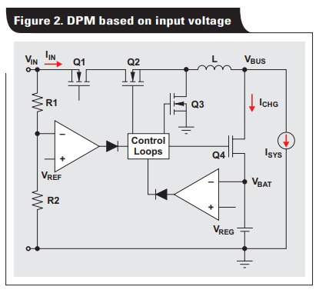

1. LTE UE Power Consumption Model For System Level Energy and Performance Optimization (Anders Jensen) – 2012

At the moment this paper was written there was a trend according to which the best take regarding the power consumption optimization was tackling with discontinuous reception in order to save bandwidth and implicitly energy and signaling. Although, the authors of the paper consider feasible to exploit system level optimizations. Therefore, they propose a power model for LTE UE which aims to lend a helping hand for further research related to this topic. The proposed model takes into account functions for UL and DL power consumption and data rate. Subsequently, experiments were conducted an LTE USB dongle to compare and validate the models’ features. Eventually, a discovery was made: the UL transmit power and DL data rates are decisive factors in system’s pwer consumption.

Model design is based on physical layer components, namely: transmit basebad (Tx BB) – turbo encoding is used which (using Forward Error Correction), transmit RF (Tx RF) – it doesn’t depend on UL data rate, but peak to average power radio is altered if modulation type is chanes, recieve RF (Rx RF) – it is independent of DL data rate, but is dependent of DL power level, receive baseband (Rx BB) – consists of tasks almost independant of DL data rate. Below, a diagram of the model is presented, where P is the power consumption and S is the power level, while R is Rx/Tx data rate.

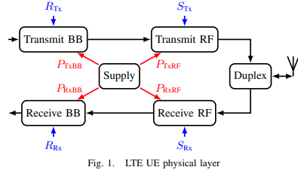

1. Securing IoT Devices using Dynamic Power Management : Machine Learning Approach (Nikhil Chawla) – 2020

This paper proposes a method of identification the malware which entered an IoT system by exploiting DPM features, namely, DVFS.

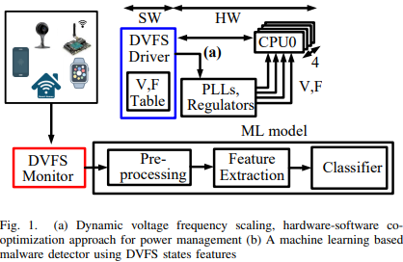

As IoT has started to migrate from cloud and fog to edge computing, which has improved performance in terms of speed of the entire architectures, serious security issues have arisen as a microcontroller can be very easily attacked. The use of high-level software antiviruses is not indicated as they consume excessive power, and as edge devices are battery dependent this would be catastrophic. This is why hardware-level protection is getting interesting. The problem with this, however, is that the hardware architecture that detects malware needs to be as versatile as possible and therefore not highly dependent on the architecture of the microcontroller it runs on. This is where the DPM comes in, specifically the DVFS. Since the DVFS is self-adjusting (its clock frequency and voltage supply) depending on the workloads the microcontroller is subjected to, it can provide useful information to an anti-virus hardware mechanism. As such, the authors of the paper propose the use of a DPM mechanism involving a stack consisting of the DVFS and an ML on top of it model for virus detection.

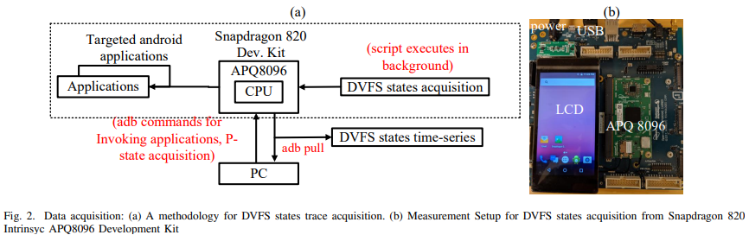

If used a Linux based OS, we can make use of CPU governors via CPUFreq module which helps us as a higher level to take over, at least partially, the hardware, which is another useful feature for anti-malware purpopses.

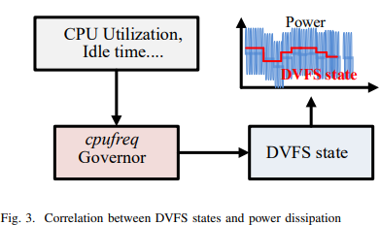

Eventually, here was exhibited an interesting method which used an improved DPM policy as a tool which laveraged not only the power saving, but the security enhancement.

1. Battery-Driven Dynamic Power Management (Luca Benini) – 2001

Up until that point most of battery performance metrics regarded provided energy taking into account an ideal model. In practice it is observed that the behaviour of the battery differs from that expected from a theoretical point of view, for example, if a battery does not have a continuous discharge, but in steps, the total energy supplied at the end of the discharge cycle is higher as a result of its chemical regeneration in the intervals between two successive discharges or, on the other hand, at the beginning of the discharge cycle the voltage at the battery terminals decreases more slowly and at the end the voltage decrease is more accelerated. Therefore, a better DPM policy should take into account these phenomena, but the bigger problem is that almost none of the work until that moment approached the problem of extending battery’s lifetime. As such, in some situations, it is prefered to have a policy which keeps the battery charged for a shorter period of time or for instance, to charge slower, but to last longer.

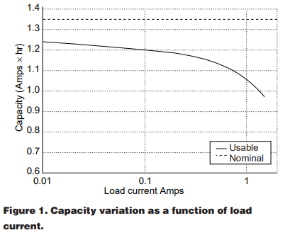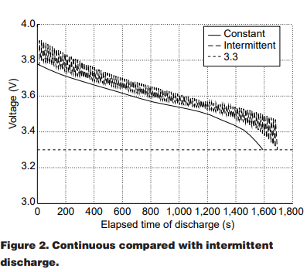

First and foremost, the one loop policy is depicted. Here, the entry time into a low power state (idle) has a predefined value called time-out. After the next time-out the system enters a lower power state (sleep) and finally a power off state. All this helps to reduce power consumption. However, these processes do not take into account the state of charge of the battery, it is only workload driven.

On the other hand, the closed loop policy consists of degrading the power state gradually accodring to battery’s power level, therefore, the more discharged the battery is, the less power consuming the next energy state is. It it noticeble that in this case extra power states are used. In the paper it was taken the example of a recorder set and besides power off, sleep, idle and fine sound power states, there was introduced the raw sound power state which is an intermediate step between fine sound and idle. Also, this policy required the use of a brand new notion, quality of service Q which is defined as the ratio between the time the device renders fine audio sound and the total running time which includes the raw sound state as well.

It is very intereseting that those two policies are not mutually exclusive. Further in the paper, policies for dual battery systems are studied. Dual battery systems have the advantage of benefitting from the fact that when one battery is discharged the served devices drain the current from the other battery, therefore, existing the posibility of being exploited the step by step discharge advantages.

Open loop policies refer to those dual battery systems which take advantage of the above mentioned phenomenon. Therefore, there is a frequency of switching the power source from one battery to the other. This policy brings in the end benefits for both temporary power savings and battery lifetime.

1. Dynamic Power Management Based on Continuous-Time Markov Decision Processes (Qinru Qiu) – 2000

Because efficient DPM depends in general on many factors which are unpredictable, the authors of the paper proposed using Markov chains as predictors for uncertainty. Within this Markov process one can identify the next components: rewards are power savings and penalties are application performance degradations and computed probability of switching from one state to another. An example of such process is depicted by the figure below: 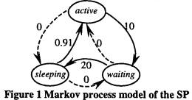

1. Formal Methods for Dynamic Power Management (Rajesh K. Gupta) – 2003

In this paper more formal methods for predicting time-outs are used. Nevertheless, paper focuses on two main directions: stochastic models, which make use of probability distributions and regressional algorithms. The authors don’t dive into details regarding experiments and results but mention that stochastic models may perform well whether they are tailored for the specific applications.

1. Dynamic power management using adaptive learning tree (Luca Benini) – 1999

The method proposed by the authors seems highly efficient when tackling with a complex power management system with many sleep states. Therefore, an “on the fly” technique which considers many traces regarding the power states dynamic such as decision trees is very appropriate for such use cases. As mentioned in [16, 17] there are other similar approaches such as Markov chain modelling or using linear regression for predicting time-outs.

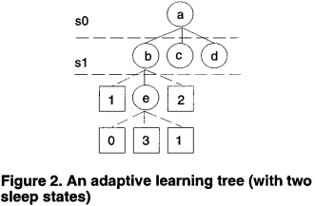

1. Policy Optimization for Dynamic Power Management (Luca Benini) – 1999

This paper proofs that DPM could be viewed as a synergy between a FSM’s flow and stochastic events. The optimization target of this model is finding the optimal policy which brings the most energy savings.

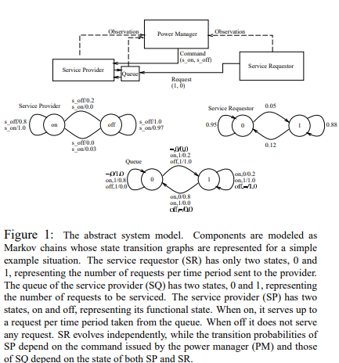

1. Power Management and Dynamic Voltage Scaling: Myths and Facts (David Snowdon) – 2005

This paper addresses the problem of energy consumed by memory which is often neglected in power models. Moreover, the suitable values for voltage and frequency are dependent on the entire application specific balance of both CPU and memory. Experiments were conducted on PLEB 2 computer (based on ARM Xscale CPU) running GNU/Linux OS.

1. Competitive Analysis of Dynamic Power Management Strategies for Systems with Multiple Power Saving States (Sandy Irani) – 2002

This paper compares a probabilistic model against a purely deterministic one. The results are a bit astounding since the dummy deterministic model performs very well in practice. Also, the probabilistic method is very efficient when dealing with clustered events.

1. Dynamic Power Management for Nonstationary Service Requests (Eui-Young Chung) – 2002

In this paper Markov chains are used for adaptive DPM. The authors’ choice was determined by the possible need to deal with systems with initially unknown workloads which should update their policy online. In general, for such problems reinforcement learning techniques are used, but, firstly, at that time they were not available, and secondly, they still require lots of computing resources which may cause an overkill situation. As workloads learning models the authors present two of them based on sliding window.

1. Energy-efficient carpool policy for wireless interfaces of mobile devices in ubiquitous environments (Sung-Hwa Lim) – 2013

Even if the desired goal is to keep the device idle as long as possible, it should be avoided frequently switching devices on/off. That’s why in this paper buffering methods are used. Therefore, only after either a predefined amount of time is elapsed, or the data buffer are about to overflow the whole amounts of data are received/transmitted. This “burst” communication seems very efficient. The paper is supported by a real test bed. Below we can see the flowchart of this threshold triggered policy:

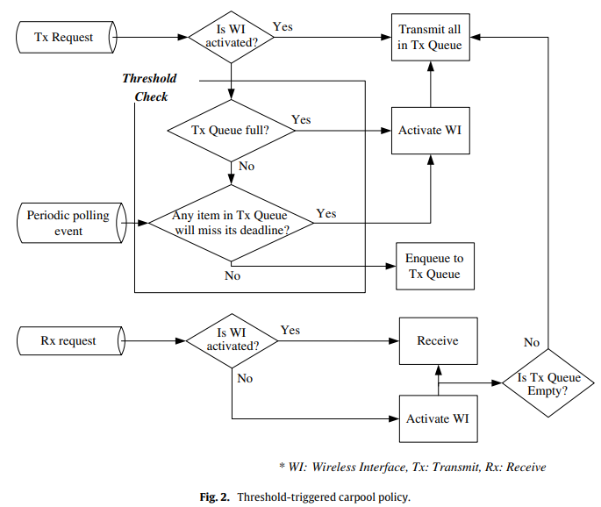

1. Grant Prediction-based Dynamic Power Management for 5G to Reduce Mobile Device (Peter Brand) – 2022

The authors of the paper propose a grant prediction-based approach of DPM. The main difference between their older approaches described earlier are based upon the new features of 5G NR network. To be more specific, state switching could be performed more often (i.e., with higher frequencies) and therefore, this enables microsleep periods. Secondly, NR came with cross slot and multi slot scheduling methods.

1. DPM-NFV: Dynamic Power Management Framework for 5G User Plane Function using Bayesian Optimization (Jaroslaw Sydir) – 2022

This approach is very similar to [24] with the exception that it focuses on the server side. Thus, a server which runs within a NR network has a ML optimized policy which makes it available only during key periods of time when the likelihood of receiving messages is relatively increased.

1. Monitoring system activity for OS-directed dynamic power management (Luca Benini) – 1998

This is an early primitive approach by which peripherals are monitored and a static policy is adopted regarding the state of the entire computing system. Here, as we can see in the figure below, we’ve got the hardware, which is the computing system, an observer, which could be part of an OS level API which interacts with a policy which in turn adjusts the hardware through a microcontroller.

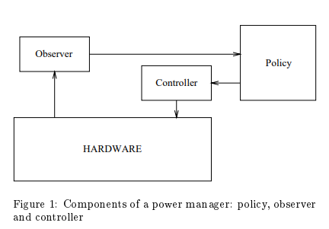

1. Guarded evaluation: Pushing power management to logic synthesis/design (Vivek Tiwari) -1996

In this paper a low-level approach is proposed which affects directly digital circuits which constitute the machine. Since digital circuits consume most of the power during transitioning in order to save power, it is necessary to avoid any kind of switching from on to off and vice-versa for any module that is not currently used, thus the clock signal will be masked for it with the aid of latches - this variant is preferable instead of using gates or multiplexers because in that case the masking circuits themselves would consume power by being fed with clock all the time, besides, they act as memory buffers keeping intact the last stored value. Those latches represent the so-called guard logic.

