
Linux Audio Conference
2016 - Berlin

About
The Linux Audio Conference (LAC) is the international conference about Free/Open-Source Software for music, sound and other media with GNU/Linux as the main platform. The 2016 edition (the 14th installment of the conference) will take place at c-base, the „Spacestation below Berlin Mitte“, Germany.

Target audience
The Linux Audio Conference brings together musicians, composers, sound artists, software developers, researchers and engineers working with GNU/Linux as an open, stable, professional platform for audio and media research and music production.

What to expect
- Paper presentations
- Workshops
- Concerts
- Sound Installations
- Live coding sessions
- Poster sessions

Special events
We will organize a Keynote held by an outstanding yet-to-be-chosen speaker of the worldwide Linux Audio Community.
There will be a Linux Sound Night taking place on Saturday, April 9th in the evening.

We plan to organize one or two excursions to notable locations during the conference to round up the conference program, especially for international attendees.

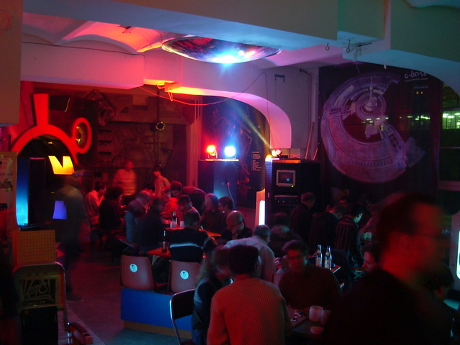
Where & When
April 6-10 2016, c-base, Rungestraße 20, Berlin, Germany
The c-base with its space and hi-tech oriented theme already served well as conference location for similar sized events and provides many of the required equipment, like live video streaming and a sound laboratory in house.

We will be able to extend the location by using rooms from the nearby Theatre Institute, so three to four content tracks in parallel, as well as a permanent poster exhibition for attendees and speakers to present their projects are possible. The accumulated area will accomodate 200-250 attendees and provides a wheelchair compatible elevator & toilet as well as ramps next to the two involved stairs.

Live recordings
With help of some volunteers of the renowned VOC (Video Operation Crew), we will be able to record and livestream the conference talks, workshops and various other events via internet, so participants all over the world can watch as well as interact (e.g. by chat based Q&A) with the conference content and participants.

Conference Experience
The Linux Audio Conference is dedicated to providing an inclusive and harassment-free conference experience for everyone, regardless of gender, sexual orientation, disability, physical appearance, body size, race, or religion. We do not tolerate harassment of conference participants in any form. Sexist language and imagery is not appropriate for any conference venue, including talks. If a participant engages in harassing behavior, the conference organizers may take any action they deem appropriate to remedy the issue.

Who?
LAC as conference concept is organized by a community of GNU/Linux free/libre software users and developers that communicate through the Linux-Audio-Users and Linux-Audio-Developers mailing lists. LAC 2016 is organized by volunteers from the fine Linux Audio User Group Berlin.



