MStar

Hardware Watchpoint使用 V1.0

© 2026 MStar Semiconductor, Inc. All rights reserved.

MStar Semiconductor makes no representations or warranties including, for example but not limited to, warranties of merchantability, fitness for a particular purpose, infringement of any intellectual property right or the accuracy or completeness of this document, and reserves the right to make changes without further notice to any products herein to improve reliability, function or design. No responsibility is assumed by MStar Semiconductor arising out of the application or user of any product or circuit described herein; neither does it convey any license under its patent rights, nor the rights of others.

MStar is a trademark of MStar Semiconductor, Inc. Other trademarks or names herein are only for identification purposes only and owned by their respective owners.
REVISION HISTORY
Revision No. | Description | Date
Ver 1.0 | - Initial release | dec 26, 2016

Hardware Watchpoint (Kernel Module) User Guide
- Kernel Module (data_breakpoint) Working Flow:
- Application (Just for testing code or command interface) => For User
- Kernel module & Kernel Driver => For developer
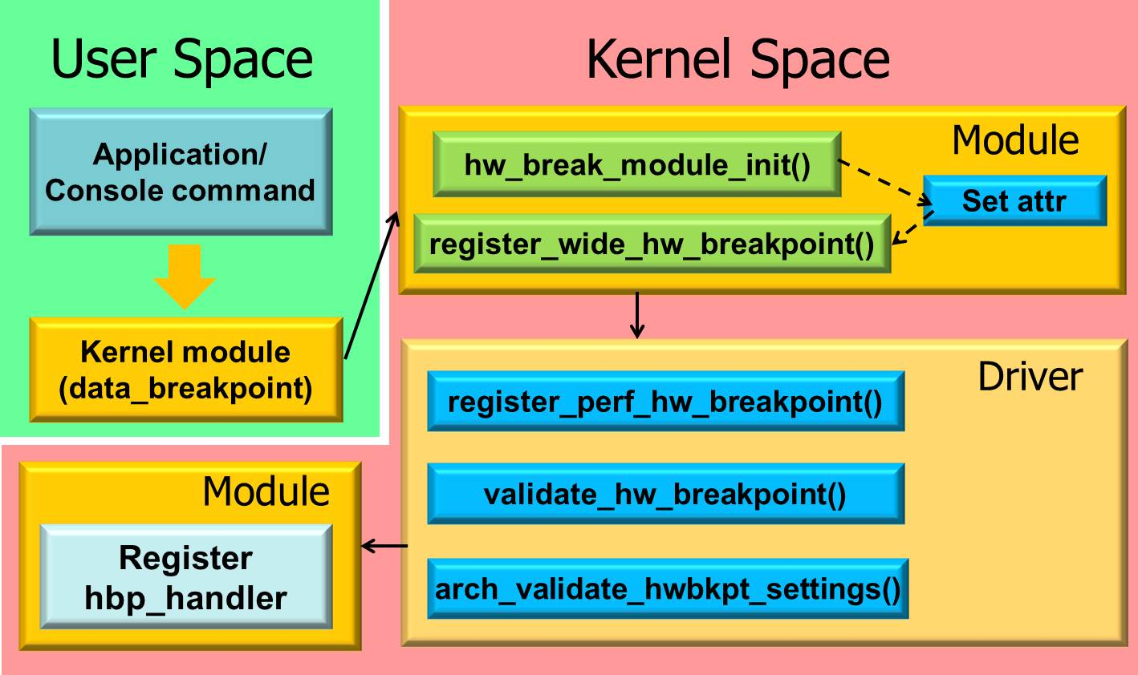
- How to use data_breakpoint kernel module
- Requirement config:
- CONFIG_HAVE_HW_BREAKPOINT=y
- CONFIG_SAMPLE_HW_BREAKPOINT=m
Enable from menuconfig
Kernel hacking =>
Sample kernel code =>
Build kernel hardware breakpoint examples -- loadable module only
- Original Usage:
Console command:
#insmod data_breakpoint.ko ksym=<ksym_name>
#rmmod data_breakpoint
Application Program:
Use system call “system()“ to provide command functionality

- Related Files:
- Arm64 Kernel:
$Kernel/samples/hw_breakpoint/data_breakpoint.c
$Kernel/arch/arm64/include/asm/hw_breakpoint.h
$Kernel/arch/arm64/kernel/hw_breakpoint.c
- Arm32 Kernel:
$Kernel/samples/hw_breakpoint/data_breakpoint.c
$Kernel/arch/arm/include/asm/hw_breakpoint.h
$Kernel/arch/arm/kernel/hw_breakpoint.c
- The development can modify sample_hbp_handler() to debug:
Source code file: $Kernel/samples/hw_breakpoint/data_breakpoint.c
sample_hbp_handler()
Compiled module file:
$Kernel/samples/hw_breakpoint/data_breakpoint.ko
- data_breakpoint module parameter:
- Addr:使用者想監測的Virtual Address
- Len: 可使用對某區段的addr做範圍監控
  - HW_BREAKPOINT_LEN_1: (表示觀察1個size為word 的address)
  - HW_BREAKPOINT_LEN_2: (觀察連續2個size為word 的address)
  - HW_BREAKPOINT_LEN_4: (觀察連續4個size為word 的address)
  - HW_BREAKPOINT_LEN_8: (觀察連續8個size為word 的address)
- Type:
- 1:當這個Addr被read/load時會trigger hw watchpoint
- 2:當這個Addr被write/store時會trigger hw watchpoint
- 3:當這個Addr被read/load,或是write/store時就會trigger
- Verification from kernel module:
New Usage after applying the attached patch:
Patch: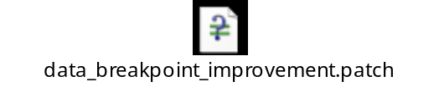
Console command:
#insmod data_breakpoint.ko addr=0x33345678 mask_len=8
#rmmod data_breakpoint
- “addr” can be any value from user space
- “mask_len” only support 1, 2, 4, 8.
User space testing code:
void main()
{
char str[128] = {0};
int *ptr = (int*)malloc(sizeof(int));
sprintf(str, "insmod /OAD/data_breakpoint.ko addr=0x%X", ptr);
system(str);
sleep(1);
*ptr = 0x11;
sleep(3);
system("rmmod data_breakpoint");
}
Compile command:
arm-none-linux-gnueabi-gcc main.c -g -o b.out
- Mstar Extension Part:
- Create Mstar Kernel module
- mdata_watchpoint module (http://hcgit:8080/#/c/77453/)
- Development User Interface (install multiple wathpoint)
- Usage method:
- #insmod mdata_watchpoint.ko
➔Need to insert mstar data watchpoint module to create file node
- #echo enable watchpoint/breakpoint $slot $addr $mask_len > /proc/mstar_watchpoint
➔ Register Watchpoint
$slot: 0~3
$addr: user space or kernel space VA
$mask_len: The length of address to monitor
ex. echo enable watchpoint 1 0xE58027 8 > /proc/mstar_watchpoint
- #echo filter pid=$PID pname=$process_name > /proc/msatr_watchpoint
➔Provide specific process information while watchpoint triggered
ex. echo filter pid=3245 pname=a.out > /proc/mstar_watchpoint
- #echo disable watchpoint/breakpoint/all $slot > /proc/mstar_watchpoint
➔ Unregister watchpoint
ex. echo disable breakpoint 1 > /proc/mstar_watchpoint
- #echo info > /proc/mstar_watchpoint
➔Show the information for registered/unregistered watchpoint
- #rmmod mdata_watchpoint
➔uninstall mstar data watchpoint module to remove file node

[Log trigger from User Space Application/Console command]
Kernel stack dump:
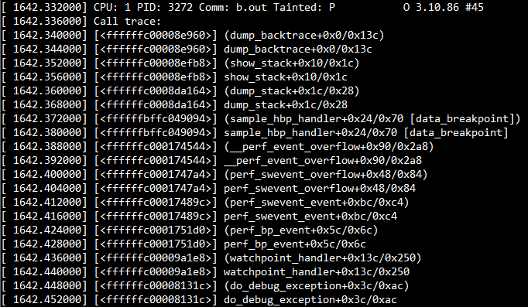
User space information dump:
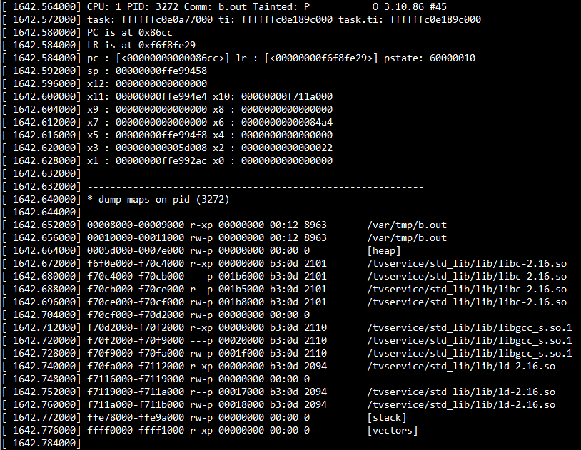

We can use Kernel API “show_user_backtrace_task” to get user process backtrace:
$Kernel/kdebugd/arch/arm/kdbg-trace.c (Currently only support on 32 bit platform)
Normal case to get backtrace:
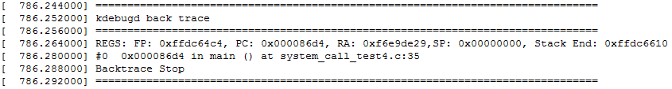
After strip the executed file:
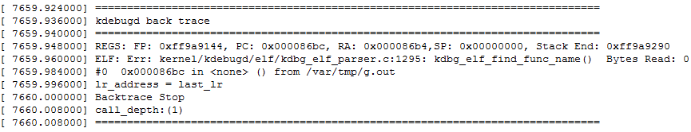
Multi level backtrace:
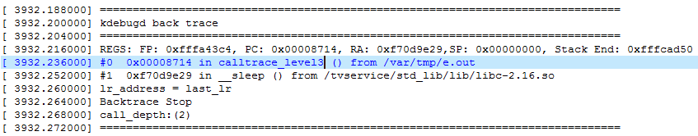
[Log trigger from Kernel]
Kernel stack dump:
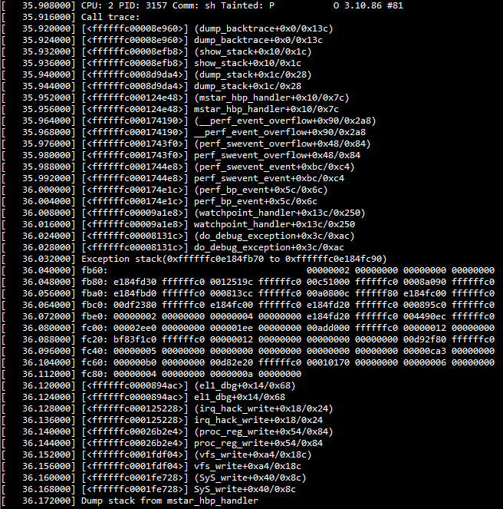

User space information dump:

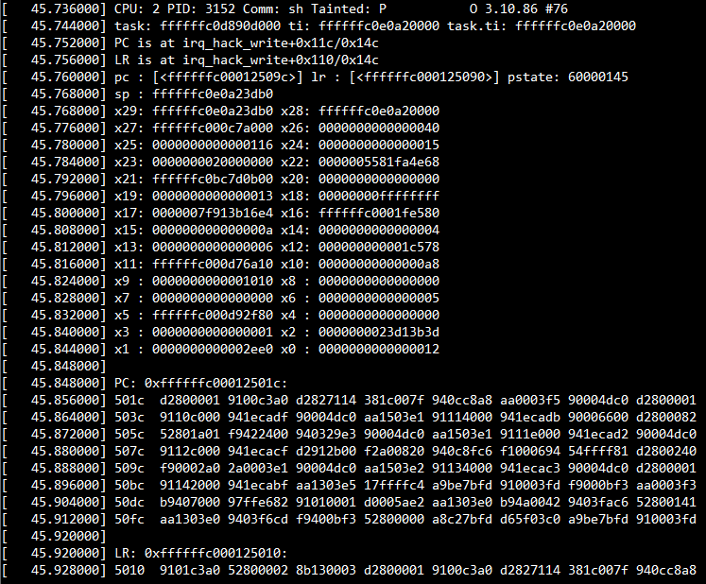
- Add Watchpoint into Kernel Driver
//header file
#include <linux/perf_event.h>
#include <linux/hw_breakpoint.h>

extern void show_usr_info(struct task_struct *task, struct pt_regs *regs, unsigned long addr);
struct perf_event * __percpu *mstar_hbp;
//Declaration handler
static void mstar_hbp_handler(struct perf_event *bp,
struct perf_sample_data *data,
struct pt_regs *regs)
{
dump_stack();
printk(KERN_INFO "Dump stack from mstar_hbp_handler\n");
show_usr_info(current, regs, regs->pc);/*for watchpoint*/
printk(KERN_INFO "Dump user info from mstar_hbp_handler\n");
printk(KERN_INFO "pid:%d, process name:%s\n", current->pid, current->comm);
#if defined (CONFIG_ARM64)
/************************************************************************
* ARM64 watchpoint will hit infinite loop while watchpoint handler triggered
* shift pc to solve this problem
***********************************************************************/
regs->pc += 4;
#endif
}
//The kernel main function
main_function()
{
int isRegisted = 0;
int ret;
struct perf_event_attr attr;
//Need to init attr for breakpoint usage
hw_breakpoint_init(&attr);
//set the attr before register
attr.bp_addr = ptr;
attr.bp_len = HW_BREAKPOINT_LEN_8;
attr.bp_type = HW_BREAKPOINT_W | HW_BREAKPOINT_R;
//Register watchpoint handler
mstar_hbp = register_wide_hw_breakpoint(&attr, mstar_hbp_handler, NULL);
if (IS_ERR((void __force *)mstar_hbp)) {
ret = PTR_ERR((void __force *)mstar_hbp);
printk(KERN_INFO "Watchpoint mstar_hbp registration failed\n");
}
else {
isRegisted = 1;
printk(KERN_INFO "HW Watchpoint slot mstar_hbp installed\n");
}

….. Your code //After registration, you can put your code here

//Unregistration watchpoint before returning
if(isRegisted == 1) {
unregister_wide_hw_breakpoint(mstar_hbp);
printk(KERN_INFO "HW Watchpoint slot mstar_hbp uninstalled\n");
}
}
- Appendix:
- ARMv8 32bit Support
The difference between Arm32 kernel and Arm64 kernel:
Only 32bit kernel use enable_monitor_mode() function.
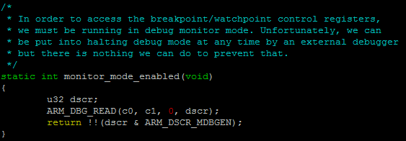
Manhanttan is ARMv8 architecture. Need to add the following change.
Or will always hit the following error:
[Error Log]
# insmod data_breakpoint.ko
Breakpoint registration failed
insmod: can't insert 'data_breakpoint.ko': No such device
ARMv8 32bit Patch:
ArmV8 32bit chip need to apply this patch to enable watchpoint functionality
diff --git a/arch/arm/include/asm/hw_breakpoint.h b/arch/arm/include/asm/hw_breakpoint.h
index eef55ea..8e427c7 100644
--- a/arch/arm/include/asm/hw_breakpoint.h
+++ b/arch/arm/include/asm/hw_breakpoint.h
@@ -51,6 +51,7 @@ static inline void decode_ctrl_reg(u32 reg,
#define ARM_DEBUG_ARCH_V7_ECP14 3
#define ARM_DEBUG_ARCH_V7_MM 4
#define ARM_DEBUG_ARCH_V7_1 5
+#define ARM_DEBUG_ARCH_V8 6

/* Breakpoint */
#define ARM_BREAKPOINT_EXECUTE 0
diff --git a/arch/arm/kernel/hw_breakpoint.c b/arch/arm/kernel/hw_breakpoint.c
index 3d44660..a711b27 100644
--- a/arch/arm/kernel/hw_breakpoint.c
+++ b/arch/arm/kernel/hw_breakpoint.c
@@ -167,7 +167,7 @@ static int debug_arch_supported(void)
/* Can we determine the watchpoint access type from the fsr? */
static int (void)
{
- return 0;
+ return get_debug_arch() == ARM_DEBUG_ARCH_V8;
}

/* Determine number of WRP registers available. */
@@ -257,6 +257,7 @@ static int enable_monitor_mode(void)
break;
case ARM_DEBUG_ARCH_V7_ECP14:
case ARM_DEBUG_ARCH_V7_1:
+ case ARM_DEBUG_ARCH_V8:
ARM_DBG_WRITE(c0, c2, 2, (dscr | ARM_DSCR_MDBGEN));
isb();
break;

- 64bit watchpoint infinite loop
After watchpoint triggered, will never jump out from watchpoint handler’s loop
Need to move CPU instruction pointer to next section.
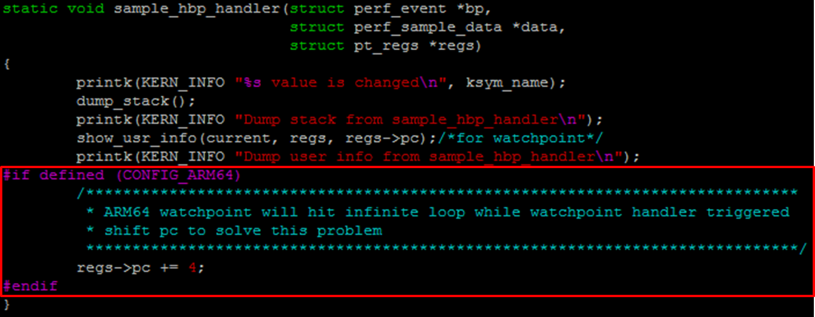

Hardware Breakpoint (Kernel Module) User Guide
The attribute “bp_type” and “bp_len” can decide use brerakpoint or watchpoint.
All of the setting for breakpoint is same as watchpoint.
But breakpoint need to use “HW_BREAKPOINT_X” type and “HW_BREAKPOINT_LEN_4” len.

The definition is included in arch/arm64/kernel/hw_breakpoint.c
Only ARM_BREAKPOINT_EXECUTE will use breakpoint control register (BCR)
* On AArch64, we only permit breakpoints of length 4, whereas
* AArch32 also requires breakpoints of length 2 for Thumb.
* Watchpoints can be of length 1, 2, 4 or 8 bytes.

- The required change to add breakpoint sample
//Only attribute need to adjust for breakpoint
attr.bp_addr = ptr;
attr.bp_len = HW_BREAKPOINT_LEN_4;
attr.bp_type = HW_BREAKPOINT_X;
In breakpoint case, the bp_addr is limited to specific address which is the one can be executed
(PC). Ex. “echo enable breakpoint 0 0xffffffc0001241a4 4 > /proc/mstar_watchpoint”.
(Limitation: User need to know the exactly PC which will be executed)
This PC address can get from vmlinux by nm command.

Breakpoint Log:
The dump information log will show breakpoint_handler
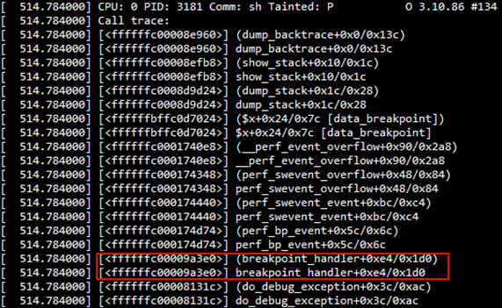

[Log trigger from Kernel driver]
