This mpatch confing is for checking if following config is enable:

CONFIG_HOLES_IN_ZONE
/*
* If it is possible to have holes within a MAX_ORDER_NR_PAGES, then we
* need to check pfn validility within that MAX_ORDER_NR_PAGES block.
* pfn_valid_within() should be used in this case; we optimise this away
* when we have no holes within a MAX_ORDER_NR_PAGES block.
*/
#ifdef CONFIG_HOLES_IN_ZONE
#define pfn_valid_within(pfn) pfn_valid(pfn)
#else
#define pfn_valid_within(pfn) (1)
#endif

alan.yu解了數個mantis issue，都是跟memory hole有關，

在3.10.23中，
當move_freepages_block() → move_freepages()：
move_freepages()會搬移一整個page_block(4MiB)到某個被要求的free_list中，
當使用sparse_memory時，中間可能會有空洞的pages，這時候必須要避開!!

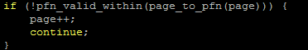

原本應要透過pfn_valid_within always()檢查該page是否在linux memory中，但這邊如果沒打開CONFIG_HOLES_IN_ZONE，會導致always return 1，根本沒檢查。

在3.10.23中，修改arch/arm/Kconfig，強制當ARCH_SPARSEMEM_ENABLE被開啟時，也打開CONFIG_HOLES_IN_ZONE
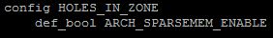

為了避免之後的kernel版本忘了開，這邊加上mpatch config保護!!
參考: http://permalink.gmane.org/gmane.linux.kernel/1174832

