W600 Arduino Development Board user Guide
Installation：
Unzip Arduino_Alhpa_0109_0.1.0.zip,follow the steps below to install library(on windows OS):
- Download the latest version of arduino IDE.
- Copy package_wmcom_index.json to AppData\Local\Arduino15
- Copy
w600-arduino-x.x.x.zip
wmtools-x.x.x.zip
gcc-arm-none-eabi-arduino-4_9-2015q1-20150306-win32.zip
to C:\Users\$USER\AppData\Local\Arduino15\staging\packages
- Swithch to arduino IDE,click Tools -> Board -> Board manager,choose the w600 board，click install.（during this operation,please keep your computer offline）
- At arduino IDE,click Tools -> Boards,select the w600 board,
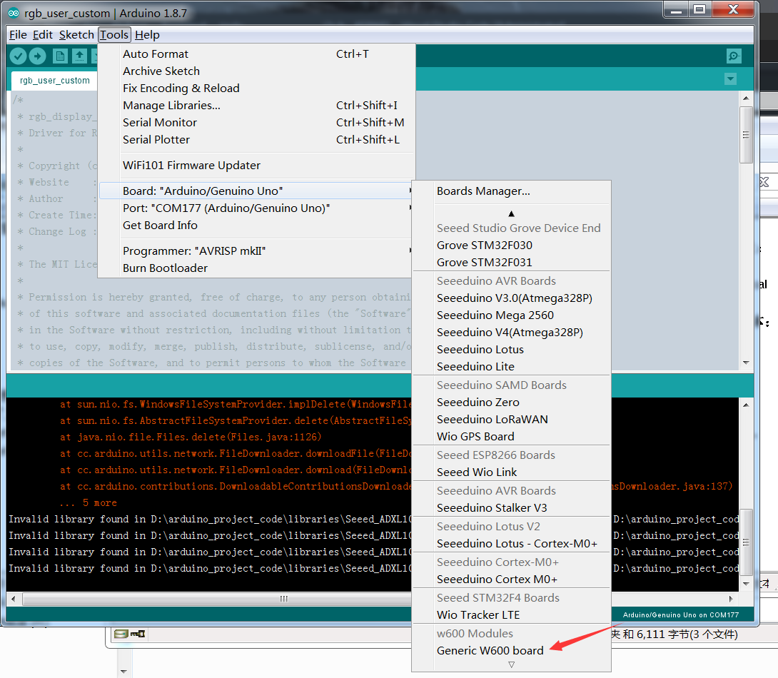
- Now you can compile the example that w600 library provided.

Uploading guide.
Due to W600 library is under developing,it does not support upload firmware via arduino IDE directly.
Please follow the instructions below before the official update:
- Find the .FLS file.
First of all,before compile,we should open compile log:click File -> preferences:
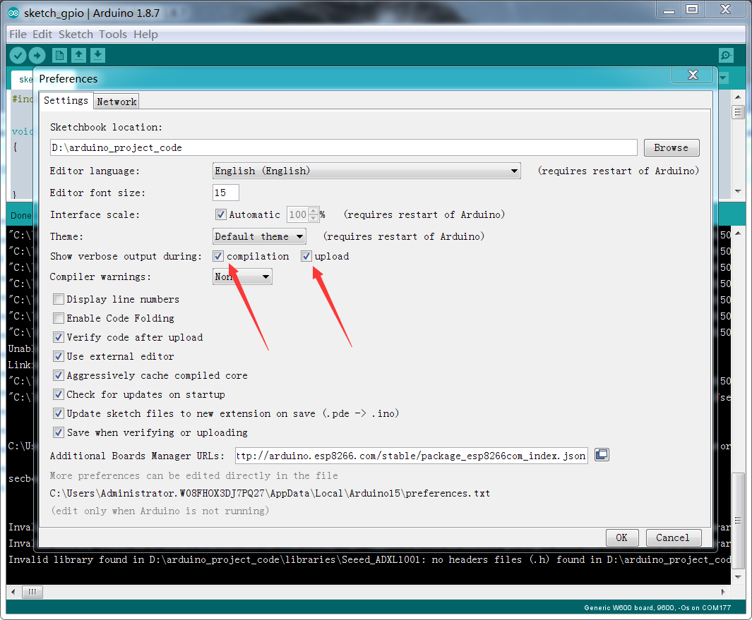
After compilation,arduino will generate a temporary directory to store the temporary files,such as *.o,*.map,*.FLS.
We can check the compile log to find the location of temporary directory,like this:
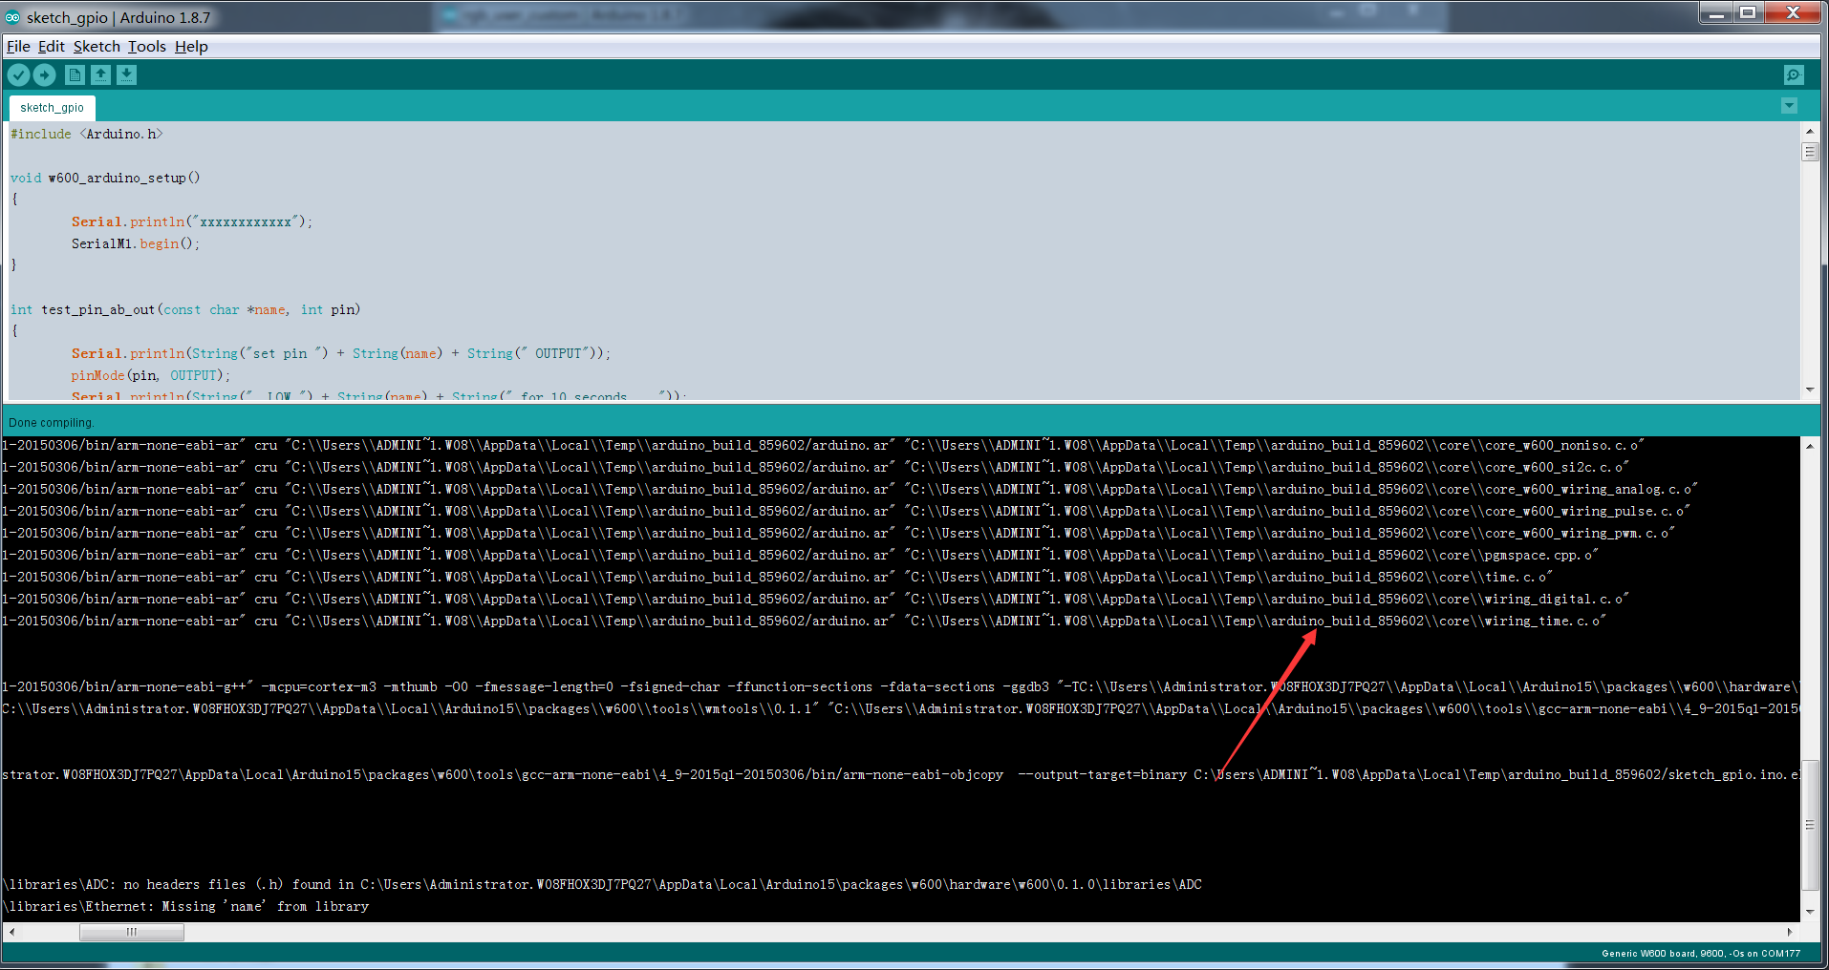
Enter C:\Users\$USER\AppData\Local\Temp\arduino_build_859602,We can see the object files:
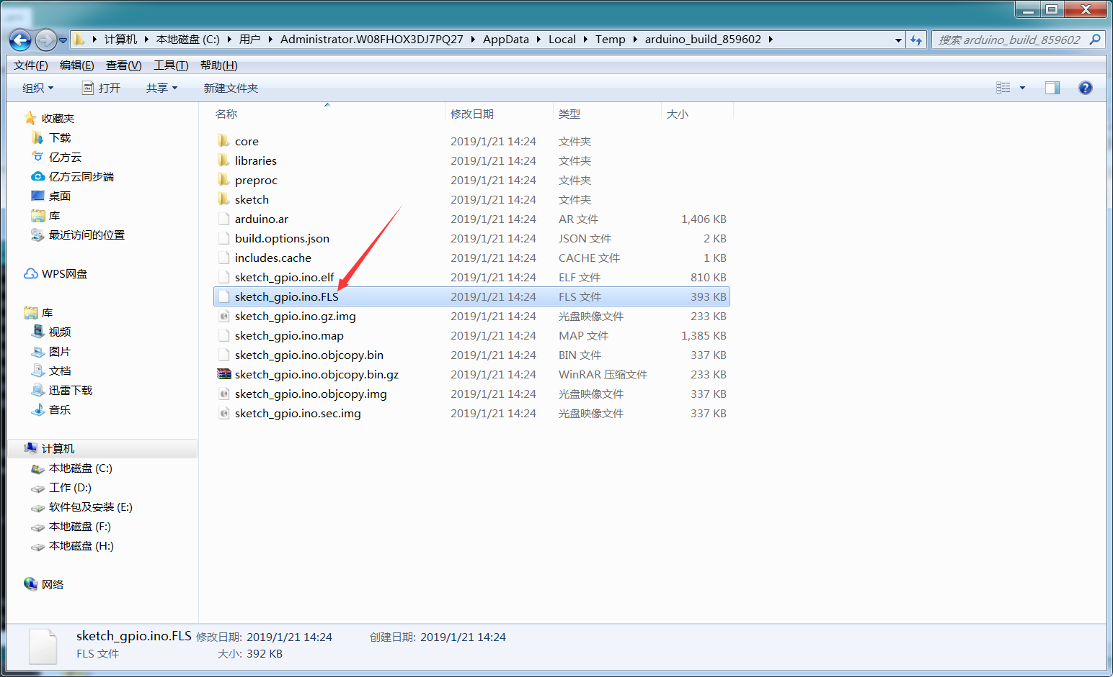
*.FLS = bootloader + application
- How to upload.
Use a serial port debugging tool,like SecureCRT,which support X moderm protocol.
Connect the USB Serial to PC,send AT command : AT+&FLSW=5000,11\r\n,The module will response:+ok
Reset module,the module will print CCCCC.......，during this time，send .FLS file with X modern.

