LVM

What is LVM?
- LVM stands for Logical Volume Management.
- LVM is a tool for logical volume management which includes allocating disks, striping, mirroring and resizing logical volumes.
- With LVM, a hard disk or set of hard disks is allocated to one or more physical volumes.
- The physical volumes are combined into logical volumes, with the exception of the /boot partition. The /boot partition cannot be on a logical volume group because the boot loader cannot read it. If the root (/) partition is on a logical volume, create a snapshot /boot partition which is not a part of a volume group.
- The main advantages of LVM are increased abstraction, flexibility and control. Logical volume can have multiple names like “database” or “root-backup”. Volumes can be resized dynamically as space requirements change and migrated between physical devices within the pool on a running system or exported easily. LVM also offers advanced features like snapshotting, striping, and mirroring.

Physical Volume (PV) : is the actual storage device that will be used in the LVM configuration. It can be an entire disk, a partition on disk or a LUN on the SAN.
Volume Group (VG) : Physical volumes are combined into volume groups.
Logical Volume (LV) : A volume group is divided up into logical volumes.

Advantages of LVM
- Logical volumes can be easily resized without any downtime or rebooting server.
- LVM created in conjunction with RAID can provide fault tolerance coupled with scalability and easy disk management.
- Snapshots allow you to backup a frozen copy of the filesystem, while keeping service downtime to a minimum.

Dis-advantages of LVM
- LVM cannot be used for the /boot because the boot loader can not read it. If you want to have the root / partition on a logical volume, you will need to create a separate /boot partition with normal ext3 file system type which is not a part of a volume group.
- Linux exclusive (almost). There is no official support in most other OS (FreeBSD, Windows..).
- Additional steps in setting up the system, more complicated.

LVM Configuration
There are two way to configure LVM
- While installing fresh OS.
- After OS installation.
Why LVM is required?
- To resize the file system’s size online we required the LVM partition in Linux. Size of LVM partition can be extended and reduced using the lvextend & lvreduce commands respectively.
- Performing consistent backups by taking snapshots of the logical volumes.
LVM Features
- It is flexible to expand the space at any time.
- Any file systems can be installed and handled.
- Migration can be used to recover faulty disk.
- Restore the file system using Snapshot features to earlier stages. etc…
Types of LVM
There are three types of logical volumes
- Linear volume
A linear volume aggregates space from one or more physical volumes into one logical volume. For example, if you have two 2GB disks, you can create a 4GB logical volume. The physical storage is concatenated. The application will see one device that is 4 GB in size. By default, we create linear volumes in LVM. Consider the following examples:
# lvcreate -L 1G -n lv_linear vg-01
Logical volume "lv_linear" created

Display information about Logical Volumes.
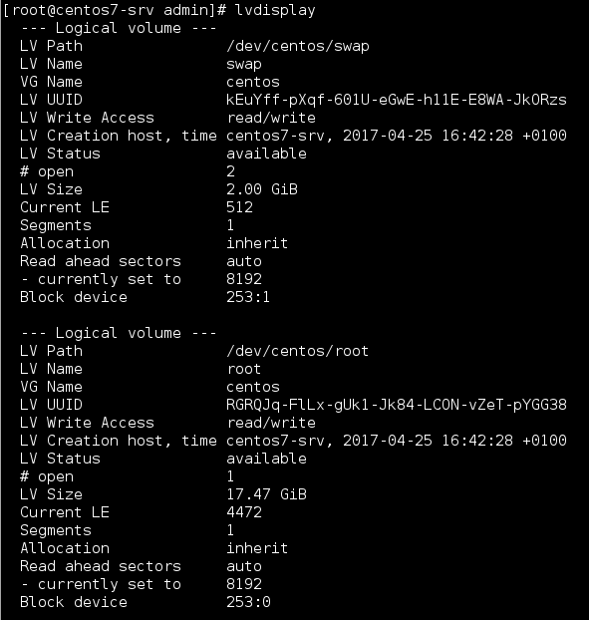

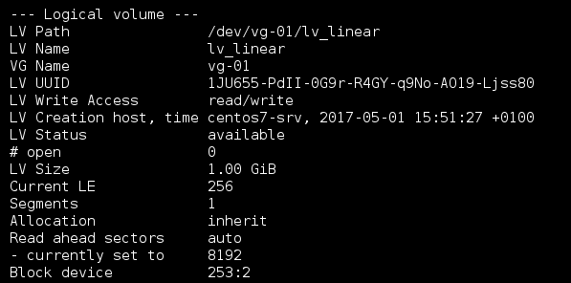
You can also use lvs command that will display the output in a configurable form.
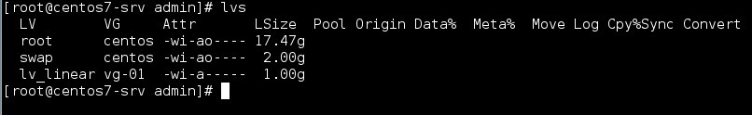
- Striped volume
When you write data to a logical volume, the file system lays the data out across the underlying physical volumes. You can control the way the data is written to the physical volumes by creating a striped logical volume. For large sequential reads and writes, this can improve the efficiency of the data I/O.

With striping, I/O can be done in parallel, below command is used to create striped volume.
# lvcreate -L 1G -i2 -I64 -n lv_stripe vg-01
Logical volume "lv_stripe" created

Now we can check with lvdisplay command
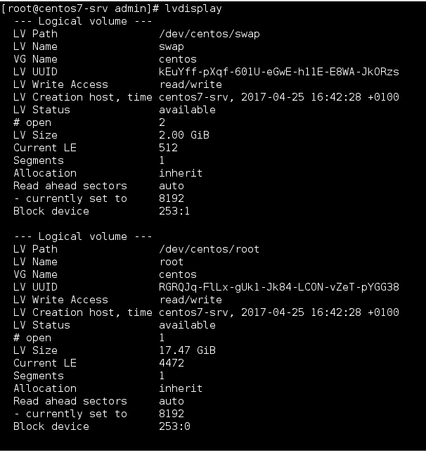
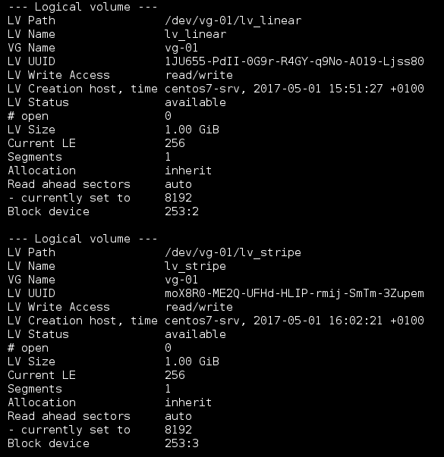

The -i denotes the numbers of stripes. This determines over how many physical volumes the logical volume will be striped. The number of stripes cannot be greater than the number of physical volumes in the volume group. The -I denotes the strip size. The above command creates a striped logical volume across 2 physical volumes with a stripe of 64kB.

Mirrored volume
A mirror maintains identical copies of data on different devices. When data is written to one device, it is written to a second device as well. This provides protection for device failures. When one leg of a mirror fails, the logical volume becomes a linear volume and can still be accessed.
An LVM mirror divides the device being copied into regions that are typically 512KB in size. LVM maintains a small log which it uses to keep track of which regions are in sync with the mirror. This log can be kept on disk, which will keep it persistent across reboots, or it can be maintained in memory. The following command will create a mirrored logical volume.
# lvcreate -L 200M -m1 -n lv_mirror vg-01
Logical volume "lv_mirror" created

Now display the mirrored logical volume created
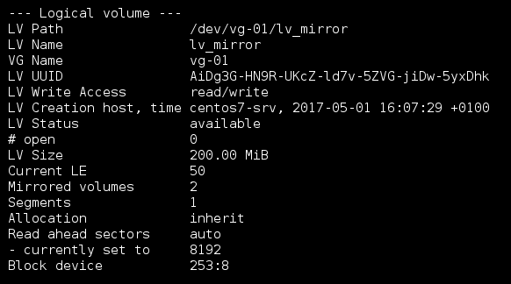

Activating LVM
The Logical Volumes can be made known to the kernel using the command lvchange. After rebooting the system or running vgchange -an, you will not be able to access your VGs and LVs. To reactivate the volume group, run the -a option is used to activate or deactivate the Logical Volume. Using y with -a option will make it known to the kernel and n will make it unavailable.
Note: When you create a volume group/logical volume it is, by default, activated. So only run this command based on specific requirements. Indicate the LV to activate.
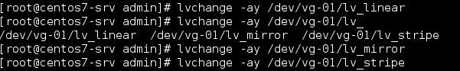

The similar command, vgchange (with -ay option) is used for activating the Volume Group.

Commands to scan PVs, LVs, and VGs.
The lvscan command scans for all logical volumes on the host
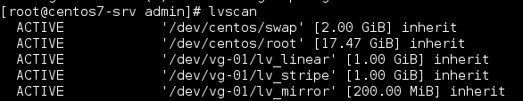

The vgscan command scans all the disks for volume groups and rebuilds the LVM cache file.
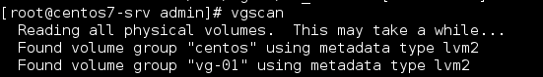

The pvscan command scans all lvm block devices for physical volumes.
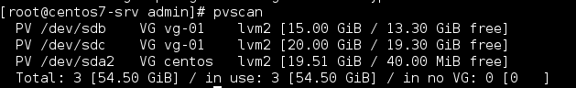

Note: All these commands, work properly on Redhat/Centos/Ubuntu systems

How to reduce LVM command line?

Step:1 Check the disk space using below command
root@bhandari:~# df -h
/dev/mapper/vg1-lvtest 7.8G 23M 7.4G 1% /test
Umount /home using below command :

Step:2 Use e2fsck command to check the file system
root@bhandari:~# e2fsck -f /dev/vg1/lvtest
e2fsck 1.42.9 (4-Feb-2014)
Pass 1: Checking inodes, blocks, and sizes
Pass 2: Checking directory structure
Pass 3: Checking directory connectivity
Pass 4: Checking reference counts
Pass 5: Checking group summary information
/dev/vg1/lvtest: 12/524288 files (0.0% non-contiguous), 71439/2097152 blocks

Step:3 Resize the partition using below command
root@bhandari:~# resize2fs /dev/vg1/lvtest 5G
resize2fs 1.42.9 (4-Feb-2014)
Resizing the filesystem on /dev/vg1/lvtest to 1310720 (4k) blocks.
The filesystem on /dev/vg1/lvtest is now 1310720 blocks long.

Step:4 Use lvreduce command to reduce the size as shown below
root@bhandari:~# lvreduce -L 5G /dev/vg1/lvtest
WARNING: Reducing active logical volume to 5.00 GiB
THIS MAY DESTROY YOUR DATA (filesystem etc.)
Do you really want to reduce lvtest? [y/n]: y
Reducing logical volume lvtest to 5.00 GiB
Logical volume lvtest successfully resized

root@bhandari:~# e2fsck -f /dev/vg1/lvtest (optional)
e2fsck 1.42.9 (4-Feb-2014)
Pass 1: Checking inodes, blocks, and sizes
Pass 2: Checking directory structure
Pass 3: Checking directory connectivity
Pass 4: Checking reference counts
Pass 5: Checking group summary information
/dev/vg1/lvtest: 12/327680 files (0.0% non-contiguous), 58462/1310720 blocks

Step:5 Mount and check the partition size
root@bhandari:~# mount /dev/vg1/lvtest /test/

How to increase the size of LVM partition ?
Below are the Logical Steps :
root@bhandari:~# lvextend -L +5G /dev/vg1/lvtest
Extending logical volume lvtest to 10.00 GiB
Logical volume lvtest successfully resized
root@bhandari:~# resize2fs /dev/vg1/lvtest
resize2fs 1.42.9 (4-Feb-2014)
Filesystem at /dev/vg1/lvtest is mounted on /test; on-line resizing required
old_desc_blocks = 1, new_desc_blocks = 1
The filesystem on /dev/vg1/lvtest is now 2621440 blocks long.

List of important LVM related files and Directories?
## Directories
/etc/lvm - default lvm directory location
/etc/lvm/backup - where the automatic backups go
/etc/lvm/cache - persistent filter cache
/etc/lvm/archive - where automatic archives go after a volume group change
/var/lock/lvm - lock files to prevent metadata corruption

# Files
/etc/lvm/lvm.conf - main lvm configuration file
$HOME/.lvm - lvm history

What are LVM1 and LVM2?
LVM1 and LVM2 are the versions of LVM.
LVM2 uses device mapper driver contained in 2.6 kernel version.
LVM 1 was included in the 2.4 series kernels.

What is the maximum size of a single LV?
For 2.4 based kernels, the maximum LV size is 2TB.
For 32-bit CPUs on 2.6 kernels, the maximum LV size is 16TB.
For 64-bit CPUs on 2.6 kernels, the maximum LV size is 8EB.

What is lvmdump ?
“lvmdump” is tool for LVM2 to collect the various information for diagnostic purposes. By default, it creates a tarball suitable for submission along with a problem report.

How to take a LVM configuration backup ?
Use “vgcfgbackup vg_name” to take the latest configuration backup of volume group.The default volume group backup location is “/etc/lvm/backup” .

How to rename volume Group ? can we rename the VG on fly?
Yes.Its possible to rename the volume group on fly. But the mounted volumes will not reflect the same unless you re-mount the volume with new VG name.
Need to update the /etc/fstab with new VG name to mount the volumes across the system reboot.

What is LVM Snapshot ?
An LVM snapshot is an exact copy of an LVM partition that has all the data from the LVM volume from the time the snapshot was created. The big advantage of LVM snapshots is that they can be used to greatly reduce the amount of time that your services/databases are down during backups because a snapshot is usually created in fractions of a second. After the snapshot has been created, you can back up the snapshot while your services and databases are in normal operation.

What is an LVM Snapshot?
- An LVM snapshot is an exact mirror copy of an LVM partition which has all the data from the LVM volume from the time the snapshot was created.
- The main advantage of LVM snapshots is that they can reduce the amount of time that your services / application are down during backups because a snapshot is usually created in fractions of a second. After the snapshot has been created, we can back up the snapshot while our services and applications are in normal operation.
- "snapshot size can vary depending on your requirement but a minimum recommended size is 30% of the logical volume for which you are taking the snapshot but if you think that you might end up changing all the data in logical volume then make the snapshot size same as logical volume ".

Scenarios : we will take a snapshot of /home which is an LVM based partition.
[root@localhost ~]# df -h /home/
Filesystem Size Used Avail Use% Mounted on
/dev/mapper/VolGroup-lv_home
5.0G 139M 4.6G 3% /home

Taking Snapshot of '/dev/mapper/VolGroup-lv_home' partition.
LVM snapshot is created using lvcreate command , one must have enough free space in the volume group otherwise we can't take the snapshot, Exact syntax is given below:

# lvcreate -s -n <Snapshot Name> -L <Size of snapshot> <lvm volume for which to take snapshot >
Example:
[root@localhost ~]# lvcreate -s -n home_snap -L1G /dev/mapper/VolGroup-lv_home
Logical volume "home_snap" created

Now verify the newly create LVM 'home_snap' using lvdisplay command.
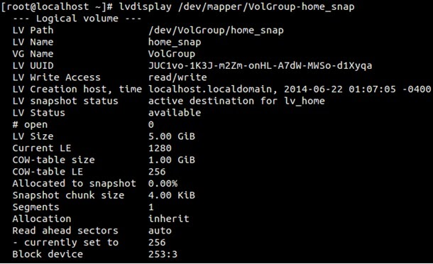

Now create the mount point (directory) and mount it.
[root@localhost ~]# mkdir /mnt/home-backup
[root@localhost ~]# mount /dev/mapper/VolGroup-home_snap /mnt/home-backup/
[root@localhost ~]# ls -l /mnt/home-backup/

How are snapshots in LVM2 different from LVM1 in Redhat Linux?
LVM1 snapshots are readonly by default where LVM2 snapshots were read/write.
What is Extents?
Each volume within a volume group is segmented into small, fixed-size chunks called extents. The size of the extents is determined by the volume group.
The extents on a physical volume are called physical extents, while the extents of a logical volume are called logical extents. A logical volume is simply a mapping that LVM maintains between logical and physical extents. Because of this relationship, the extent size represents the smallest amount of space that can be allocated by LVM.
Physical Extents (PE)
Physical Extends are basic units of logical volume which are created while creating physical volume, not sure if it can be changed later. Default is 4Mb that means we can increase the size of LVM by multiple of 4MB.

If the vg02 has two physical volumes called /dev/sdc/ & /dev/sdd. How do you remove /dev/sdd from vg02.
“vgreduce vg02 /dev/sdd/”

How to scan disks for existing volume group ?
Use “vgscan” to scan existing volume group from newly connected SAN or DISKS.
But you should use “pvscan” prior to executing this command.

How to scan a logical volume from exising volume group?
lvscan

How to stop the logical volume ? or deactivate the logical volume ?
lvchange -an /dev/vg_name/lv_name.

How to activated the logical volume which in deactivated state ?
lvchange -ay /dev/vg_name/lv_name

How to disable the volume group ? or Deactivate the volume group ?
vgchange -an volume_group_name

How to enable the volume group ? or Activate the volume group ?
vgchange -ay volume_group_name

How do you find that what are the disks are used for logical volume mirroring?
use “lvs -a -o +devices”

How to list the imported volume groups ?
Use “vgs” command to display the imported volume group.

How to list the available logical volumes on the system?
Use “lvs” command to list the available logical volumes on the system.

How to list the available physical volumes in LVM?
Use “pvs” command to list the available physical volumes.

How to see the detailed volume group information ?
Use “vgdisplay vg_name”

How to see the detailed logical volume information ?
Use “lvdisplay /dev/vg_name/lv_name”

How to see the detailed physical volume information ?
Use “pvdisplay /dev/disk_name” Ex: pvdisplay /dev/sde

How to take a LVM configuration backup ?
Use “vgcfgbackup vg_name” to take the latest configuration backup of volume group.The default volume group backup location is “/etc/lvm/backup” .

Refer:http://www.unixarena.com/2013/08/linux-lvm-volume-group-operations.html

How to resize root file system on RHEL 6?
Here is the list of steps to reduce the root file system (lv_root) on a RHEL 6 Linux server:
Boot the system into rescue mode. Do not mount the file systems (select the option to 'Skip' in the rescue mode and start a shell)
Bring the Volume Group online
#lvm vgchange -a -y
Run fsck on the FS
#e2fsck -f /dev/vg_myhost/lv_root
Resize the file system with new size
#resize2fs -f /dev/vg00/lv_root 20G

Reduce the Logical Volume of the FS with the new size
#lvreduce -L20G /dev/vg00/lv_root
Run fsck to make sure the FS is still ok
#e2fsck -f /dev/vg00/lv_root

Optionally mount the file system in the rescue mode
#mkdir -p /mnt/sysimage/root
#mount -t ext4 /dev/mapper/vg00-lv_root /mnt/sysimage/root
#cd /mnt/sysimage/root
Unmount the FS
#cd
#umount /mnt/sysimage/root
Exit rescue mode and boot the system from the hard disk
#exit
Select the reboot option from the recue mode
[root@host]# mkfs.ext3 -m 0 /dev/mynew_vg/vol01
the -m option specifies the percentage reserved for the super-user, set this to 0 if you wish not to waste any space, the default is 5%
How to increase the size of the LVM partition?
Ans: Below are the Logical Steps :
– Use the lvextend command (lvextend -L +100M /dev/<Name of the LVM Partition> , in this example we are extending the size by 100MB.
– resize2fs /dev/<Name of the LVM Partition>
– check the size of partition using ‘df -h’ command
How to reduce or shrink the size of the LVM partition?
Below are the logical Steps to reduce size of LVM partition :
-Umount the filesystem using umount command,
-use resize2fs command , e.g resize2fs /dev/mapper/myvg-mylv 10G
-Now use the lvreduce command , e.g lvreduce -L 10G /dev/mapper/myvg-mylv
Above Command will shrink the size & will make the filesystem size 10GB.
Find the imported volume group?
# vgs
Find a list of available logical volume groups?
# lvs
Find a list of available physical volume groups?
# pvs
Find what disks are used for logical volume?
# lvs -a -o +devices

How to re-create the device files for LVM volumes?
Run “vgmknodes” to recreate the LVM device file.

