Army School Damana
National level Science Exhibition 2010
iCruzer i386 : a multipurpose robotics project
Brief:-
iCruzer i386 is a multipurpose robotics project, aimed at sparking innovation & inspiring the students and bringing all-new, innovative research to everyone. Basically it’s a hardware and software project, uses most branches of sciences, physics, IT, biology, mathematics, etc..
Objective:-
The aim of the project was to develop a project that inspires and encourages students while keeping the learning curve and the cost to the minimum for the end user.
Scientific principle:-
It uses lots of scientific principles from most branches of sciences, for example, it uses, the principles of electronic, mechanics, acoustics, in physics, uses principles of biology for example in machine learning and face detection, mathematics and IT is all over, for example, the project comes with its icruzer OS, which is yet another embedded linux , comes with alots of drivers, (kernel mode apps), user mode apps.
Diagram
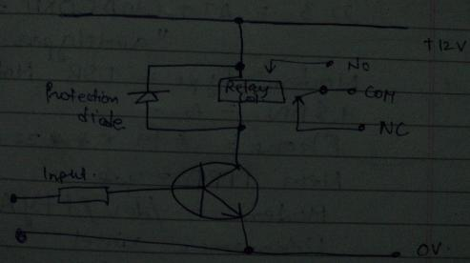
This is how a single relay in the controller chip is controlled, the controller chip contains 4 such repeative circuits for controlling 4 relays.
Update
After state level science exhibition , I went on with the following updations..
Made the iCruzer i386 OS (an embedded OS),Satellite control, Hackers Inside(a keystroke logger), NoUSB ( a kernel mode driver),SpySym007(a kernel mode driver), 3DR( 3d video recorder), Redesigned the controller chip, Improved voice recognition, face detection..
Cost
The project can be build from scratch for approx. RS 500…this includes the cost of the controller chip only, this cost can be extremely lowered by reusing the household items. This cost excludes the cost of the headphone, the webcam, the system itself, and the toy…
Further scope
Each and every application of the project comes with a big scope, for example you can use the voice and face detection in your home, or in atm… like instead of swapping your card to open the atm door, you can use the face detection to open it for you, same in your home. You can use the speech recognition to control the equipments in your home, and with this project you can go on building a complete automation system and yes, that with a satellite control too.. There is always a scope for the updation by the end user, don’t worry about licensing or anything else, go on. The complete package of the icruzer i386, the sources and designs comes with a GNU GPL license..
A multipurpose robotics project by
Raja Pranit Singh jamwal
Army School Damana muthi jammu

