VesselPlanner for KSP1
Instruction Manual
Version 0.6.44
VesselPlanner is a planning and telemetry mod for Kerbal Space Program 1.12.x. It helps you analyze an existing stage, design a future stage, build a vessel one stage at a time, and record flight telemetry.
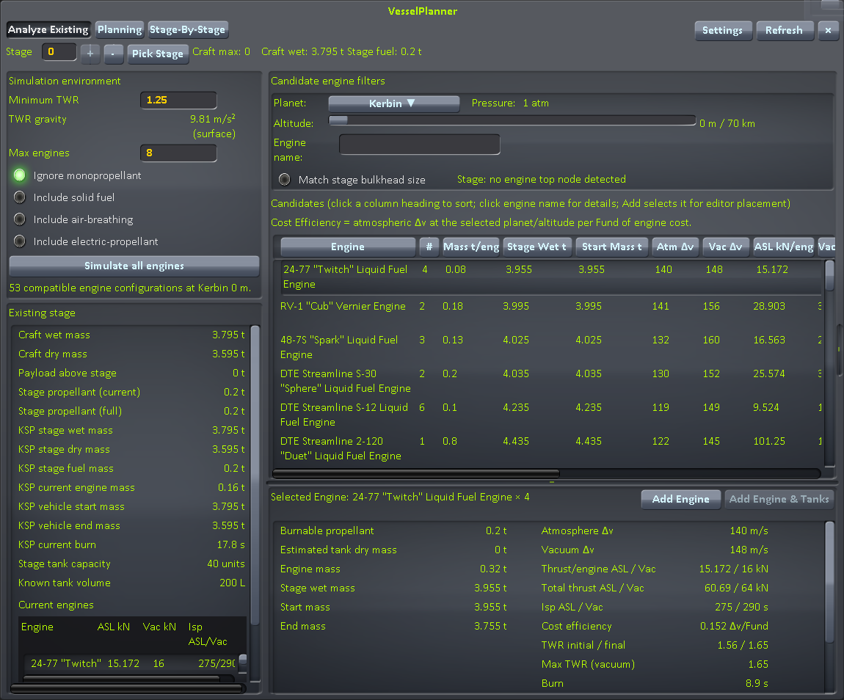
Main VesselPlanner window in the VAB/SPH (Analysis mode)

Kerbal Space Program 1.12.x

1. Requirements
VesselPlanner requires:
- Kerbal Space Program 1.12.x
- ToolbarController
- ClickThroughBlocker
The required mod files are normally installed under:
GameData/001_ToolbarControl/
GameData/000_ClickThroughBlocker/

2. Installation
- Remove any older GameData/EngineStagePlanner folder so KSP does not load both the old and new assemblies.
- Copy VesselPlanner into:
KSP_ROOT/GameData/VesselPlanner/

- Make sure the plugin DLL is located at:
KSP_ROOT/GameData/VesselPlanner/Plugins/VesselPlanner.dll

- Start KSP.
VesselPlanner can read older EngineStagePlanner settings, Stage-By-Stage plans, and flight maxima if the new VesselPlanner copies do not already exist.
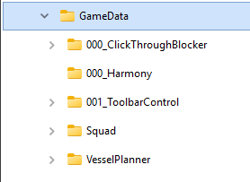
GameData folder showing VesselPlanner and its dependencies

3. Opening VesselPlanner

In the VAB or SPH
Click the VesselPlanner ToolbarController button. Look for the transparent checklist-and-rising-graph icon.
The editor window has three operating modes:
- Planning — design a stage that does not yet exist.
- Analyze Existing — inspect a stage already on the vessel and compare replacement engines.
- Stage-By-Stage — build and save a complete vessel plan one stage at a time.

In Flight
Click the same toolbar button to open the Flight Telemetry graph.

VesselPlanner toolbar button

Editor Instructions

4. Planning Mode
Use Planning when you want VesselPlanner to size a future stage.

Step 1 — Select Planning
Choose Planning at the top of the window.

Step 2 — Enter the stage requirements
Set the values in the Requirements pane:
- Target Δv — required delta-v for the stage.
- Δv basis — Vacuum or Atmosphere.
- Minimum TWR — minimum acceptable thrust-to-weight ratio.
- Payload — mass carried above the new stage.
- Body — celestial body used for gravity and atmospheric calculations.
- Altitude — altitude used for atmospheric thrust and Isp.
- Max engines — largest engine cluster VesselPlanner should test.
- Tank structural ratio — estimated tank dry mass divided by propellant mass.
Future stage numbers may be higher than the craft's current maximum stage.
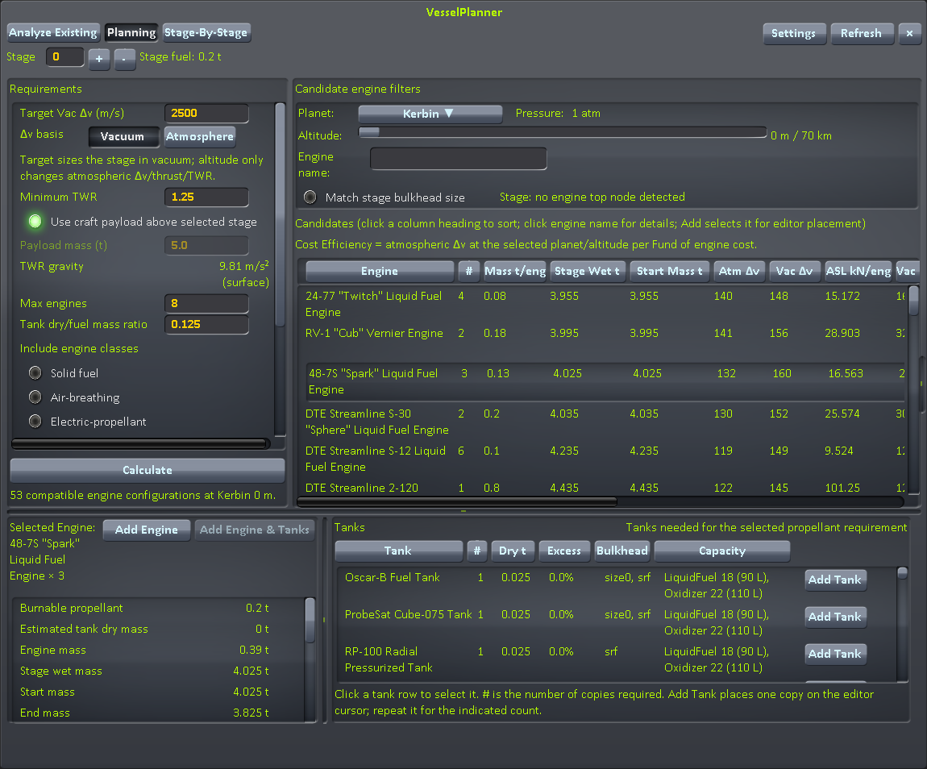
Planning Requirements pane with sample values

Step 3 — Calculate
Click Calculate.
VesselPlanner tests compatible engines and engine counts and fills the candidate engine list.

Step 4 — Select an engine
Click an engine row in the candidate list.
The Selected Engine pane shows detailed information for that solution, including thrust, TWR, mass, delta-v, burn time, and propellant requirements.
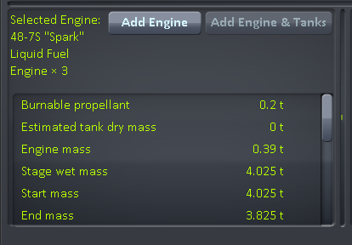
Candidate engine list and Selected Engine pane

Step 5 — Select a tank
The Tanks pane shows tank combinations that can hold the required propellant.
Each row shows information such as:
- tank name
- number required
- dry mass
- cost efficiency (kg of required-propellant capacity per Fund)
- excess capacity
- total capacity
- KSP bulkhead profile
Click a tank row to select it. The selected tank is highlighted and is also shown beneath the selected engine name. Cost Eff. is kilograms of required-propellant capacity per Fund and is sortable.
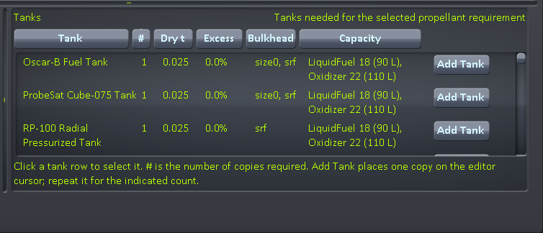
Tanks pane with one tank row selected

Step 6 — Add parts
Depending on what you are doing, use:
- Add — selects the engine part for placement in the editor.
- Add Engine — selects the currently highlighted engine for placement.
- Add Tank — selects one copy of that tank for placement.
When a Stage-By-Stage stage is open, these buttons add the selected parts to the plan instead of placing them directly on the editor cursor.

5. Analyze Existing Mode
Use Analyze Existing to inspect a stage that already exists on the vessel.

Step 1 — Select the stage
Enter a stage number or use Pick Stage and click a part on the vessel.
You can also click a stage header in KSP's stock staging list.
In Analyze Existing mode, the selected stage cannot be higher than the vessel's current maximum stage.

Step 2 — Review the Simulation Environment
The upper-left Simulation Environment pane contains the controls used for the engine comparison, including:
- Minimum TWR
- TWR gravity
- Max engines
- engine filters
- propellant filters
- Simulate all engines

Step 3 — Review Existing Stage information
The lower-left Existing Stage pane summarizes the selected stage. Depending on your Settings choices, it can show:
- craft wet and dry mass
- payload above the stage
- stage wet, dry, and propellant mass
- current engine mass
- vehicle start and end mass
- current burn time
- current engines
- stage resources
- tank capacity and known tank volume
Analyze Existing mode showing Simulation Environment and Existing Stage panes

Step 4 — Compare candidate engines
The right side lists engines that can be simulated against the current stage.
Select an engine row to see its detailed result below the list.
Useful filters include:
- engine-name search
- Match stage bulkhead size
- Ignore monopropellant
Click Add or Add Engine to select a replacement engine for placement in the editor.

6. Reading the Engine List
The main VesselPlanner editor window is horizontally resizable from 1150 to 1850 pixels. Drag the grip on the right edge to change the width; the selected width is remembered. If the candidate engine table is wider than the available space, use the horizontal scrollbar at the bottom of the engine list. The sortable column-heading buttons scroll horizontally with the engine rows so the headings remain aligned with their columns. The synchronized header area is 34 pixels tall.
The candidate engine table can include the following columns:
Column | Meaning
Engine | Engine part name
# | Number of engines in the tested cluster
Mass t/eng | Dry mass of one engine part
Stage Wet t | Wet mass of the stage itself
Start Mass t | Full vehicle mass accelerated at ignition
Atm Δv | Delta-v at the selected body and altitude
Vac Δv | Vacuum delta-v
ASL kN/eng | Sea-level thrust for one engine
Vac kN/eng | Vacuum thrust for one engine
TWR | Atmospheric thrust-to-weight ratio
Max TWR | Vacuum-thrust TWR
Isp | Specific impulse
Burn | Estimated burn time
Fuel | Required propellant
Δv/Fund | Delta-v divided by engine cost
Bulkhead | Engine bulkhead profile where available
Add | Select the engine for placement or add it to an open plan stage

The visible columns can be changed in Settings → Engine Columns.

Sorting
You can sort engine solutions by goals such as:
- lowest wet stage mass
- lowest propellant
- lowest engine cost
- shortest burn
- highest TWR
- highest Isp

Stage-By-Stage Instructions
For a more detailed walkthrough, see Manual/VesselPlanner-Stage-by-Stage-Tutorial.docx, included with the source package.

7. Creating a Stage-By-Stage Plan
Use Stage-By-Stage to design and save an entire vessel before building it.
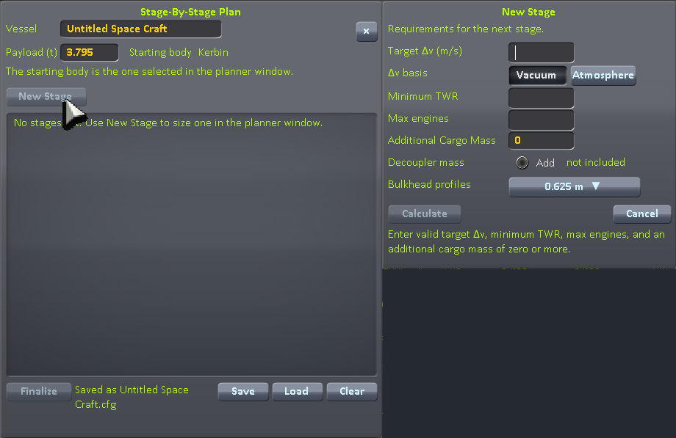
Stage-By-Stage Plan window

Step 1 — Open Stage-By-Stage mode
Choose Stage-By-Stage from the top of the editor planner.
The Stage-By-Stage Plan window opens with its left edge aligned to the main VesselPlanner window and its top edge immediately below the main mode-button row.
When solid editor backgrounds are enabled, the Stage-By-Stage Plan uses a 0.36 gray background shade, lighter than the main planner, so it is easier to distinguish.
The plan window contains:
- vessel/craft name
- payload/starting mass
- starting body
- list of planned stages
When you start a new Stage-By-Stage plan, VesselPlanner initializes Payload (t) automatically:
- if a vessel is already in the editor, VesselPlanner uses that vessel's current full wet mass;
- if the editor is empty, VesselPlanner uses 5.0 t.
A plan that already contains stages keeps its existing payload mass when you return to Stage-By-Stage mode.

Step 2 — Create a stage
Click New Stage.
The New Stage dialog opens immediately to the right of the Stage-By-Stage Plan window, with both top edges aligned and the dialog's left edge adjacent to the plan window's right edge.
The New Stage/Edit Stage dialog uses the same 0.36 gray solid background shade as the Stage-By-Stage Plan.
The New Stage dialog is modal. Other VesselPlanner windows cannot be used until you click Calculate or Cancel.
Enter:
- Target Δv
- Δv basis
- Minimum TWR
- Max engines
- Additional Cargo Mass
- Add decoupler mass
- optional Bulkhead profiles
Additional Cargo Mass is non-propellant dry mass carried by that stage. It is separate from the vessel payload.
When Add decoupler mass is enabled, VesselPlanner adds the configured decoupler mass for the selected stack profile to the stage fixed dry mass. The values come from GameData/VesselPlanner/decouplerMasses.cfg. If several matching stack profiles are selected, the largest matching decoupler mass is used.
For Stage 2 and later, the dialog shows Previous stages mass. This is the original plan payload plus the full wet mass of all previously planned stages, and VesselPlanner automatically uses it as the payload for the current stage.
Tab moves through the numeric entry fields; Shift+Tab moves backward.
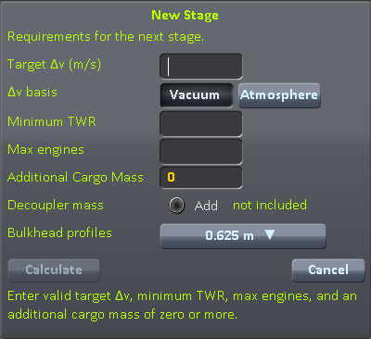
New Stage dialog with all entry fields visible

Step 3 — Choose bulkhead profiles if needed
VesselPlanner presets the Bulkhead Profiles selection when New Stage opens. For the first stage, an existing editor vessel uses its open lower bottom node, falling back to the top node. For later stages, the previous stage engine bottom node is used, falling back to its top node. You can then change the selection as needed.
- srf is listed first for surface-attached parts.
- stack profiles such as size0, size1, size1p5, size2, and so on follow it.
- leaving all profiles unselected allows all profiles.
The selected profiles filter both engine candidates and tank suggestions for that stage.

Step 4 — Calculate the stage
Click Calculate.
The main VesselPlanner window comes to the front and displays the Planning solution for that stage.

Step 5 — Select an engine and tank
- Select an engine from the candidate list.
- Select a tank from the Tanks pane.
- Confirm the Selected Engine pane shows both:
- the selected engine and quantity
- the selected tank and quantity

Step 6 — Add the engine and tanks to the stage
Click Add Engine & Tanks.
The button is disabled until a tank is selected.
It adds the selected engine and the selected tank quantity to the open Stage-By-Stage stage. After the add completes, the Stage-By-Stage Plan window is brought to the front.
You can also use the individual Add, Add Engine, and Add Tank controls.
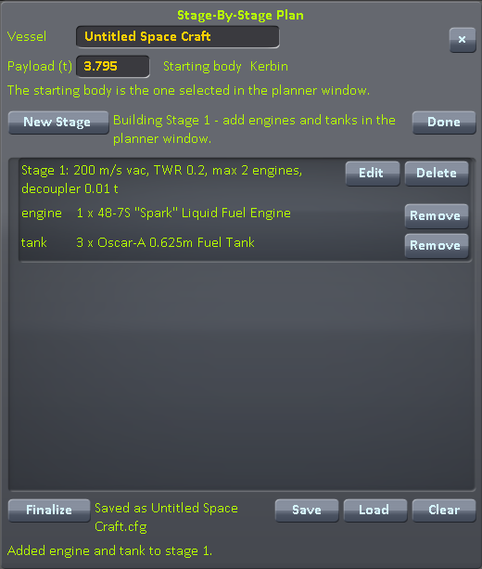
Stage-By-Stage stage after engine and tanks have been added

Step 7 — Finish or edit the stage
Use:
- Done — close the currently open stage without finalizing the complete plan.
- Edit — reopen the stage requirements and recalculate while keeping the selected parts.
- Delete — remove a stage from the plan.
- Remove — remove an individual planned part.

Step 8 — Save the plan
Click Save.
Plans are stored in:
GameData/VesselPlanner/PluginData/Plans

Step 9 — Finalize the plan
Click Finalize when the stage plan is complete.
After finalizing:
- New Stage is no longer available.
- Each planned part receives an Add button for placing it in the editor.
- The main planner closes so the plan can be used as a build list.
Use Reopen if you need to edit the plan again.

Loading a saved plan
Click Load to open the saved-plan list.
You can:
- load a plan
- delete a saved plan
Deleting requires confirmation and removes only the saved plan file.

Settings

8. Editor Settings
Click Settings in the editor planner.
Settings are saved in:
GameData/VesselPlanner/PluginData/VesselPlannerSettings.cfg

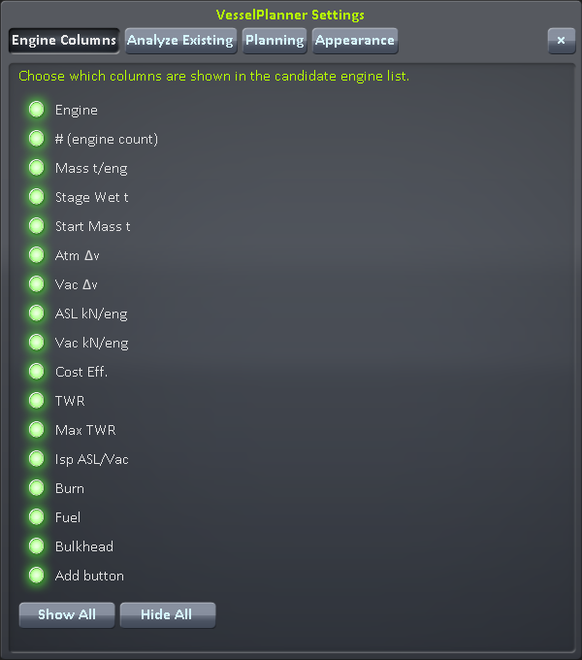
Editor Settings window

Engine Columns
Choose which columns are visible in the engine candidate table.
Use Show All or Hide All for quick changes.

Analyze Existing
Choose which informational lines are displayed in the Existing Stage pane.
You can also choose whether the planner closes after a successful engine Add operation.

Planning
Choose whether the planner closes after a successful Add, Add Engine, or Add Tank operation.

Appearance
Appearance options include:
- KSP skin or Alternate skin
- Use solid backgrounds for all editor windows
Solid backgrounds are enabled by default for new configurations. The setting applies to the main editor planner, Settings window, and Stage-By-Stage windows.

Flight Telemetry

9. Using the Flight Graph
Click the VesselPlanner toolbar button while in Flight.
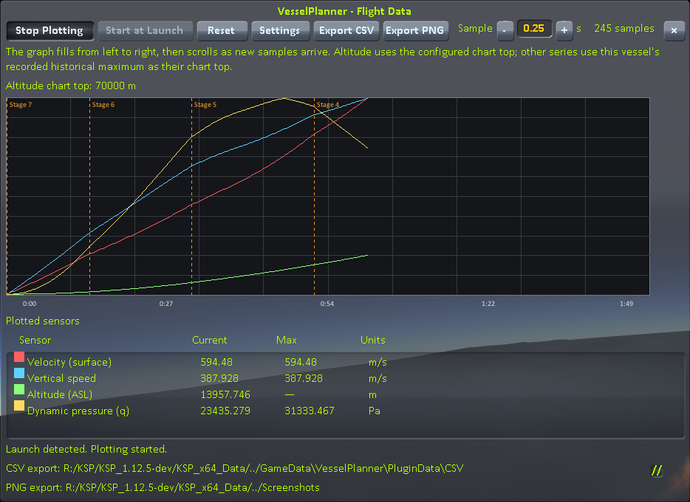
Flight telemetry graph during ascent

The Flight Data window has a fixed height and resizes horizontally only from the right-edge grab handle. Vertical grid lines stay fixed during resizing. Time labels can be shown on every grid line, every other line, or every third line (default); labels remain centered on those fixed lines. Expanding the graph adds positions only on the right. The separate Flight Plot Settings window remains resizable in both directions.

Starting a recording
- Start at Launch may be armed while the vessel is still PRELAUNCH.
- Recording starts automatically when the vessel leaves PRELAUNCH.
- Reset clears the current graph samples and stage markers.
- Sampling pauses when KSP is paused.

Sample interval
The default sample interval is 0.25 seconds.
Use the - and + buttons or type a value directly. Valid values are from 0.05 to 60 seconds.

Available telemetry
VesselPlanner can record and plot:
- surface velocity
- orbital velocity
- vertical speed
- acceleration
- G-force
- altitude ASL
- altitude above terrain/surface
- dynamic pressure (q)
- vessel mass
- angle of attack
- vessel resources
- stock ModuleEnviroSensor outputs

Stage markers
Stage activations appear as vertical dashed markers labeled with the stage number.

Historical maxima
For non-altitude series, VesselPlanner keeps per-vessel maximum values and uses them for graph scaling.
They are stored in:
GameData/VesselPlanner/PluginData/FlightSensorMaxima.tsv

Reset does not erase these maxima. Use Clear Max Values for Vessel in Flight Settings if you want to clear them.

10. Flight Settings and Export
Open Settings from the flight graph.
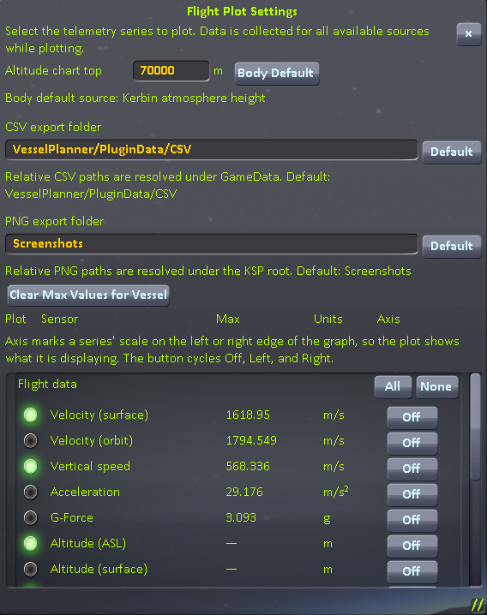
Flight Settings window showing Plot, Sensor, Max, and Units columns

Choose which flight data, resources, and sensor values are plotted. Resources and sensors refresh automatically. Time labels can be shown on every line, every other line, or every third line (default); the choice is saved in VesselPlannerSettings.cfg.

Window background
Enable Use solid background for Flight Data window to make the Flight Data graph window opaque while retaining the selected KSP/alternate skin, title, and border styling. The opaque layer is drawn behind the single Flight Data window, which avoids the duplicate/ghost-window flicker that can otherwise appear while resizing. The setting is saved in VesselPlannerSettings.cfg as SolidFlightWindowBackground and is enabled by default for new configurations; an existing saved value is preserved.

CSV export
Default location:
GameData/VesselPlanner/PluginData/CSV

The CSV location is configurable. Relative CSV paths are resolved under GameData; absolute paths are also accepted.

PNG export
Default location:
KSP_ROOT/Screenshots

The PNG location is configurable. Relative PNG paths are resolved from the KSP root; absolute paths are also accepted.
Use:
- Export CSV — export the selected telemetry series.
- Export PNG — save an image of the currently visible graph.

Reference

11. Important Calculation Notes

TWR
TWR uses the selected body's gravity. Atmospheric TWR uses thrust at the selected atmosphere/altitude; maximum TWR uses vacuum thrust.

Delta-v
The results table shows both atmospheric and vacuum delta-v. In Planning, the selected Δv basis determines which value is used to size the stage.

Stage mass
- Stage Wet t is the mass of the stage itself.
- Start Mass t is the full vehicle mass accelerated when that stage starts.

Tank planning
Planning estimates tank dry mass with the tank structural ratio until an actual tank choice is made.

Resources
Propellant requirements are shown in KSP resource units and mass. Where resource volume data is available, VesselPlanner also estimates physical tank volume.

12. Files Created by VesselPlanner
Typical persistent files are stored under:
GameData/VesselPlanner/PluginData/

Important files and folders include:
GameData/VesselPlanner/decouplerMasses.cfg — optional Stage-By-Stage decoupler and stack-separator reference masses.
VesselPlannerSettings.cfg Editor and flight settings
FlightSensorMaxima.tsv Per-vessel telemetry maxima
Plans/ Saved Stage-By-Stage plans
CSV/ Default CSV export folder

PNG exports default to:
KSP_ROOT/Screenshots

13. Troubleshooting

VesselPlanner does not appear
Check that:
- ToolbarController is installed.
- ClickThroughBlocker is installed.
- VesselPlanner.dll is under GameData/VesselPlanner/Plugins.
- the old GameData/EngineStagePlanner installation has been removed.

An engine or tank is missing from the list
Check:
- engine-name filters
- propellant filters
- bulkhead-profile selections
- editor part filters supplied by other mods
- Analyze Existing's Match stage bulkhead size option

Add Engine & Tanks is disabled
In Stage-By-Stage mode, select a tank row first. The combined button requires both an open stage and an explicitly selected tank.

An older saved Stage-By-Stage plan has no decoupler setting
Plans created before decoupler-mass support load with Add decoupler mass disabled. Older cargo behavior is unchanged.

14. License
See License.md for license information.

