Engine Stage Planner
User Manual
A mod for Kerbal Space Program 1.12.x
Engine Stage Planner helps you pick engines. In the VAB/SPH it tells you which engines will actually meet a delta-v and TWR target for a given stage. In flight it plots telemetry on a scrolling graph.

Contents
1. Installation 1
1.1 Required mods 1
1.2 Copy the files 1
2. Opening the window 1
3. The two editor modes 1
4. Using Analyze Existing 1
Step 1 — Pick the stage 1
Step 2 — Set up the simulation environment 1
Step 3 — Choose a body and altitude 1
Step 4 — Read the results 1
Filters available in this mode 1
5. Using Planning 1
Step 1 — Enter your targets 1
Step 2 — Set the tank ratio 1
Step 3 — Read the results and the tank table 1
6. Reading the candidate table 1
Sorting 1
Propellant display 1
7. Adding parts to your craft 1
8. Settings 1
Engine Columns page 1
Analyze Existing page 1
Planning page 1
Appearance page 1
9. Flight telemetry plotter 1
Starting a recording 1
Sample interval 1
What can be plotted 1
Flight settings 1
How the graph scales 1
Exporting 1
10. How the numbers are calculated 1
Which engines appear as candidates 1
Thrust and TWR 1
Mass boundaries 1
Burn time 1
Resources 1
11. Known limits 1
12. Version notes 1

1. Installation

1.1 Required mods
Engine Stage Planner will not run without these. Install them first.
Mod | File it must provide
ToolbarController | GameData/001_ToolbarControl/Plugins/ToolbarControl.dll
ClickThroughBlocker | GameData/000_ClickThroughBlocker/Plugins/ClickThroughBlocker.dll

1.2 Copy the files
Place these four files under GameData/EngineStagePlanner:
From | To
EngineStagePlanner/bin/Release/EngineStagePlanner.dll | GameData/EngineStagePlanner/Plugins/EngineStagePlanner.dll
EngineStagePlanner/PluginData/Textures/icon_38.png | GameData/EngineStagePlanner/PluginData/Textures/icon_38.png
EngineStagePlanner/PluginData/Textures/icon_24.png | GameData/EngineStagePlanner/PluginData/Textures/icon_24.png
EngineStagePlanner.version | GameData/EngineStagePlanner/EngineStagePlanner.version

Start KSP. If the toolbar button appears in the VAB, you're installed.
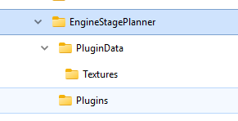

2. Opening the window
One toolbar button does everything. It appears in the VAB, the SPH, and in Flight.
- In the editor, it opens the planner.
- In flight, it opens the telemetry graph.

The planner window starts closed every time you enter the editor — click the button to open it.

The Engine Stage Planner button on the KSP application toolbar.

Both windows can be dragged from any empty area and resized using the grip in the lower-right corner. Clicks won't leak through to parts behind the window, and the windows close themselves automatically when KSP starts loading a new scene.

3. The two editor modes
Mode | Use it when
Analyze Existing | You already have a craft built and want to know which engine to put on a stage that already has tanks and fuel.
Planning | You have a delta-v target and a payload mass, and you want the mod to size the stage for you from scratch.

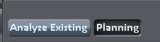

The Analyze Existing / Planning selector at the top of the planner.

4. Using Analyze Existing

Step 1 — Pick the stage
You have three ways to choose which stage to analyze:
- Type a number into the Stage field.
- Click Pick Stage, then click any part on your craft. The planner jumps to that part's stage.
- Click the orange header of any stage in KSP's normal staging list on the right of the screen.

While Pick Stage is armed, the mod temporarily locks the editor so your click selects a part instead of grabbing and detaching it. Normal editing returns as soon as you release the mouse.
In this mode you cannot select a stage number higher than the craft's current maximum stage — the field clamps itself, including when you add or remove stages.

Pick Stage armed, cursor hovering a fuel tank on the craft.

Step 2 — Set up the simulation environment
The left column splits into two panes. The top pane, Simulation environment, is always visible and holds everything that affects the run:
- Minimum TWR — candidates below this are rejected.
- TWR gravity — filled in automatically from the body you select.
- Max engines — the largest cluster size the mod will try.
- Simulation filters — engine name text filter, bulkhead matching, ignore monopropellant.
- Simulate all engines — run the sweep.
- Simulation status — progress and result count.

Below it, the Existing stage pane shows what the mod found on your craft: wet and dry masses, payload above the stage, propellant currently loaded versus full capacity, current engine mass, burn time, tank volume, and the list of engines already installed.
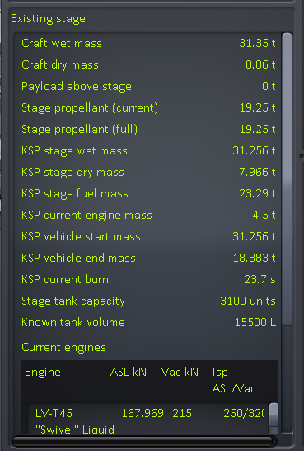

The two stacked panes — Simulation environment above Existing stage.

Step 3 — Choose a body and altitude
Click the current-body button to open a vertical list of celestial bodies. Pick one, then set an altitude with the slider. The mod uses KSP's own atmospheric pressure model and each engine's real atmosphere curve, so the atmospheric numbers are what you'd actually get there.
The body list draws on top of the rest of the window rather than pushing it down, and it stays anchored to the button as you move the planner around.
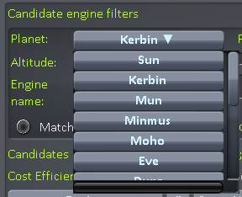

The body list open beneath the current-body button.

Step 4 — Read the results
The candidate list shows every compatible engine, simulated against the propellant actually loaded in that stage right now — not maximum tank capacity. See Section 6 for what each column means.

Filters available in this mode
- Engine name — live, case-insensitive text search.
- Match stage bulkhead size — only shows engines whose top attach node size matches the top node of the engines already on that stage.
- Ignore monopropellant — hides any candidate whose mass-bearing propellant includes MonoPropellant.

5. Using Planning
Planning sizes a stage that doesn't exist yet.

Step 1 — Enter your targets
Input | Meaning
Target delta-v | Interpreted as vacuum delta-v
Minimum TWR | Rejection threshold
Payload | Mass sitting on top of this stage
Planet / body | Sets TWR gravity automatically
Altitude | Only affects the atmospheric columns
Max engine count | Largest cluster to try
Tank structural ratio | See Step 2

You may type a future stage number here that's higher than your craft's current maximum — that's the point of the mode. Planning's top row is deliberately simpler than Analyze Existing's; it has no Pick Stage, Craft max, or Craft wet controls.

The Planning input panel filled in with a sample target.

Step 2 — Set the tank ratio
Planning has to guess tank dry mass before you've picked a tank, so it uses a tank dry mass ÷ propellant mass ratio. 0.125 is a reasonable stock-like default. If you select a stage that already has resource-bearing parts, the mod infers a ratio from them for you.
The solver loops on this: propellant mass depends on tank dry mass, and tank dry mass depends on propellant mass.

Step 3 — Read the results and the tank table
Because Planning sizes the stage from vacuum delta-v, the stage geometry is fixed. Moving the altitude slider will not change propellant load, wet/dry mass, vacuum delta-v, tank requirements, or burn time. It only changes the atmospheric delta-v, atmospheric thrust, and atmospheric TWR shown for that fixed stage.

Below the engine results, the Tanks needed table lists each available tank type with:
- how many copies you'd need
- total tank dry mass
- excess capacity
- supplied resource capacity

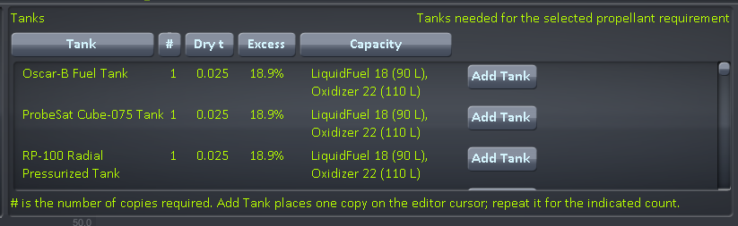

The Tanks needed table showing several tank options.

6. Reading the candidate table
The list is capped at 300 pixels tall and scrolls, so growing the window won't let the engine list swallow the UI. Sorting and filter changes recalculate immediately.
Column | What it is
Engine | Part name
# | How many engines in this candidate configuration
Stage Wet t | Mass of this stage only — no payload, no upper stages
Start Mass t | Full vehicle mass accelerated at ignition; this is what drives delta-v and TWR
Atm Δv | Delta-v at your selected body and altitude
Vac Δv | Vacuum delta-v
ASL kN/eng | Sea-level thrust of one engine
Vac kN/eng | Vacuum thrust of one engine
TWR | Atmospheric TWR, using total thrust of all engines
Max TWR | Vacuum-thrust TWR, sortable
Isp | Specific impulse
Burn | Burn duration
Fuel | Propellant required
Δv/Fund | Atmospheric delta-v divided by total engine cost
Add | Puts that engine on the editor cursor

Note the deliberate split: the per-engine kN columns show one engine, while TWR uses all of them. The selected-result detail panel shows both per-engine and total thrust so you can see the multiplication.

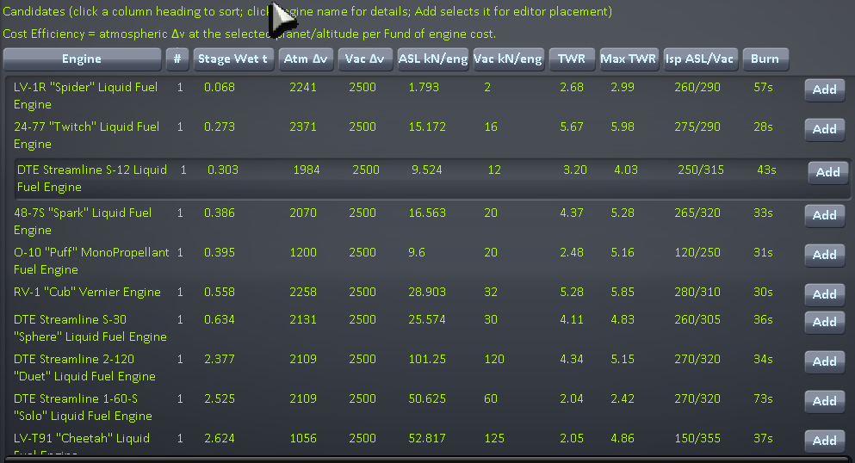

The full candidate list with several engines ranked.

Sorting
Pick one optimization goal from the vertical toggle group:
- Lowest wet stage mass
- Lowest propellant
- Lowest engine cost
- Shortest burn
- Highest TWR
- Highest Isp

Propellant display
Requirements are shown in KSP resource units and in mass. Where the resource definition supplies a volume, estimated physical tank volume in litres is shown too.

7. Adding parts to your craft
Three buttons place parts, all using KSP's normal editor spawning path:
- Add on any candidate row — places that engine on the cursor.
- Add Engine on the selected result — same thing for the highlighted candidate.
- Add Tank in the Tanks needed table — places one copy. Click it again for each copy the table calls for.

For multimode engines, both listed modes point at the same underlying part.
Optionally, the planner can close itself after a successful placement. Analyze Existing and Planning have separate preferences for this, and the window only closes if KSP actually put the part on your cursor.
IMAGE PLACEHOLDER
images/add-engine.png

An engine attached to the cursor immediately after clicking Add.

8. Settings
Open Settings from the editor planner. Everything is saved to:
GameData/EngineStagePlanner/PluginData/EngineStagePlannerSettings.cfg
and restored next time you run KSP. The Settings window drags from any unused background area.
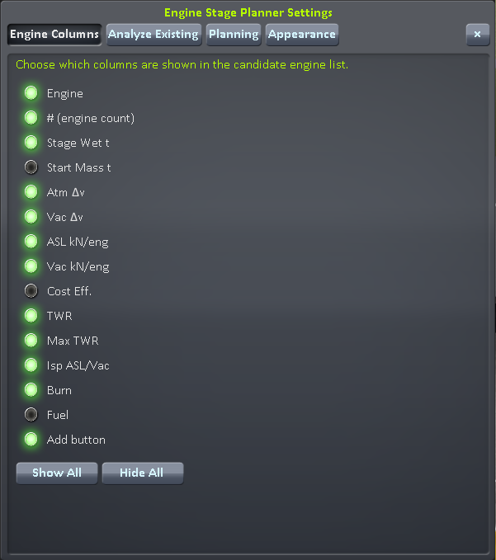

The Settings window with its page tabs visible.

Engine Columns page
Turn any candidate table column on or off individually — Engine, count, Stage Wet, Start Mass, atmospheric and vacuum delta-v, atmospheric and vacuum thrust, cost efficiency, TWR, Max TWR, Isp, Burn, Fuel, and the row Add button. Show All and Hide All are one-click presets.

Analyze Existing page
Controls which informational lines appear in the Existing stage pane: craft wet/dry mass, payload above stage, current and full stage propellant, KSP stage wet/dry/fuel masses, current engine mass, vehicle start/end mass, current burn, tank capacity and known tank volume, the Current Engines section, and stage-resource lines.
Simulation controls are never hidden by these settings. This page also holds the close-planner-after-Add option for Analyze Existing.

Planning page
Its own independent close-planner-after-Add / Add Engine / Add Tank option.

Appearance page
Use solid backgrounds for all editor windows gives the planner and the editor Settings window an opaque dark underlay while keeping normal KSP borders and title styling. Off by default. It does not affect flight windows.

9. Flight telemetry plotter
Click the same toolbar button in flight to open the graph.
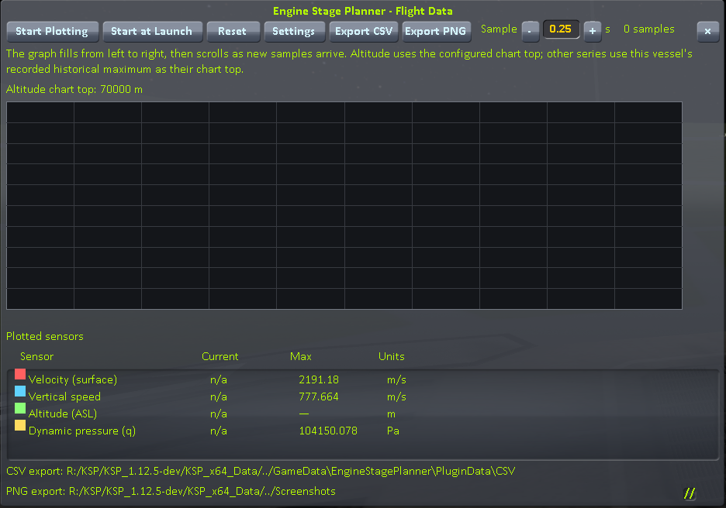

The telemetry graph mid-ascent with several series plotted.

Starting a recording
- Start at Launch can be armed while the vessel is in PRELAUNCH. When the vessel leaves PRELAUNCH, existing data is cleared and recording begins automatically. Once you're already flying, this button is disabled.
- Reset clears the current plot samples and stage markers.
- Sampling pauses with the game and resumes only after you unpause and the sample delay has elapsed.

Sample interval
The Sample field sits at the top of the plotter toolbar. Default is 0.25 seconds. The − and + buttons step it by 0.25 s, and you can type an exact value from 0.05 to 60 seconds. It sets the minimum real-time delay before the next sample is recorded.

What can be plotted
- Surface velocity and orbital velocity
- Vertical speed
- Acceleration
- G-force
- Altitude ASL and altitude above surface
- Dynamic pressure (q)
- Vehicle mass
- Angle of attack
- Every resource carried by the active vessel
- Output from any stock ModuleEnviroSensor on the vessel

All available sources are recorded while plotting, so switching which series are visible can redraw data you already collected.

Flight settings
Open Settings from the graph to choose series. Flight data, resources, and sensors are grouped separately, each with All/None controls. The table shows Plot, Sensor, Max, and Units. The main plotted list also shows Current and Max per series.
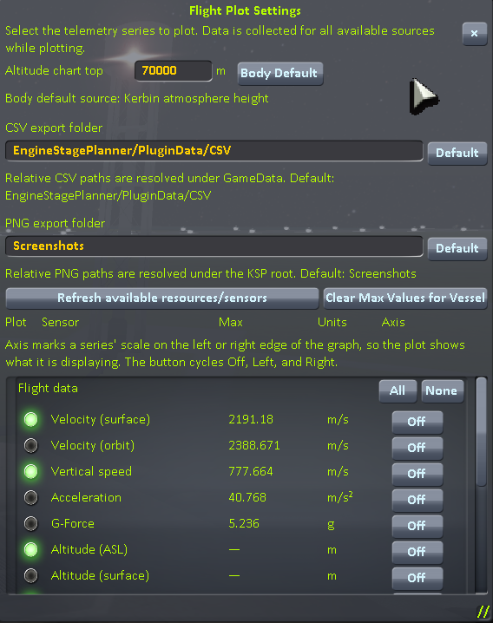

The flight Settings series selection table.

How the graph scales
- The graph fills left to right with fixed horizontal sample spacing. Once it hits the right edge, the window scrolls and old data moves left.
- Elapsed time since plotting started is labelled along the bottom as m:ss, or h:mm:ss on long runs.
- Stage activations appear as orange dashed vertical lines labelled Stage N. They scroll with the data and are cleared by Reset or Start at Launch.
- Altitude series use a configurable Altitude chart top with a zero baseline. By default that's the launch body's atmosphereDepth, or 10% of body diameter for an airless body. Altitude intentionally stores no Max value because this setting controls its scale.
- Every other series scales to a per-vessel historical maximum recorded across all launches and reverts in the current save. The lower bound follows currently visible data, so series with wildly different units can share one graph.

Maxima persist in:
GameData/EngineStagePlanner/PluginData/FlightSensorMaxima.tsv
Reset deliberately preserves them. Use Clear Max Values for Vessel to wipe the current craft's non-altitude maxima without clearing the current plot.

Exporting
Export CSV writes the selected series as comma-separated text. Export PNG writes an image of the currently visible graph. Both land in Screenshots/EngineStagePlanner.

10. How the numbers are calculated
You don't need this section to use the mod, but it explains why the numbers are what they are.

Which engines appear as candidates
Candidates come from KSP's loaded part database after the editor's ExcludeFilters are applied. If another mod hides an engine through KSP's editor filter API, it's hidden here too. The currently selected editor category is not applied.

Thrust and TWR
- TWR gravity comes from the selected body's surface gravity automatically.
- For conventional rockets, vacuum thrust is the configured ModuleEngines.maxThrust; atmospheric thrust follows the ratio of atmospheric to vacuum Isp from the engine's atmosphere curve.
- Engines whose fuel flow genuinely depends on atmosphere or velocity use KSP's own flow calculation, with a sanity fallback.
- Analyze Existing honours each installed engine's editor thrust limiter and shows individual ASL and vacuum thrust per engine.
- Analyze Existing also carries the mass of loaded stage resources the candidate engine cannot burn, so they drag down TWR and delta-v exactly as they would in game.

Mass boundaries
Analyze Existing prefers KSP's own VesselDeltaV / DeltaVStageInfo results, which respect the stock staging and fuel-flow model:
- Stage Wet t uses stageMass
- Start Mass t uses the full vehicle startMass
- Retained payload is startMass − stageMass

Installed engine mass is removed using DeltaVPartInfo.dryMass before candidate engine mass is added, so the existing engine isn't counted twice.
The branch scanner still identifies the stage's resource inventory, tank volume, and engine list, and acts as a fallback when the stock delta-v simulation isn't ready yet. Parts found by the branch scan are excluded from the payload-above-stage sum so they aren't double counted.

Burn time
Mass flow is derived from vacuum thrust and vacuum Isp rather than getMaxFuelFlow:
mdot = F / (Isp × g0)
t = mPropellant × Isp × g0 / F
Burn rate is therefore independent of the selected body and altitude. In Analyze Existing, mPropellant is the mass of the propellant mixture the candidate engine can actually burn, limited by what's loaded in the stage — KSP's whole-stage fuelMass is not substituted in. This stops unrelated stage resources from inflating burn duration.
The rocket equation uses KSP's standard gravity constant, 9.80665 m/s².

Resources
The full propellant list is read from each ModuleEngines / ModuleEnginesFX module. Nothing about LiquidFuel/Oxidizer or any other mixture is assumed.
- Every resource with a positive engine ratio is kept in the requirement set, including intake and electrical resources.
- Resources that contribute to Isp and have mass drive the rocket equation.
- ignoreForIsp resources stay visible as auxiliary requirements but don't define mass flow.
- Physical volume comes from PartResourceDefinition.volume. There is no hard-coded volume table, so stock and modded resources both work from whatever definitions your install has loaded.

11. Known limits
The planner is a good heuristic, not a full flight simulator. These are not currently modelled:
- Dynamic tank type/configuration switching by RealFuels, B9, MFT-style modules after the prefab loads.
- Jet velocity curves and intake-air flight-state modelling beyond static pressure-based Isp and thrust.
- Engine variants controlled by arbitrary third-party modules beyond loaded ModuleEngines.
- Full MechJeb-style fuel-flow simulation for asparagus, crossfeed, and drop-tank arrangements.

For unusual modded fuel-flow systems, use Planning with a manually entered payload mass — it doesn't depend on the stage scan being right.

12. Version notes
Version | Change
0.2 | Tanks needed table; Add / Add Engine / Add Tank editor placement; bulkhead-size filtering; Ignore monopropellant
0.3.6 | Existing-stage simulation uses current resource amounts, not max capacity; Planning fixed to vacuum Δv so altitude no longer resizes the stage
0.3.7 | Candidate list capped at 300 px and scrollable; immediate filter recalculation; Δv/Fund column
0.4.12 | Sample interval moved to the flight toolbar with ± 0.25 s buttons; stage markers driven by GameEvents.onStageActivate
0.4.13 | Default flight sample interval returned to 0.25 s
0.5.0 | Generic engine-resource support; density and volume read from PartResourceDefinition
0.5.7 | Stock startMass/endMass boundaries; burn time from thrust and Isp instead of getMaxFuelFlow; elapsed-time labels on flight graph; planner starts closed
0.5.13 | Burn duration computed from propellant the candidate engine can actually use
0.5.14–0.5.19 | Stage clamping in Analyze Existing; wider mass/thrust columns; column and info-line visibility settings; persistent draggable Settings; per-mode close-after-Add; Alt+P removed; Simulation environment split into its own pane; Appearance opaque-window option
0.5.25 | Corrected the scene-switch callback signature to GameEvents.FromToAction<GameScenes, GameScenes>

