


MySpamGuard 2.1
User Guide

Research & Development Unit
Open Source Competency Center (OSCC),
MAMPU,
Lot E302-34, Enterprise Building 3,
63000 Cyberjaya, Selangor
Tel: 03-83191200
Fax: 03-83193206

Table of Contents
Introduction 1
Login to MySpamGuard 2
MySpamGuard Dashboard 3
Status Bar 4
Main Menu Bar and Display Bar 6
Recent Messages 6
Lists 7
Quarantine 8
Reports 9
Tools/Links 11
Maintenance 14

Introduction
MySpamGuard is an email spam solution. It searches the headers and text of incoming emails to determine whether it is spam based on the procmail instruction or rules set by the user. MySpamGuard will classify the suspected spam accordingly; email sent by a virus, email from a known spam source which is definitely spam, and email which is probably spam. It then tags the filtered out email with the appropriate header and respond accordingly to the action specified by the users.

New features in MySpamGuard 2.1
- Easy installation process. The files needed will be downloaded automatically by the installer.
- All modules needed in MySpamGuard are combined as one package. The modules are:
    - SpamAssassin – spam checking aplication
    - MailScanner – email scanning for general filtering
    - ClamAV – anti virus solution
- Minimum configuration because most of the configuration is installed automatically by the installer
- Automatic update for all package from OSCC repository server

Login to MySpamGuard
Open url to login to the MySpamGuard. It will prompt for username and password. Then click on the OK button. Example as below:
Mail URL: http://DOMAIN_NAME/mailscanner
Username: admin
Password: admin (encrypted)

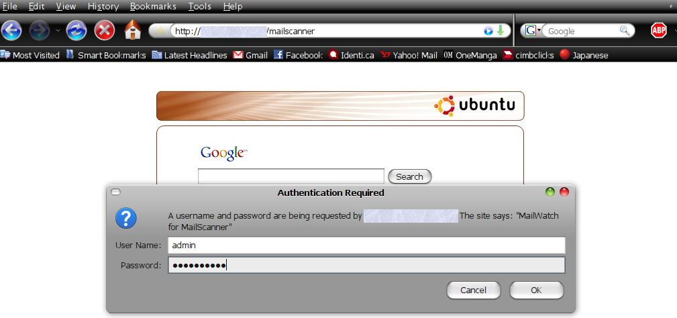
Figure 1

MailScanner are using MailWatch as front-end for user to check for process happened in the system.

MySpamGuard Dashboard
Right after you login to MySpamGuard, it will open up main page of MySpamGuard or also know as MySpamGuard Dashboard as shown in Figure 2. MySpamGuard Dashboard are divide into three section:
- Status Bar
- Main Menu Bar
- Display Bar – Display for Main Menu Bar

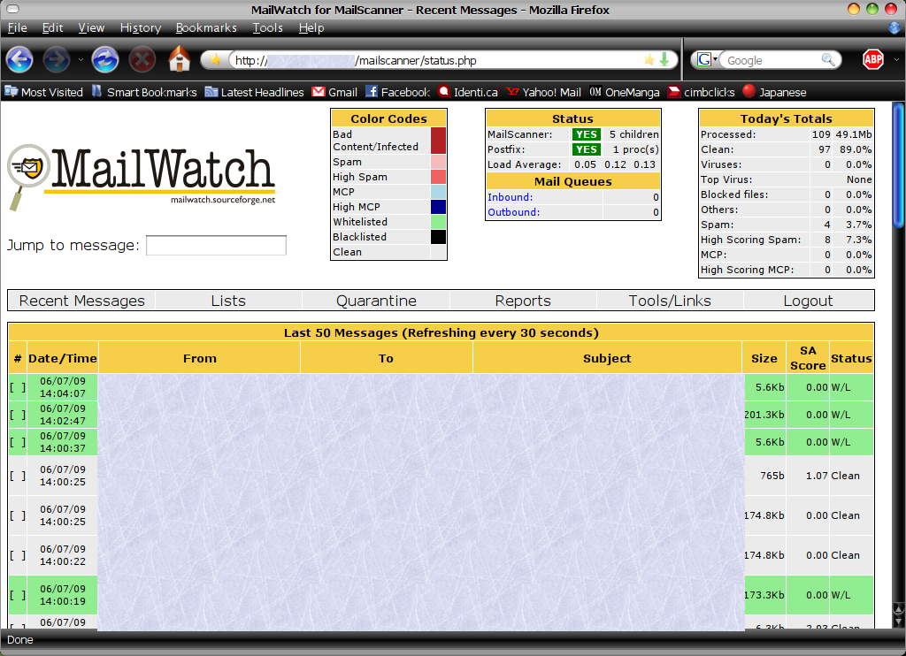

Status Bar

Main menu Bar

Display Bar

Figure 2

Status Bar

MySpamGuard will display summary of process happened within system in Status Bar:
- Color Codes
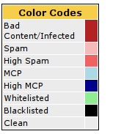
Color Codes will differentiate incoming email into its category as shown in Figure 3.
For example: In Figure 2, we can identified incoming email that are listed under Whitelisted lists based from the color codes of that email.
Figure 3
- Status and Mail Queues
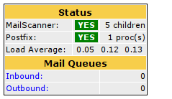
The status of main process that run the whole system will be shown in Status box.
As for Mail Queues is the total incoming or outgoing email that has been delayed.
Figure 4

- Today's Totals
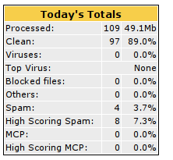
From Today's Totals box, it will show you summary of today statistic.

Figure 5

- Jump to message
Jump to message is an application for user to locate/view email summary by type in email ID in the field provide as shown in Figure 6
Insert Email ID in this field
Figure 6

Main Menu Bar and Display Bar

Figure 7
There are five (5) services can be choose from Main Menu Bar; the services choose will be shown in Display Bar:
- Recent Messages
- Lists
- Quarantine
- Reports
- Tools/Links

Recent Messages

They will navigate to 50 latests messages, and it will refresh for every 30 seconds to update the latest list.
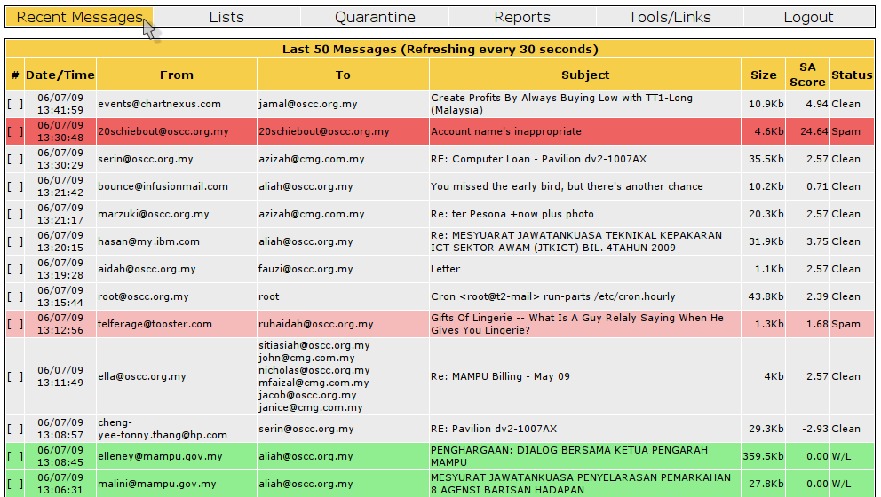
Figure 8
User can also review email summary by checking the # box, as shown in Figure 9.
Figure 9

Lists

Using Lists service, user can manually add new Whitelist/Blacklist address into the system.
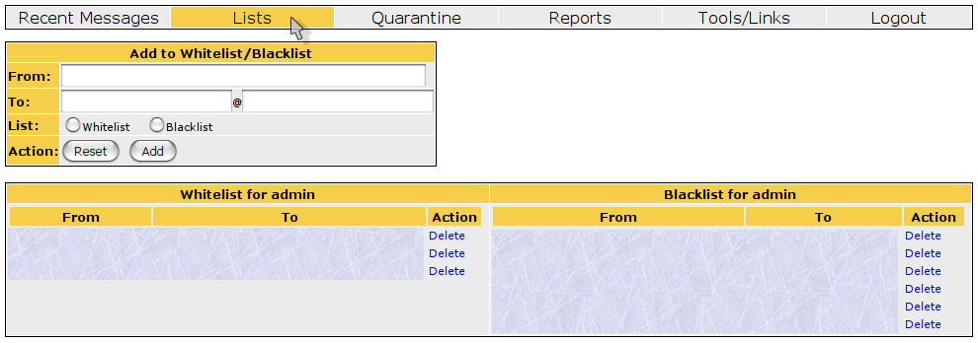
Figure 10
Adding function
Deleting
function
- Adding new address into Lists
    - Fill in the field in the Add to Whitelist/Blacklist Box with the sender and recipient address.
    - Next, check either radiobutton Whitelist or Blacklist.
    - Finally, click button Add to update the new address.
- Deleting address from Lists
    - Click Delete from the Action column in the Whitelist for admin or Blacklist for admin

Quarantine

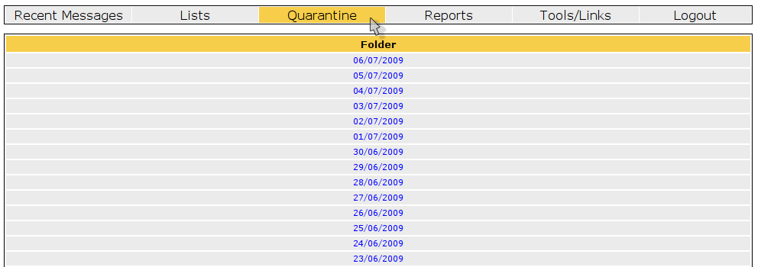
Figure 11
All email that is calculated with lower spamassassin (SA) score, will be stored in Quarantine. Email with lower SA score will be stored by their respective date. Example as shown in Figure 12 and Figure 13.
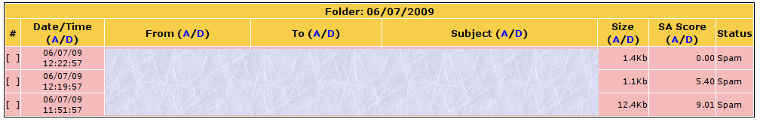
Figure 12
Click on directory to view email listing on that respective date. Click on # column in order to view email summary. Scroll to the end of the email summary to view Quarantine box.
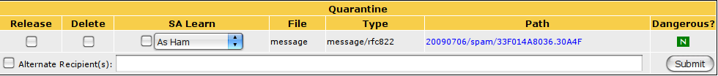
Figure 13
There are few options available in Quarantine box, such as:
  - Release or Delete options
  - SA Learn : An enhancement for system to recognize email pattern, be it spam or ham(clean) email.

Reports

Service to generate report based from few options available in the Reports section, as shown in Figure 14. User can also change variable for the report by adding new filter in the Add Filter section.
In Statistic (Filtered) section will list out statistic of incoming email in your system from oldest record to newest record define in your Active Filter
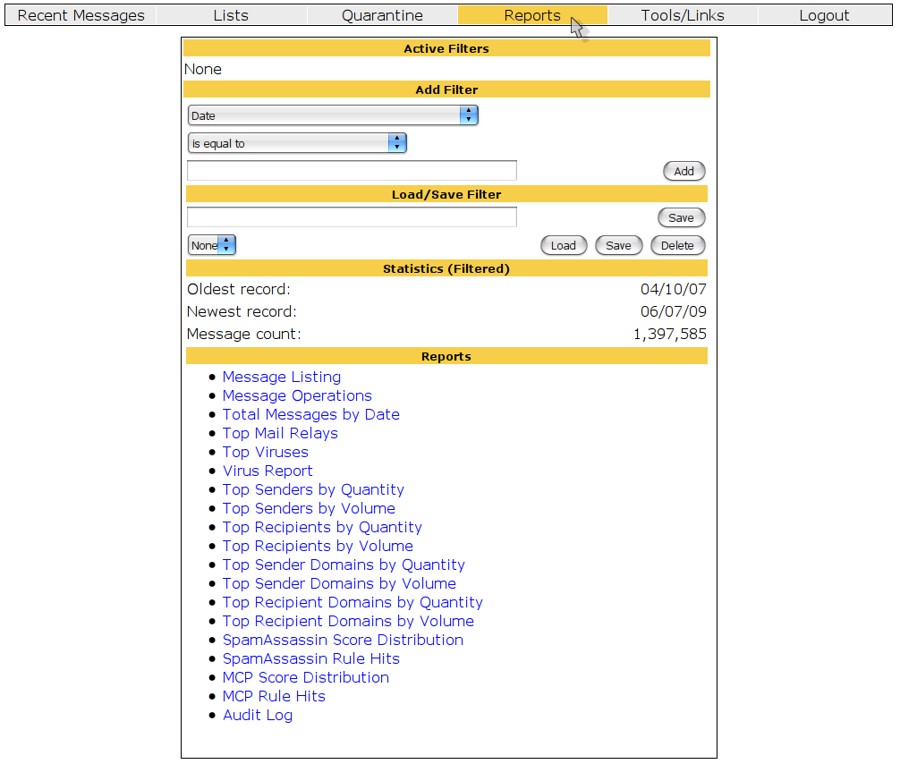

Add Filter section

Report template

Figure 14
- Adding filter
    - Example: Change period (date) to generate report.
    - First, in the Add Filter section, choose variable to use in the Filter. Since we are going to change period use in the system, choose Date from the drop down menu.
    - Next, change the variable for the Date from the drop down menu to is equal to.
    - Then, key in date as in format YY/MM/DD as shown in the Figure 15.
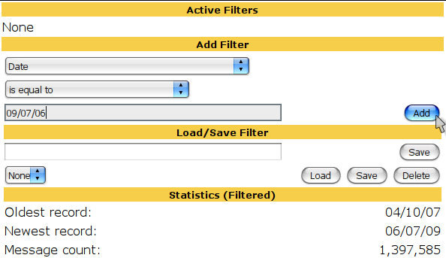

Figure 15
    - Finally, click button Add to submit new filter in the system. As shown in Figure 16, It has update Active Filters to Date is equal to '09/07/06'. Total count email for the 06 July 2009 is 389 number of emails.
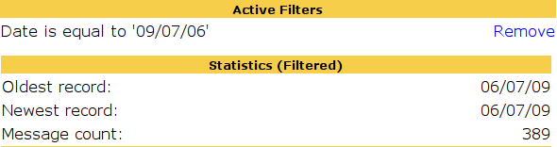
Figure 16
- Selecting report template from Reports listing
    - First, you have to add new variable in the Add Filter section as in previous example.
    - Next, choose one of options available in the Reports section. Example of report on Total Mail Processed by Date from 01 July 2009 until 06 July 2009

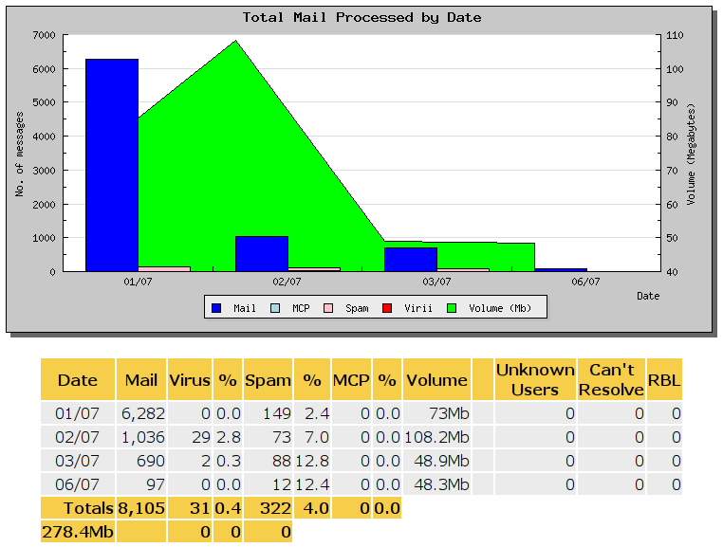

Figure 17

Tools/Links

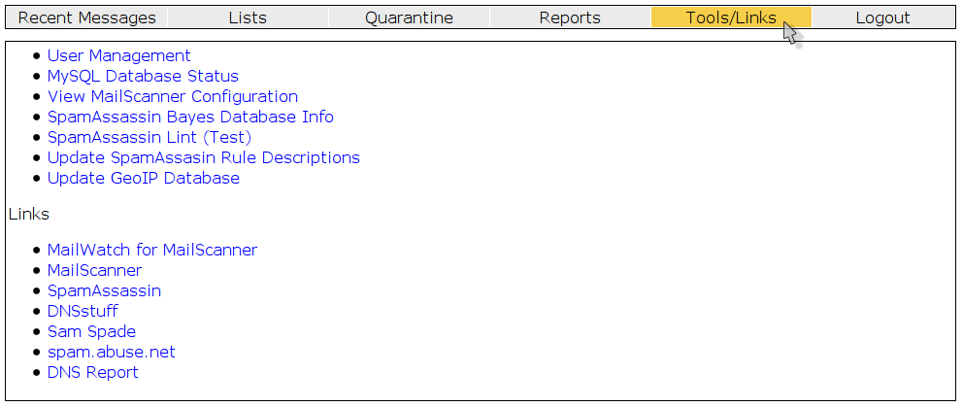
Figure 18
Tools/Links provide service such as:
- User management
  - Administrator can add new user to the system, delete or edit existing user in the system
  - First, click on User Management from the list available.
  - It will display User Management box. Administrator have options to apply action available in the Actions column for existing user.
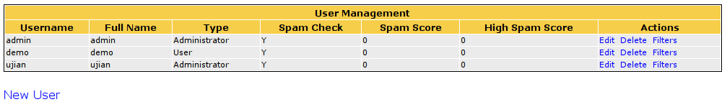
Figure 19
Adding function
Action function
  - Aside from that, administrator also have the options to add new user into the system by click New User underneath User Management box. Click New User to display New User box as shown in Figure 20.
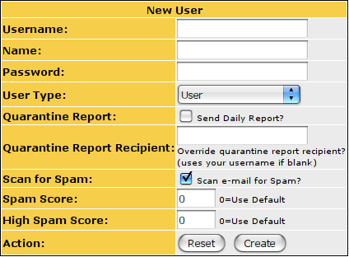

Figure 20
  - Fill in the requirement field in order to add new user into the system.
  - Once you finish fill in all the requirement field, click button Create to submit new user in the system.

- Update status for MySQL by click link MySQL Database Status.
- Viewing configuration MailScanner to check on spamassassin score and other configuration by click link View MailScanner Configuration.
- Updating Spamassassin rules in the system by click link Update SpamAssassin Rule Description.

Maintenance
The following should be checked on a regular basis:

Network connections
The administrator should verify the server is reachable from the public network to avoid service interruption. Network monitoring is beyond the scope of these manual.

Log files
With the log files, it is possible to identify and monitor hardware and software problems on the servers. The log files should be checked at least once a week. All log files in /var/log/ directory.

Services
Used to start, stop or cancel a service on a local or remote computer. It is also a tool to set up recovery actions to take place if a service should fail. Should be checked in case of service failure.

e.g:
#/etc/init.d/[service_name] start/stop/status

Package update/patch
Check that the latest package update/patches has been installed on the servers. It should be checked and done at least once a month.

Disk Space
to verify that there is always enough space on the most mission critical servers. It should be done at least once a week. Use df -lh command.

Password change
Password should be changed periodically, at least every three months.

ClamAV update
Execute command freshclam frequently to verify automatic update is successfully done.

Check SpamAssassin rules
Execute command sa-update -D at least once a month to download the latest spamassassin rules.

