


MYSPAMGUARD
Administration Manual
Version 2.1

OPEN SOURCE COMPETENCY CENTRE (OSCC) MAMPU
Level 3, APT E302-E304
Enterprise Building, Persiaran APEC
63000 Cyberjaya
Selangor
Tel: (6)03-8319 1200
Fax: (6)03-8319 3206
E-mail: helpdesk@oscc.org.my
http://opensource.mampu.gov.my

Table of Contents
INTRODUCTION 1
OBJECTIVES 1
FEATURES 2
ARCHITECTURE 2
ADMINISTRATION 4
Login Page 4
MySpamGuard Console 4
Status Bar 5
Menu Bar 7
Maintenance 15

INTRODUCTION
MySpamGuard is an email spam solution. It searches the headers and text of incoming emails to determine whether it is spam based on the procmail instruction or rules set by the user. MySpamGuard will classify the suspected spam accordingly; email sent by a virus, email from a known spam source which is definitely spam, and email which is probably spam. It then tags the filtered out email with the appropriate header and respond accordingly to the action specified by the users.

New features in MySpamGuard 1.1
- Easy installation process. The files needed will be downloaded automatically by the installer.
- All modules needed in MySpamGuard are combined as one package. The modules are:
SpamAssassin – spam checking aplication
MailScanner – email scanning for general filtering
ClamAV – anti virus solution
- Minimum configuration because most of the configuration is installed automatically by the installer
- Automatic update for all package from OSCC repository server
- Easy to upgrade to the next version

OBJECTIVES
MySpamGuard assists the Public Sector agencies to achieve the following objectives:
- To reduce number of incoming spam email in user's inbox..
- Easy to handle or managing the incoming spam email using MailWatch the Spam System front-end.
- Administrator have the total handling for rules use to block incoming spam email.

FEATURES
Some of the features available in MySpamGuard are:
- Easy installation process. The files needed will be downloaded automatically by the installer.
- All modules needed in MySpamGuard are combined as one package. The modules are:
  - SpamAssassin – spam checking aplication
  - MailScanner – email scanning for general filtering
  - ClamAV – anti virus solution
- Minimum configuration because most of the configuration is installed automatically by the installer

ARCHITECTURE
There are three components in MySpamGuard which are Spam Component, Spam Database, and MySpamGuard Console.
- Spam Component using MailScanner as the spam and vrirus email blocker
- All mail and data for suite component in MyWorkSpace will be stored in the Mail Database.
- There are two mail transporters used in MyWorkSpace:
  - Postfix acts as a Mail Transfer Agent (MTA) which transfers electronic mail messages from one computer to another.
  - DBMail acts as a Mail Delivery Agent (MDA) which stores and retrieves email received between the MTA and database.




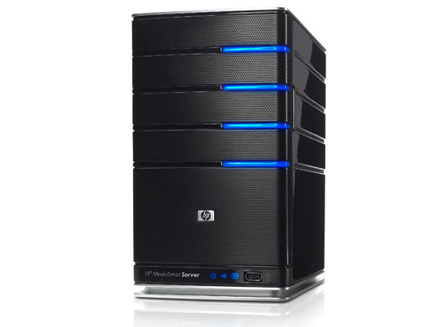
Figure 1 : Architecture Diagram
MySpamGuard
Mail Server
All spam/virus email will be block at MySpamGuard
End-User

ADMINISTRATION

Login Page
Open your web browser to login into MySpamGuard Console, as shown below:
URL: http://DOMAIN_NAME/mailscanner
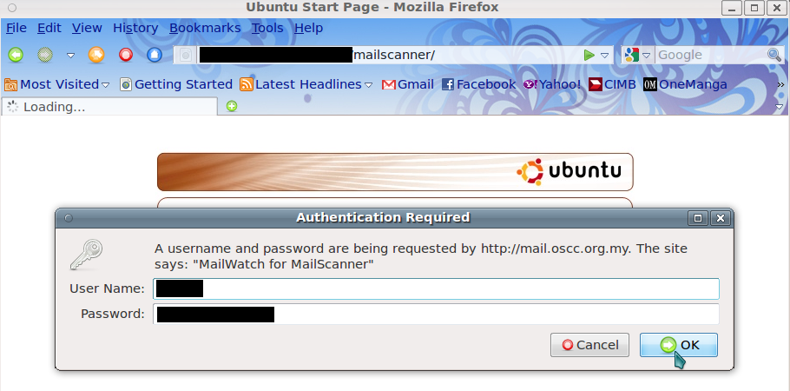

MySpamGuard Console
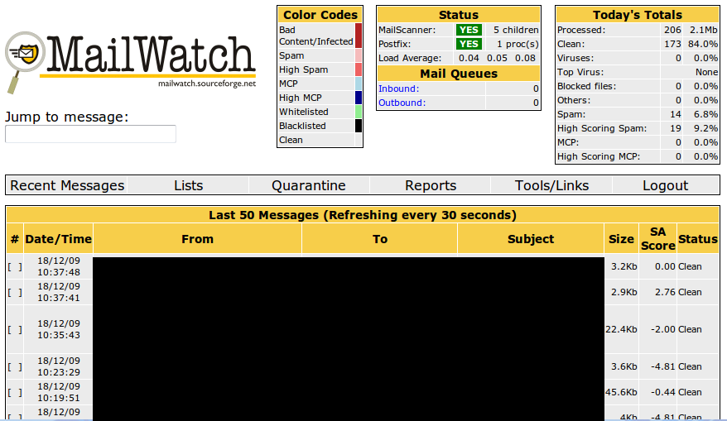
After the first login, the main console will show the Recent Messages of incoming email in the system.

Status Bar
The Status Bar contains five services which is Jump to Message, Color Codes, Status, Mail Queues and Today's Total.

Jump to message
We can use the Jump to message service to locate messages using message ID. For example, the message ID is 1998E1350001.40D8E, if admin key-in the ID at the field provided at Jump to message, admin can retrieve the e-mail summary.

Color Codes
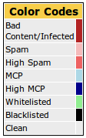Illustration 1: Color Codes box
We are using Color Codes to distinguish clean, spam and virus e-mail from one to another.

Explanation for each color:
- Bad Content/Infected
The e-mail contains spam and virus. E-mails that are catogerised as spam e-mail (e-mail with high SpamAssassin score, by default > 6.0) are blocked at MySpamGuard server and stored in the Quarantine folder.
- Spam
E-mails with low SpamAssassin scores are identified as spam and stored in Quarantine folder.
- High Spam
E-mails with higher SpamAssassin (by default score is > 10.0) scores are identified as High Spam and will be stored in the Quarantine folder.
- MCP
Message Content Protection (MCP) allows you to write rules for scanning the text content of e-mail messages in order to trap messages that contain certain numbers of keywords and/or phrases that should not leave beyond your company into the internet. It could also be used to ban mails containing pornographic phrases and so on, without having to mess with Spam Actions or have custom spam rules.
- High MCP
E-mails with a high number of MCP are blocked at MySpamGuard.
- Whitelisted
All e-mails which are whitelisted are allowed passage from MySpamGuard server.
- Blacklisted
All e-mails which are blacklisted are blocked at the MySpamGuard server and not released.
- Clean
All the clean e-mails are color-coded in grey color. These e-mails have SpamAssassin's scores below the spam score.

Status
The Status box shows the current status of two main services running in MySpamGuard which is MailScanner and Postfix. It also shows the Load Average for the whole system.
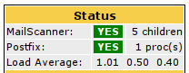Illustration 2: Status box

Mail Queues
The Mail Queues box notifies of Inbound or Outbound e-mails. Inbound shows incoming e-mail and Outbound shows the outgoing e-mail.
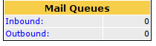Illustration 3: Mail Queues box

Today's Total
Total box shows a summary of the total incoming e-mails, e-mails that contains spam and virus and etc.
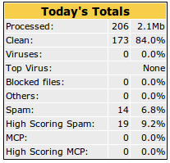Illustration 4: Today's Total box

Menu Bar

The Main Menu Bar provides a list of options to display recent messages, white/black list, quarantined e-mails, reports, user management tools and logout menu.
Illustration 5: Menu Bar
Recent Messages
After the first login, the first content displayed on the MySpamGuard Console are Recent Messages. It shows the last 50 messages on the system and periodically updates every 30 seconds.

Lists
Using the Lists service, e-mails or IP addresses can placed as whitelisted or blacklisted by selected the appropriate boxes.
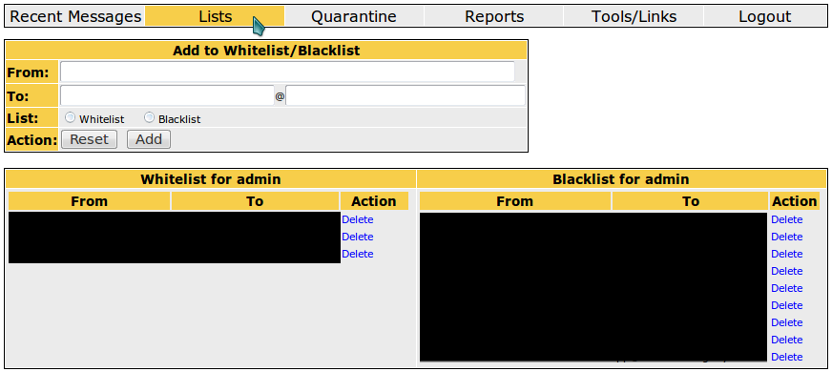Illustration 6: Lists

Quarantine
Quarantine shows all the quarantine e-mails with low SpamAssassin score. All quarantined e-mail will be kept and grouped by its date.
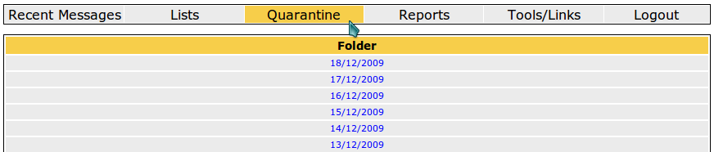Illustration 7: Quarantine
Below is the Illustration of quarantine folder:
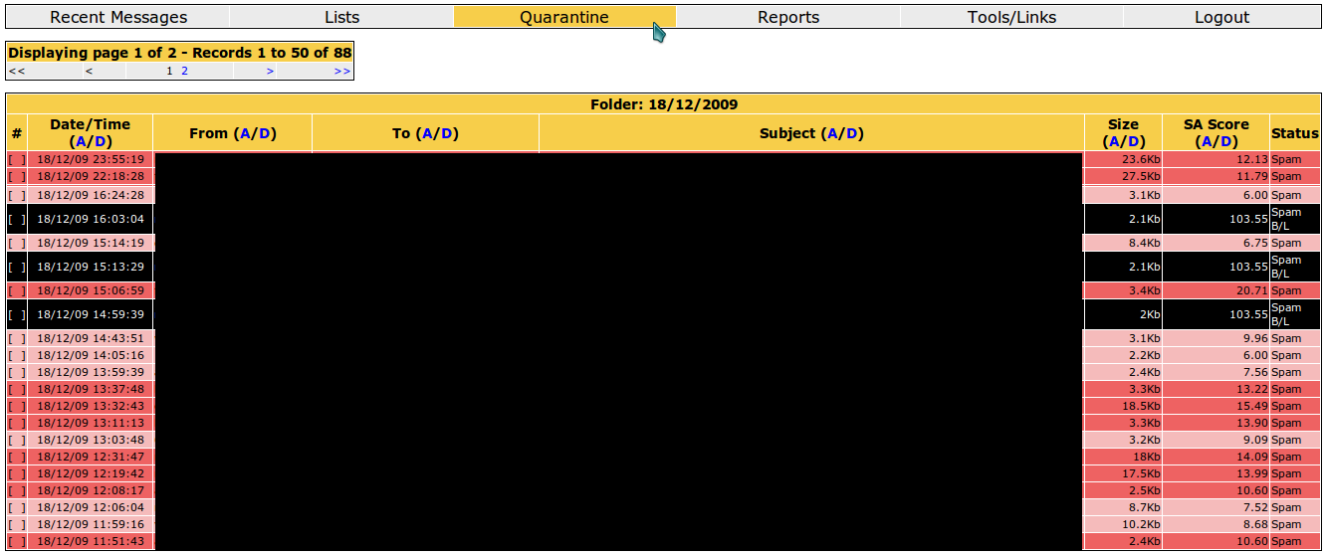Illustration 8: Quarantine folder
Reports
Administrators can generate reports or statistics for a certain period. A report can also use the preferred filter such as user e-mail address (sender or recipient), e-mail header or other filter provided in Add Filter section. The filter option we add in the Add Filter will be the parameter use to generate the report.
Aside from that, administrator can perform SA Learn update using service Message Operations in Reports section.
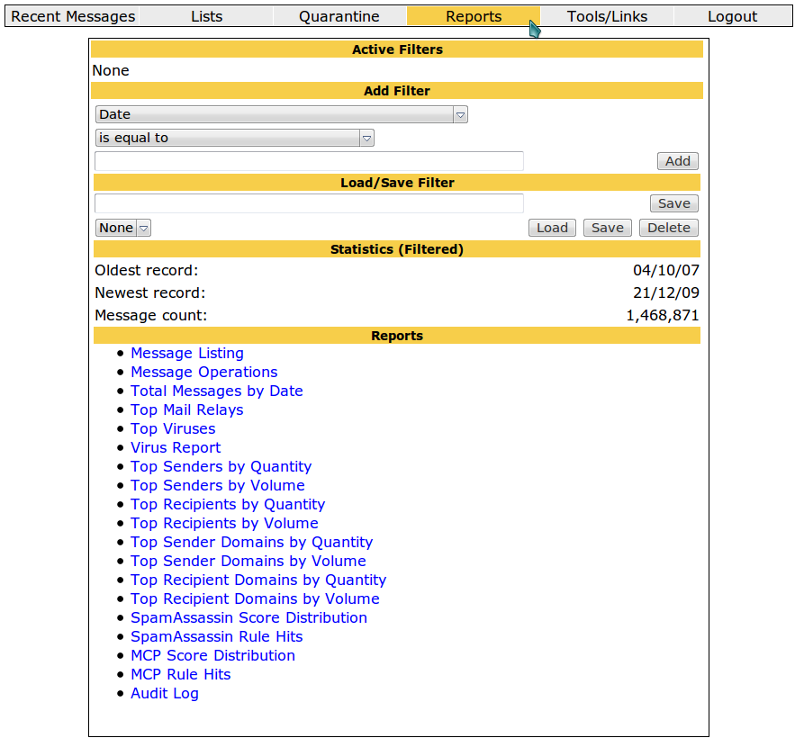Illustration 9: Reports
In this example, a report on Total Messages by Date and Top Senders by Quantity for period from 15 December until 20 December 2009 is produced:
First, add period time in the Add Filter
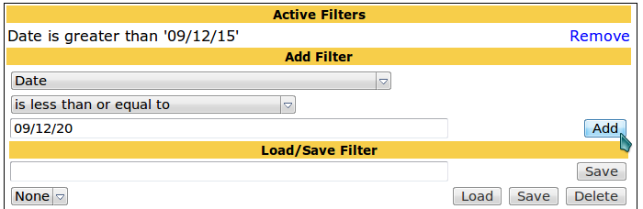Illustration 10: Adding filter
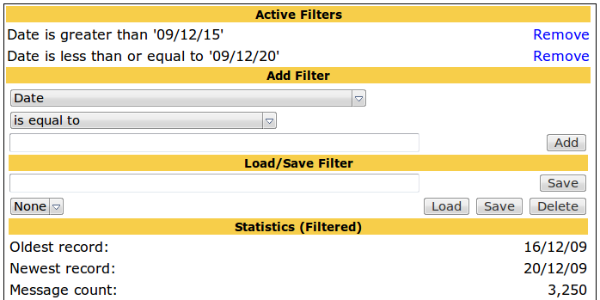
You can see the total e-mail within period (period based on Active Filter) in the Statistics (Filtered).

To generate report for Total Messages by Date, select Total Messages by Date in the Reports section. Reports will be shown in graph based from the period time used.
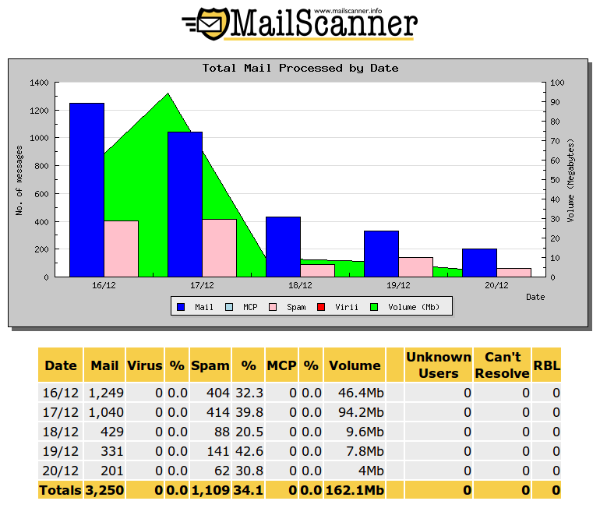Illustration 11: Graph for Total Messages by Date
To generate report for Top Sender by Quantity, select Top Sender by Quantity in the Reports section. Reports will be shown in pie-chart form based from the period time used.
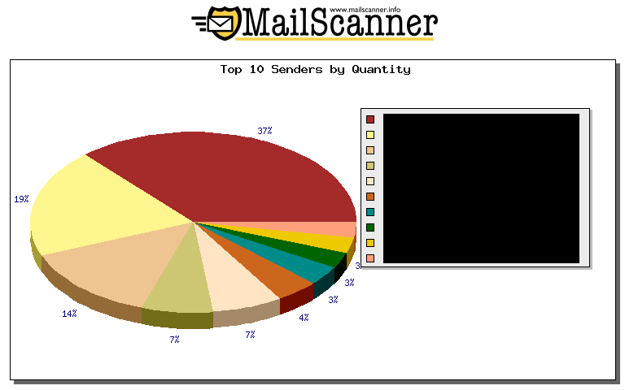Illustration 12: Chart for Top Sender by Quantity
Tools/Links
In Tools/Links, administrator can perform few task in here:
- Manage users such as adding new users and editing or deleting existing users under User Management
- Updating package/rule such as SpamAssassin (spam scanner) and ClamAV (virus scanner)
- Preview data (configuration) such as MailScanner and SpamAssassin

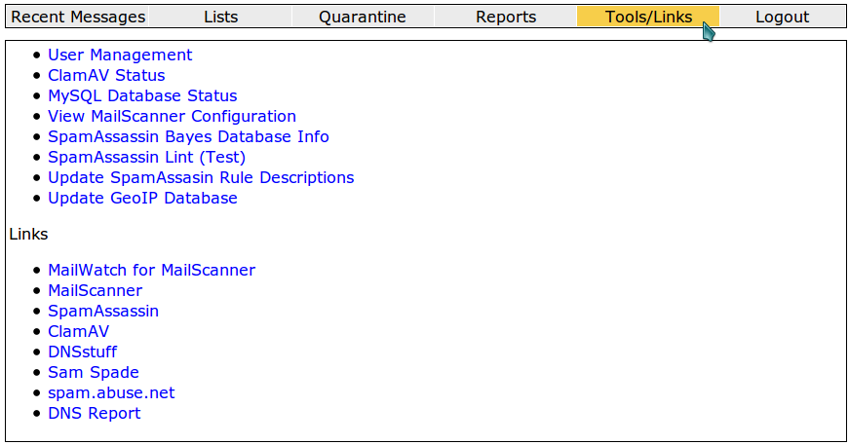Illustration 13: Tools/Links
User Management
All user management can be done in MySpamGuard Console at Tools/Links under User Management section. Click at the User Management will show latest user and their role in the system.
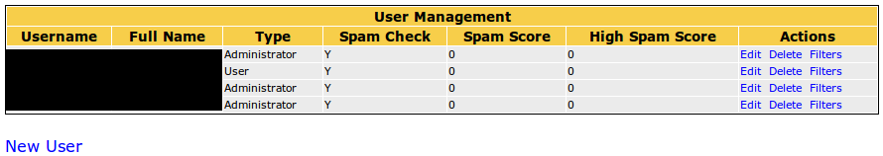Illustration 14: User Management
Administrators have the privilege to perform actions as listed in the Actions such as editing, deleting or filtering for existing user, and aside from that, they also have the privilege to create new users for the system.
To create new user for the system, click at button New User under the User Management box.

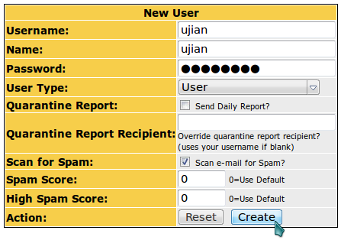Illustration 15: New User box

Fill in the field required such as Username, Name and Password for the new user. Administrators has to decide the user role/permission within the system. New roles can be added in the User Type.
Next, click on Create to create new user for the system.

MAINTENANCE
The following should be checked on a regular basis:

Network connections
The administrator should verify the server is reachable from the public network to avoid service interruption. Network monitoring is beyond the scope of these manual.

Log files
With the log files, it is possible to identify and monitor hardware and software problems on the servers. The log files should be checked at least once a week. All log files in /var/log/ directory.

Services
Used to start, stop or cancel a service on a local or remote computer. It is also a tool to set up recovery actions to take place if a service should fail. Should be checked in case of service failure.

e.g:
#/etc/init.d/[service_name] start/stop/status

Package update/patch
Check that the latest package update/patches has been installed on the servers. It should be checked and done at least once a month.

Disk Space
to verify that there is always enough space on the most mission critical servers. It should be done at least once a week. Use df -h command.

Password change
Password should be changed periodically, at least every three months.

ClamAV update
Execute command freshclam frequently to verify automatic update is successfully done.

Check SpamAssassin rules
Execute command sa-update at least once a month to download the latest spamassassin rules.

