Release Notes
  - Stock Awesome

V.4.0.5
Table of Contents
V.4.0.4 1
Release Features 3
Upgrading 4
Upgrade Path 4
Database Changes 4
File System Changes 4
Enhancements 5
Validation For Currency Form 5
Data Grid 5
Fixes 6
Invoice Creation 6
Department Data Creation 6
Created Products Do not show up in Invoice Module 6
Known Issues and Problems 7
Products Excel and PDF export 7
Workaround 7

Release Features

Barcodes and Labels
From Version 4.0.5 we provide the ability to create beautiful barcodes. As of now we have only two presets and we are willing to add more for you. If you have a certain design you want implemented please email me at dwanyoike@codedcell.com

Small Label


Big Label With Additional Information

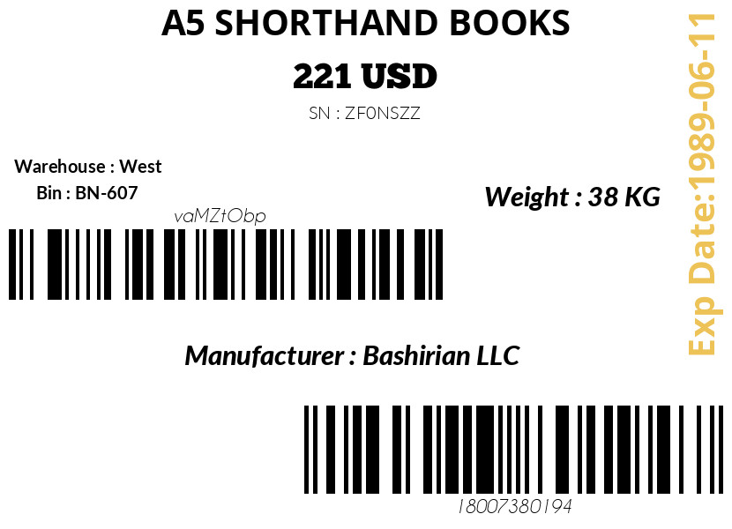

Upgrading

Upgrade Path
To install this update as a patch your previous Stock Awesome Version Number must be V.4.0.3. You can check for your current version in your application footer.

Database Changes
- None

File System Changes
Please see attached file on files and folders that have changed Please note that you do not need to re-install the whole application you can simply use the patch file to upgrade your system. Simply replace the changed files using the ones in the patch file.

Enhancements

Validation for Currency Form
The Currency Form doesn’t allow null values for the exchange rate field now.

Data Grid
Filter Records divider doesn’t show up if there is no module specific filter.
The default filter that was named Latest Products is now renamed to Latest.
User Module Now has Filters

Fixes

Invoice Creation
This Update Fixes an issue with creating invoices where you would get the error
Class 'CodedCell\Repository\Invoice\SalesOrderItem' not found

Department Data Creation
Fixed an issue with the creation of Departments Due to missing Date Picker Input add-on and Wrong arguments in DepartmentController Store Function

Picture Uploads
Fixed existing error where when picture is uploaded it is saved on filesystem but is not visible in UI to the end user.

Known Issues and Problems

Products Excel and PDF export
When extracting excel or PDF document in the Products module an error occurs. This happens when you have a long list of items that causes the server to hang due to memory limits

Workaround
- Use Excel
- Filter records to the absolute minimum you need using Grid Filters
[Example:]
None

