需要如下：

Master：192.168.1.135 VIP：192.168.1.102

Bakup：192.168.1.248 VIP：192.168.1.102

### 定义grains坏境：

|  |
| --- |
| salt '192.168.1.135' grains.setvals "{'name':'nginx_keepalived','roler':'master','vip':'192.168.1.102'}" |
| salt '192.168.1.237' grains.setvals "{'name':'nginx_keepalived','roler':'bakup','vip':'192.168.1.102'}" |

查看定义内容：

[root@localhost keepalived]# salt '*' grains.item {'name','roler','vip'}

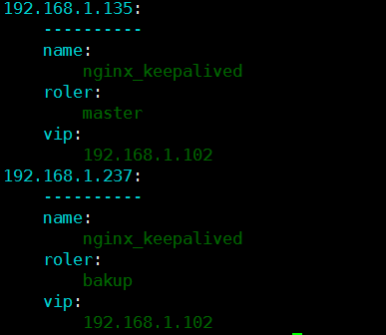

### 目录结构：

/etc/salt/prod/keepalived

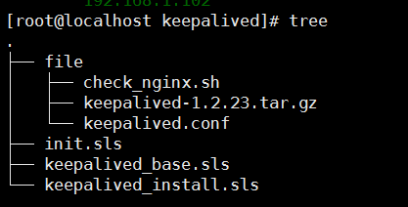

|  |
| --- |
| [root@localhost keepalived]# cat file/check_nginx.sh  #!/bin/bash  flag=`ps -C nginx --no-header |wc -l`  if [ $flag -eq 0 ];then  /usr/local/nginx/nginx  sleep 3  if [ `ps -C nginx --no-header |wc -l` -eq 0 ];then  killall keepalived  fi  fi |

|  |
| --- |
| [root@localhost keepalived]# cat file/keepalived.conf  ! Configuration File for keepalived  global_defs {  notification_email {  sysadmin@firewall.loc  }  notification_email_from Alexandre.Cassen@firewall.loc  smtp_server 192.168.200.1 #邮件服务器地址  smtp_connect_timeout 30  router_id LVS_DEVEL  }  vrrp_script chk_http_port {  script "/etc/keepalived/check_nginx.sh" #检测脚本  interval 2  weight 2 #执行间隔时间  }  vrrp_instance VI_1 {  {% if grains['roler'] == 'master' %}  state MASTER #设置为主  priority 101  {% elif grains['roler'] == 'bakup' %}  state BACKUP #设置为备  nopreempt #当主down时，备接管，主恢复，不自动接管  priority 51  {% endif %}  interface eth0  virtual_router_id 51  authentication { #验证信息  auth_type PASS  auth_pass q1w2e3r4!  }  track_script {  chk_http_port  }  virtual_ipaddress {  {{ grains['vip'] }} dev eth0 scope global label eth0:1 #虚拟IP地址  }  } |

#### Sls文件：

|  |
| --- |
| [root@localhost keepalived]# cat keepalived_base.sls  /etc/keepalived:  file.directory:  - mode: 755  - makedirs: True  /etc/keepalived/check_nginx.sh:  file.managed:  - source: salt://keepalived/file/check_nginx.sh  - user: root  - group: root  - mode: 755  /etc/keepalived/keepalived.conf:  file.managed:  - template: jinja  - source: salt://keepalived/file/keepalived.conf |
| [root@localhost keepalived]# cat keepalived_base.sls  /etc/keepalived:  file.directory:  - mode: 755  - makedirs: True  /etc/keepalived/check_nginx.sh:  file.managed:  - source: salt://keepalived/file/check_nginx.sh  - user: root  - group: root  - mode: 755  /etc/keepalived/keepalived.conf:  file.managed:  - template: jinja  - source: salt://keepalived/file/keepalived.conf  [root@localhost keepalived]# cat keepalived_install.sls  keepalived_install:  file.managed:  - name: /data/tools/keepalived-1.2.23.tar.gz  - source: salt://keepalived/file/keepalived-1.2.23.tar.gz  cmd.run:  - name: cd /data/tools&&tar xvzf keepalived-1.2.23.tar.gz&&cd keepalived-1.2.23&&./configure --prefix=/usr/local/keepalived&&make &&make install&&cp /usr/local/keepalived/etc/sysconfig/keepalived /etc/sysconfig/keepalived&&mkdir /etc/keepalived &&ln -s /usr/local/keepalived/etc/keepalived/keepalived.conf /etc/keepalived/&&cp /usr/local/keepalived/sbin/keepalived /usr/sbin/&&cp /usr/local/keepalived/etc/rc.d/init.d/keepalived /etc/rc.d/init.d/&&chmod +x /etc/rc.d/init.d/keepalived&&chkconfig keepalived on |
| [root@localhost keepalived]# cat init.sls  include:  - keepalived.keepalived_base  - keepalived.keepalived_install |

### 安装：

salt '*' state.sls saltenv='prod' keepalived.keepalived_init

启动keepalived：

salt '*' cmd.run 'service keepalived restart'

### 可以设置组名测试：

[root@localhost keepalived]# vim /etc/salt/master

nodegroups:

keepalived: G@name:nginx_keepalived

[root@localhost keepalived]# salt -N keepalived test.ping

192.168.1.237:

True

192.168.1.135:

True